Ms. M. Dunne & Ms. E. Lynch (4th Class)
Class Work – Monday 20/4/20 – Friday 24/4/20

Dear Parents/Guardians,

We hope you are all safe and well and the children enjoyed plenty of sunshine and eggs over Easter. We have outlined work below for the week beginning 20/4/20. We realise that some students may not have access to the internet/computer so please do not worry just try to do whatever you can. We have highlighted work that if possible, you could email back to us. This new system may have some technical issues to begin with but hopefully over time it will work out. If you are unable to send work back please do not worry, just keep whatever work has been completed in a copy and we can view it when school resumes.

Written activities/ maths can be completed in copies-there is no need to print the attached sheets. Include a title, date and page numbers. Encourage children to check for capital letters, spellings and full stops.
In maths we are moving onto the topic of time. This topic is best explored through hands-on real life activities-timetables, cooking, timing activities (running, cycling). Please remember that if your son/daughter is having any difficulties be assured that it will be covered upon return to school.

Folens publishers have made their online resources free to students during the time off. We highly recommend using their online Abair Liom and Planet Maths resources. Steps on how to register are included in Monday’s Gaeilge work.

CJ fallon have also made their resources free and we will be completing activities from Léigh sa Bhaile D. See picture on the next page.

We hope the children are enjoying their time at home and look forward to hearing from you all soon,

Kind Regards Eileen Lynch & Maeve Dunne

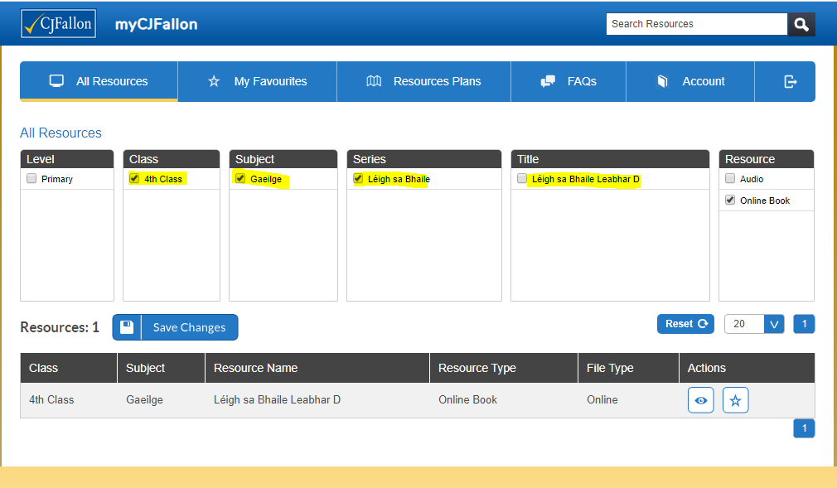

Teachers’ Names | E. Lynch & M. Dunne
Class level | 4th
Suggested work for week beginning | 20th April
Teachers email address | mslynch4thclass@gmail.com  maevedunne4thclass@gmail.com
Correction of work | Work that we have highlighted should be submitted to the appropriate teacher’s e-mail address above. This can be a photograph of the copybook page or the answers can be typed into the e-mail. Please write your child’s name in the subject part of the e-mail.  Work that is not highlighted should be corrected by an adult/parent. Irish and maths answers have been attached below. Please do not show the answers to your child until they have completed their tasks.
Message from teacher/s | You can also email me if you have any queries or questions. Please write your child’s name in the subject box of the email.

Remember to tune into the RTE Home School Hub every day at 11.00

Monday 20/4/20
Happy Birthday Morne
English | Treasury D  Reading & Writing  The Marrog P-82  Complete A,B,C P-83 (Please scan and email this work back to me)  Reading: Library book / audio book- for at least fifteen minutes every day
Gaeilge | Abair Liom- Ag an Aerfort  Comhrá – (Conversation)- lgh 156 & 157  Litriú- p 63 (j) i agus í- scríobh cúig abairt ag baint úsáid as na focail.( Write five sentences using the new words)  Go to folensonline.ie  - Click register.  - Select Teacher  - For roll number use the code: Prim20
Maths | Master Your Maths  Week-25 Monday P54  Division Tables  $÷$7 https://www.topmarks.co.uk/maths-games/daily10 may be useful  Planet Maths Time  Complete page 143  folensonline- resources –time 2
Spellings | English  Spelling Made Fun List 21- spellings are attached below  Learn spellings 1-4  Gaeilge  Lgh 63 (J) Litriú 1, 2 éadaí, dinnéar  *Students are going be asked to complete their spelling test on Fridays at home.
PE | 30 Minutes of physical exercise every day. You may find the following links useful:  • Zumba Dance Party – https://www.youtube.com/watch?v=FHo9QaJ1DyI  • Dance Tutorial – https://www.youtube.com/watch?v=FRnEDoVRaa0  • Body Coach for Kids – https://www.youtube.com/watch?v=d3LPrhI0v-w&safe=active  Key Stage 2 – https://www.bbc.co.uk/teach/ks2-physical-education/zj2n92p  • Yoga for Kids – https://www.youtube.com/watch?v=X655B4ISakg
Science | Small World Geography & Science  Unit 18 – Materials and Change  Complete – Question A 1-7 P-106  Optional Extra activities  Cornflour Experiment  Cornflour cannot decide if it is a liquid or solid!  https://www.theguardian.com/science/2008/may/02/physics7  Materials and their Properties – https://www.science-sparks.com/category/key-stage-2-science/materials-and-their-properties-key-stage-2/  *If you have the materials, it would be great to do some of the experiments in this chapter or if you find some online. You could email a picture of your experiment before the end of April.

Tuesday 21/4/20
Happy Birthday Rianne
English | Treasury D  Read ‘The Marrog’ P-82  Creative writing- p83 part D- Plan your story and write an opening paragraph.  Grammar- Adverbs p 84 (A)  Reading: Library book / audio book
Gaeilge | Abair Liom- Ag an Aerfort  Comhrá – (Conversation)- lgh 156 & 157  Lgh 158- An raibh tú ar eitleán riamh? Cá ndeachaigh tú?  Lgh 158 Léigh agus freagair na ceisteanna 1-6  (Please scan and email this work back to me)
Maths | Master Your Maths  Week-25 Monday P54  Division Tables  $÷$7  Planet Maths Time  Complete page 144  *Answers to Master Your Maths Week 25 and Planet Maths have been attached for parents
Spellings | English  Spellings Made Fun list 21  Learn spellings 5-8  Gaeilge  Lgh 63 (J) Litriú : ag ithe lóin, bileog
SESE | Small World Geography & Science  Unit 18 – Materials and Change  Complete – Question B 1-6 P-106

Wednesday 22/4/20
Happy Birthday Marlyn & Tristan
English | Treasury D  Adverbs- p84 (B)  Creative writing- p83 D. Complete your story. Don’t forget to proof read –check capital letters, spellings and full stops. (Please scan and email both pieces of work back to me)  Reading: Library book / audio book
Gaeilge | Abair Liom- Ag an Aerfort  Comhrá – (Conversation)- lgh 159- B  Scríobh an comhrá- lgh 159 C
Maths | Master Your Maths  Week-25 Monday P55  Division Tables  $÷$7  Planet Maths Time  Complete page 145  *
Spellings | English  Spelling Made Fun List 21  Learn spellings 9-12  Gaeilge  Lgh 63 (J) Litriú : ispíní, trampailín
History | History Quest  Shops and Shopping P-79  The children will gain an understanding of the origins of trade and shops and how shopping has changed over time.  Complete Activity A (1-10), Activity B (1-5)

Thursday 23/4/20
English | Treasury D  Goldilocks –p86. Write a list of the correct words in your copy.  Grammar Prefixes(The sheet is attached below)  Complete questions 1-6 (Please scan and email this piece of work back to me)  Reading: Library book / audio book
Gaeilge | Abair Liom  Léamh – lgh 159- comhrá  Scríobh – lgh 160 –D  Léigh sa bhaile leabhar D- https://www.cjfallon.ie/  Lgh 6-Éide scoile nua- léigh agus freagair na ceisteanna
Maths | Division Tables  $÷$7  Planet Maths Time  Complete page 146  *
Spellings | English  Spelling Made Fun List 21  Learn spellings 13-16  Gaeilge  Lgh 63 (J) Litriú : ríomhaire, ag imirt cispheile
Art | Draw or paint a shop from the future. You may send a photo of your picture.

Friday 24/4/20
Happy Birthday Ailish
English | Grammar: Collective nouns (The sheet is attached below)  Complete questions 1-5 (Please scan and email this piece of work back to me)  Reading: Library book / audio book
Gaeilge | Abair Liom  Léamh & Comhrá– lgh 159 ( B)  Léigh sa bhaile leabhar D- https://www.cjfallon.ie/  Lgh 7 An Siopa Leabhar- léigh agus freagair na ceisteanna
Maths | Master Your Maths  Week-25 Friday Test P-90  Division Tables  Tables test- https://www.topmarks.co.uk/maths-games/daily10 may be useful  Planet Maths- Time  Check-up p 147
Spellings | English Spelling Test – list 21& Litriú Gaeilge .
Music | Tune into RTE School Hub  Music with Myleen Klass (optional)  https://www.youtube.com/channel/UCQh2wgJ5tOrixYBn6jFXsXQ

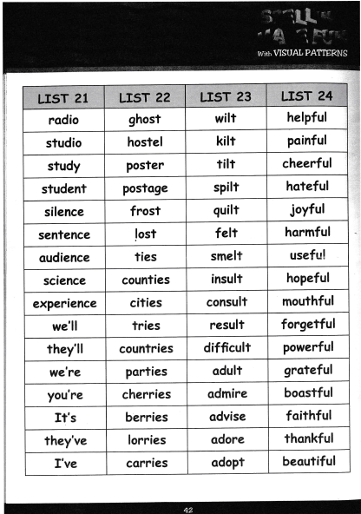
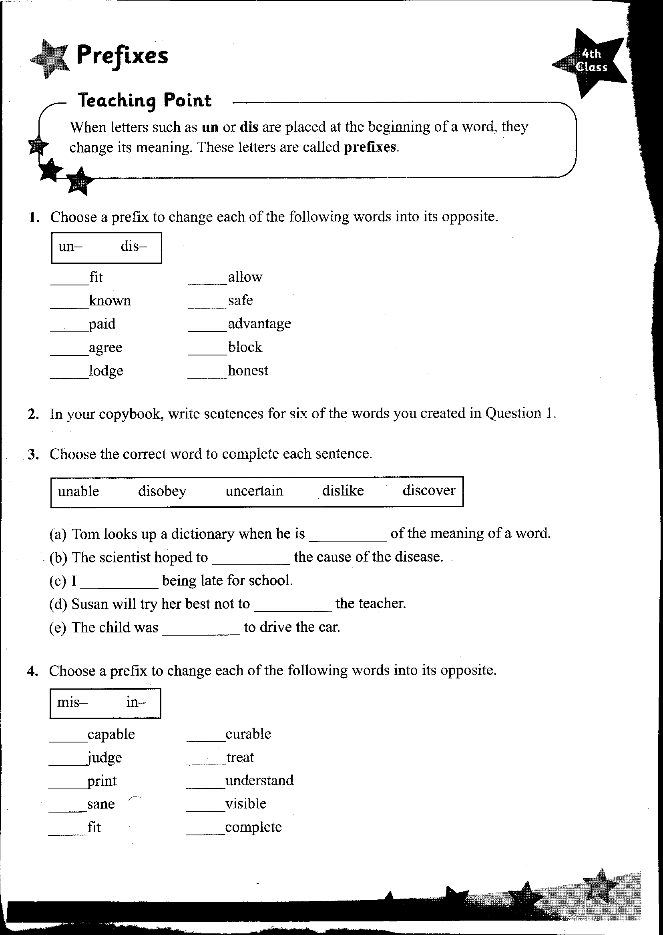
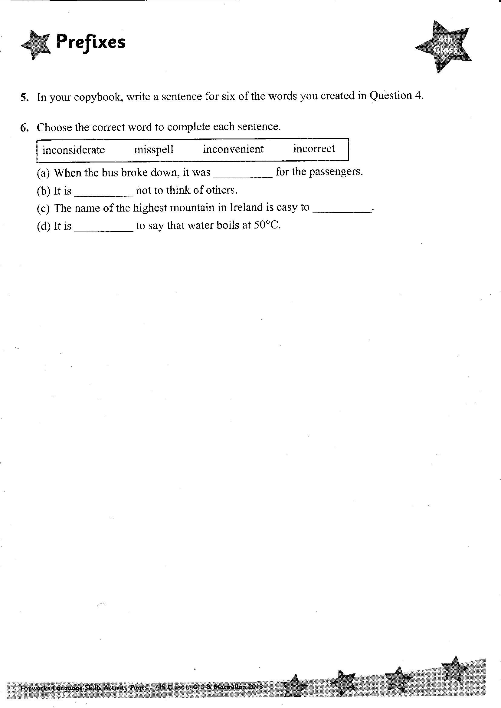
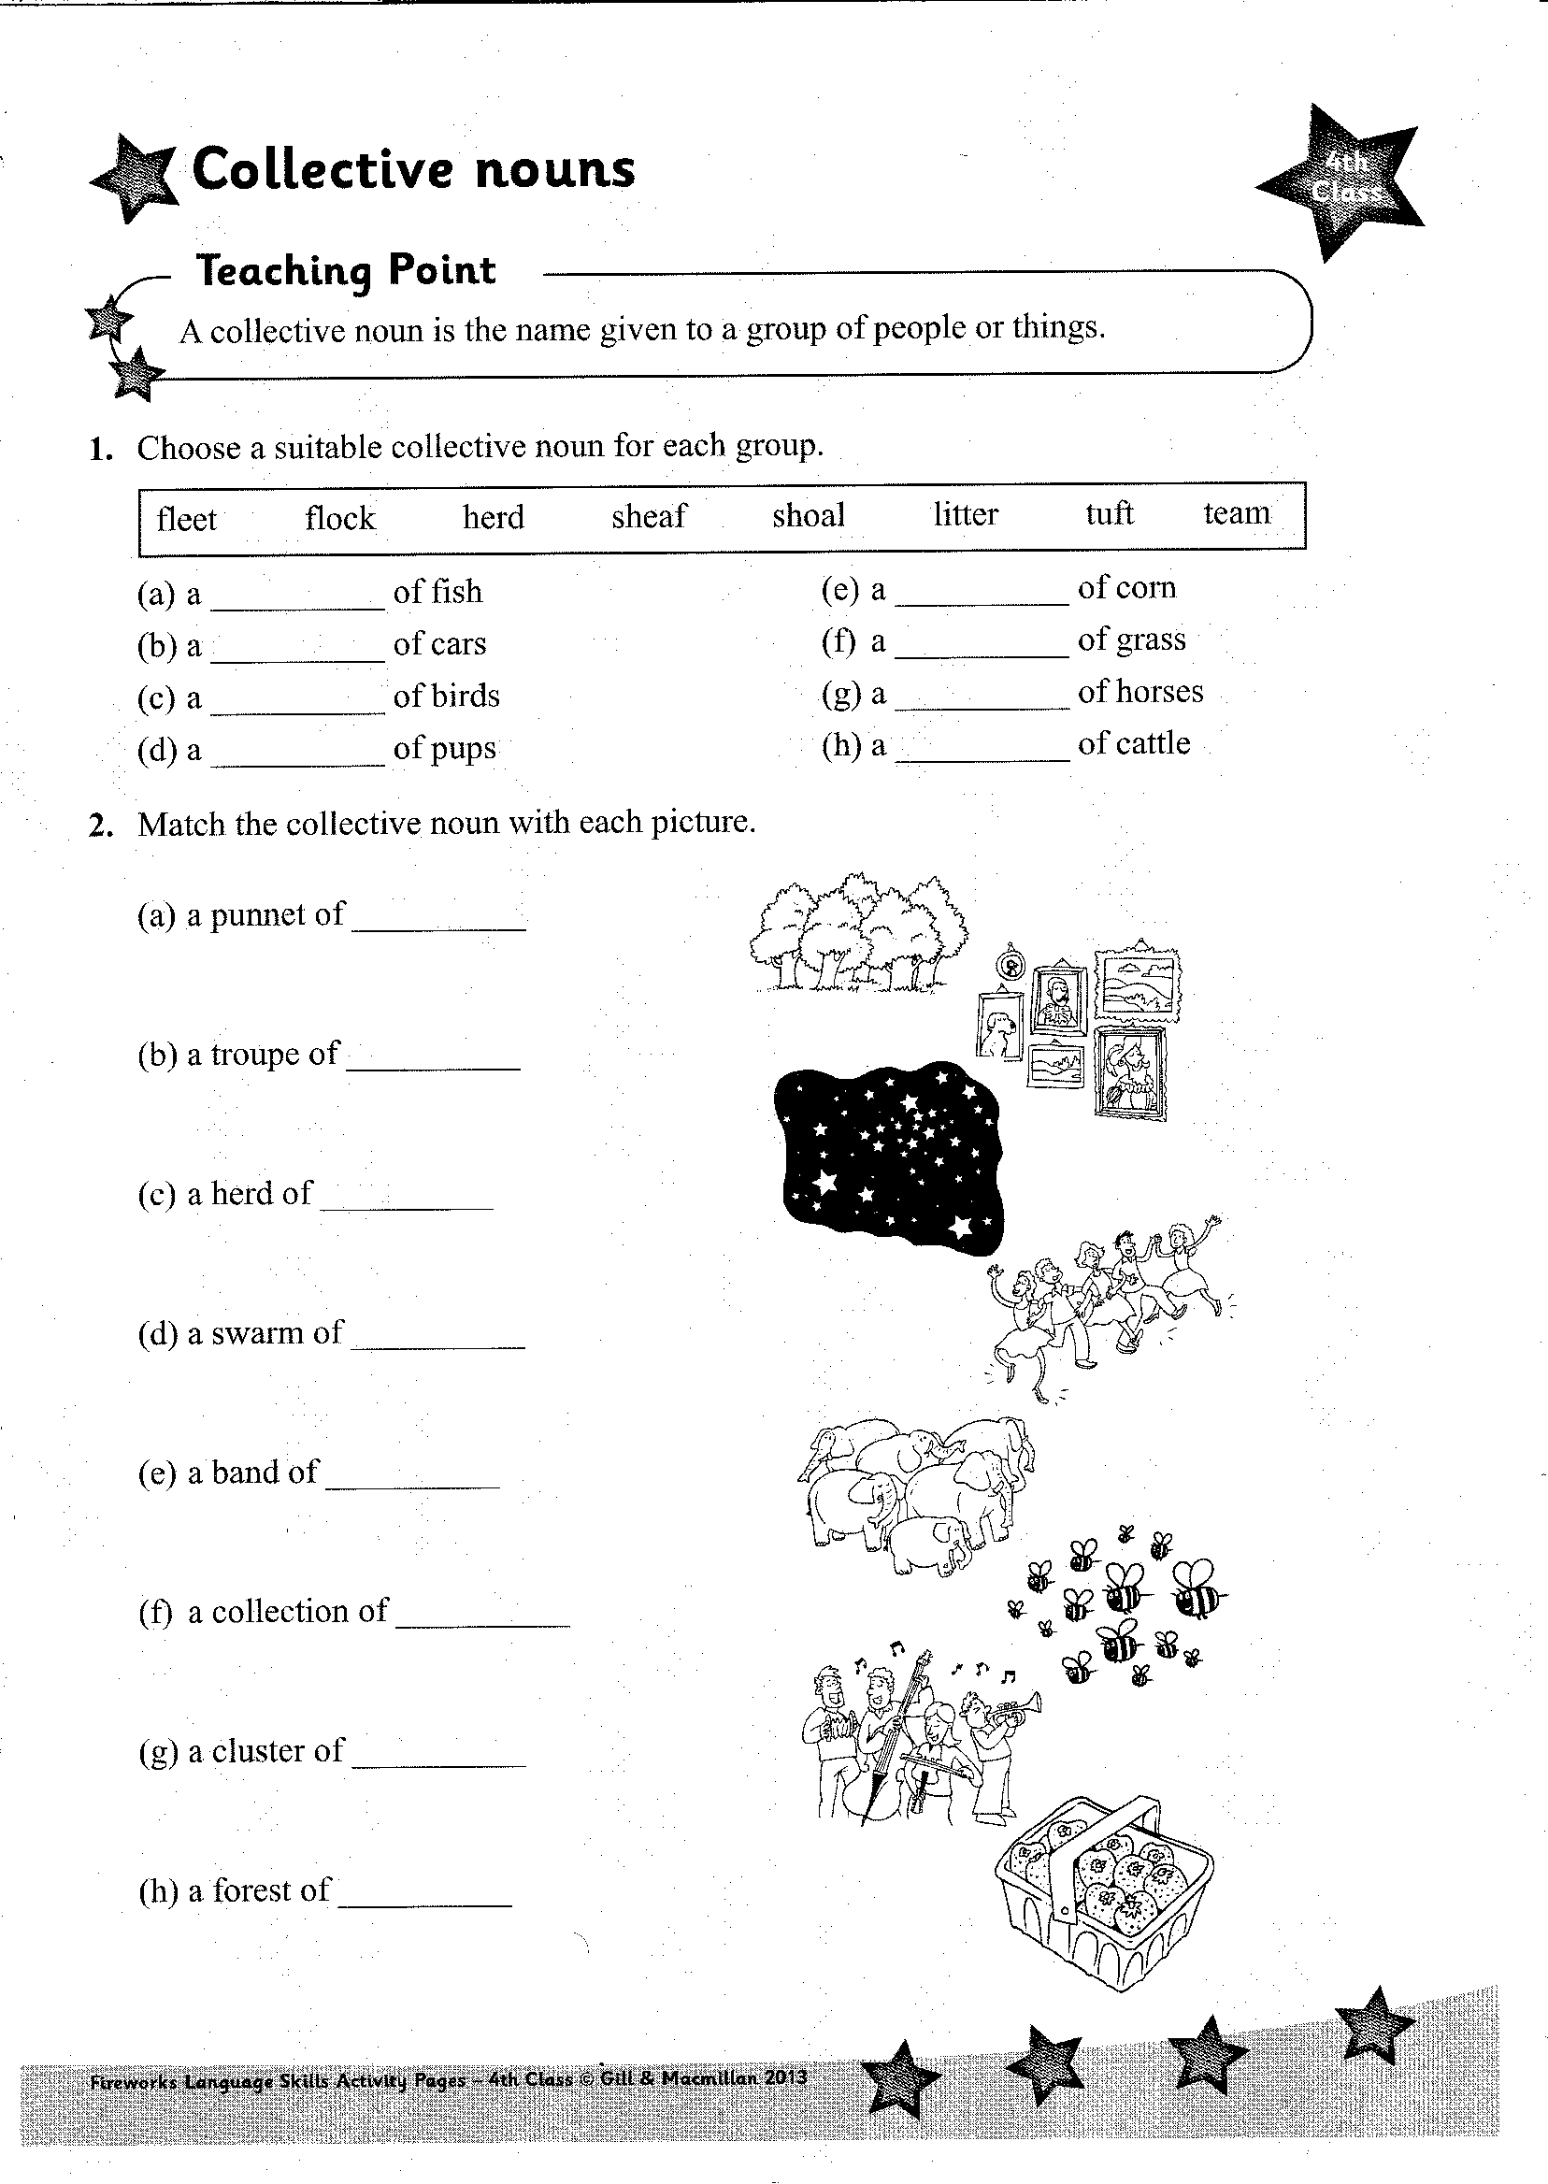
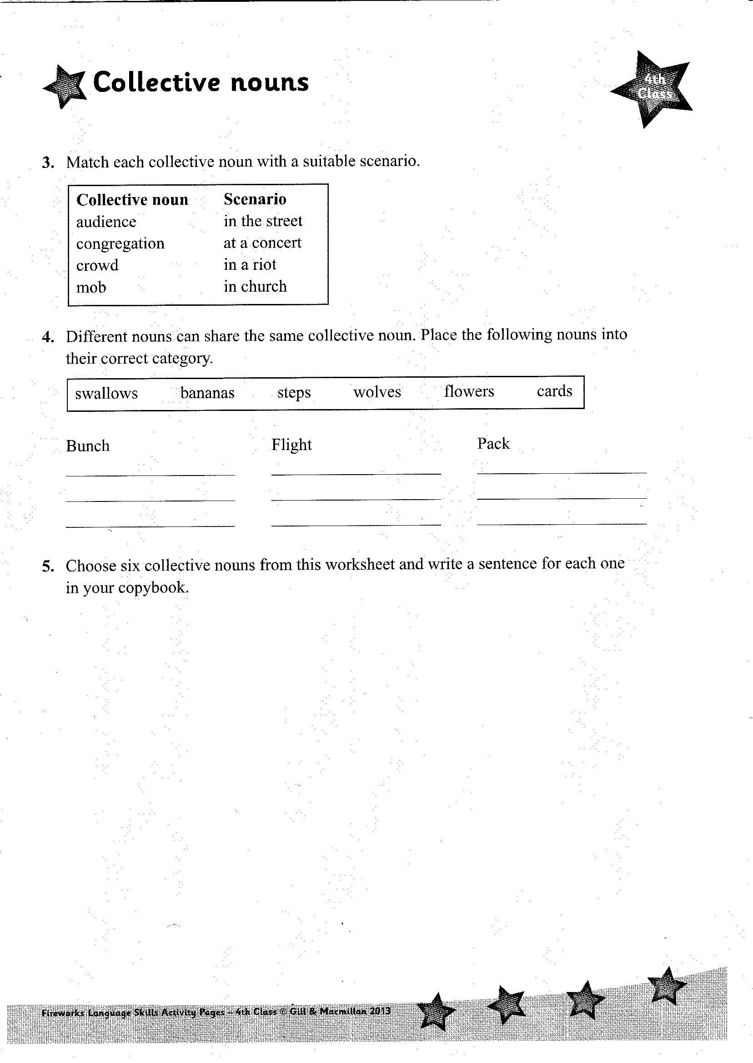
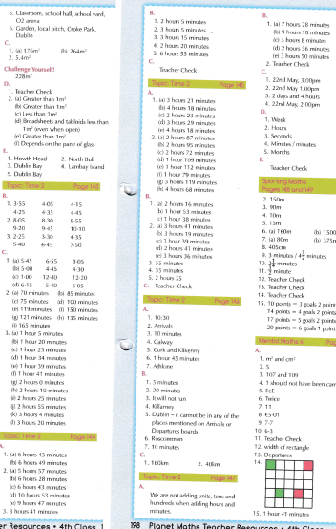
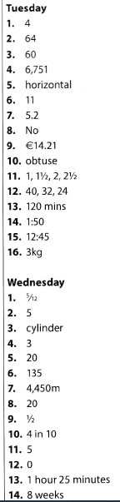
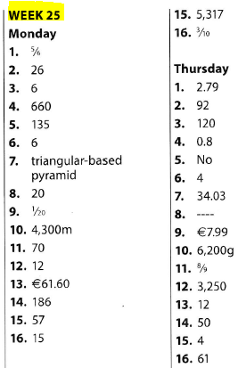

Master your maths test 25 answers
1. 3/8
2. 5/12
3. 6
4. 36
5. 195
6. 3.25kg
7. ½
8. 33
9. 140
10. hexagonal- based pyramid
11. 4,010
12.--
13. 3200
14. €2.02
15. 1,700 ml
16. 1 in 2
17. 40
18. 40
19.---
20. 3.14

Freagraí/ Irish Answers
Abair liom lgh 158
1. Is lé Seán Ó Sé an ticéad agus pás seo.
2. Tá sé ag dul go Páras.
3. Beidh sé ag eitilt ag a deich a chlog/ 10.00.
4. Suíochán 10f.
5. Ó Sé.
6. 1 Meán Fomhair 2008

Abair Liom Lgh 159 (C)
Ca mbeidh tú ag eitilt inniu?
Beidh mé ag eitilt go dtí an Spainn.
An bhfuil an ticéad agat?
Tá seo duit.
Cé mhéad duine a bheidh ag taisteal inniu?
Ceathrar
Beidh tú ag imeacht ó Ghéata a hocht.

Abair Liom lgh 160 D
1. Thit pas Dhaidí ar an talamh.
2. Thóg Mamaí buidéal uisce amach as an mála.
3. Stop an garda slándála Séan san aerfort.
4. Bhí scuaine daoine ag fanacht ag an ngeata.
5. Chuir Daidí an mala trom ar an tralaí.
6. Chonaic Síofra bratach na hÉireann ar an eitleán.

Léigh Sa Bhaile D
Éide Scoile Nua
1. Tá sé a leathuair tar éis a hocht.
2. Thosaigh Mamaí ag gaire.
3. Tá éide scoile nua ag Aisling.
4. Chuir Aisling na héadaí scoile nua uirthi.
5. D’imigh sí ar scoil.

An Siopa Leabhar
1. Chuaigh Mamaí agus Luke go dtí an chathair inné.
2. Bhí leabhar mata ag teastáil ó Luke.
3. Bhí imní ar Mhamaí.
4. Chuaigh said isteach sa siopa deireanach.
5. Thug Mamaí póg don siopadóir.

