Ms Rodgers, Mrs Smith & Ms Gormley
Senior Infants - Week 20th April 2020

Dear Parents,
We hope you and your families are doing well during these surreal times. Weekly, we wait on the news from Leo to return to school to see our students and colleagues who we miss so dearly now! We crave to return to a normal life, but are blessed to have good health. We hope you and your families have been in good health too during Covid 19, as we do think about you all. We hope the Easter bunny came to all our Senior Infants.
As Senior Infant teachers we to try to continue to provide you with a scheme of work, resources and support. We can only imagine how things have been at home for you all and the difficulties endured with the distant learning: ICT skills, lack of WIFI, printers & ink, etc. but we sincerely appreciate all you are doing. Our scheme of work follows our yearly plans, to ensure we are on target. Please note all our NEW resources/worksheets for the week can be found on the Senior Infant Padlet link:
https://padlet.com/gormleyeimear/mc5cul7zg3a7

Mr Kilcoyne has now provided you with our emails as below:
- Ms Rodgers - missrodgersseniorinfants@gmail.com
- Ms Gormley - missgormleyseniorinfants@gmail.com
- Mrs Smith - mrssmithseniorinfants@gmail.com

Please email us any of your questions/queries or even a simple message to say hello and we will then receive your email address. We have highlighted in the scheme below, the samples of work you can email your class teacher if you wish. We will then look at your child’s work and see how they are getting on. Please do not worry if you don’t know how to email the work back, just drop us an email and let us know how your child is doing under your guidance. If you have no printer for the worksheets, please just write it onto a plain piece of paper for your child to complete. Only complete whatever work you can do in the day from our scheme, as it is only a guide. We understand these are challenging times and we are all trying our best, which is all we can do.
We can’t wait to hear from you all and see how our Senior Infants are doing!

Take Care and Stay Safe,
Ms Rodgers, Ms Gormley & Mrs Smith
Teachers’ Names | Ms. Rodgers Ms. Gormley & Mrs Smith
Class level | Senior Infants
Suggested work for week beginning | 20th April 2020
Teachers email address | - missrodgersseniorinfants@gmail.com  - missgormleyseniorinfants@gmail.com  - mrssmithseniorinfants@gmail.com
Correction of work | Work that we have highlighted should be submitted to the appropriate teacher’s e-mail address above. This can be a photograph of the copybook page or the answers can be typed into the e-mail. Please write your child’s name in the subject part of the e-mail. Work that is not highlighted should be corrected by an adult/parent.
Message from teacher/s | Hello Senior Infants,  We hope you are all well and the Easter Bunny came with lots of nice chocolate eggs.  We know that you are working hard for all your parents and listening to all they are saying. We are missing you dearly and our classroom routine.  We hope you are enjoying the work on the Padlet and we can’t wait to see some of your great work. Please continue to wash your hands.Take care Senior Infants.  Ms Rodgers, Ms Gormley & Mrs Smith

Ms Rodgers, Mrs Smith & Ms Gormley
Senior Infants - Week 20th April 2020
Monday 20th April | Tuesday 21st April | Wednesday 22nd April | Thursday 23rd April | Friday 24th April
P.E (Links on {Padlet)  Reading: Stop that Dog! (6 words)  Literacy: Stop that Dog Worksheet 1  Maths: Monday Mental Maths Page 40  Think of a number between 1-10. Say the number that is 1 less and 1 more than this number. Repeat this 6 times.  Handwriting:  Practice writing capital F.  (see formation below)  Gaeilge: ‘Sa Bhaile phrases’ on the  Padlet-Altram  Music: Kids Karaoke (Padlet): Sing a song with a family member. | Reading: Stop that Dog (6 words).  Literacy: Stop that dog worksheet 2.  Maths: Money  Children build up familiarity with coins up to 10c.  1.Look at the shape of the coin and images on the coin.  2.Do some coin rubbing's with a coin or pencil.  3.Try and make totals up to 5c using 1c and 2c coins (you could set up a pretend shop with things priced 1c-5c).  Phonics: ‘ut’ Family  Listen to:  https://www.youtube.com/watch?v=UQE4EUpED6s.  Write out 6 words in the ‘ut’ family e.g. cut, shut, hut, nut, gut, doughnut. Draw a picture for each word or write a sentence.  History - Lesson 1: Listen to ‘The Children of Lir’ on Padlet.  -Answer the questions.  -Retell story in your own words orally. | Reading: Stop that Dog (6 words)  Literacy: Write out 6 words that start with ‘pr’ - pram, prim, pray, prowl, prize etc. Challenge: write a sentence for them.  Maths:  1.Wednesday Mental Maths Page 41  2. Think of a number between 1-10. Say the number that is 2 less and 2 more than this number. Repeat this 6 times.  Try online maths money game http://planetmaths.folensonline.ie/resources/senior/activities/pm_si_112/money.html  Gaeilge: ‘Sa Bhaile’ Listen to the story on Padlet:  - Complete true/false activity orally  Handwriting:  Practice writing capital G. (see formation below)  History - Lesson 2:  -The Children of Lir sheet(true or false Q’s)  -Draw a picture in each box to tell the story  Religion: Theme: 8 Lesson 1 ‘The Church’.  Watch video ‘A house of Prayer’.  Sing song ‘The Church’  Discuss important events that happen in the Church.  Discuss why mass is online and the importance of our parish praying at home during Covid 19.  Mass is streamed online every day from the Cathedral at 10am https://www.churchservices.tv/letterkenny | Reading: Stop that Dog (6 words)  Literacy: Dictation: ‘ut’ Word Family: Call out 6 sentences for your child to write: 1. I fell and cut my arm. 2. Put the nut in the bag.  Maths: Money  1.Start with online maths game  2.Try and make totals up to 10c using 1c, 2c and 5c. You could set up a pretend shop e.g. put 6c beside an apple.  Gaeilge: ‘Sa Bhaile’-Go back over story on Padlet:  - Complete true/false activity orally.  Geography - Water  Listen and sing along to ‘The Water’ song https://www.youtube.com/watch?v=CwpHMPH-WbM  - Discuss when/how we use water everyday.  - Draw pictures in the 4 water droplets page to show how we can use water. | Reading: Stop that Dog (6 words)  Literacy: Write news: Today is Friday. I am happy with the work I have done this week.  Handwriting:  Practice writing capital H. (see formation below)  Maths:  1.Maths worksheets attached.  2.Can you remember all the ways to make 8. Write them out (e.g. 5+3). You could also try this activity to make totals of 9 or 10.  Oral Maths: Count backwards/forwards to 20.  Science -Floating and Sinking  - What does ‘float’ and ‘sink’ mean?  - Watch ‘Floating & Sinking’ on padlet.  - Complete worksheet on floating & sinking.  SPHE/Art:  Belonging:  Discuss: How they can show a positive & caring attitude during Covid 19. Draw their hand & cut it out. Write on each finger how they have been helping at home during Covid 19.

If you require any additional work, please go to any of the book companies online and you have free access to all the Senior Infant books. We have included a Reading link on the Padlet too.

For additional reading: Oxford Reading Tree online have access to readers in all levels. Please click the link to access all: www.oxfordowl.co.uk

You might like to tune in to RTE School Hub which is on every day at 11am.

Also, don’t forget Mrs Higgins is doing dance fitness classes ‘Dance Fitness with Tina’ every Monday, Wednesday and Friday at 12pm on Facebook.

RESOURCES

Please note that all worksheets, resources, online games are on the senior infants padlet https://padlet.com/gormleyeimear/mc5cul7zg3a7. On the padlet, you will see that the worksheets are laid out day by day. This is how the padlet looks:

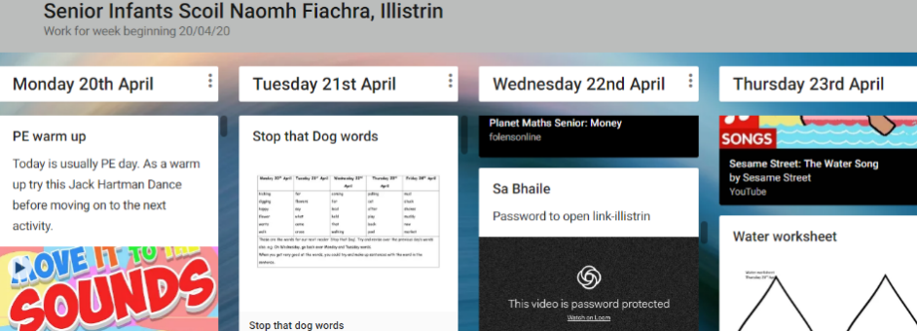

However, if some of your prefer, the worksheets are also attached to this letter.

Cursive Handwriting
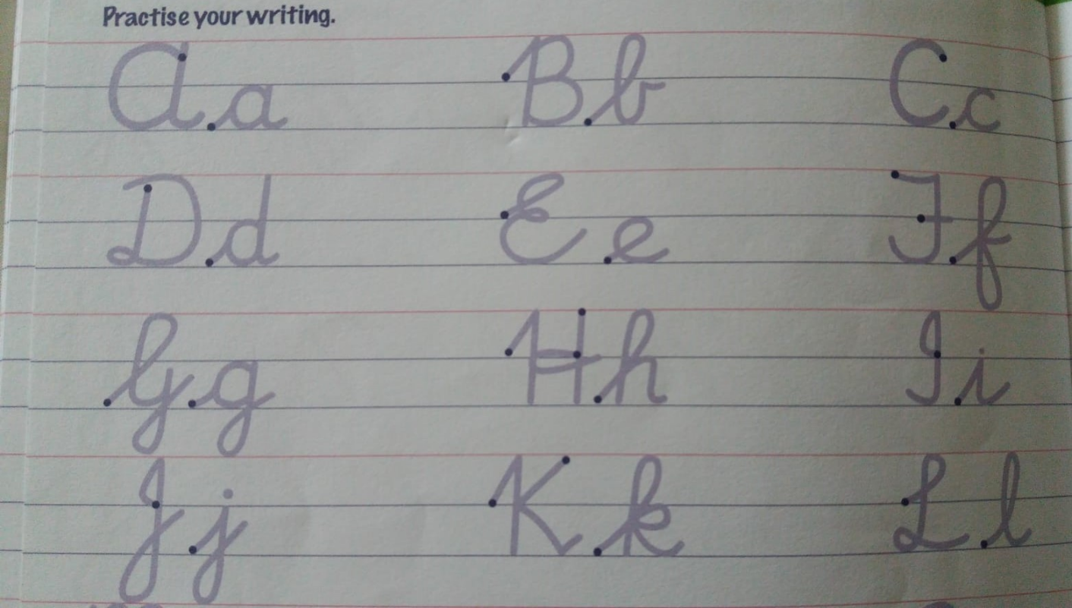

Maths Money
Thursday 23rd April
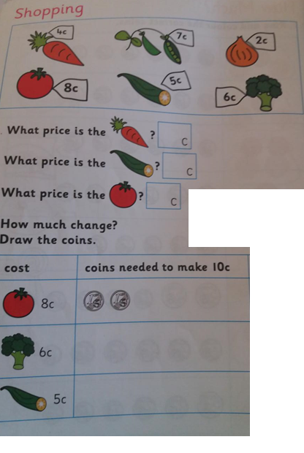

Money - Thursday 23rd April

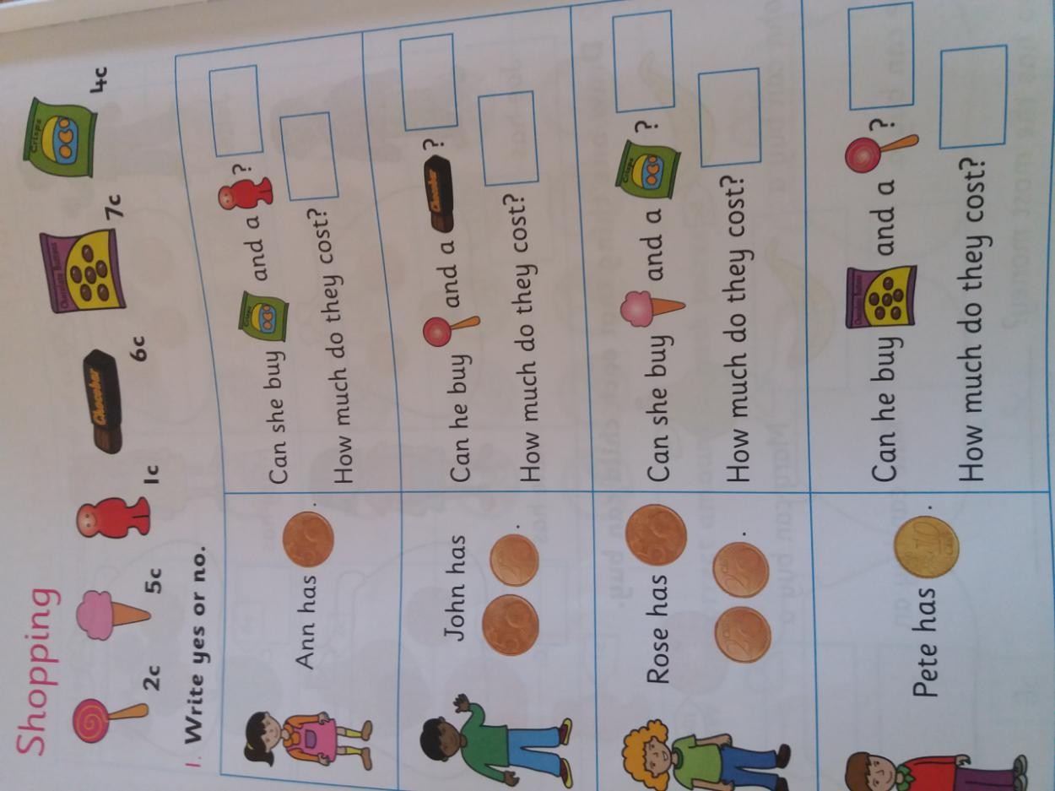

+

+

+

+

+

4
+
1

+

yes

Science - Floating & Sinking
Friday 24th April
Predict what you think will happen-will it float or sink? It might be a good idea to pick the object up in your hand to check to see if it is heavy or light.
 | Float | Sink
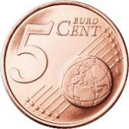
5c coin
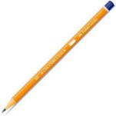
pencil
empty bottle
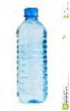
full bottle
teaspoon
Pick two things from around the house and draw them in

History - The Children of Lir
Wednesday 22nd April
Question | Write yes or no in the box
- Lir had four children.
- The children were turned into ducks.
- Lir read stories to his children.
- When they heard a school bell ring they turned back into children.
- The children returned to live in the kingdom

Lir had 4 children, 1 daughter and 3 sons. They lived in a castle. | Their stepmother Aoife turned the children into 4 swans.
The children stayed as swans for 900 years until they heard a church bell ring. | The children returned to live in their father’s castle.

Geography - Water
Thursday 23rd April

4 ways I use water?

