27/4/20

Dear Parents/Guardians,
I hope you are all doing well. The first week of the online feedback is completed and I have been very impressed with the standard of work and effort that all the students are putting in. As I mentioned last week, I know this is a difficult time for everyone especially children and it can be very challenging to get them focused. I hope that this new system brings some routine to them and helps in continuing their learning. I do realise that some students may not have access to the internet/computer so please do not worry, just try to do whatever you can.
In maths this week we are covering the area of problem solving. This is an area that children in general find very difficult, so I have included a few links from YouTube to try and help to explain it. Please remember that if your son/daughter is having any difficulties be assured that it will be covered upon return to school.
As mentioned last week to aid the learning of Gaeilge go to Folens Online. They link directly with the content being covered and explicitly teach the vocabulary and grammar of each Abair Liom chapter.
The answers to this week’s Gaeilge, Mental Maths & Planet Maths have been attached below. The answers are to be used after the work is completed.
I am so proud of all the students and the efforts they have put in during the first week of online feedback. It is a new concept for all of us and it is very evident that we are all embracing it well. Please feel free to email me if you have any issues at all.

Kind regards,
Ciaran Gallagher.

Teacher’s Name | Ciaran Gallagher
Class level | 4th Class
Suggested work for week beginning | 27/4/20
Teachers email address | mrcgallagherfourthclass@gmail.com
Correction of work | Work that I/we have highlighted should be submitted to the appropriate teacher’s e-mail address above. This can be a photograph of the copybook page or the answers can be typed into the e-mail. Please write your child’s name in the subject part of the e-mail.  Work that is not highlighted should be corrected by an adult/parent.
Message from teacher | You can also email me if you have any queries or questions. Please write your child’s name in the subject box of the email.

Remember to tune into the RTE Home School Hub every day at 11.00

Monday 27/4/20
English | Witches Spiders and Cowboys  Reading & Writing  Wanted P-164  Complete questions 1-10 P-167  (Please scan and email this piece of work back to me)  Oral Language  Questions 11&12 P-167  Grammar (Adjectives)  Complete parts 1-6 in the sheet attached below
Gaeilge | Abair Liom- Ag an Aerfort  Comhrá – (Conversation)- lgh 156 & 157  Léamh – An Sorcas – (The sheet is attached below)  Scríobh – Freagair na ceisteanna A, B, C & D (This sheet is attached below and accompanies the story of the circus)
Maths | Master Your Maths  Week-29 Monday P-62  Multiplication Tables  Revise Multiplication Tables (Times 7)  Planet Maths P-162 – Problem Solving 1 Topic 27  Complete A 1-8, B 1-8 & C P-162  https://www.youtube.com/watch?v=s3jP0vnFSxE
Spellings | English  Jolly Phonics Spelling List – 30 (-ist) Complete the work on the left-hand side of the sheet.  Learn spellings 1-5  Gaeilge  Aonad– 30 Peataí - Litriú 1-3  *Students are going be asked to complete their spelling test on Fridays at home, at the back of their spelling book.
Science | Small World Geography & Science  Unit 18 – Materials and Change P-105  Complete – Question A 1-6 & B 1-8 P-109  Optional Extra activities  Cornflour Experiment  Cornflour cannot decide if it is a liquid or solid!  https://www.theguardian.com/science/2008/may/02/physics7  Materials and their Properties – https://www.science-sparks.com/category/key-stage-2-science/materials-and-their-properties-key-stage-2/  *If you have the materials it would be great to do some of the fantastic experiments in this chapter. You could email me to let me know how you got on. I will attach an experiment log sheet for anyone who does one of the experiments to complete.

Tuesday 28/4/20
English | Witches Spiders and Cowboys  Reading & Writing  A Holiday by the Sea P-168 & Complete questions 1-4 P-169  Muhammad Ali (Sheet is attached below) Complete questions 1-5  Oral Language  Which holiday destination would you pick from the story ‘A Holiday by the Sea’?  Grammar (Words from other languages)  Complete parts 1-7 of the sheet which is attached below.
Gaeilge | Abair Liom- Ag an Aerfort  Comhrá – (Conversation)- lth 156 & 157  Lth 158- An raibh tú ar eitleán riamh? Cá ndeachaigh tú?  Léamh agus Scríobh  Lth 158 Léigh agus freagair na ceisteanna 1-6
Maths | Master Your Maths  Week-29 Tuesday P-62  Multiplication Tables  Revise Multiplication Tables (Times 7)  Planet Maths P-162 – Problem Solving 1 Topic 27  Complete A 1-8, B 1-8 P-163 & A 1-3 P-164  (Please scan and email this piece of work back to me)
Spellings | English  Jolly Phonics Spelling List – 30 (-ist) Complete the right-hand side of the sheet.  Learn spellings 6-10  Gaeilge  Aonad – 30 Peataí - Litriú 4-6  *Students are going be asked to complete their spelling test on Fridays at home, at the back of their spelling book.
Geography | Small World Geography & Science  Unit 17: The Sun P-100  Read P-100 - 104  Complete A 1-7, B 1-6 & C 1-5 P-104  https://www.youtube.com/watch?v=Wr-CRKsTYGs  Day and Night Video  https://www.youtube.com/watch?v=l64YwNl1wr0  Earth Rotation and Revolution Crash Course for Kids

Wednesday 29/4/20
English | Reading & Writing  ‘Marathon’ complete questions 1-5 (The sheet is attached below)  (Please scan and email this piece of work back to me)  D.E.A.R time (Drop everything and read)  Read a book or material of your liking for 15mins.  Grammar (Homonyms)  Complete 1-4 (The sheet is attached below)
Gaeilge | Abair Liom- Ag an Aerfort  Comhrá – (Conversation)- lgh 159- B  Scríobh an comhrá- lgh 159 C  Please scan and email this piece of work back to me)
Maths | Master Your Maths  Week-29 Wednesday P-63  Multiplication Tables  Revise Multiplication Tables (Times 7)  Planet Maths P-162 – Problem Solving 1 Topic 27  Complete B 1-3, C 1-3, D 1-3 & E 1-3 P-164
Spellings | English  Jolly Phonics Spelling List – 30 (-int) Learn spellings 10-14  Gaeilge  Aonad – 30 - Peataí - Litriú 7-8  *Students are going be asked to complete their spelling test on Fridays at home, at the back of their spelling book.
Art | Time Capsule  Time capsules are fun to make, and even more, fun to open years down the line. A time capsule can be any container that holds objects meant for people to open in the future, whether that be in 5, 10, or even 100 years. We are living during a very historical moment in time and although there are challenges it would be nice to symbolize it with a time capsule buried on the school grounds when we return to school.  Your task this week is to do a self-portrait and include a sheet with information about yourself. Things to include in this sheet would be for example – your likes/dislikes, pastimes, favourite song/movie etc. If you find this difficult it would be lovely to write a letter to yourself on what your hopes and aspirations for the future are. You could also mention how you found living during the coronavirus in your information.

Thursday 30/4/20
English | Reading & Writing  ‘First to the South Pole’ complete questions 1-5 (The sheet is attached below)  D.E.A.R time (Drop everything and read)  Read a book or material of your liking for 15mins.  Grammar (Extending Sentences)  Complete 1-3 (The sheet is attached below)
Gaeilge | Abair Liom- Ag an Aerfort  Léamh – lth 159- comhrá  Scríobh – lth 160 –D
Maths | Master Your Maths  Week-29 Thursday P-63  Multiplication Tables  Revise Multiplication Tables (Times 7)  Planet Maths P-162 – Problem Solving 1 Topic 27  Complete A, B & C P-165  (Please scan and email this piece of work back to me)
Spellings | English  Jolly Phonics Spelling List – 30 (-ist) Learn spellings 14-18  Gaeilge  Aonad – 30 - Peataí - Litriú 9-10  *Students are going be asked to complete their spelling test on Fridays at home, at the back of their spelling book.
History | History Quest  Shops and Shopping P-79  The children will gain an understanding of the origins of trade and shops and how shopping has changed over time.  Complete Activity B (1-5) P-83  Activity C (1-6) P-84

Friday 1/5/20
English | Reading & Writing  ‘JFK’ complete questions 1-5 (The sheet is attached below)  D.E.A.R time (Drop everything and read)  Read and book or material of your liking for 15mins.  Grammar (Link Words)  Complete question 1-5
Gaeilge | Abair Liom Ag an Aerfort  Léamh & Comhrá– lgh 159 ( B)  Gramadach na huimhreacha pearsanta – lth 160 - E
Maths | Master Your Maths  Week-29 Friday Test P-94  Multiplication Tables  Revise Multiplication Tables (Times 7)  Planet Maths P-162 – Problem Solving 1 Topic 27  Complete A, B & C P-166  Test Yourself  Complete question 1-10 (The sheet is attached below)
Spellings | English Spelling Test (1-18) & Litriú Gaeilge (1-10).  (Please scan and email this piece of work back to me)
PE | 30 Minutes of physical exercise every day. You may find the following links useful:  • Zumba Dance Party – https://www.youtube.com/watch?v=FHo9QaJ1DyI  • Dance Tutorial – https://www.youtube.com/watch?v=FRnEDoVRaa0  • Body Coach for Kids – https://www.youtube.com/watch?v=d3LPrhI0v-w&safe=active  Key Stage 2 – https://www.bbc.co.uk/teach/ks2-physical-education/zj2n92p  • Yoga for Kids – https://www.youtube.com/watch?v=X655B4ISakg

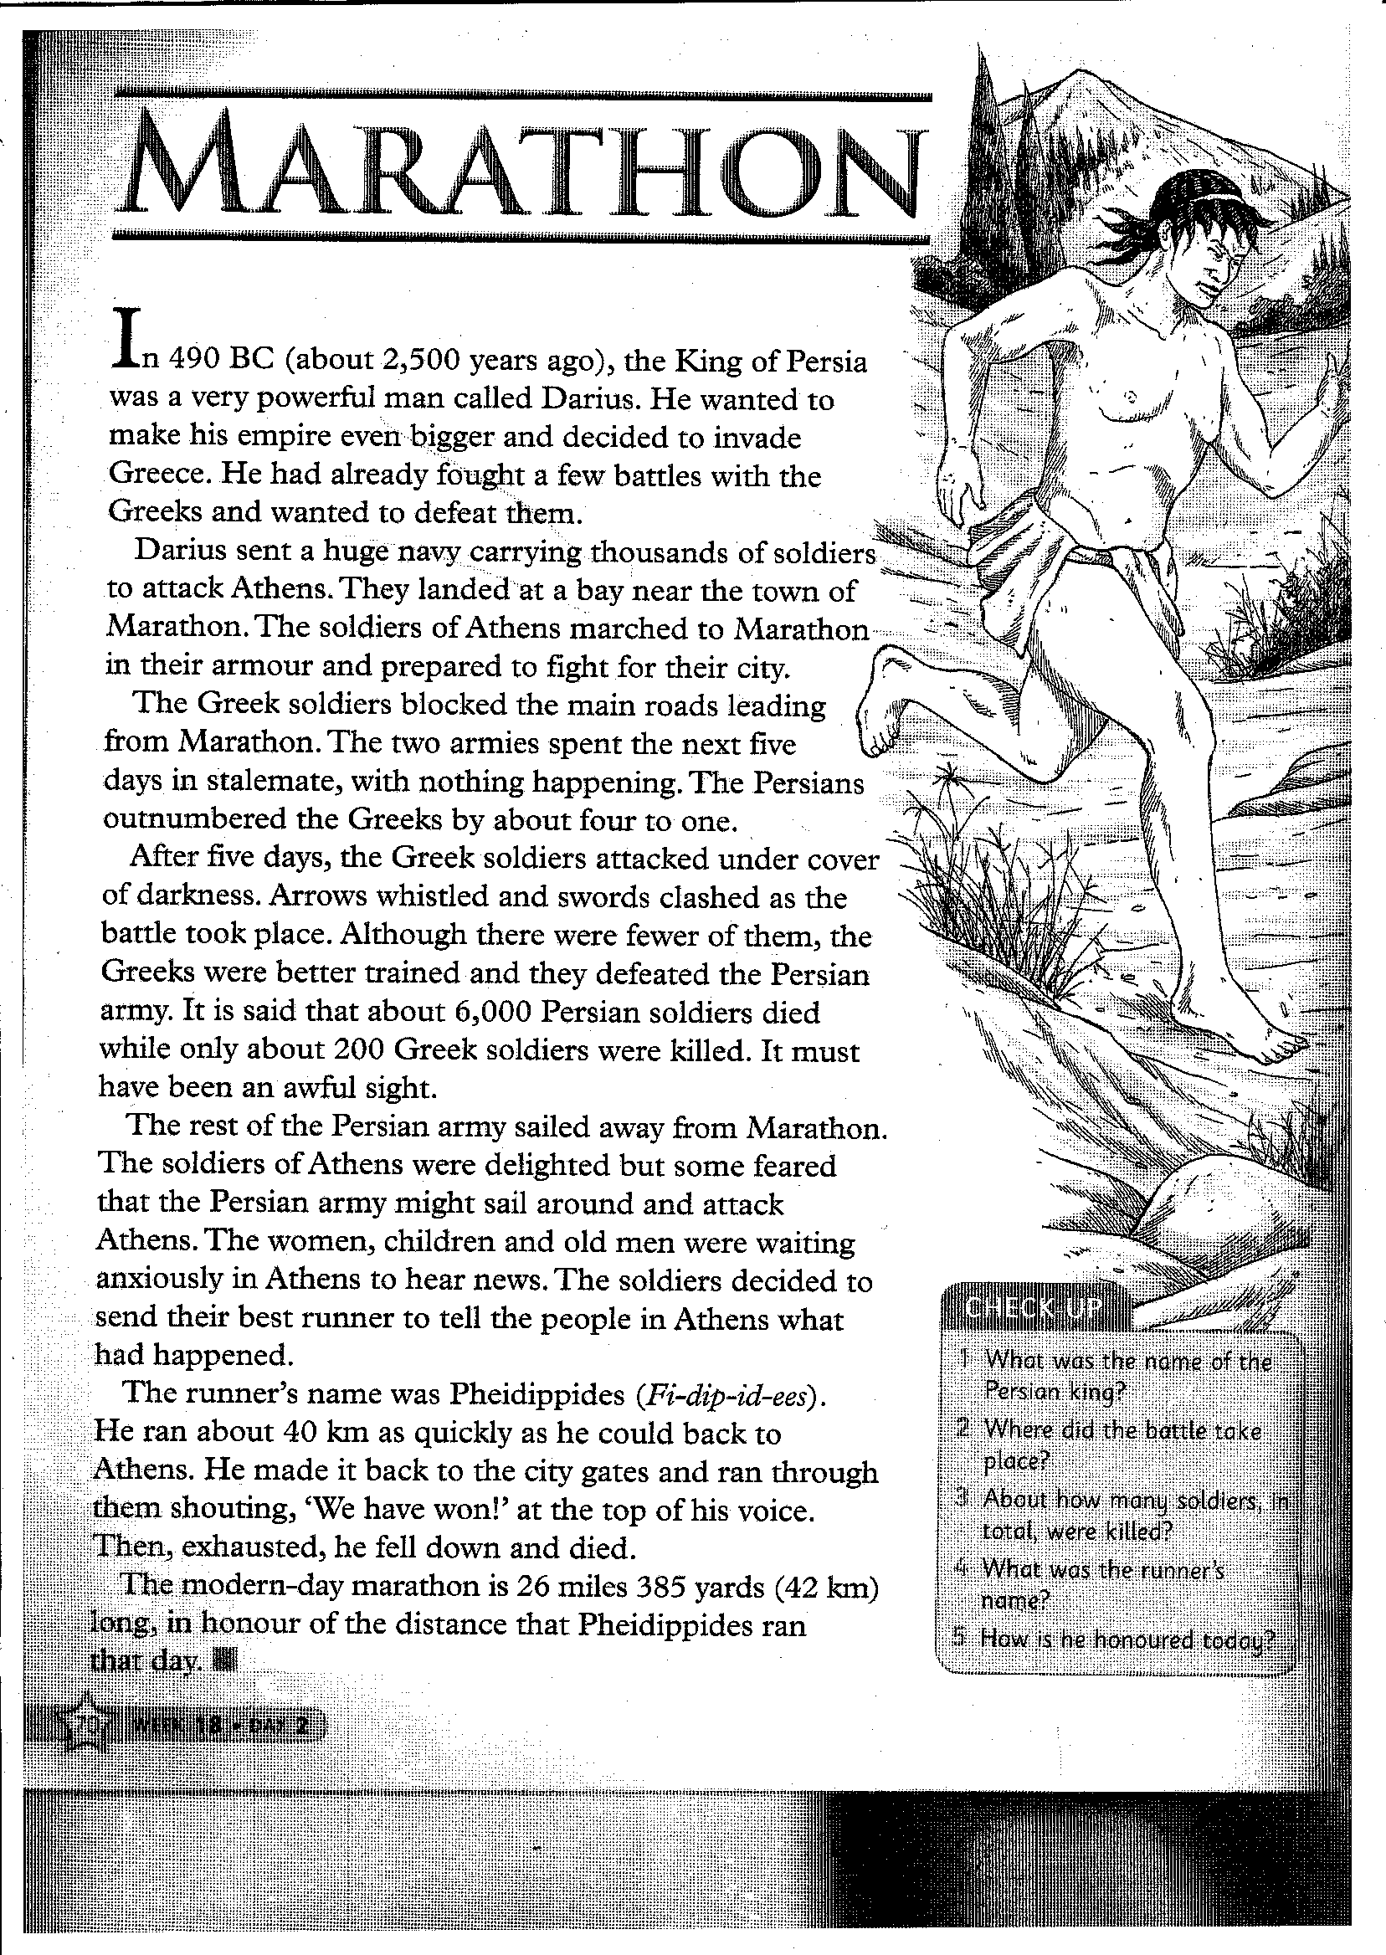
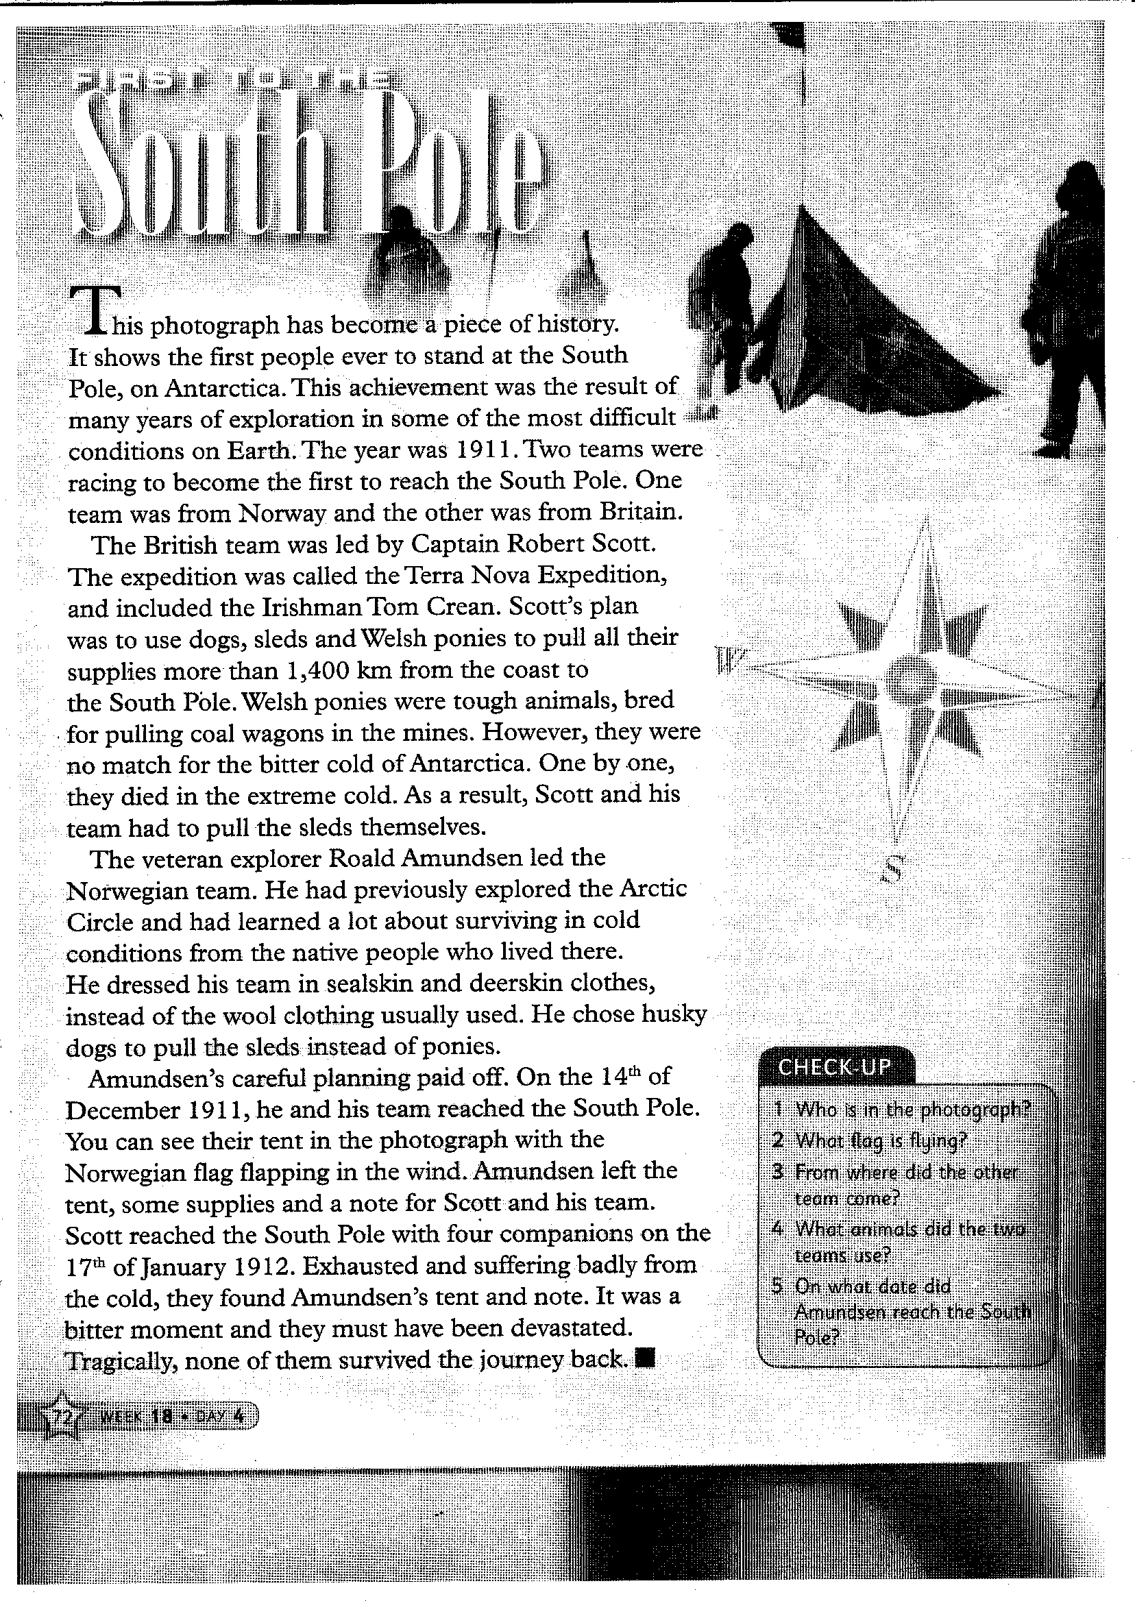
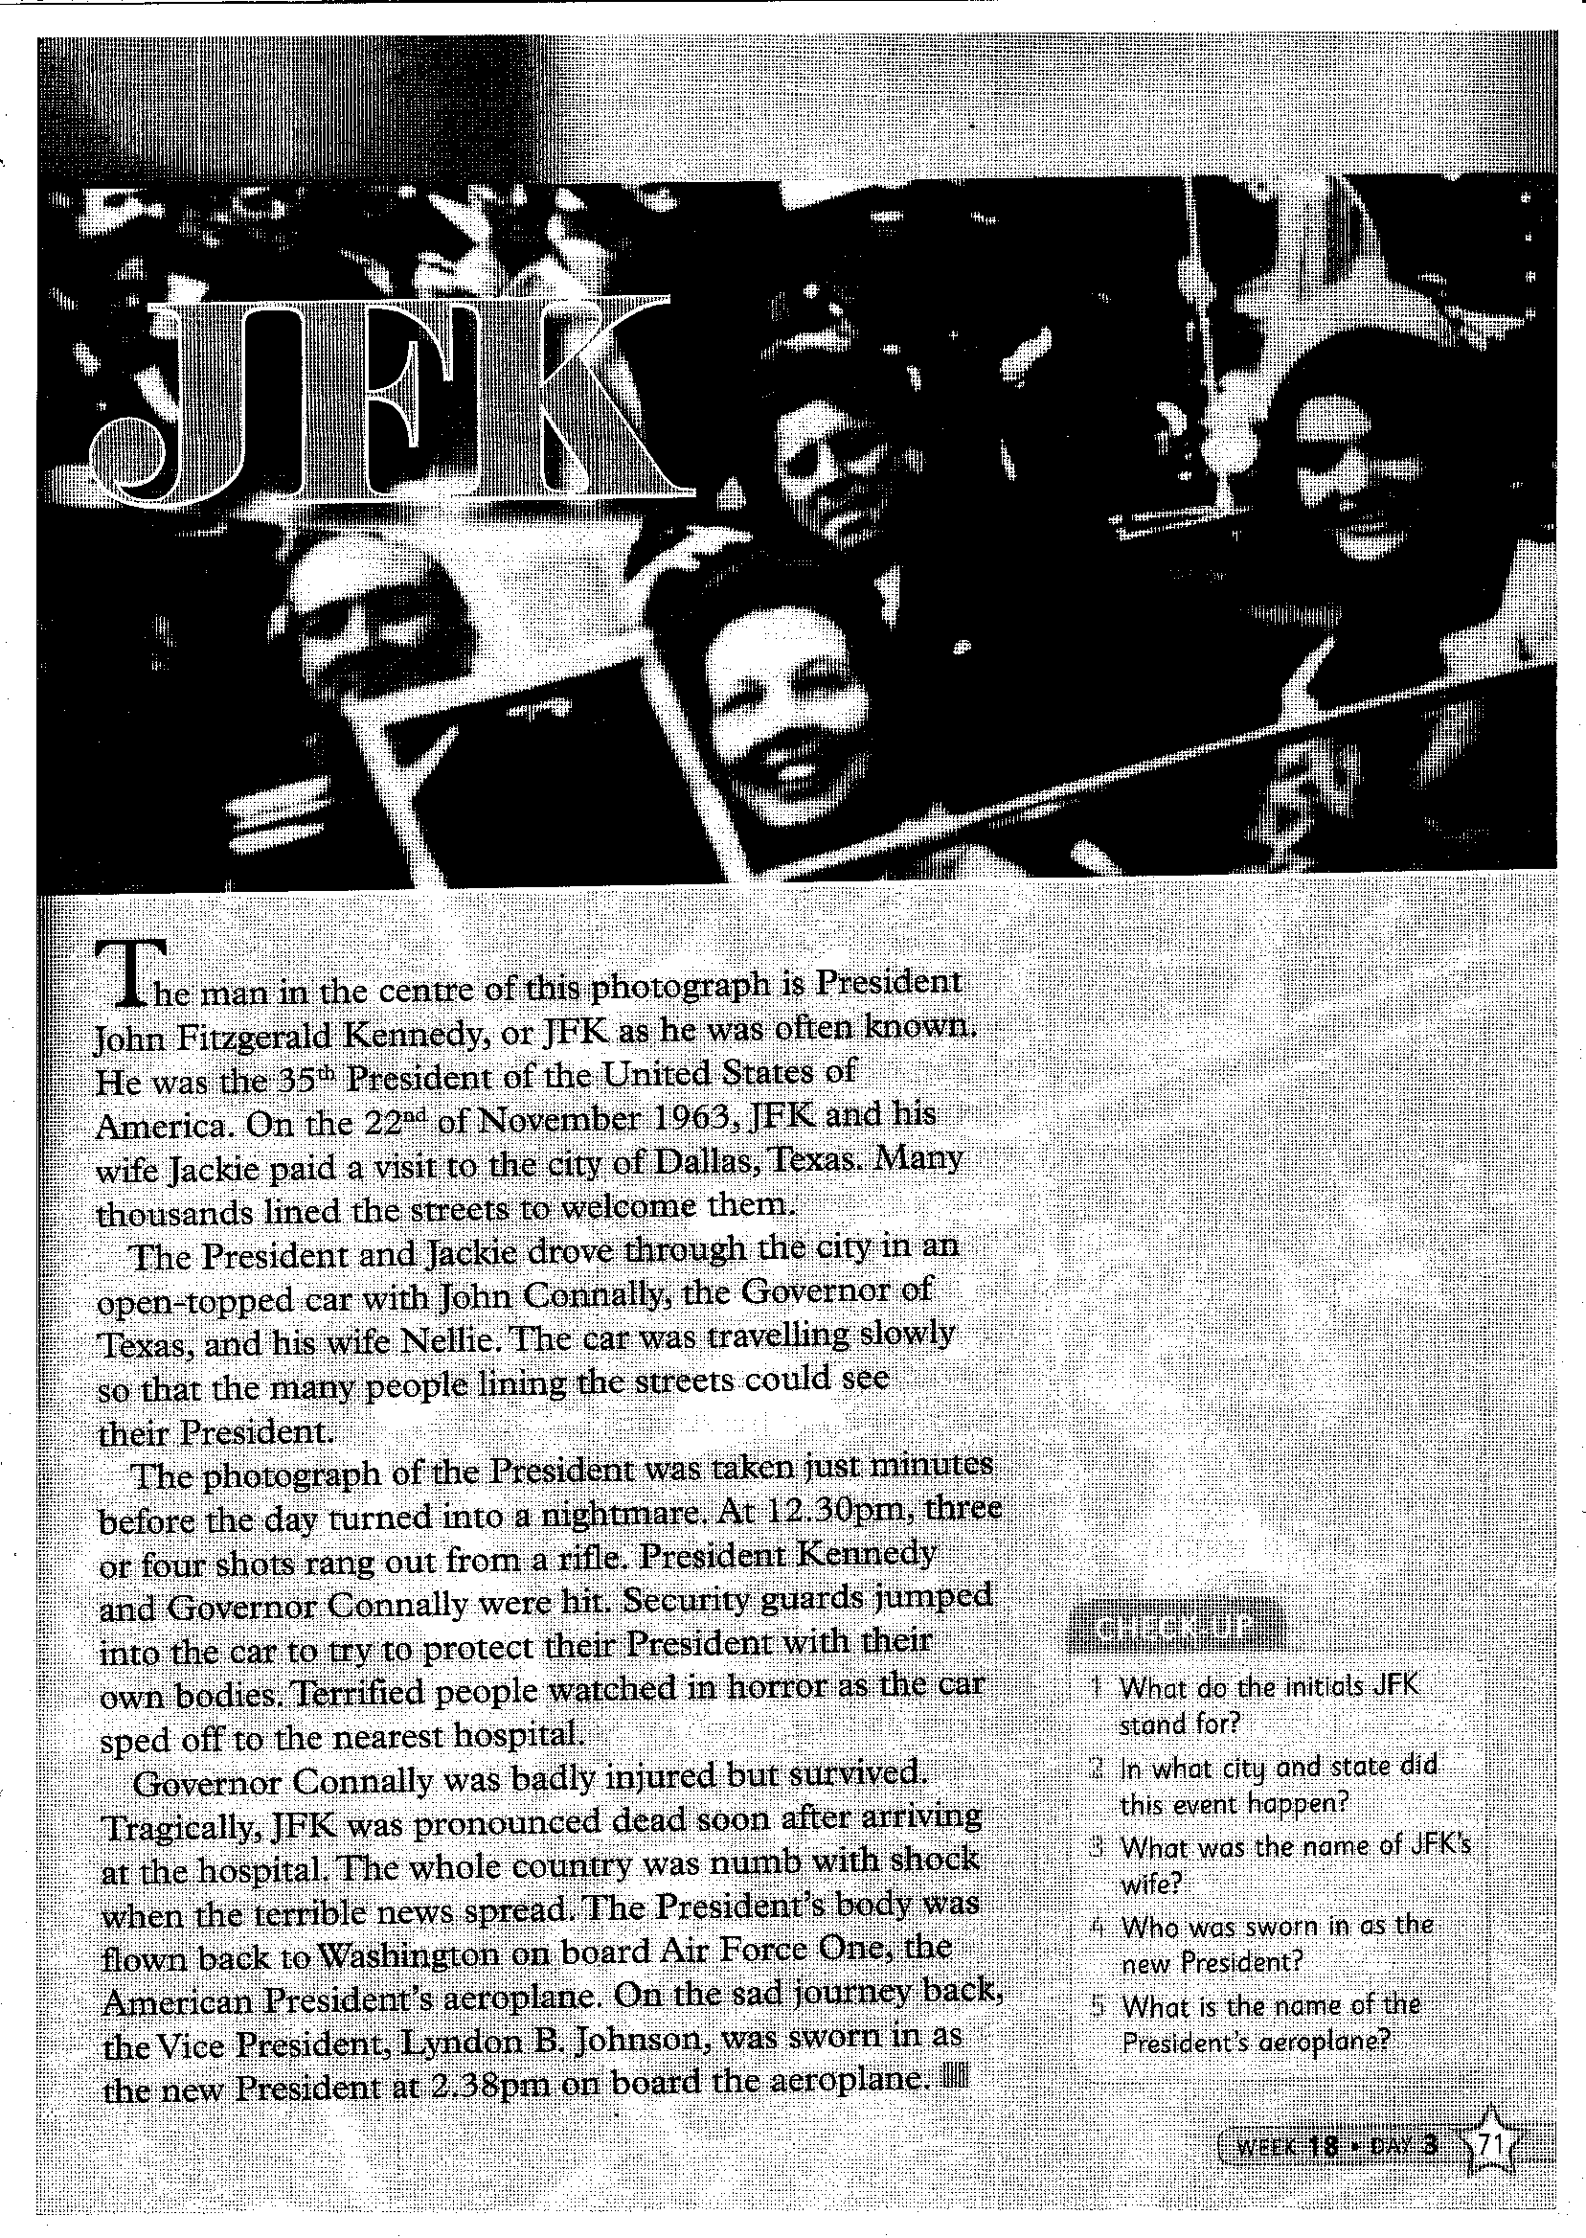
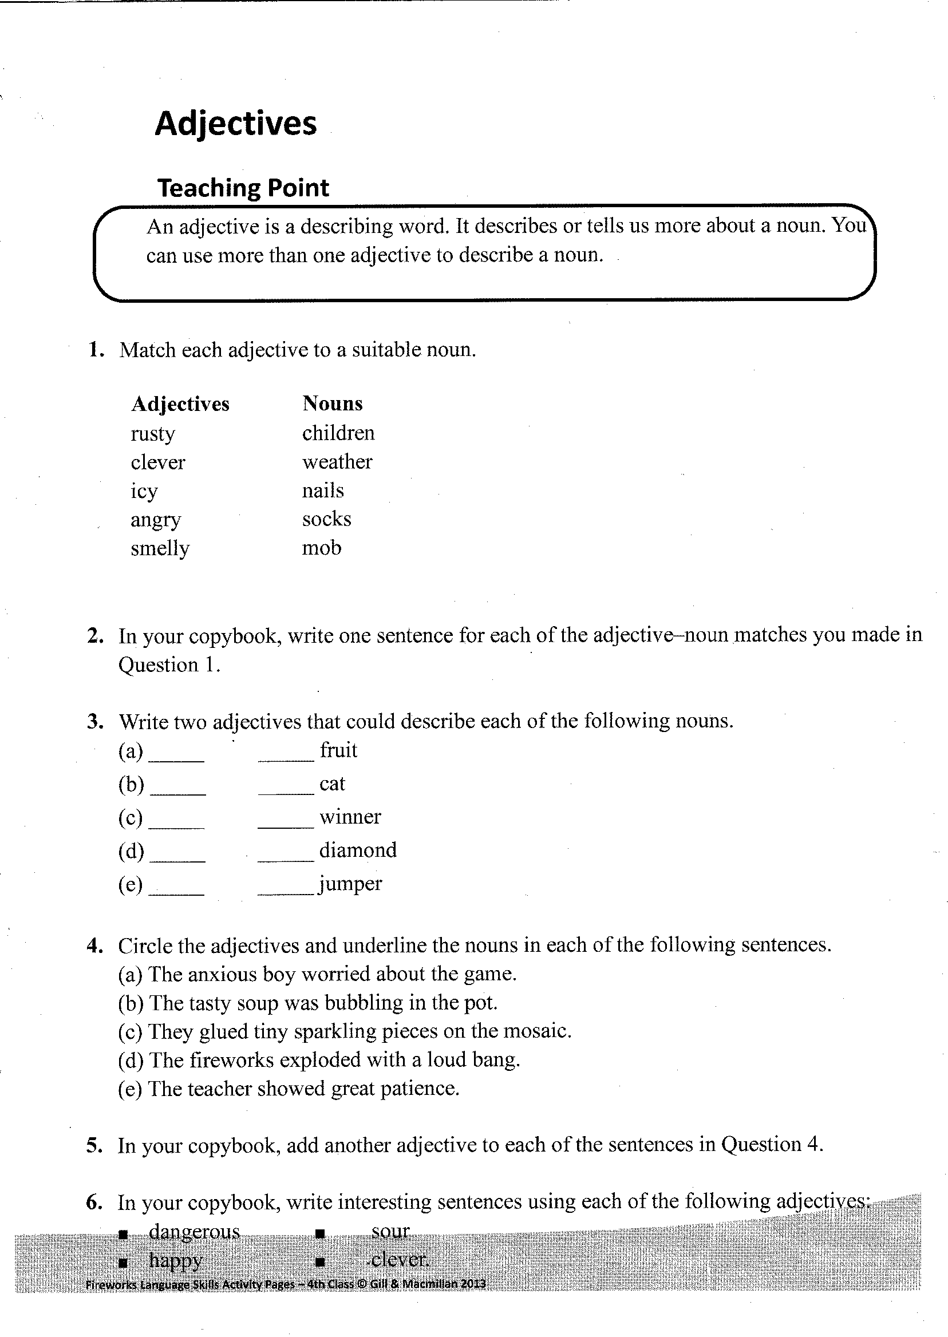
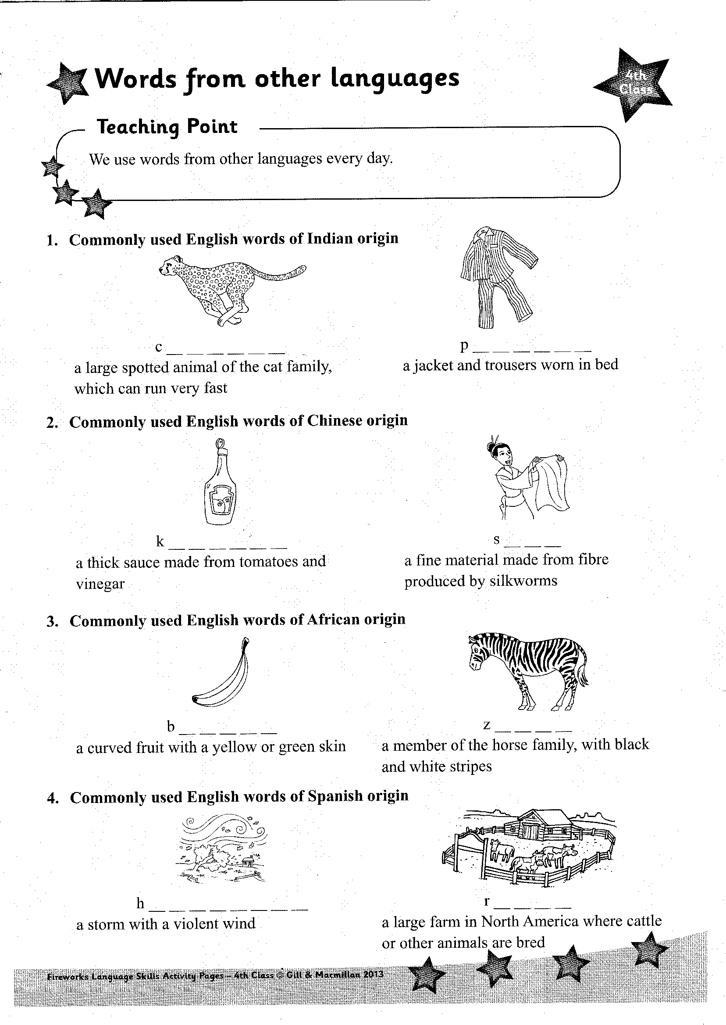
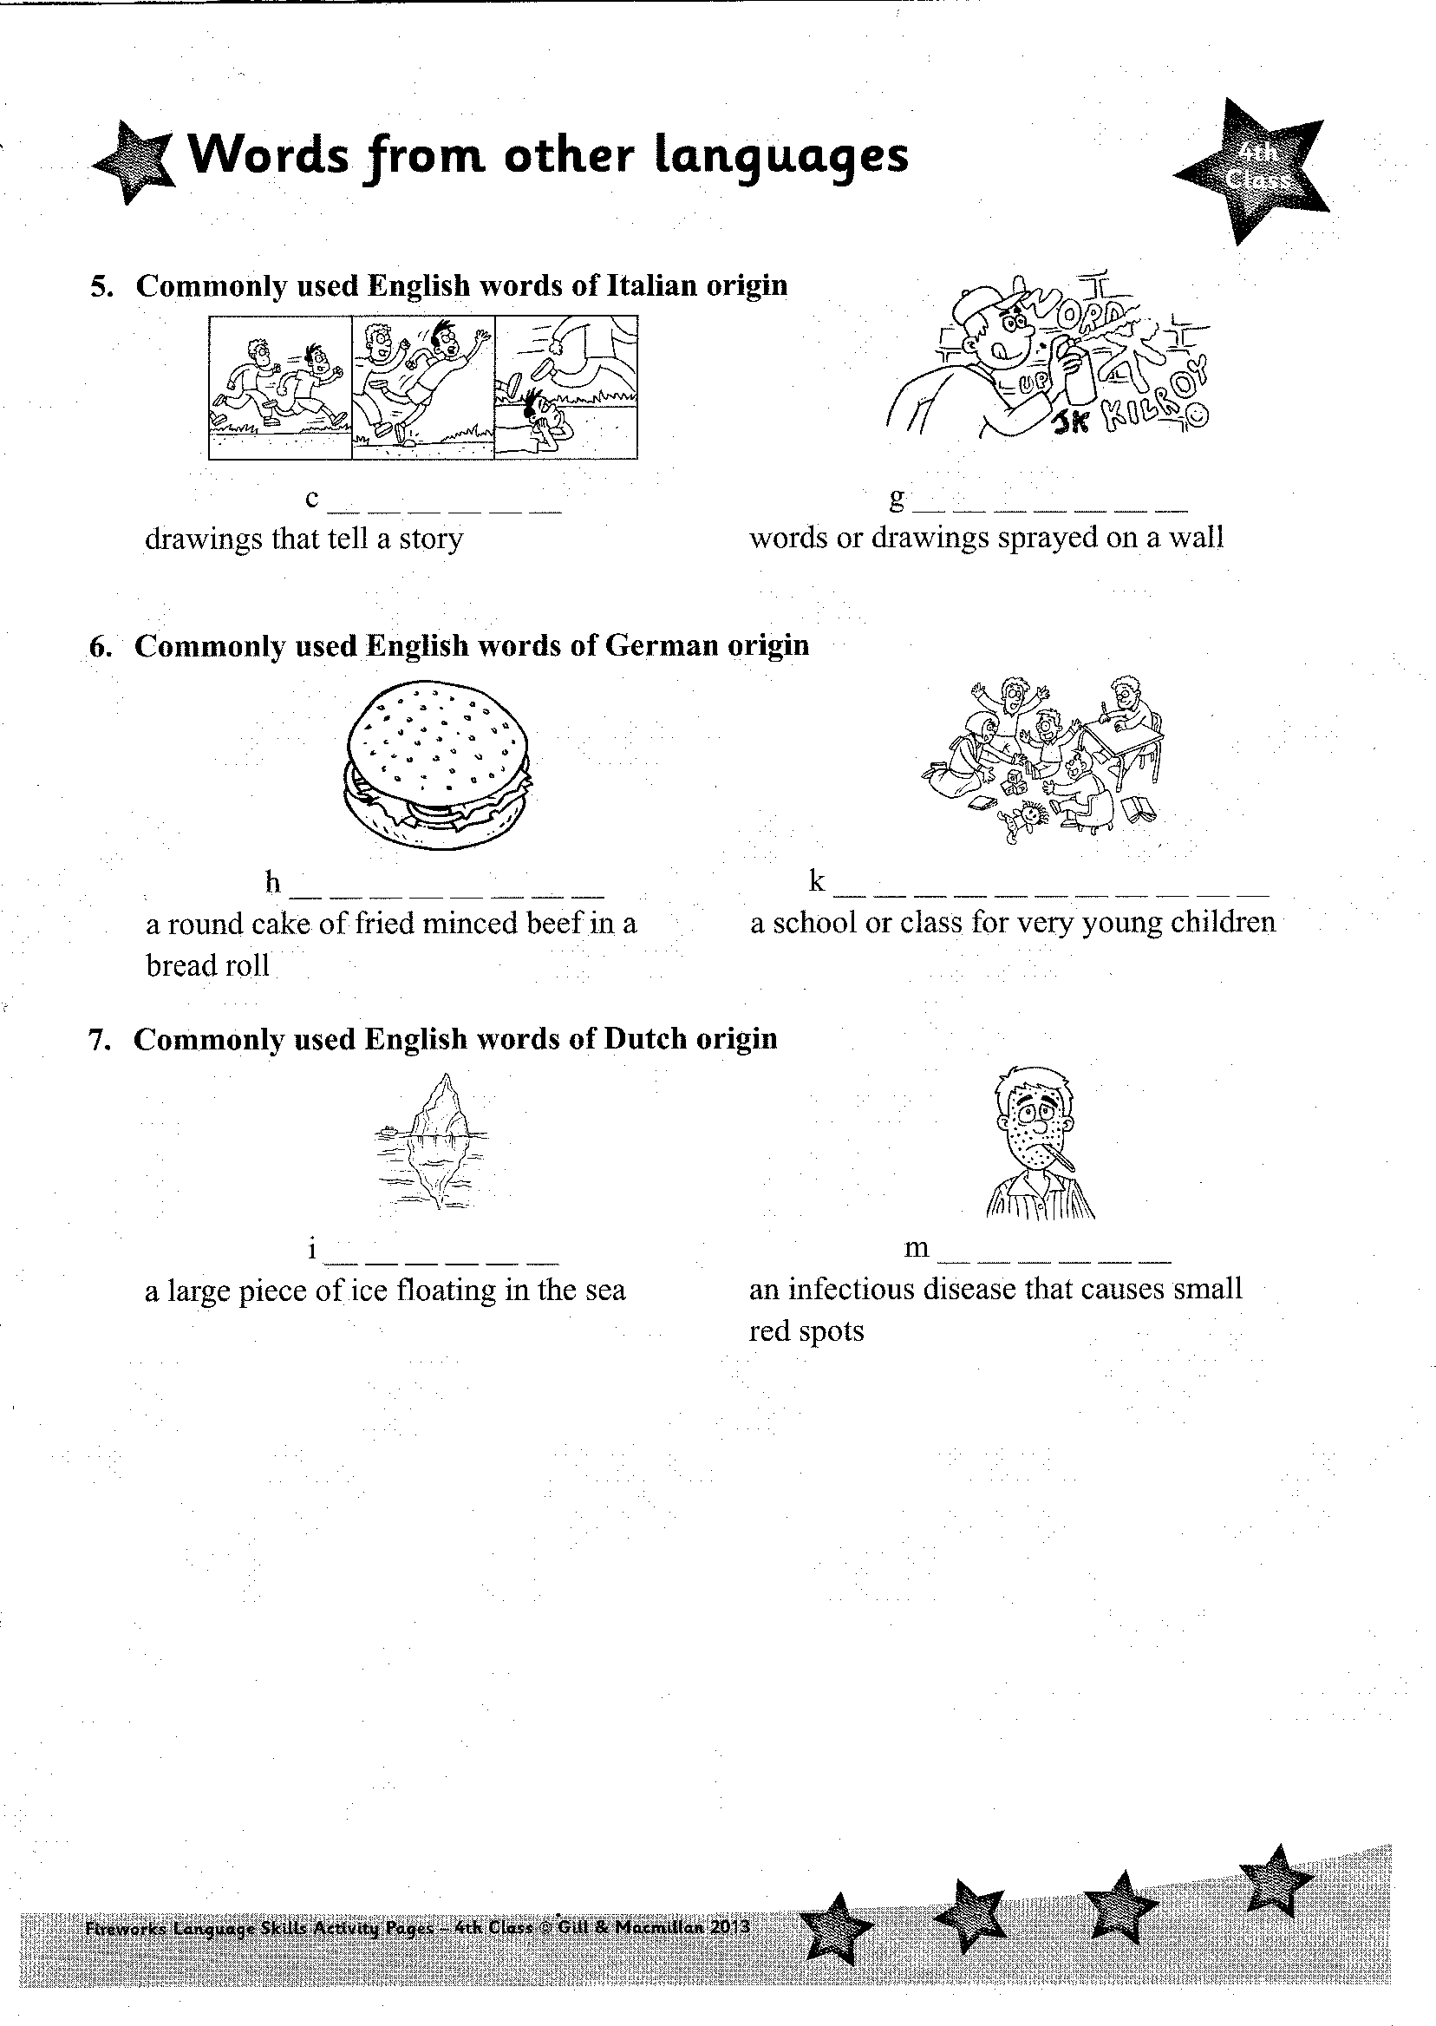
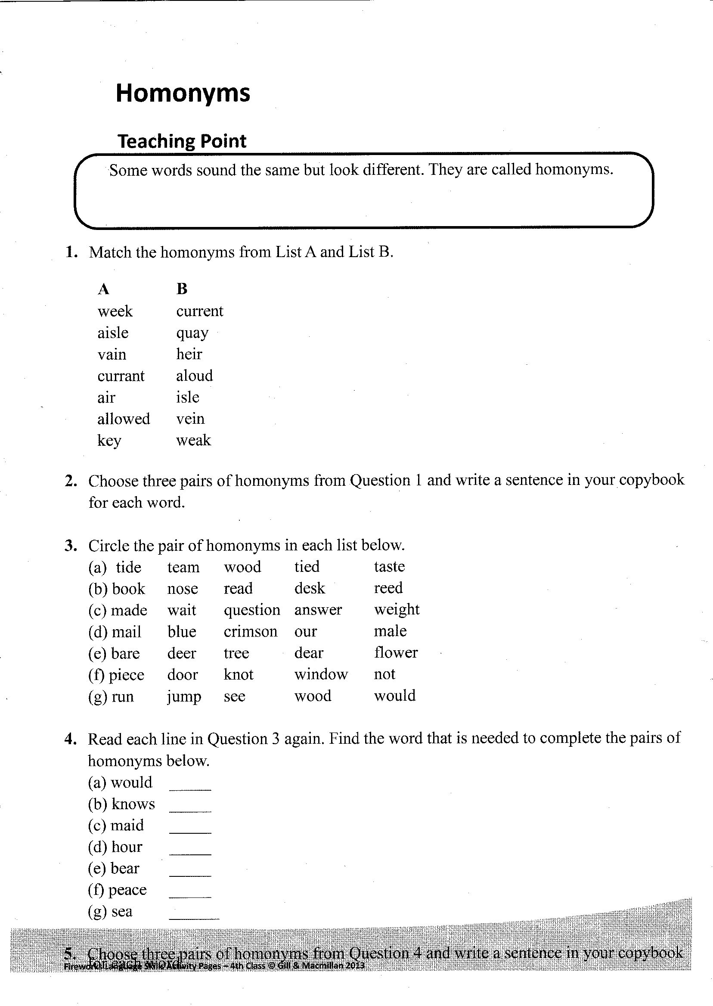
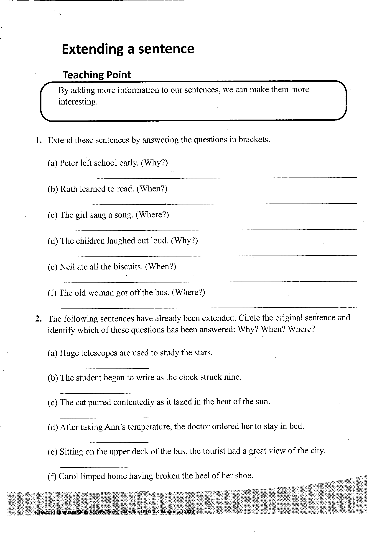

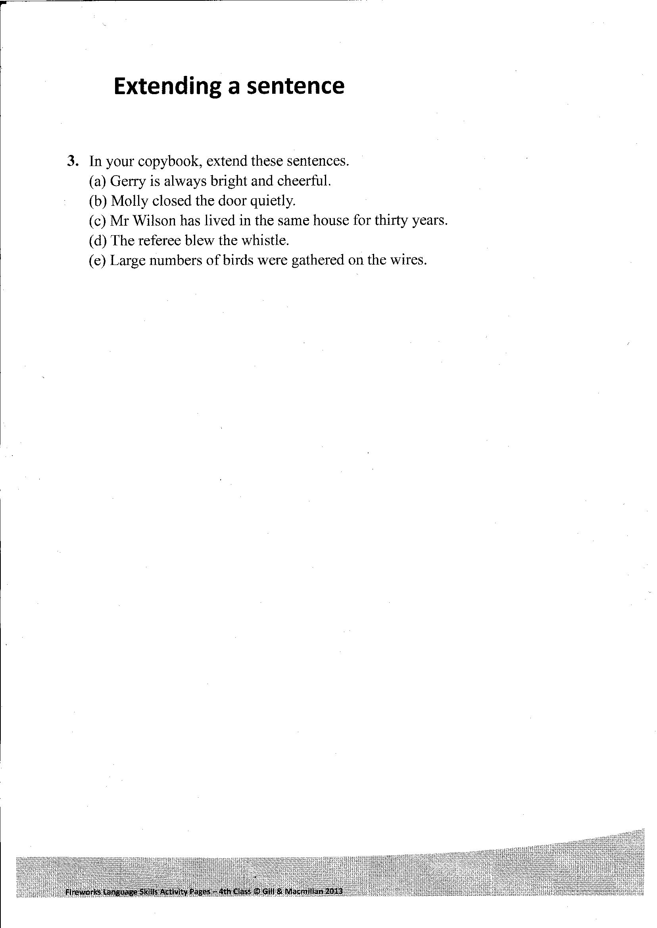

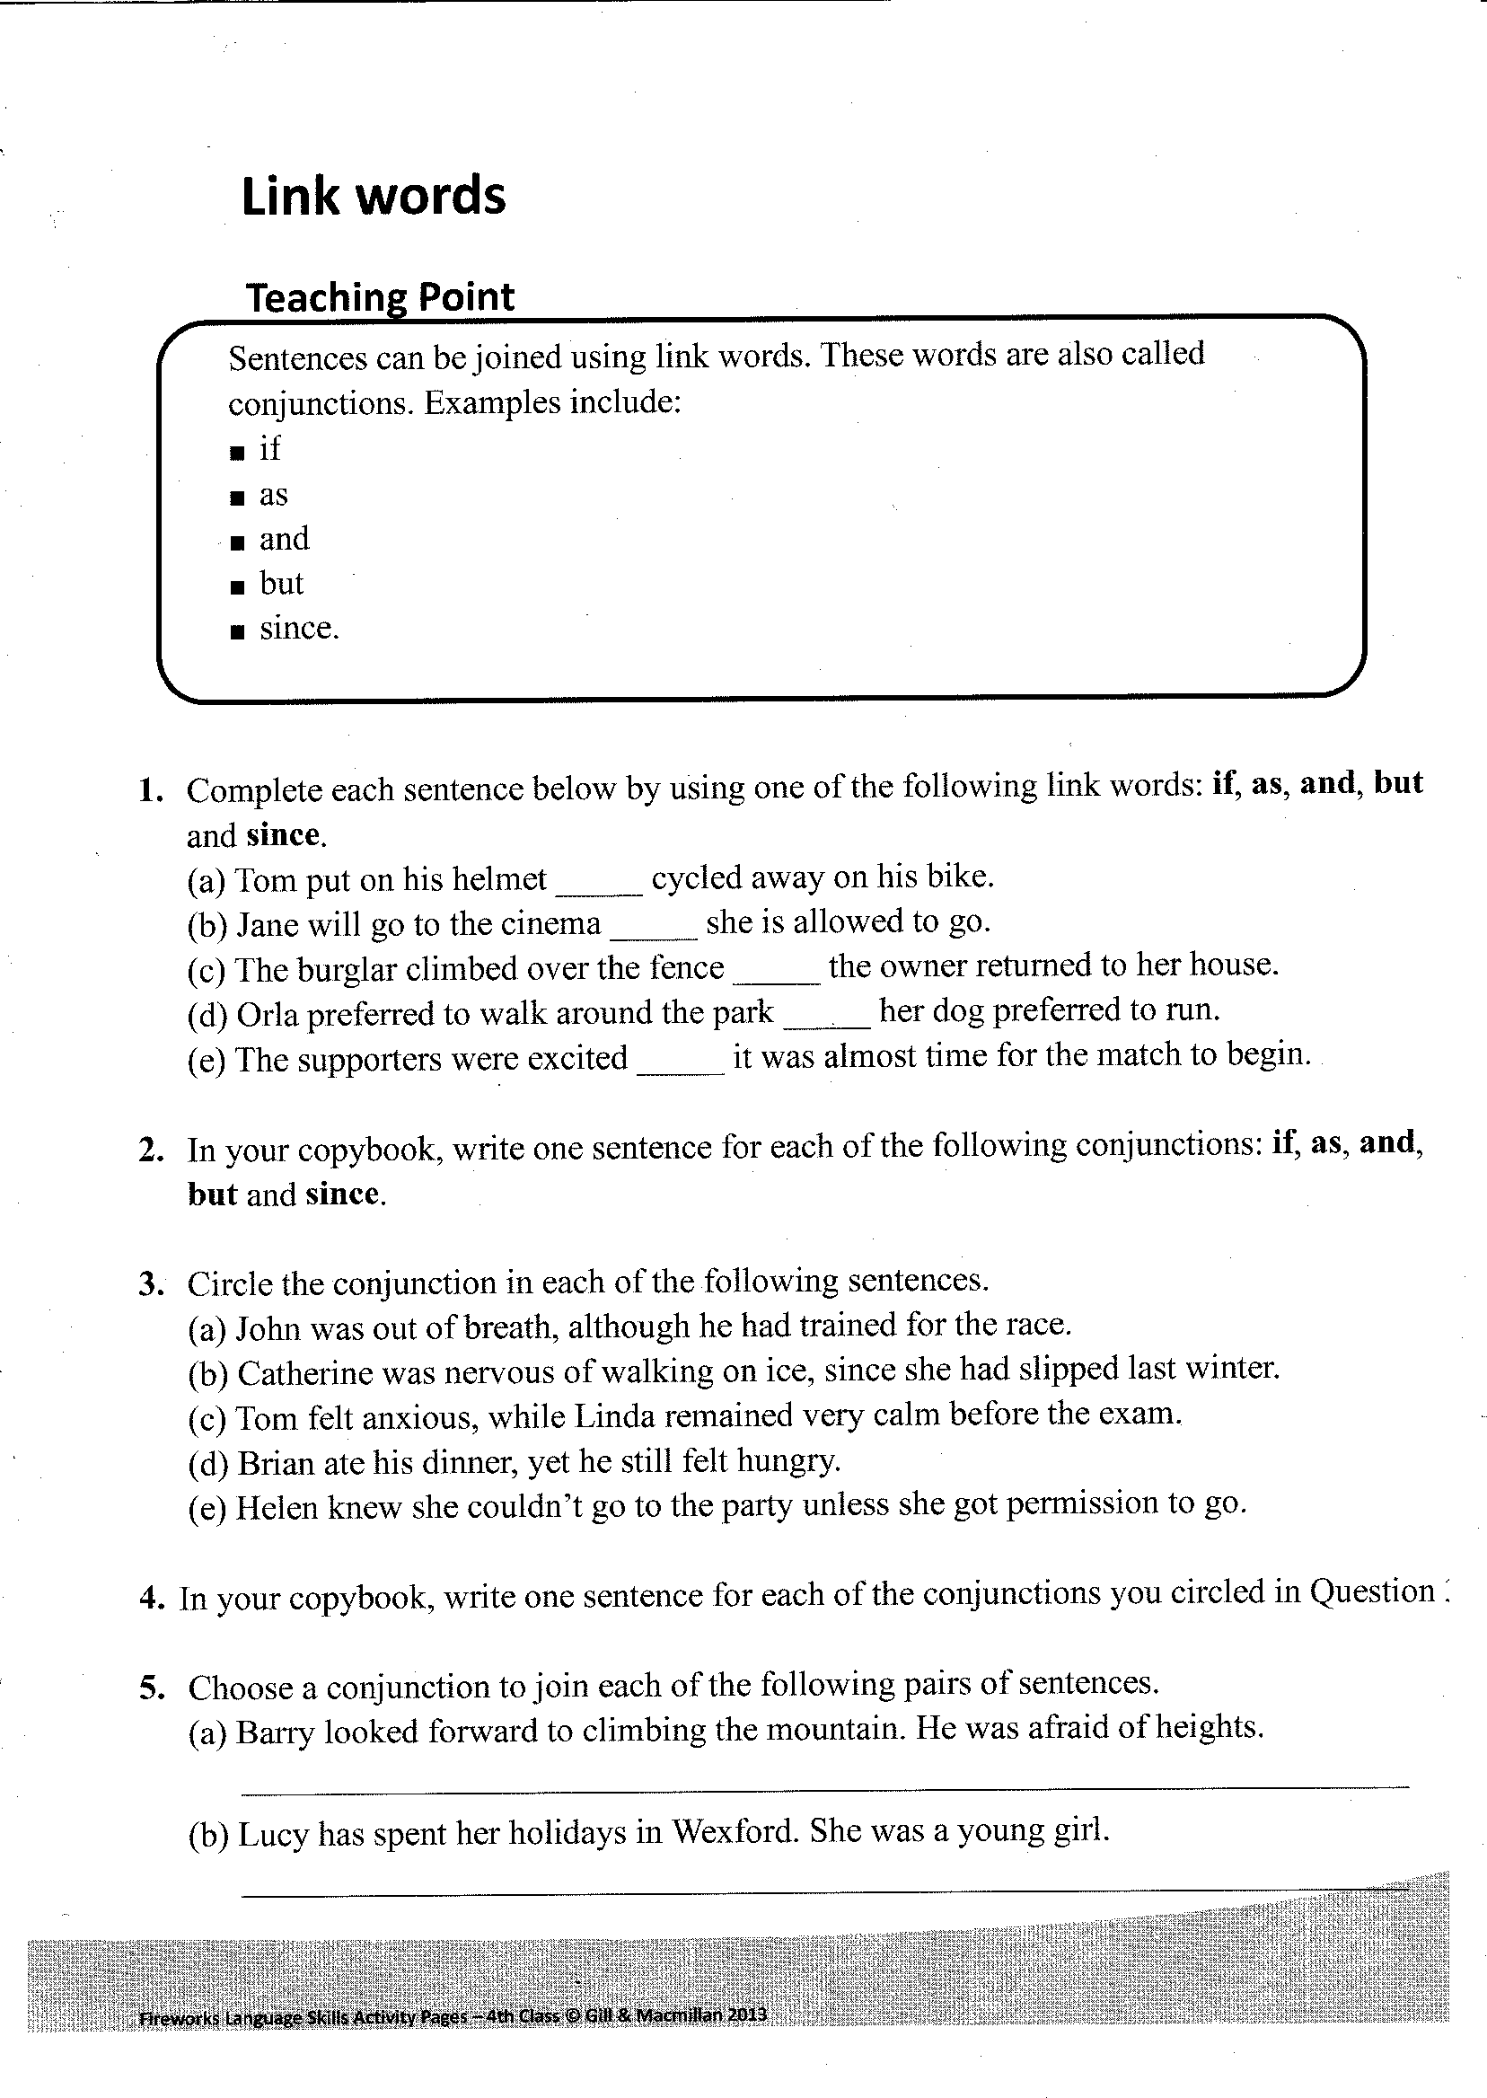
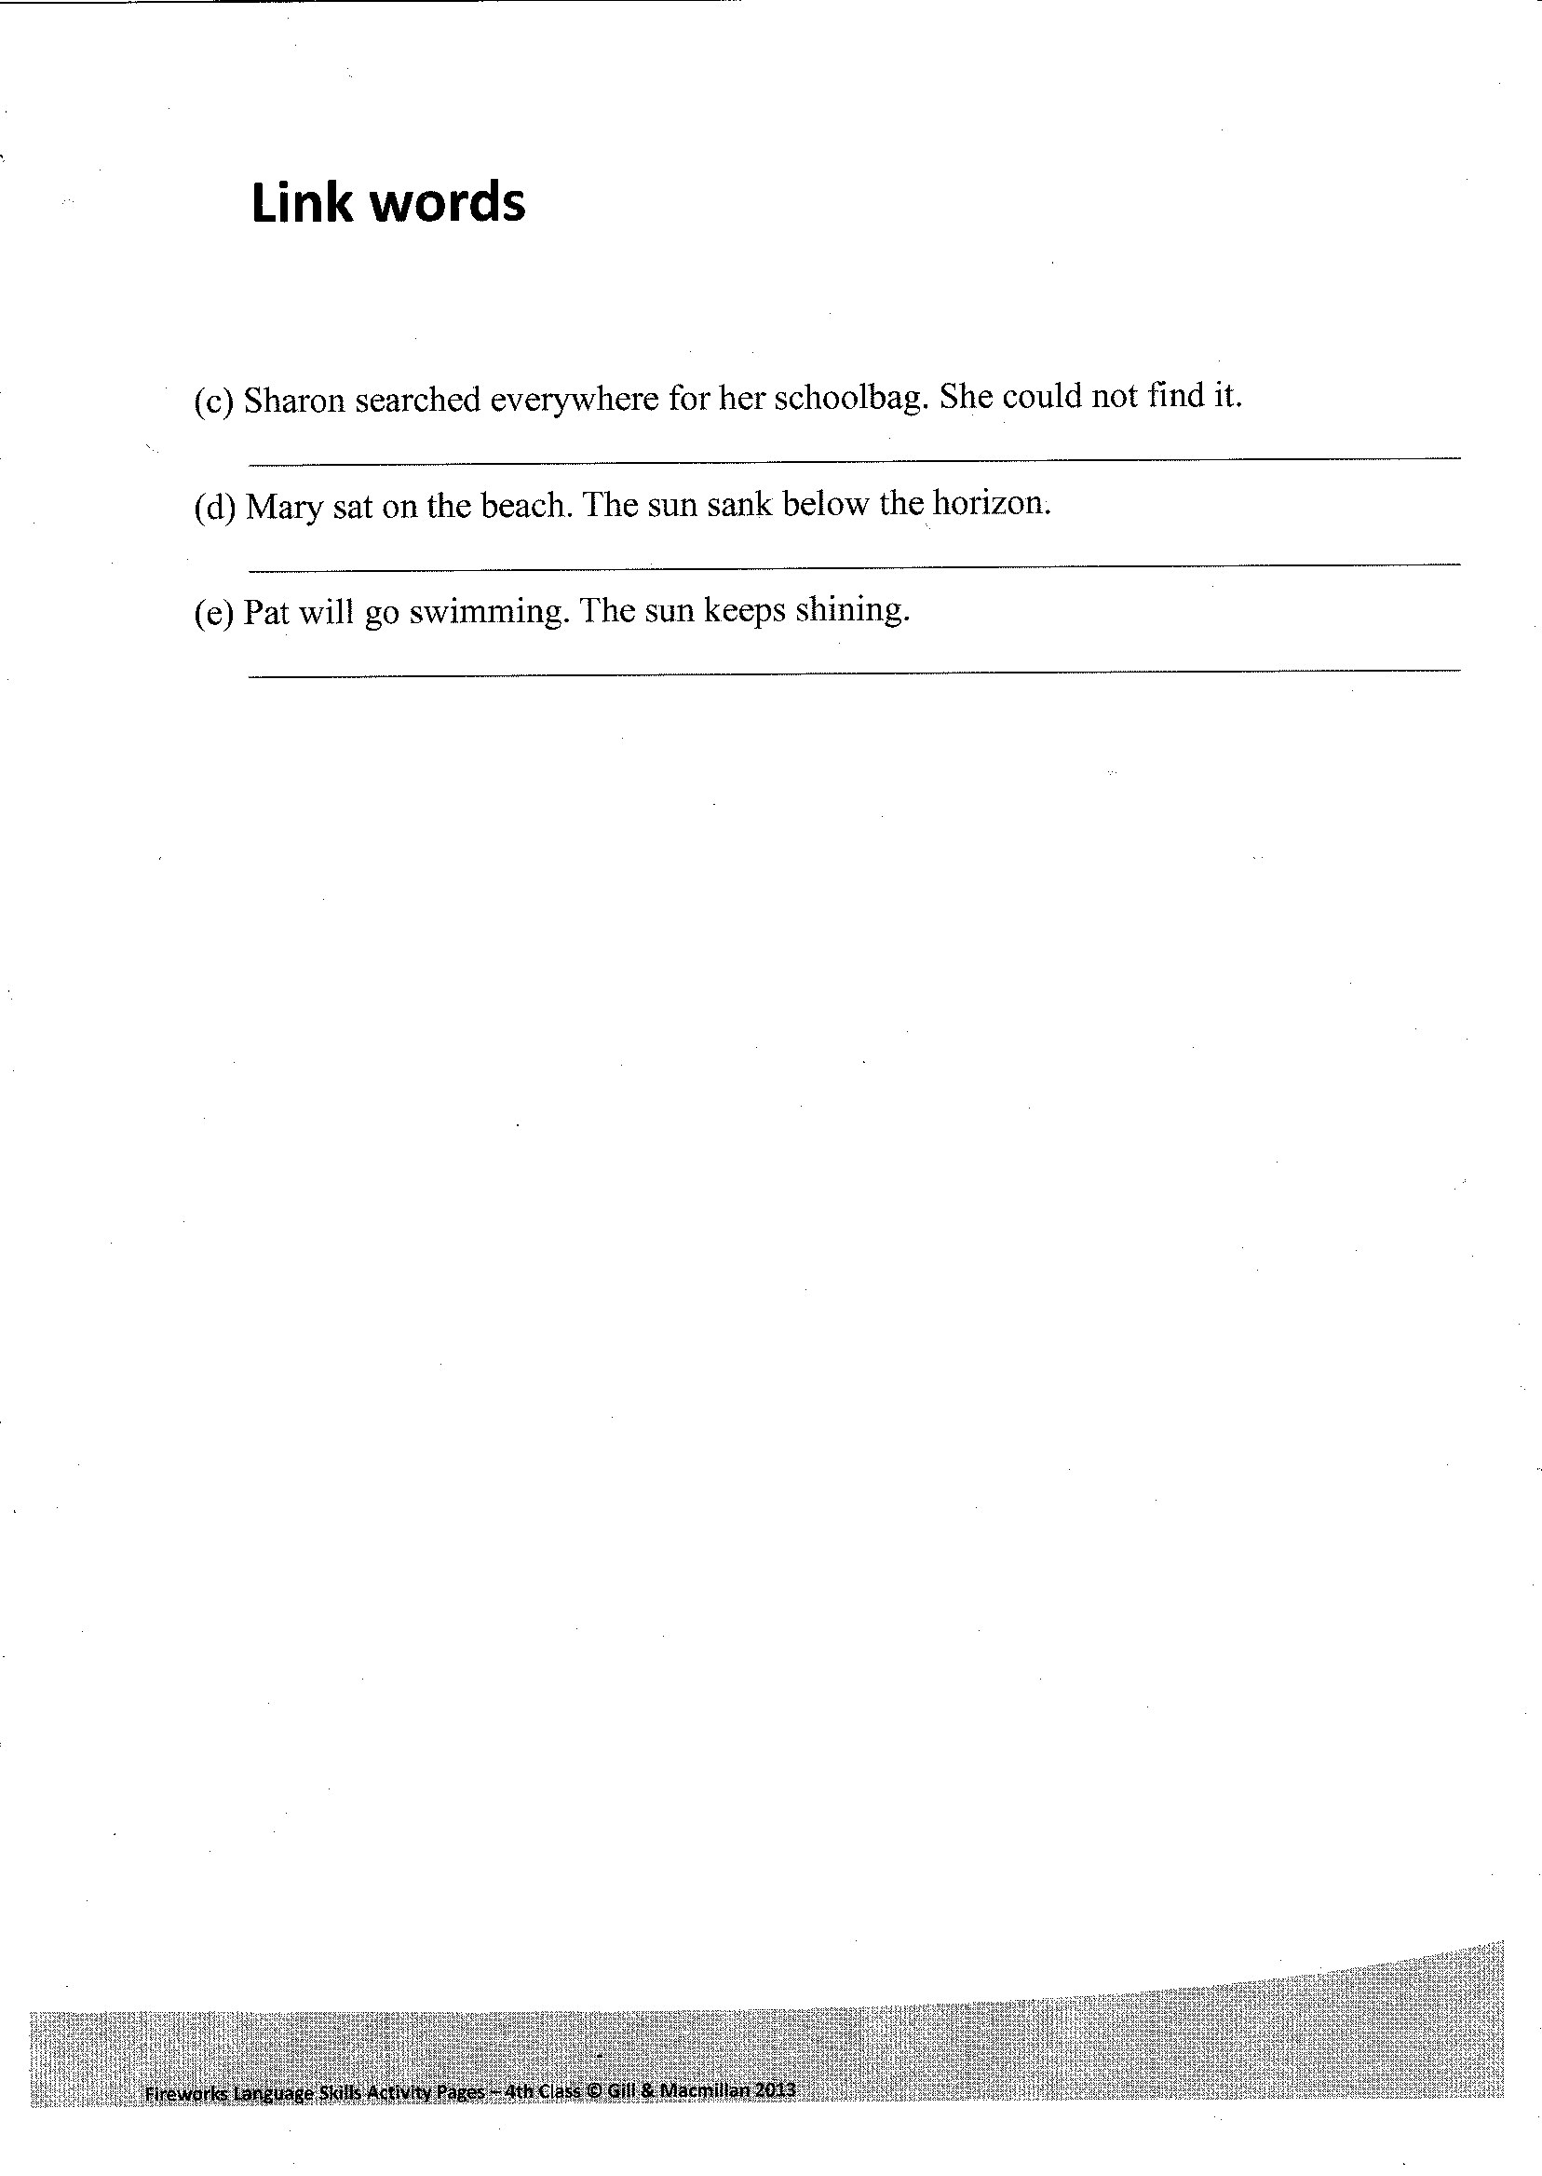
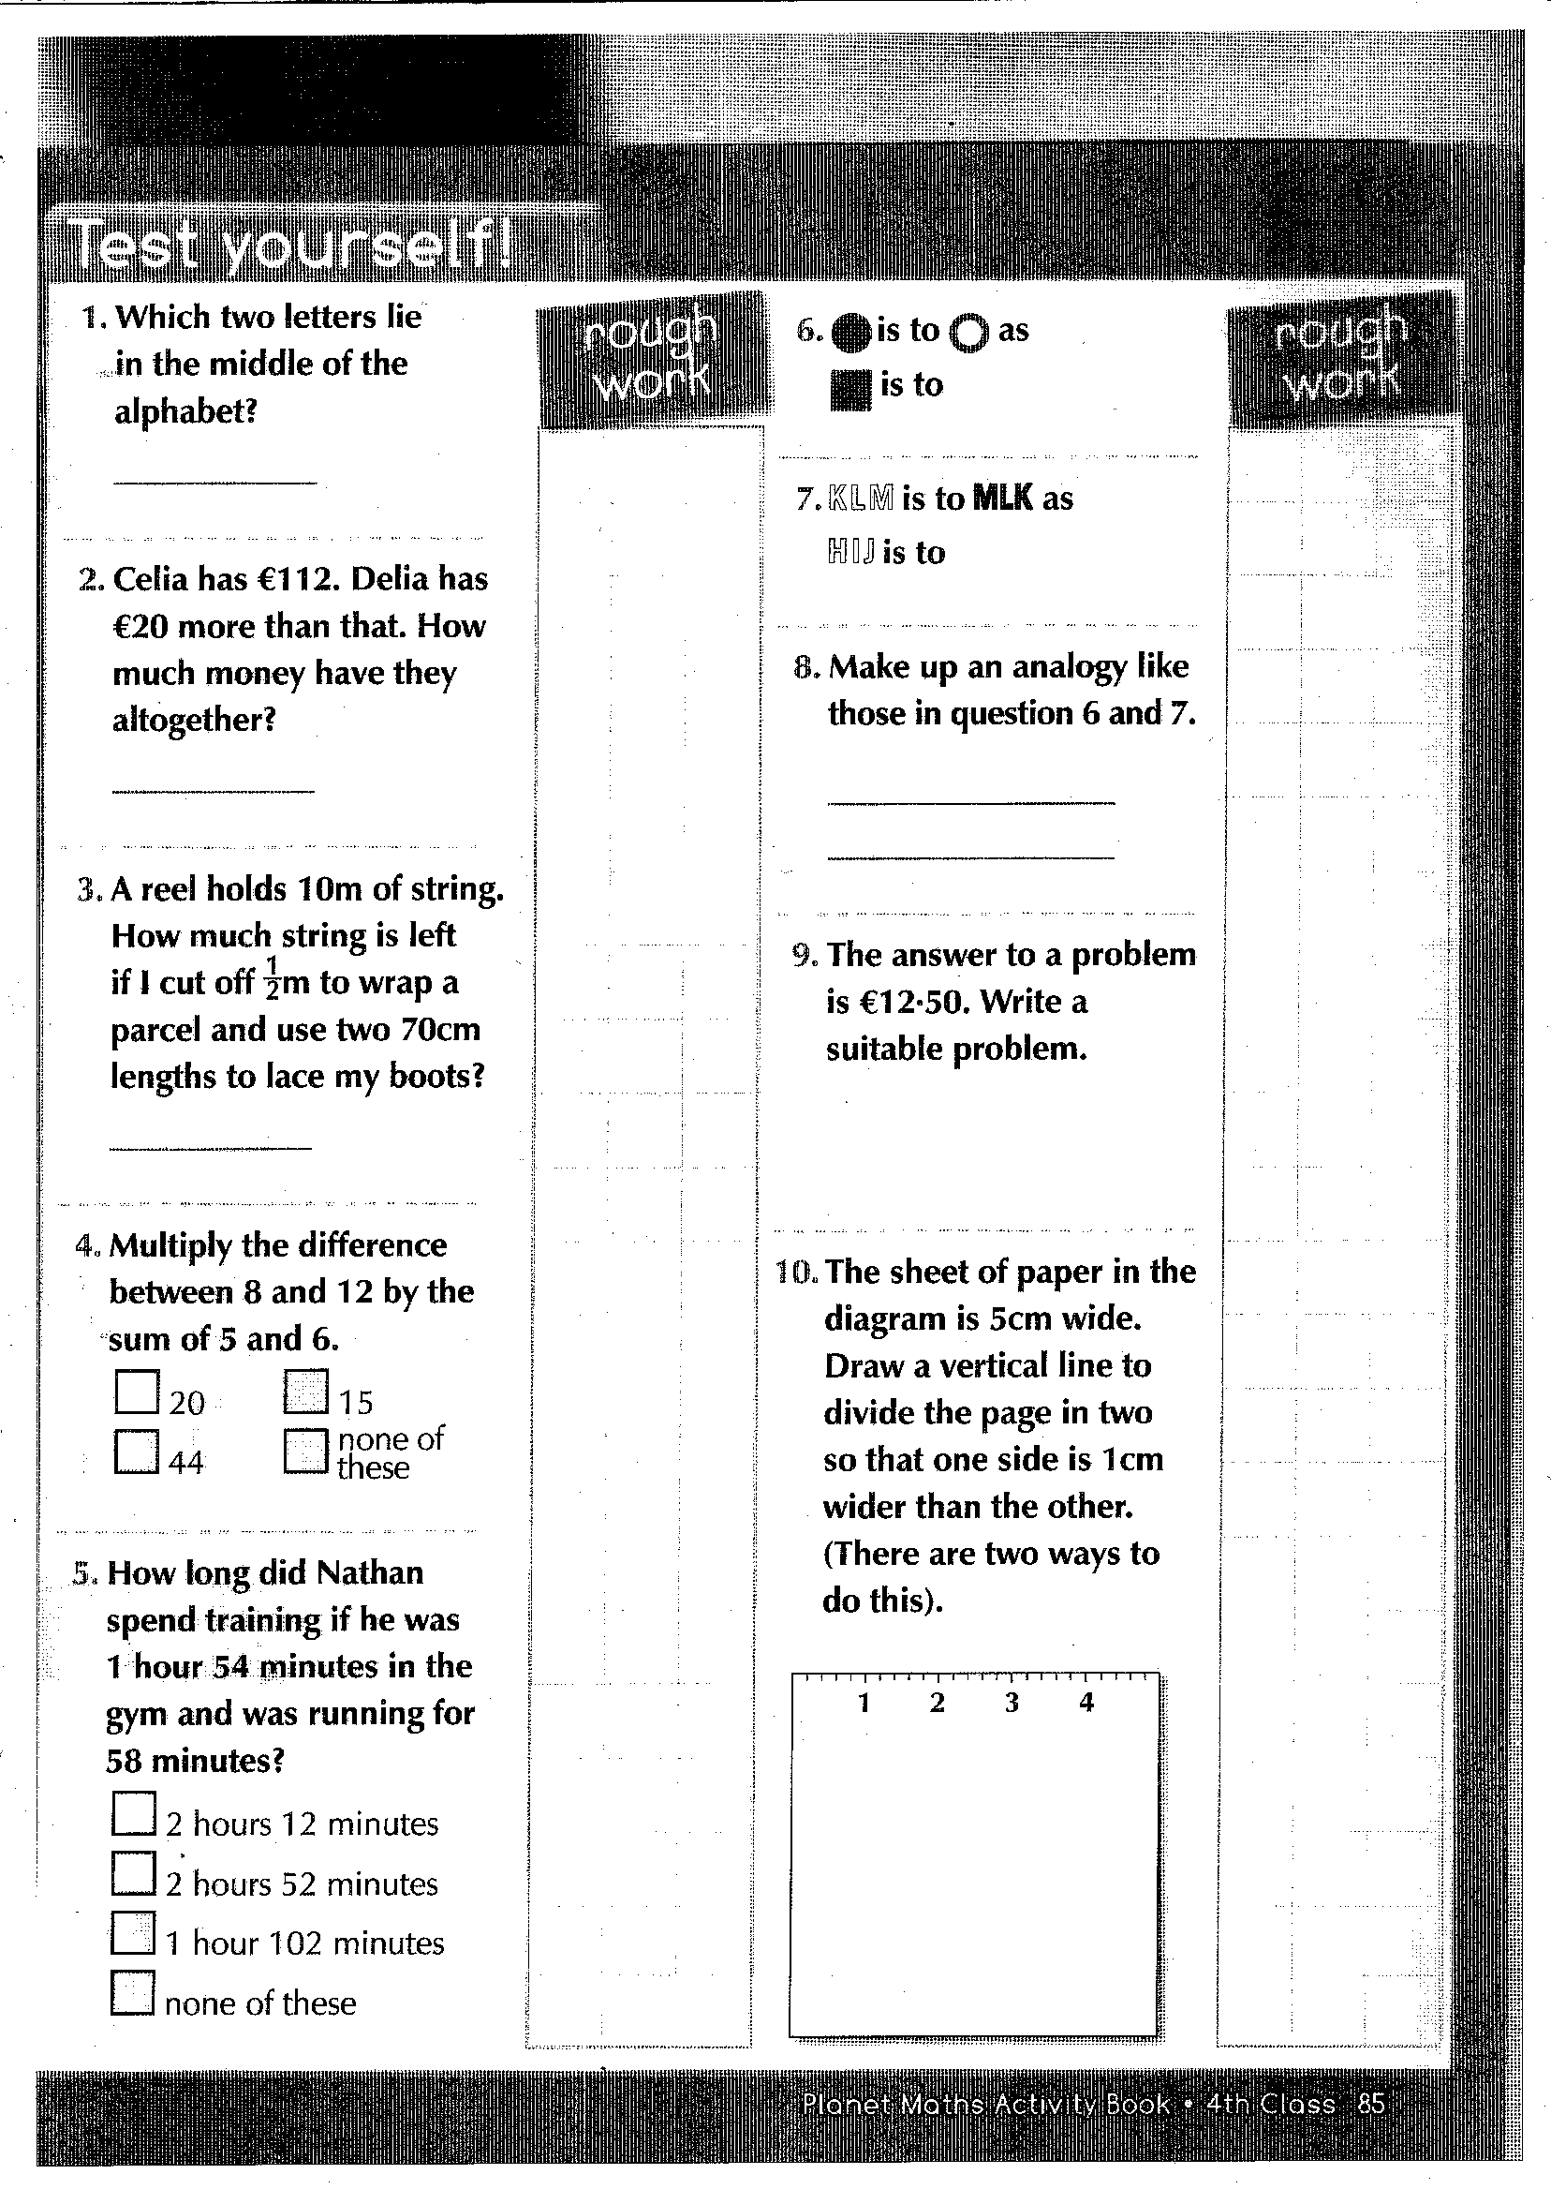
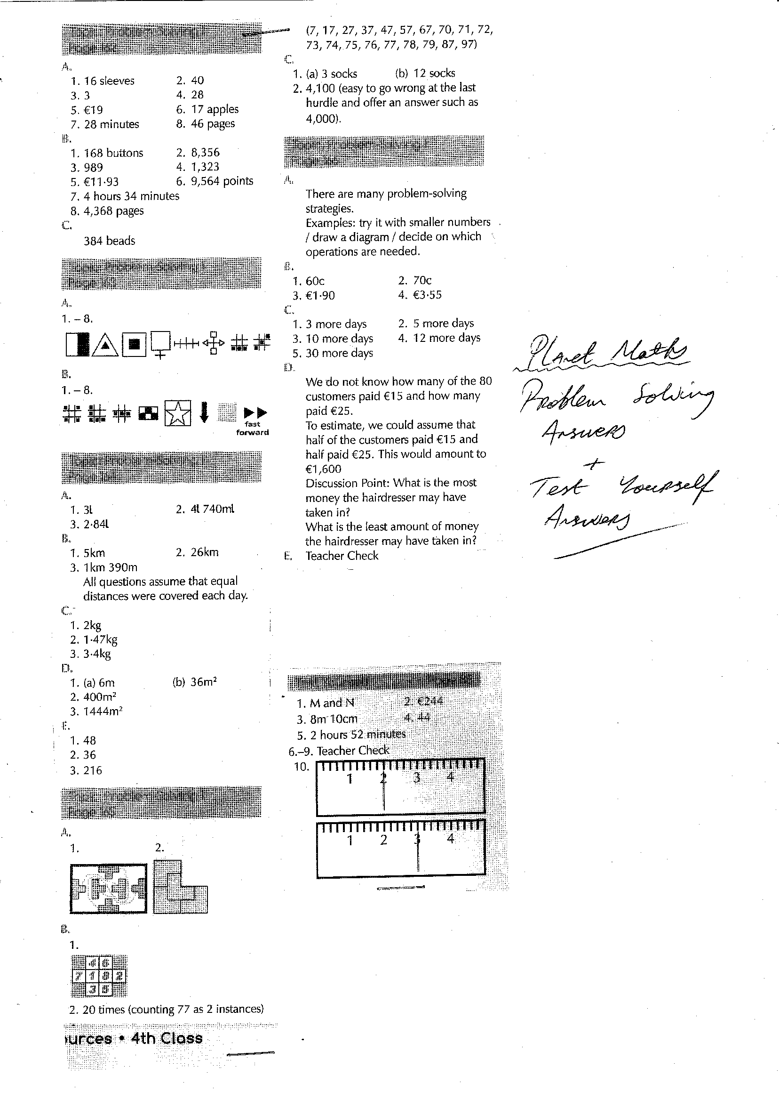
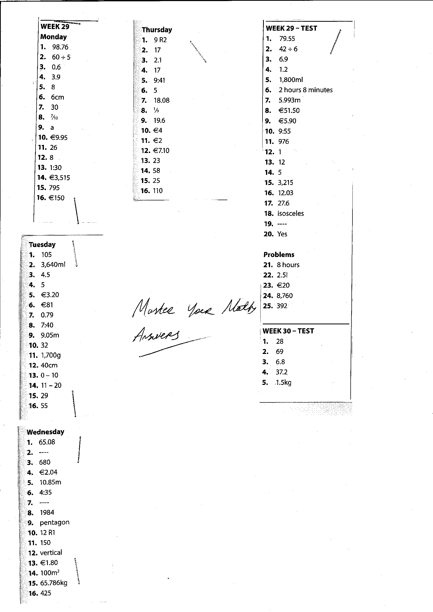
Experiment Write-Up
Experiment name:
Equipment:
What I did:
What I discovered:
visit twinkl.com

