17/4/20

Dear Parents/Guardians,

I hope you are all well at home. I realise that this is a difficult time for everyone. I have outlined work below to be completed for the week beginning 20/4/20. I do realise that some students may not have access to the internet/computer so please do not worry just try to do whatever you can. I have put in bold sections of work that if possible, you could scan and email back to me so I can review it. This new system may have some technical issues to begin with but hopefully over time it will work out. If you are unable to send work back please do not worry, just keep whatever work has been completed in the copy that was given out and I can view it when school resumes. Mr Kilcoyne has updated the school website with the emails of all the teachers so please email it to my new address.

In maths we are moving onto the topic of area. This is an area that the children have not done before in class, so I have included a few links from YouTube to try and explain it. Please remember that if your son/daughter is having any difficulties be assured that it will be covered upon return to school.

To aid the learning of Gaeilge, Folens publishers have made their online resources free to students during the time off. I highly recommend using their online Abair Liom resources. They link directly with the content being covered and explicitly teach the vocabulary and grammar of each Abair Liom chapter. Use the following steps to gain access 1. Go to folensonline.ie 2. Click register 3. Select Teacher 4. For roll number use the code: Prim20.

Answers to this week’s Gaeilge, Mental Maths & Planet Maths have been attached below. The answers are to be used after the work is completed.

I hope everyone has been safe and happy over the past few weeks and I am really looking forward to seeing everyone back at school soon. I would love to hear how the children are getting on and what interesting inventive things they may have gotten up to over the past few weeks, so please feel free to email me.

Kind regards,

Ciaran Gallagher.

|  |  |
| --- | --- |
| **Teacher’s Name or Teachers’ Names** | Ciaran Gallagher |
| **Class level** | 4th Class |
| **Suggested work for week beginning** | 20/4/20 |
| **Teachers email address** | mrcgallagherfourthclass@gmail.com |
| **Correction of work** | Work that I/we have highlighted should be submitted to the appropriate teacher’s e-mail address above. This can be a photograph of the copybook page or the answers can be typed into the e-mail. Please write your child’s name in the *subject* part of the e-mail.  Work that is not highlighted should be corrected by an adult/parent. |
| **Message from teacher/s** | You can also email me if you have any queries or questions. Please write your child’s name in the *subject* box of the email. |

**Remember to tune into the RTE Home School Hub every day at 11.00**

|  |  |
| --- | --- |
| **Monday 20/4/20** | |
| **English** | **Witches Spiders and Cowboys**  **Reading & Writing**  Guide Dogs P-141  Complete questions 1-3 P-143 **(Please scan and email this piece of work back to me)**  **Oral Language P-143 Questions 1-3**  **Grammar Verbs** (The sheet is attached below)  Complete questions 1-6 **(Please scan and email this piece of work back to me)**  **Reading** (Witches Spiders and Cowboys)  The Vikings P-76-79 |
| **Gaeilge** | **Abair Liom**  (1 chapter per fortnight this chapter will be completed this week it was started the week before Easter.  **Léamh** – Léigh scéal Cú Chulainn – lth - 148  **Comhrá** – E Caitheamh aimsire lth -151 (Conversation) |
| **Maths** | **Master Your Maths**  Week-28 Monday P-60  **Multiplication Tables**  Revise Multiplication Tables (Times 6)  **Planet Maths P-138**  Complete Sections B, C, D P-138, A, B P-139  <https://www.youtube.com/watch?v=d_6XOBpoDz4> |
| **Spellings** | **English**  Jolly Phonics Spelling List – 29 (-ent) Complete the left-hand side of the sheet.  Learn spellings 1-5  **Gaeilge**  Aonad – 28 Is Fearr an tSláinte ná na Táinte - Litriú 1-3  \***Students are going be asked to complete their spelling test on Fridays at home, at the back of their spelling book.** |
| **Science** | **Small World Geography & Science**  Unit 18 – Materials and Change P-105  Complete – Question A 1-7 & B 1-6  **\***If you have the materials it would be great to do some of the fantastic experiments in this chapter. You could email me to let me know how you got on. I will attach an experiment log sheet for anyone who does one of the experiments to complete. |

|  |  |
| --- | --- |
| **Tuesday 21/4/20** | |
| **English** | **Witches Spiders and Cowboys**  **Reading & Writing**  Matilda P-146  Complete questions 1-13 P-151  **Oral Language**  Can you remember how you felt on your first day of school?  **Grammar (Collective Nouns)**  Complete sections 1-5 |
| **Gaeilge** | **Abair Liom**  **Léamh** – Léigh scéal Cú Chulainn – lth - 148 (Reading)  **Scríobh** –  H. Gramadach: An forainm réamhfhoclach ‘do’ -lth – 153  I. Na litreacha ‘ái’. Cén focal é? lth – 153 |
| **Maths** | **Master Your Maths**  Week-28 Tuesday P-60  **Multiplication Tables**  Revise Multiplication Tables (Times 6)  **Planet Maths P-138**  Complete sections A, B P-140 **(Please scan and email this piece of work back to me)** |
| **Spellings** | **English**  Jolly Phonics Spelling List – 29 (-ent) Complete the right-hand side of the sheet.  Learn spellings 6-10  **Gaeilge**  Aonad – 28 Is Fearr an tSláinte ná na Táinte - Litriú 4-6  \***Students are going be asked to complete their spelling test on Fridays at home, at the back of their spelling book.** |
| **Geography** | **Small World Geography & Science**  Unit 17: The Sun P-100  Read P-101/102  Complete (Cloze Exercise) – A  <https://www.youtube.com/watch?v=Wr-CRKsTYGs>  Day and Night Video  <https://www.youtube.com/watch?v=l64YwNl1wr0>  Earth Rotation and Revolution Crash Course for Kids |

|  |  |
| --- | --- |
| **Wednesday 22/4/20** | |
| **English** | **Witches Spiders and Cowboys**  **Reading & Writing**  Alice in Wonderland P-155  Complete questions 1-9 P-159 **(Please scan and email this piece of work back to me)**  **Oral Language**  Lewis Carroll shows great imagination in bringing the playing cards to life. Do you agree?  **Grammar (Word Sorting)**  Complete section 1-4 |
| **Gaeilge** | **Abair Liom**  **Léamh** – Léigh scéal Cú Chulainn – lth - 148 (Reading)  **Léamh** – Caitheamh aimsire Aoife agus Dháithí lth154 – J read top part  -Léigh scéal Aoife |
| **Maths** | **Master Your Maths**  Week-28 Wednesday P-61  **Multiplication Tables**  Revise Multiplication Tables (Times 6)  **Planet Maths P-138**  Complete Sections A, B P-141  Division Early Finishers (1-12 Sheet attached below) |
| **Spellings** | **English**  Jolly Phonics Spelling List – 29 (-ent)  Learn spellings 10-14  **Gaeilge**  Aonad – 28 Is Fearr an tSláinte ná na Táinte - Litriú 7-8  \***Students are going be asked to complete their spelling test on Fridays at home, at the back of their spelling book.** |
| **Art** | Go onto the ‘I am an Artist’ website pick a picture that you are inspired by and using whatever art resources you have at home create your own version of the picture.  <http://www.iamanartist.ie/>  Email me the finished piece if you can I would love to see it and maybe try and put a collage of images together. |

|  |  |
| --- | --- |
| **Thursday 23/4/20** | |
| **English** | **Witches Spiders and Cowboys**  **Reading & Writing**  Roman Life P-161  Complete questions 1 A, B, C & 2  **Oral Language**  What is your favourite pastime and why?  **Grammar (Prefixes)**  Complete sections 1-6 |
| **Gaeilge** | **Abair Liom**  **Léamh** – Léigh scéal Cú Chulainn – lth – 148 (Reading)  **Scríobh** – Críochnaigh scéal Dhaithí lth 154 J |
| **Maths** | **Master Your Maths**  Week-28 Thursday P-61  **Multiplication Tables**  Revise Multiplication Tables (Times 6)  **Planet Maths P-138**  Check-up B, C, E P-142 **(Please scan and email this piece of work back to me)** |
| **Spellings** | **English**  Jolly Phonics Spelling List – 29 (-ent)  Learn spellings 14-18  **Gaeilge**  Aonad – 28 Is Fearr an tSláinte ná na Táinte - Litriú 9-10  \***Students are going be asked to complete their spelling test on Fridays at home, at the back of their spelling book.** |
| **History** | **History Quest**  **Shops and Shopping P-79**  The children will gain an understanding of the origins of trade and shops and how shopping has changed over time.  Complete Activity A (1-10) |

|  |  |
| --- | --- |
| **Friday 24/4/20** | |
| **English** | **Witches Spiders and Cowboys**  **Reading & Writing**  The Roman Chronicle P-162  Blues Blaze to Victory P-163  Complete questions 1 & 2 P-162  Complete question 1 & 2 P-163  **Oral Language**  Which of the two-newspaper articles did you find the most interesting and why?  **Grammar (Adverbs)**  Complete sections 1-7 |
| **Gaeilge** | **Abair Liom**  **Léamh** – Léigh scéal Cú Chulainn – lth - 148 (Reading)  **Scríobh** – Scríobh faoi do chaitheamh aimsire féin. – lth 155 K *  * Please use attached vocabulary sheet for help. |
| **Maths** | **Master Your Maths**  Week-28 Friday Test P-93  **Multiplication Tables**  Revise Multiplication Tables (Times 6)  **Area Assessment**  Test yourself area assessment **(Sheet is attached below)** |
| **Spellings** | English Spelling Test (1-18) & Litriú Gaeilge (1-10).  **(Please scan and email this piece of work back to me)** |
| **PE** | <https://rtejr.rte.ie/10at10/>  <https://www.jumpstartjonny.co.uk/home>  <https://www.gonoodle.com/>  Kids Indoor Circuit Training – The template is attached below of exercises you can do inside your house or out in the garden. Have fun give it a go. |

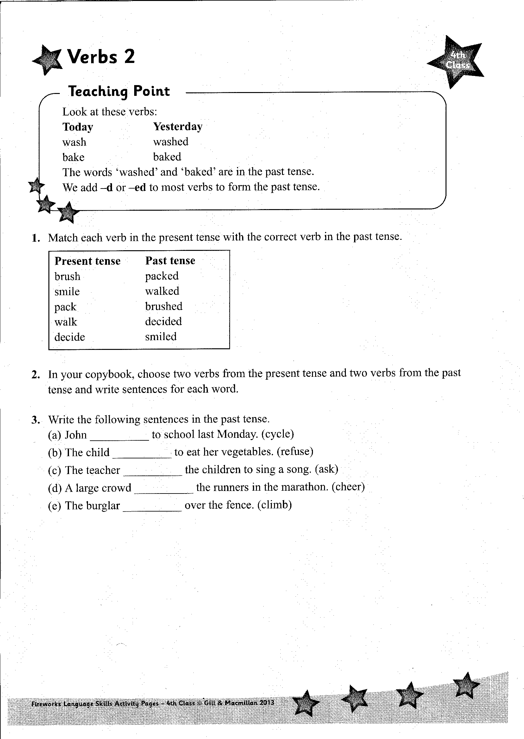

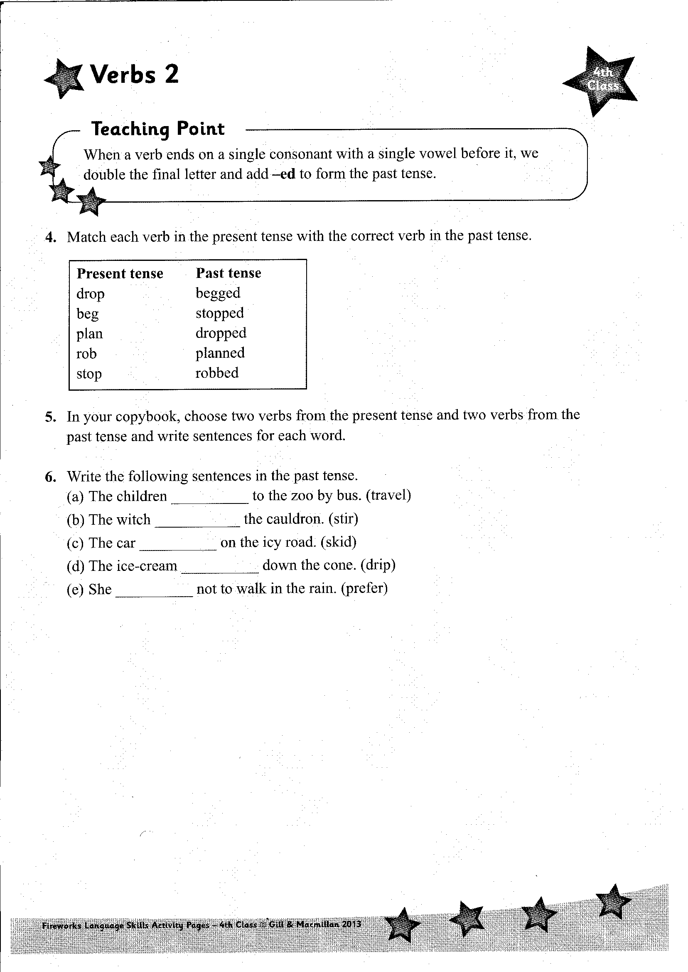

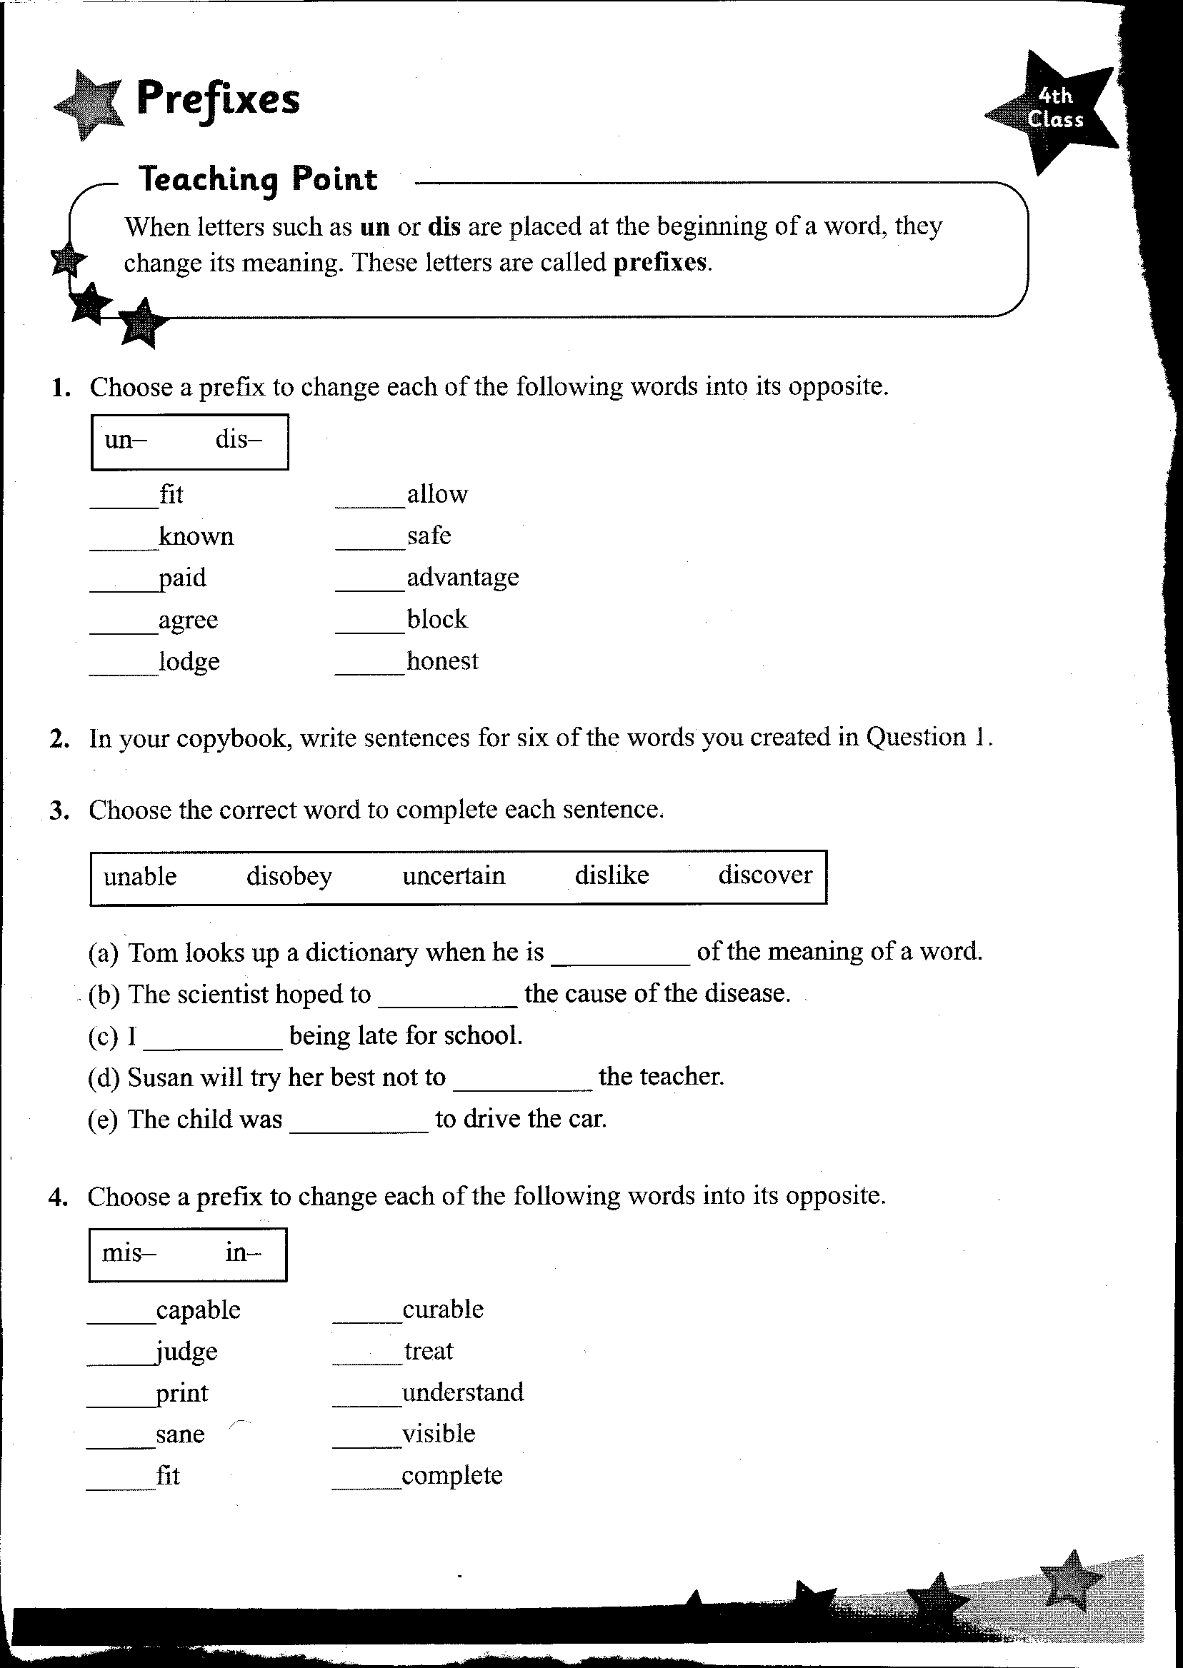

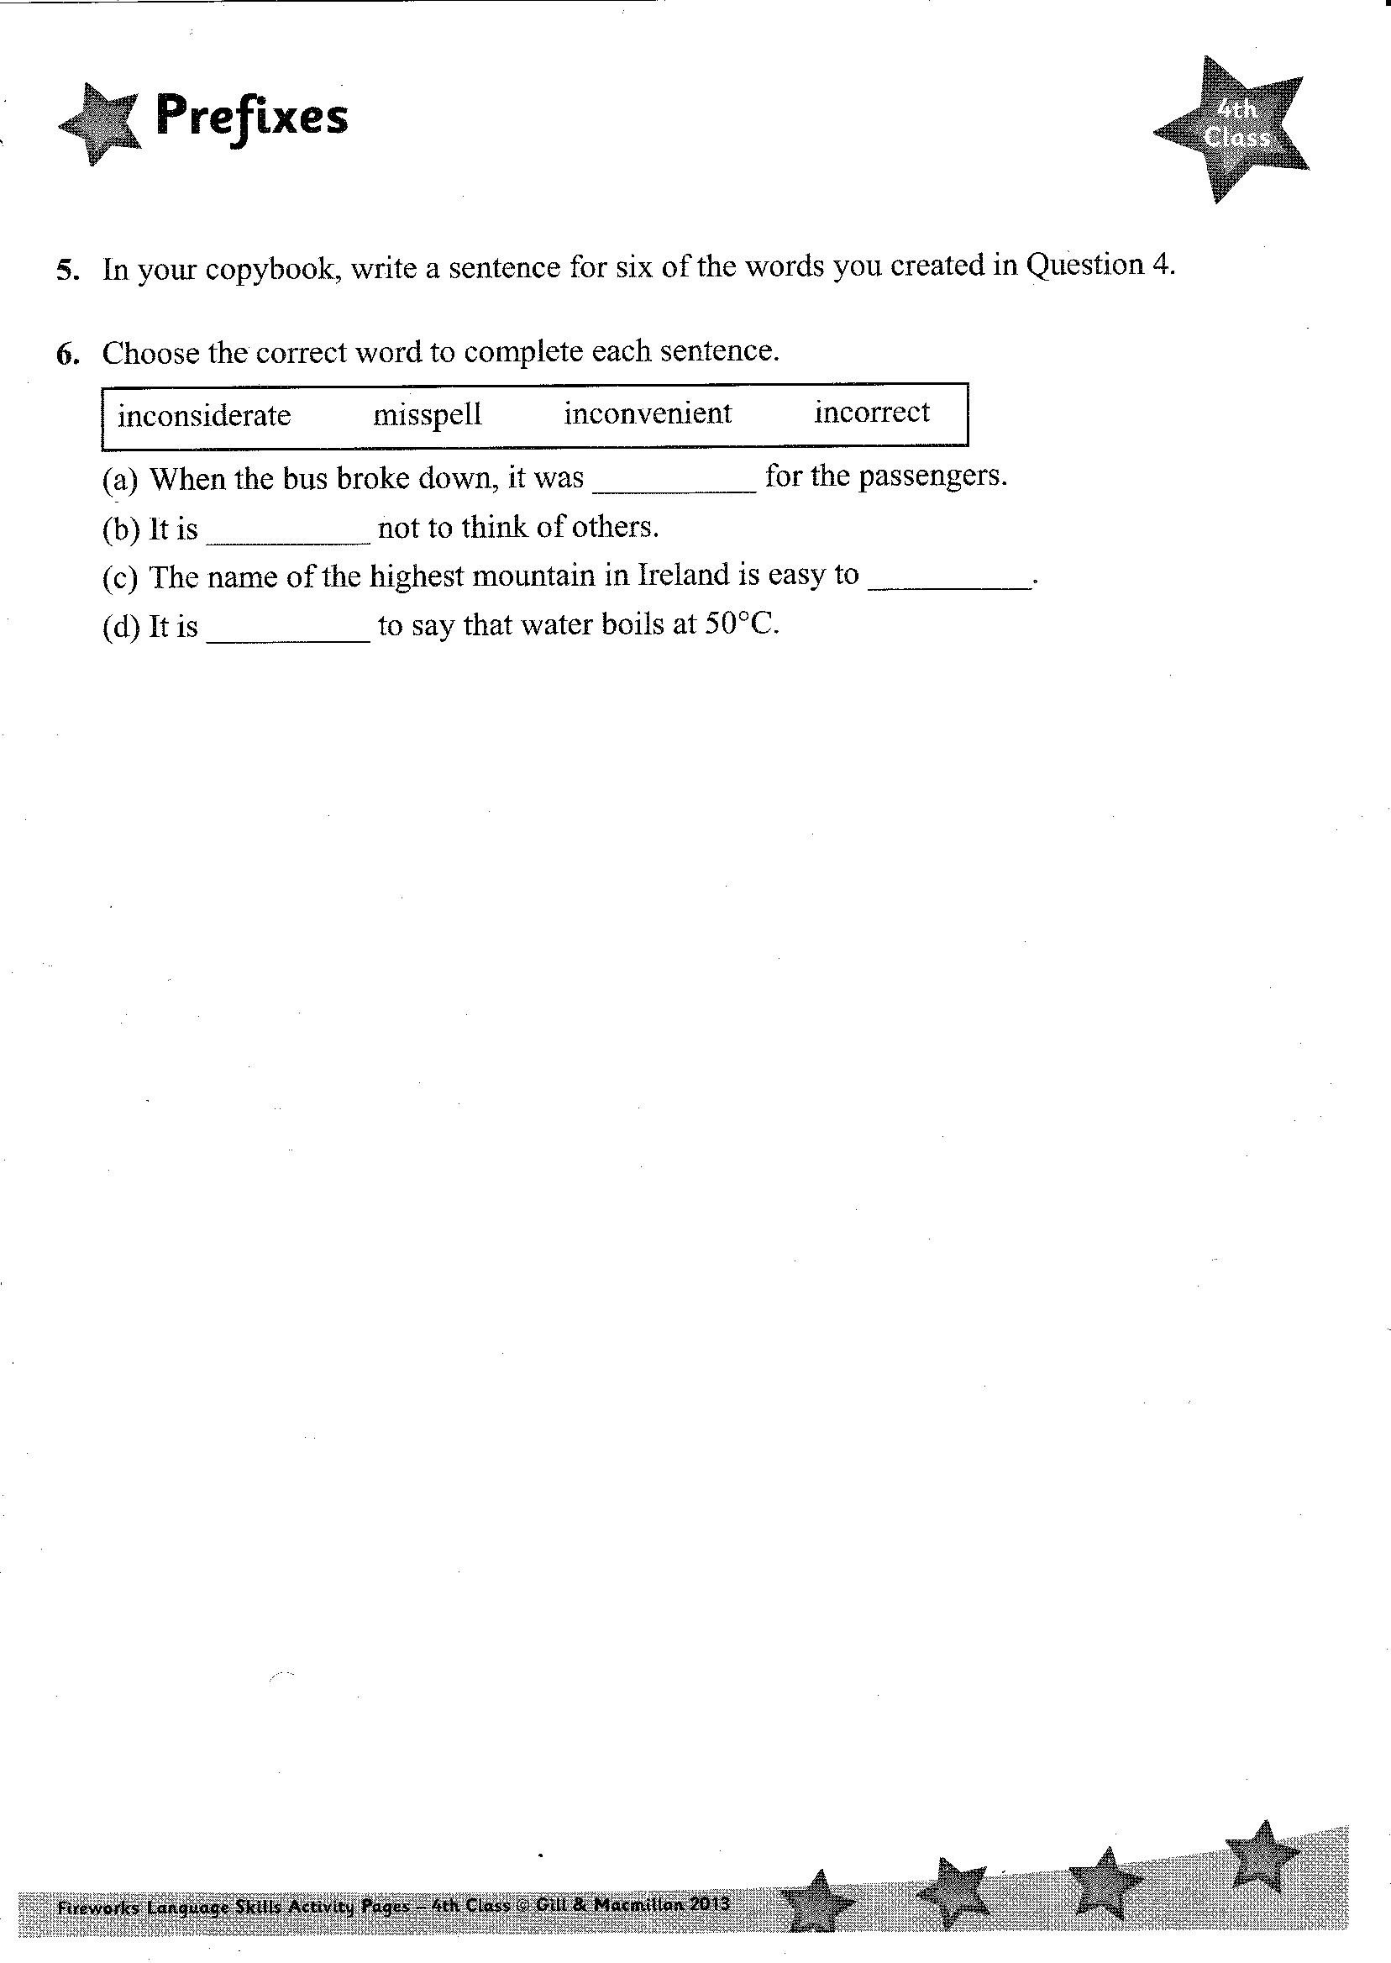

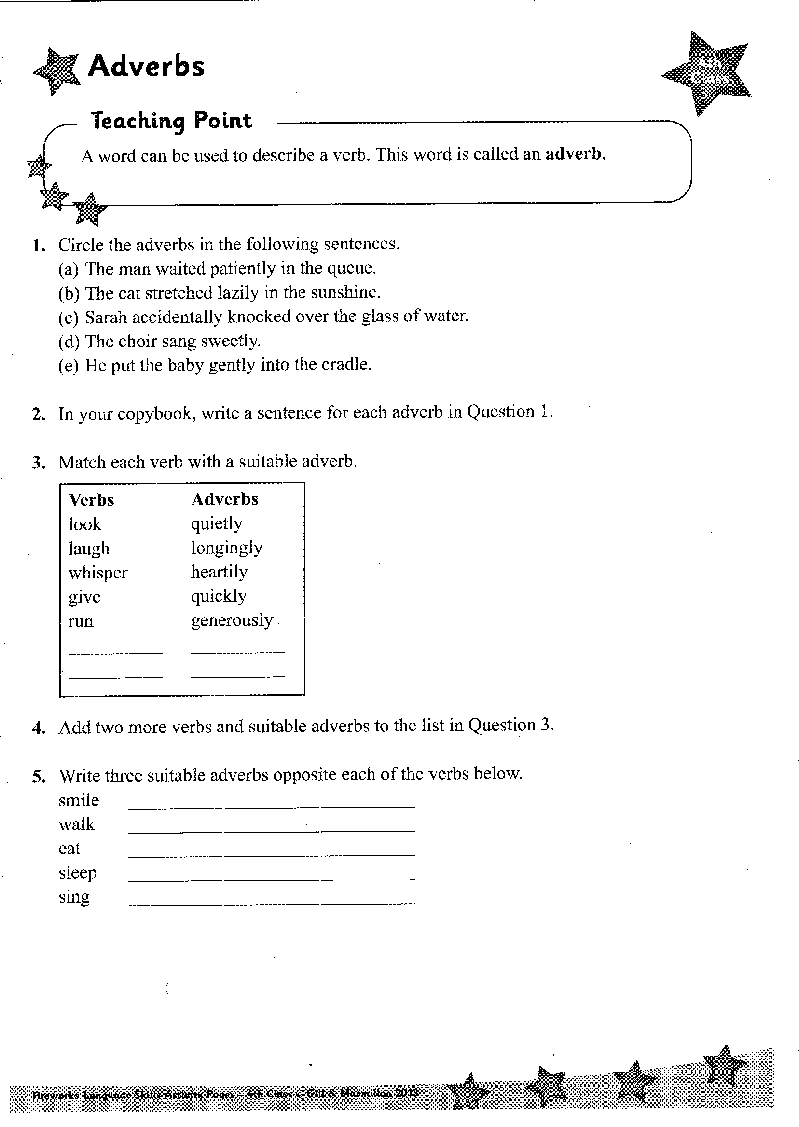

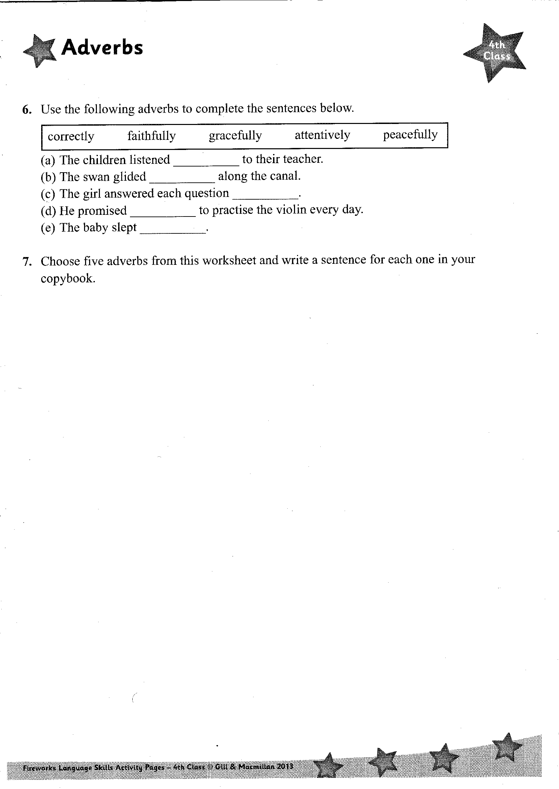

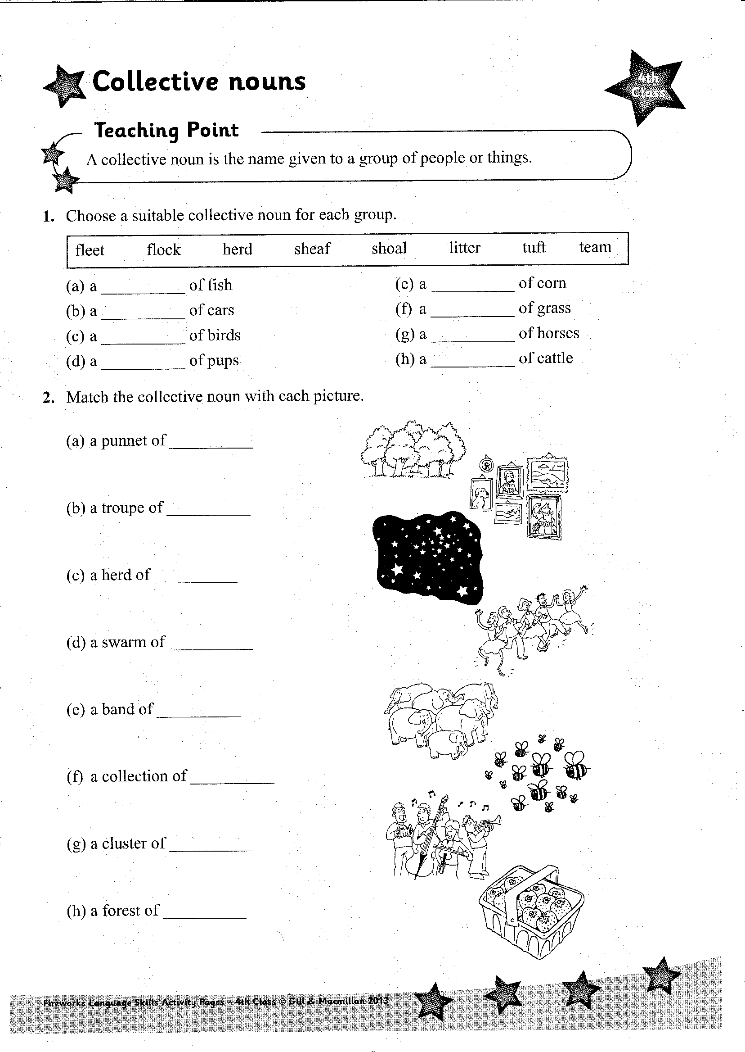

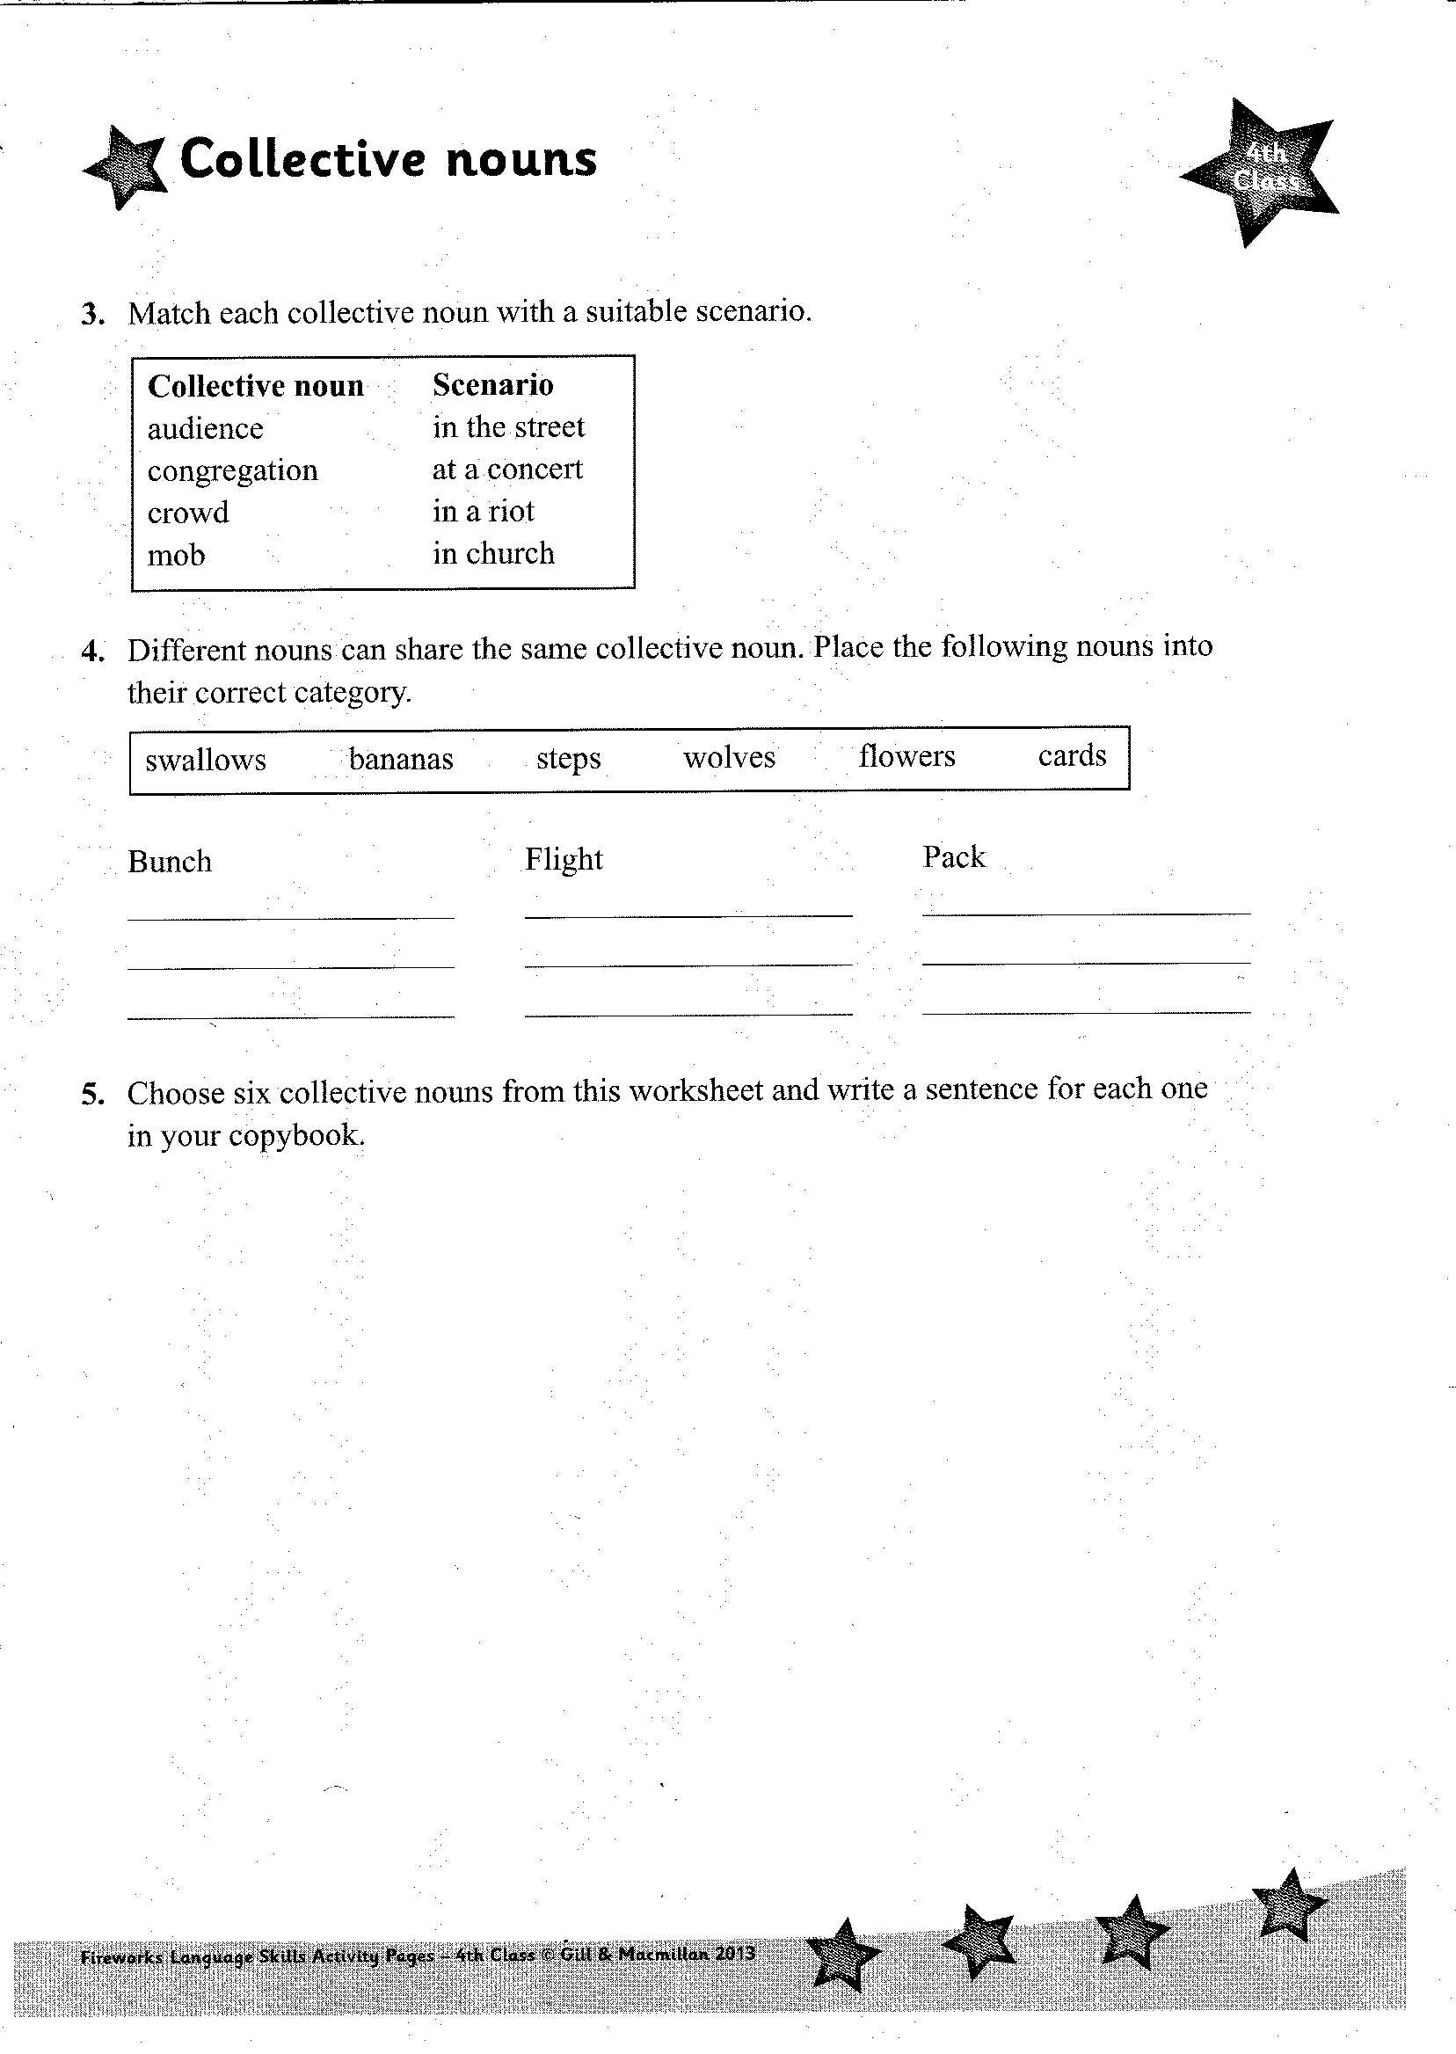

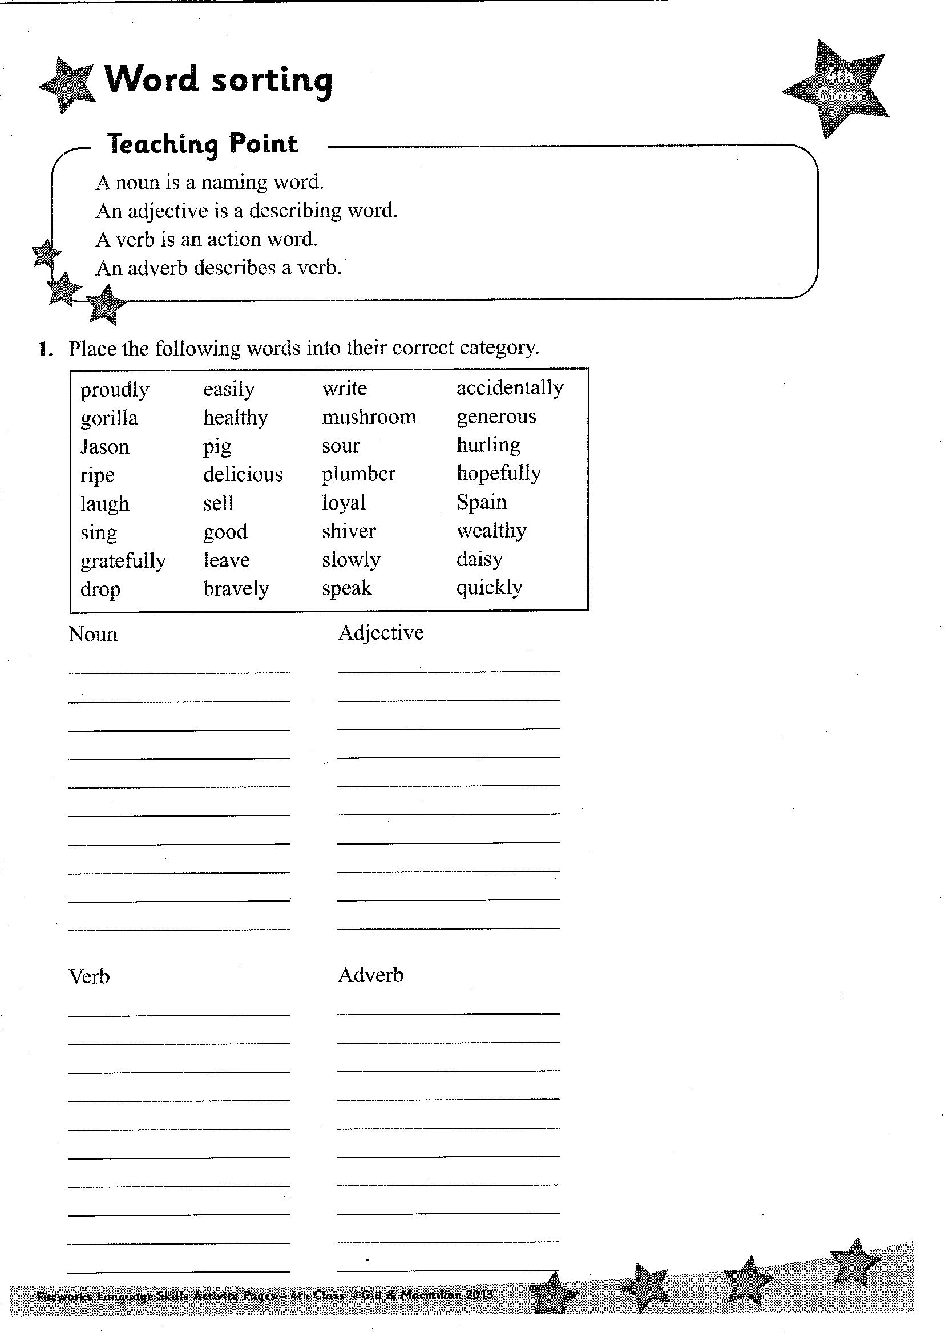

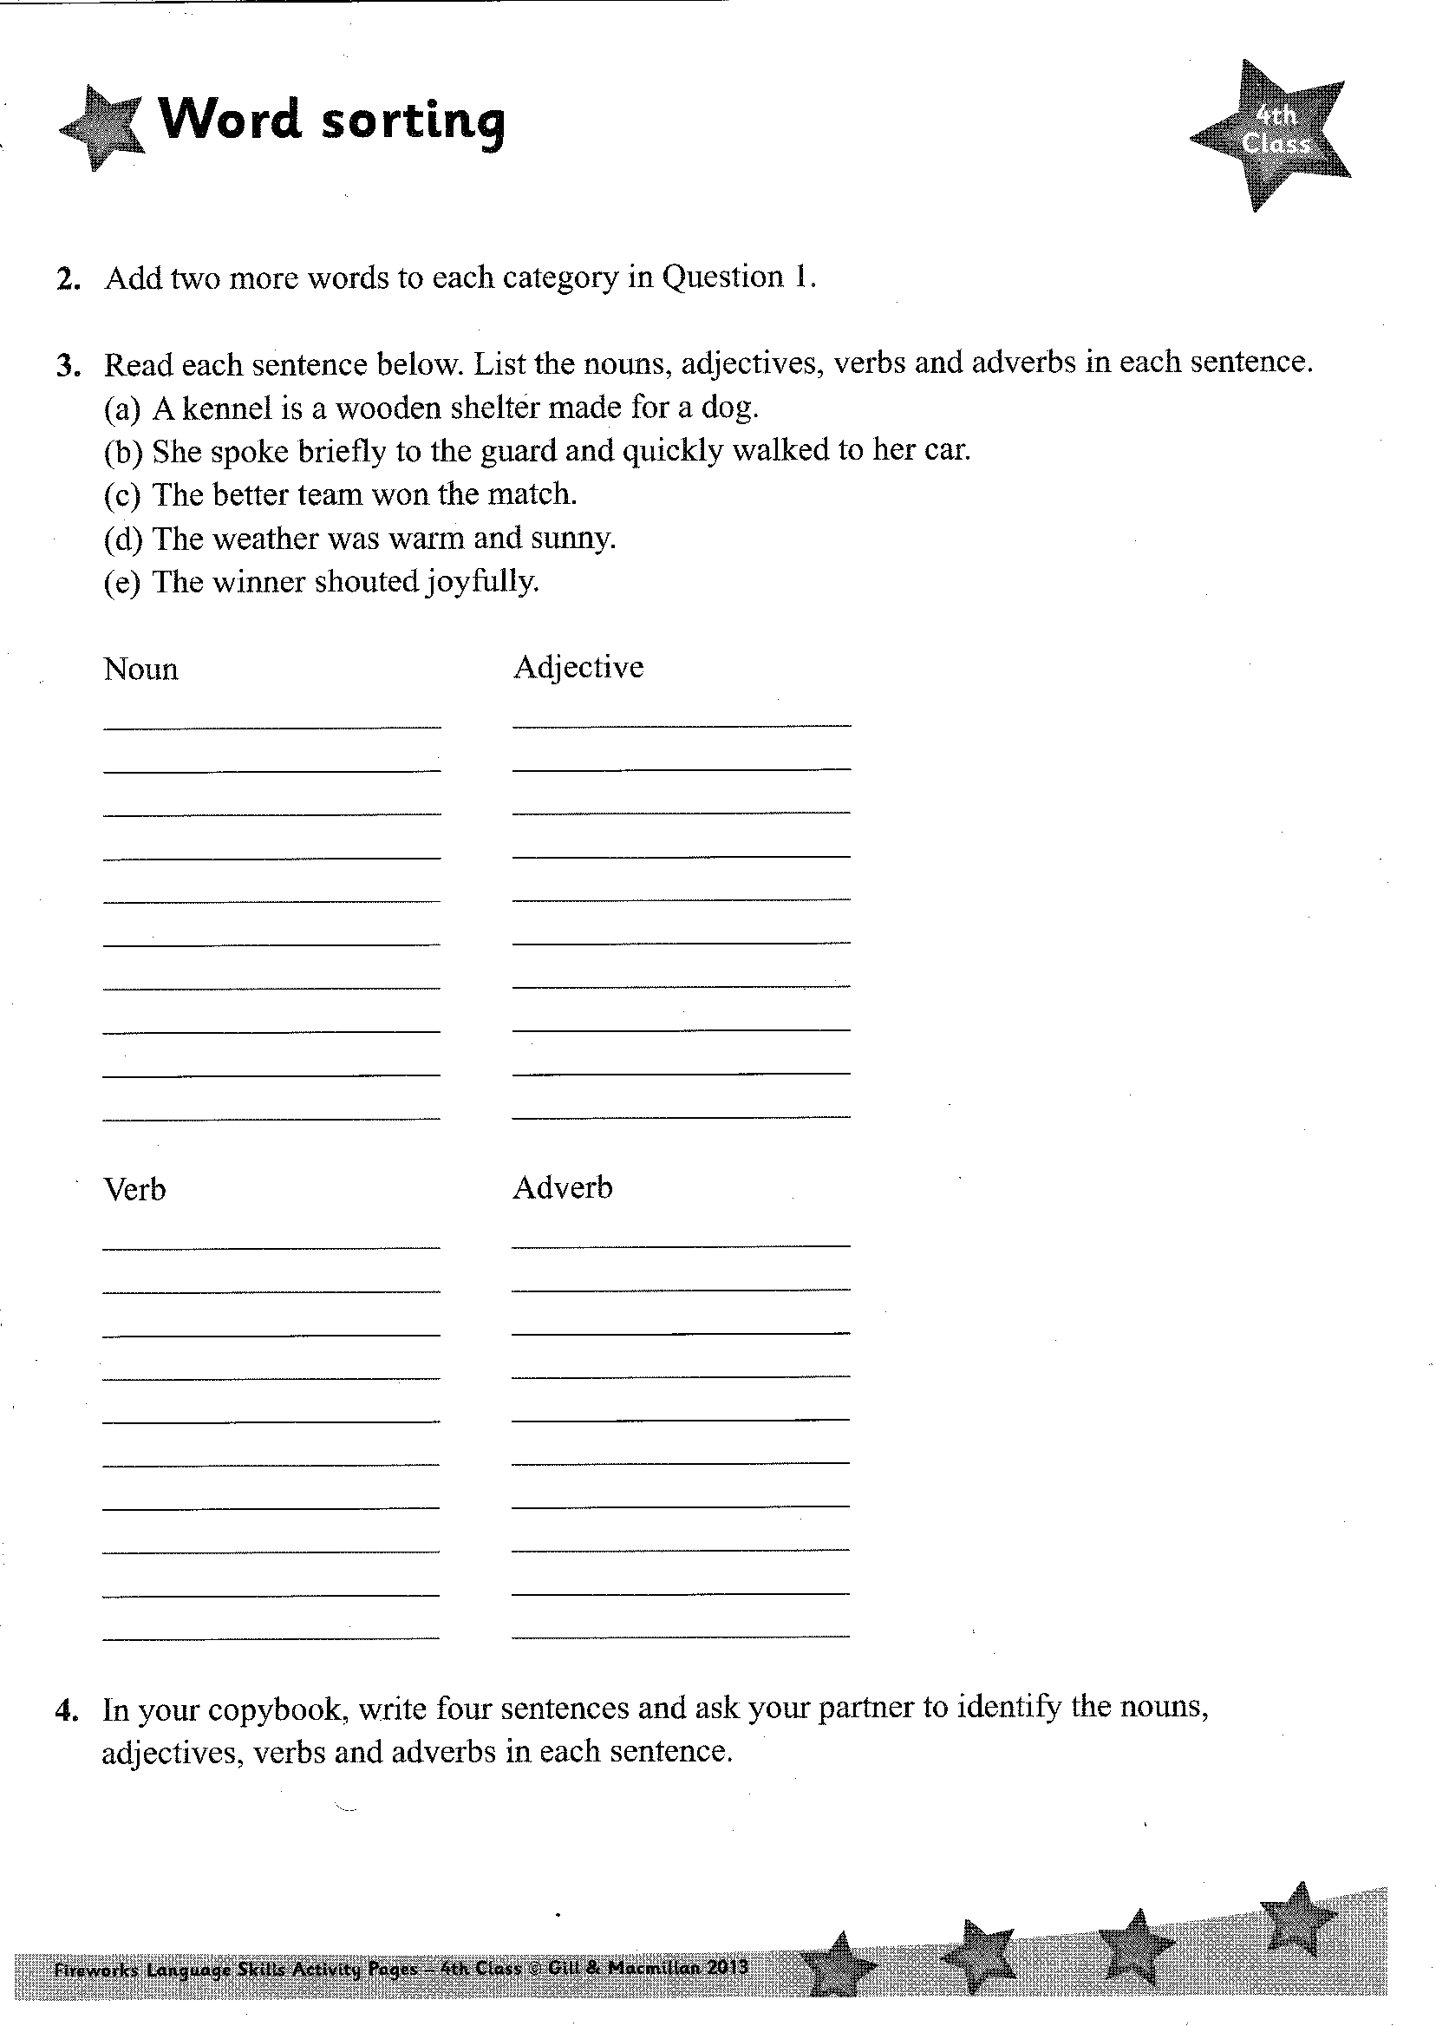

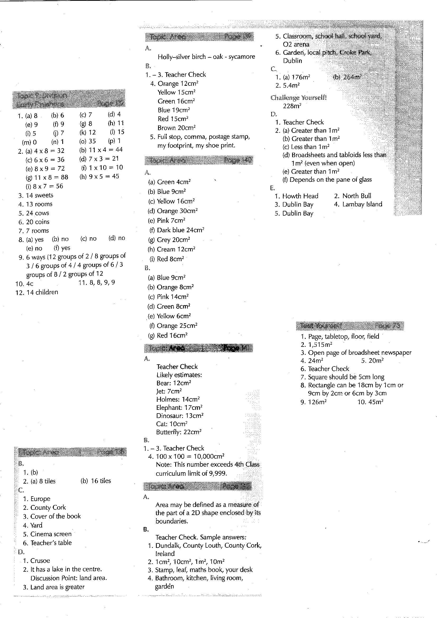

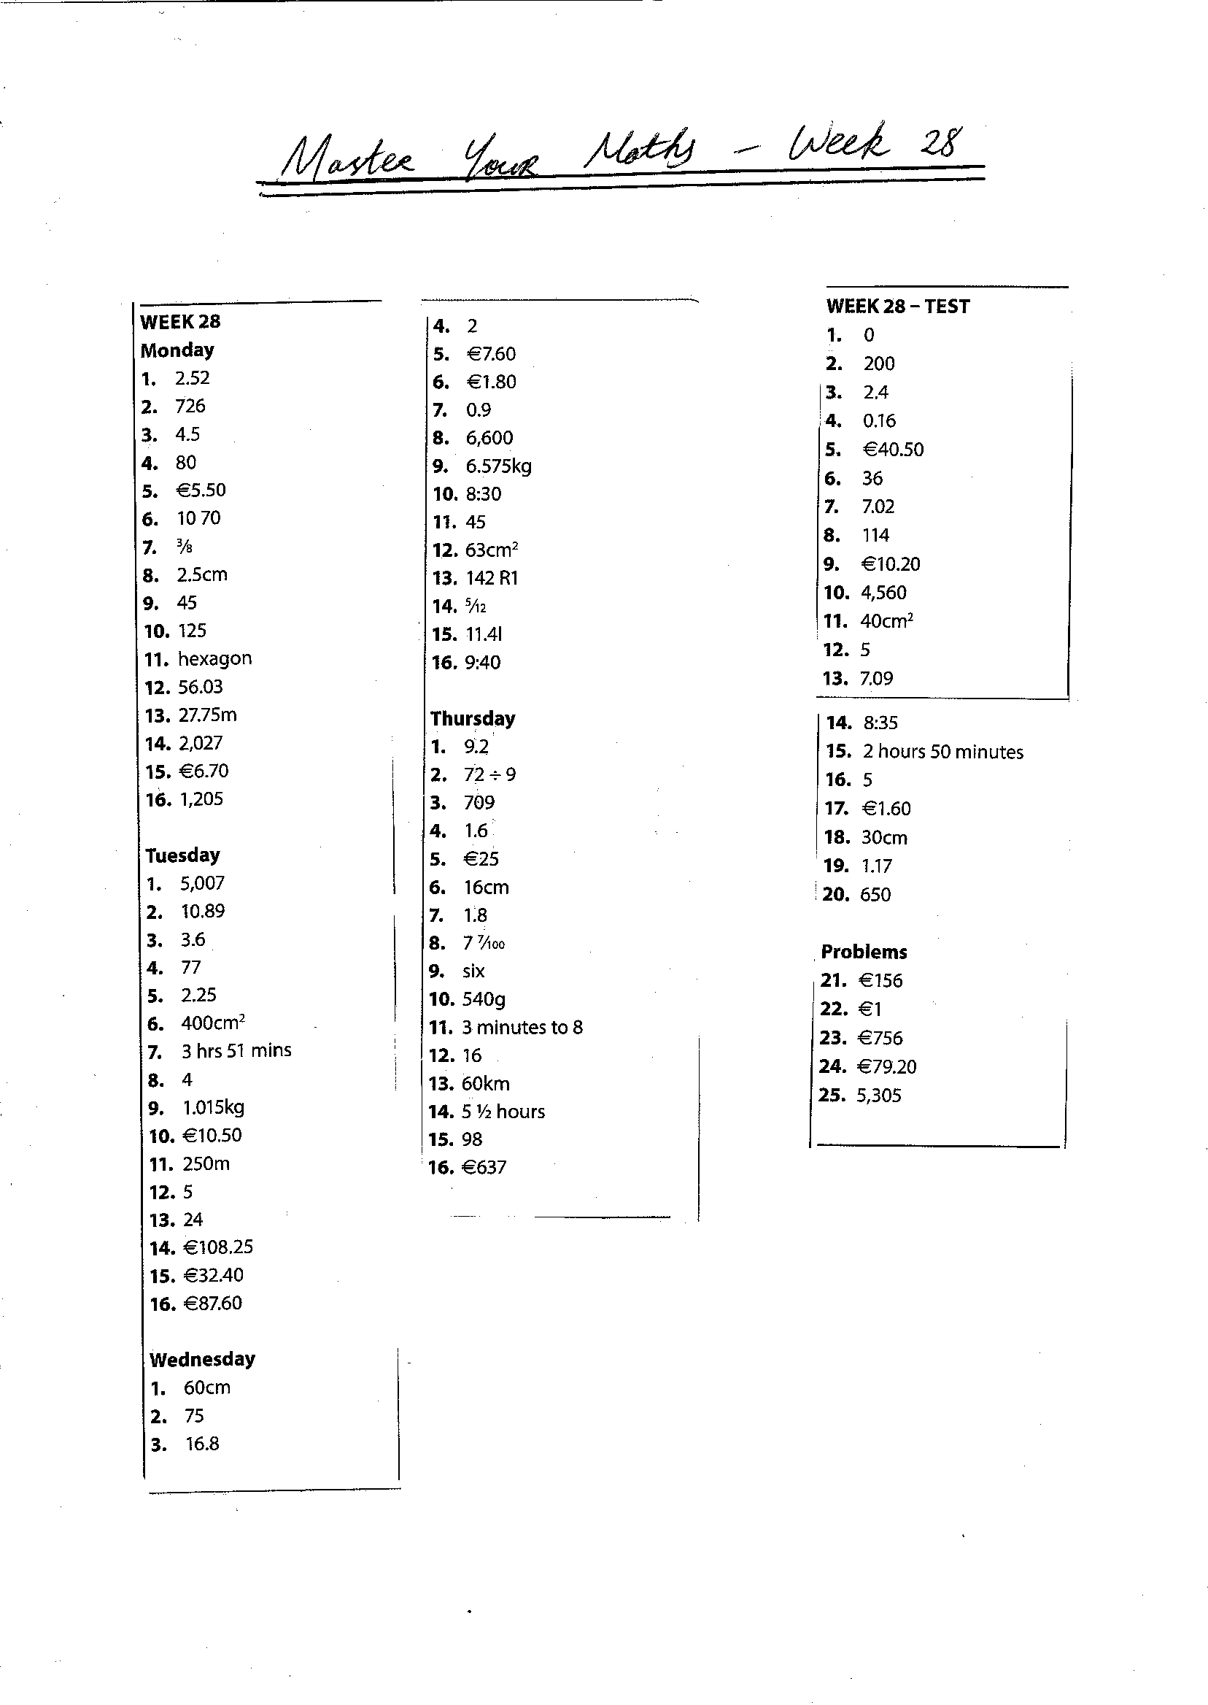

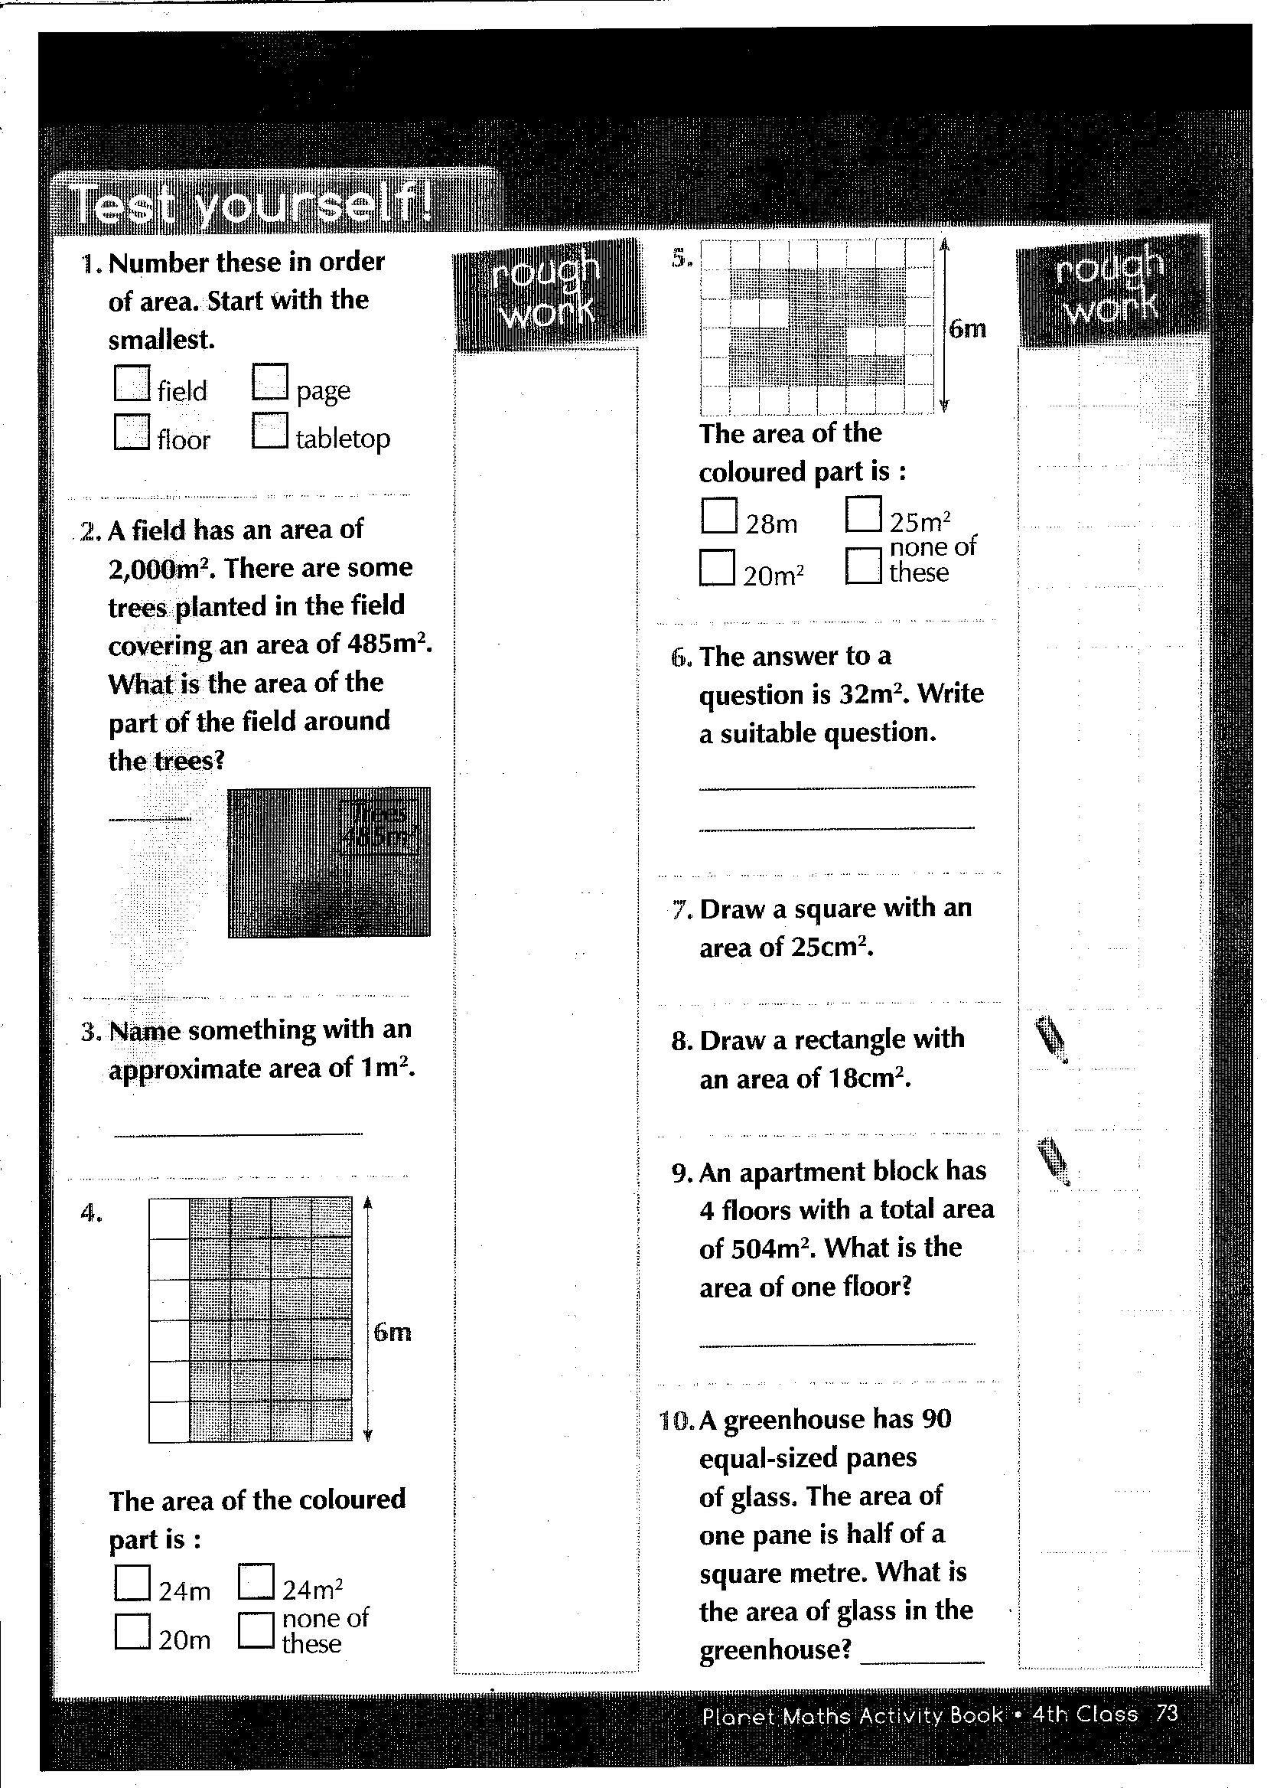

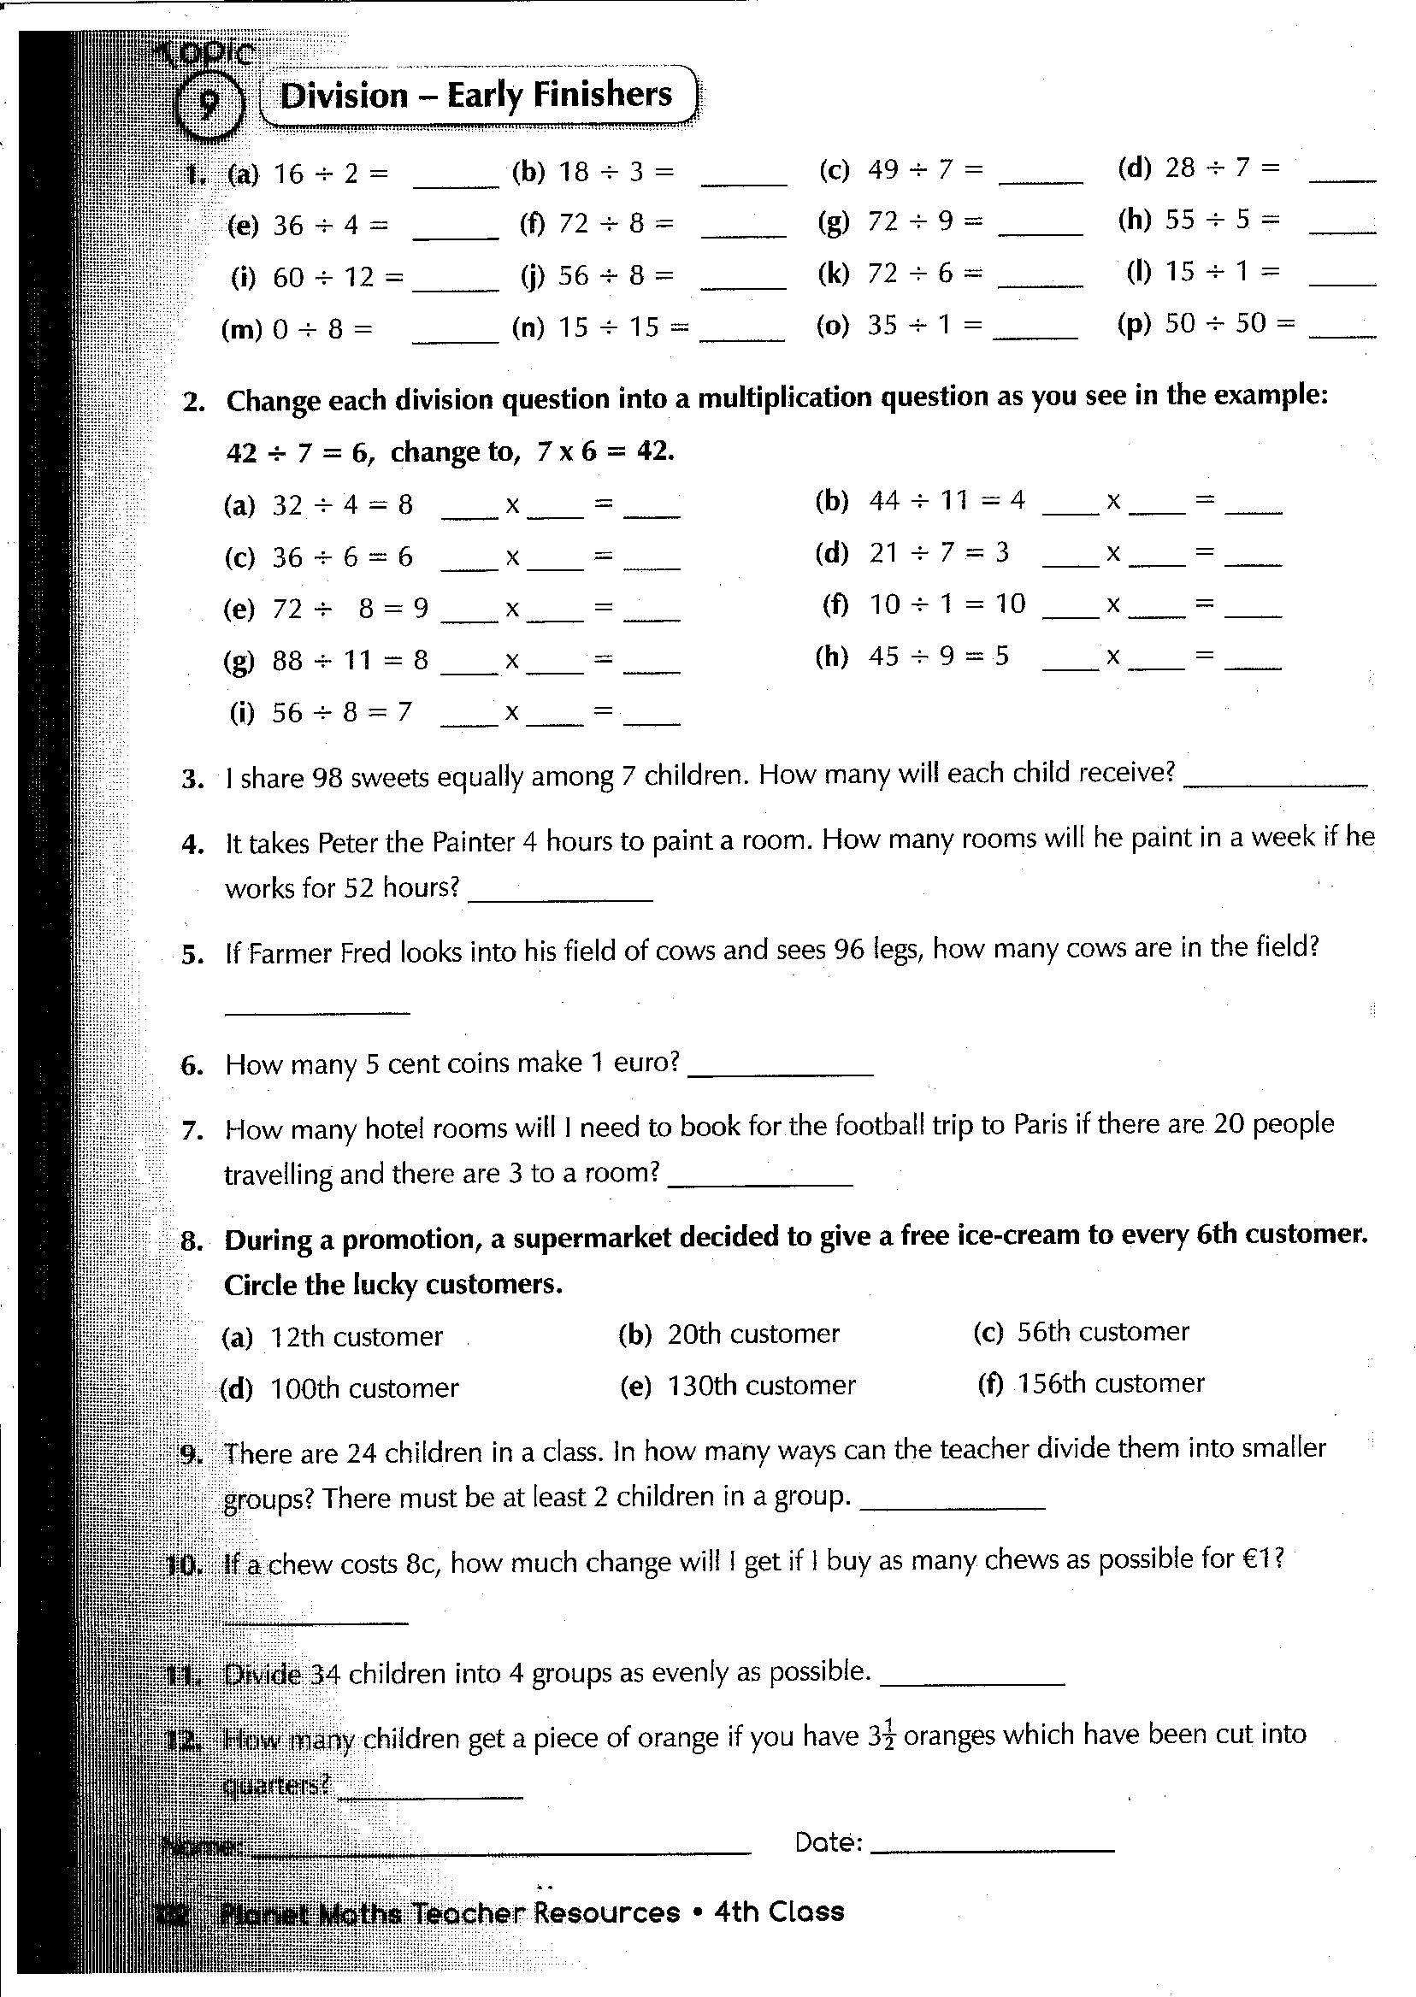

**Experiment Write-Up**

**Experiment name:**

**Equipment:**

**What I did:**

**What I discovered:**

**visit twinkl.com**



