Scoil Naomh Fiachra, Illistrin.
Mrs Stewart, Mrs Doyle & Mrs Lafferty.
WEEK 3– Junior Infant Work

Dear Parents,
We completely understand these are unprecedented times and that getting time to complete work at home with your child can be difficult. The following document is a guided weekly plan of work along with the required worksheets for you to follow with your child at home. You will also find a Padlet link below for Junior Infants where there are links to all resources needed for the specific curriculum areas. Please feel free to do as much or as little as you feel. We have also included a list of suggested Easter activities if you so wish to do with your child over the Easter break.

- Padlet link for Junior Infants - https://padlet.com/rachaelstewart2020/dr7vtapza006

Note from the EAL department of Scoil Naomh Fiachra
This week was to be international week in Illistrin NS. We would still like to celebrate this with our families and the wider community. Maybe you could include a lesson on a country of interest to your family, listen to music from a different country or do some art work from another country. We are asking the school community to send some artwork, a song, or a piece of written work to illistrininternational@gmail.com We will then compile the photos we receive to create a video for our website and Illistrin PA Facebook page. Let’s work together to celebrate our school while staying apart!

Monday 30th March 2020:

- Jolly Phonics – Listen to the song for the sound ‘z’ and practice sounding it out along with the action. Draw/find 3 things that make the ‘z’ sound.
- Just Cursive – Practice writing the letter ‘n’. There is a video provided on the padlet to support children when forming the letter ‘n’. Complete 2 lines of the practice page on the letter ‘n’.
- Reading – practice the following words from the Splash Word Box; Mum, into, at, can.
- Music – Old Mc Donald Had a Farm. Listen to the song provided on the padlet and sing along.
- SESE – Spring: Listen to the Story on ‘Signs of Spring’. Go on a Spring Hunt and fill out the Spring Hunt Checklist on your travels.

Tuesday 31st March 2020:
- Jolly Phonics – Listen to the song for the sound ‘z’ and practice sounding it out along with the action. Draw/find 3 things that make the ‘z’ sound.
- Just Cursive – Complete 2 lines of the practice page on the letter ‘n’.
- Reading – practice the following words from the Splash Word Box; sees, looks, Yes, on.
- Maths – Look at the Powerpoint presentation ‘All About the Number 4’. Complete the number 4 formation worksheet.
- SESE – Spring: Explore the signs of Spring and label.
- P.E. – Enjoy some physical movement with the body coach Joe Wicks. There is a link provided on the padlet.
Wednesday 1st April 2020:
- Jolly Phonics – Listen to the song for the sound ‘w’ and practice sounding it out along with the action. Play a game of ‘I Spy’ using words that make the ‘w’ sound.
- Just Cursive – Complete 2 lines of the practice page on the letter ‘n’.
- Reading – practice the following words from the Splash Word Box; water, jumps, it, you.
- Grow in Love – Theme 6 – ‘Jesus Dies on the Cross’. Complete pages 38-39.
- SESE – Spring: Listen to ‘The Daffodil’ Story.
- SPHE – Practice some meditation with Cosmic Kids Yoga.

Thursday 2nd of April 2020:
- Jolly Phonics – Listen to the song for the sound ‘w’ and practice sounding it out along with the action. Play a game of ‘I Spy’ using words that make the ‘w’ sound.
- Just Cursive – Complete 3 lines of the practice page on the letter ‘n’.
- Reading – practice the following words from the Splash Word Box; jump, me, Zack, dad.
- Maths – Look at the Powerpoint presentation ‘All About the Number 4’. Complete the number 4 formation and counting worksheet.
- SESE – Spring: Listen to ‘The Blue Tit’ Story.
Friday 3rd of April 2020:
- Jolly Phonics – Revise the sounds ‘z’ and ‘w’.
- Reading – practice the following words from the Splash Word Box; I, splashes, little, see, Splashes.
- Gaeilge – Dathaigh an Ubh Cásca de réir uimhir/Colour the Easter Egg by number.
- Literacy – Listen to the story ‘Saving Easter’ on Twinkl.ie.
- Baking – Make some delicious cookies as a treat for all your hard work.

Suggested Easter Activities
1. Egg and Spoon Race – who can balance their egg on the spoon without letting it fall? | 2. Easter Egg Hunt – how many eggs can you find? | 3. Make Easter Chocolate Nests using Rice Krispies, chocolate and mini eggs.
4. Watch Easter Movies e.g. Peter Rabbit. | 5. Make Easter shaped pancakes. How create can you get? | 6. Egg Art-using plastic/hard boiled eggs, decorate your own egg using paint or stickers.
7. Play Bunny, Bunny, RABBIT!  An Easter variation of Duck Duck GOOSE! | 8. Thumbprint Easter Chicks Card Craft | 9. Make a bunny sandwich.
10. Make Easter bunnies using playdough and pipe cleaners. | 11. Colouring - Easter Colouring sheets available on Twinkl.ie | 12. Make Easter cupcakes.
13. Read some classics e.g. The Tale of Benjamin Bunny; The Tale of Mr.Tod. | 14. Egg Rolling- take turns rolling eggs down a hill. The egg that travels the furthest wins! | 15. Musical Statues – doing the Bunny Hop!

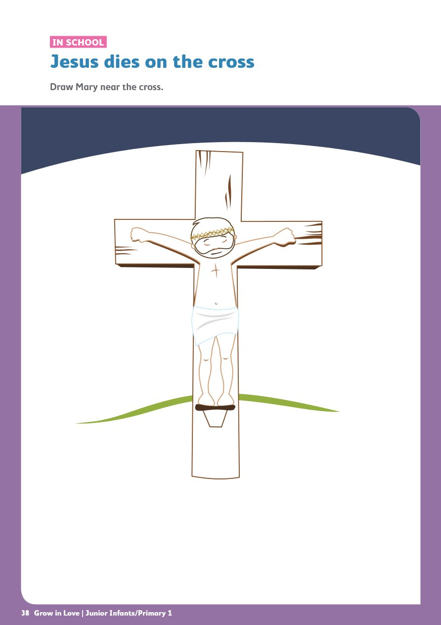

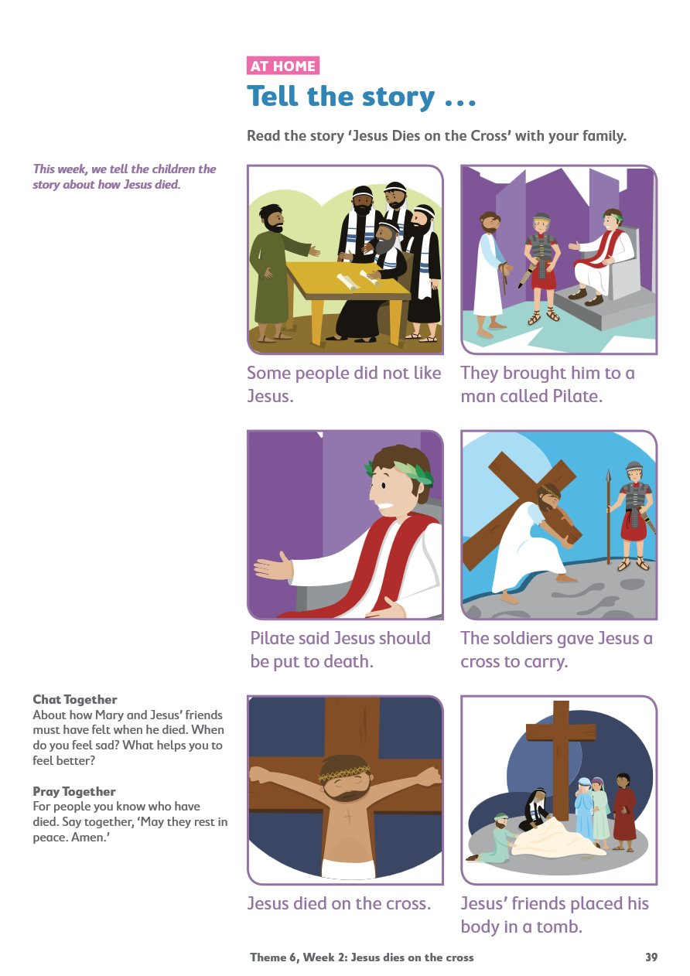
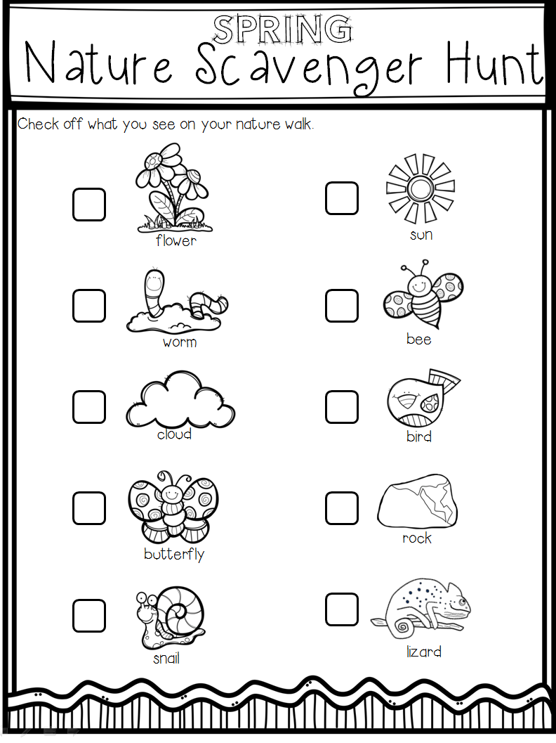

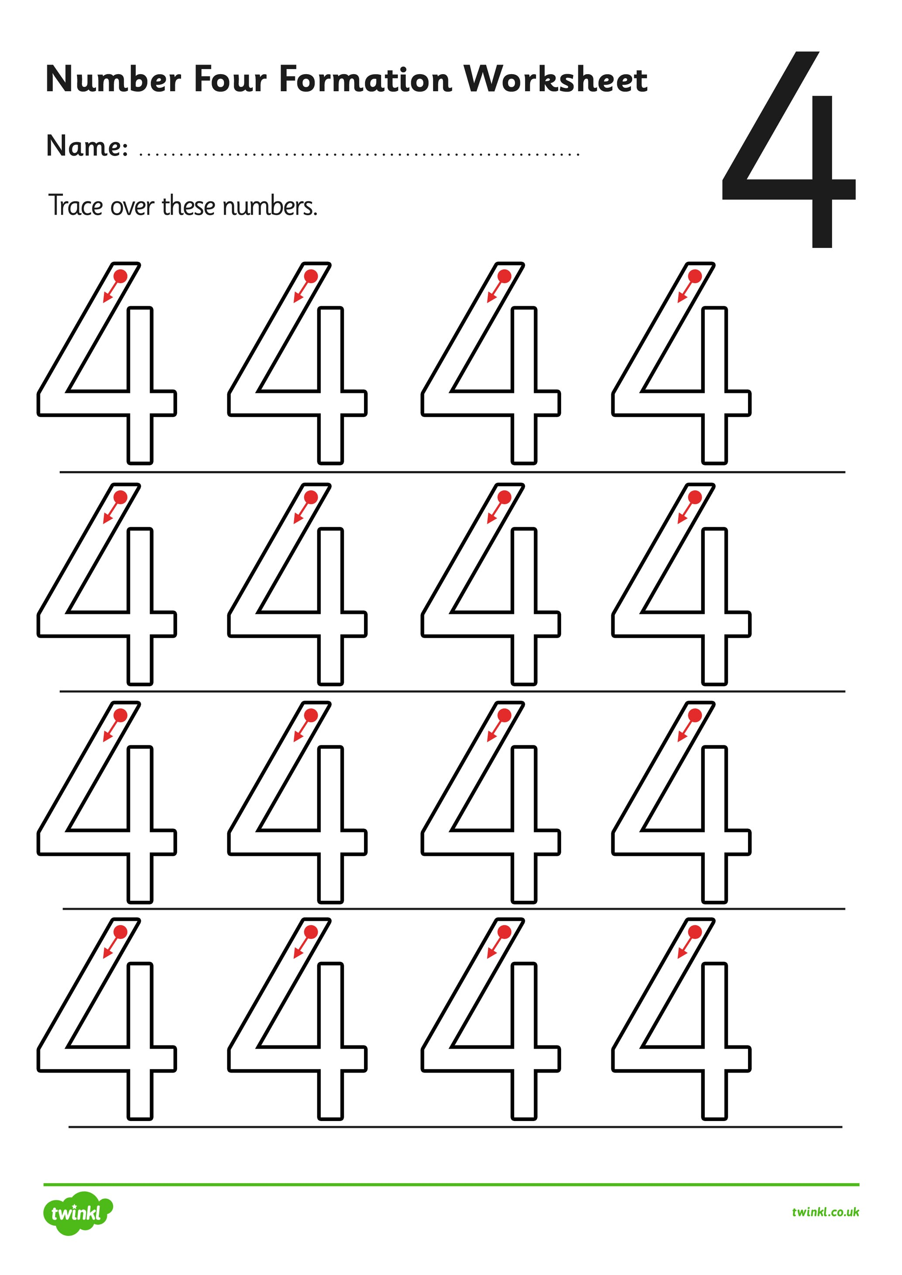

flower bud

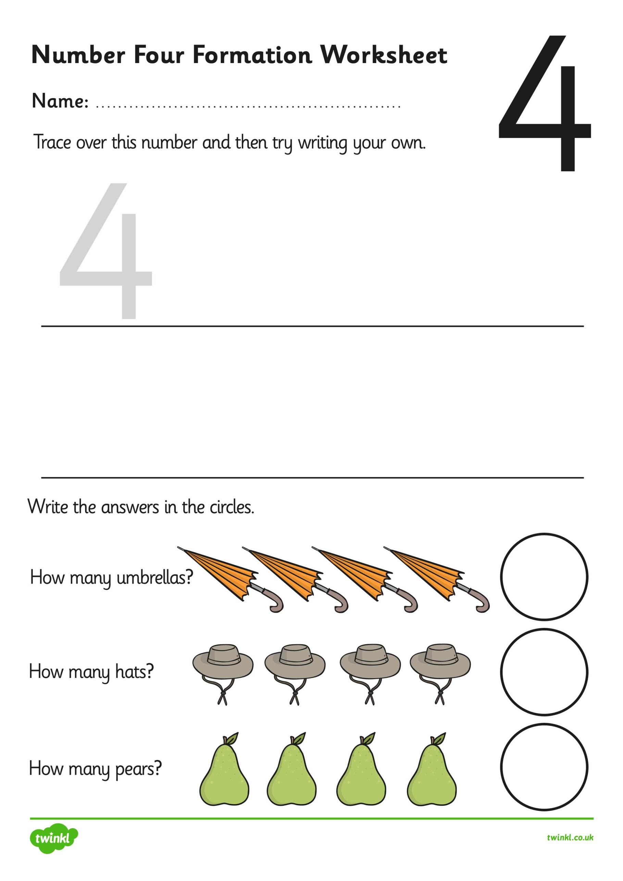

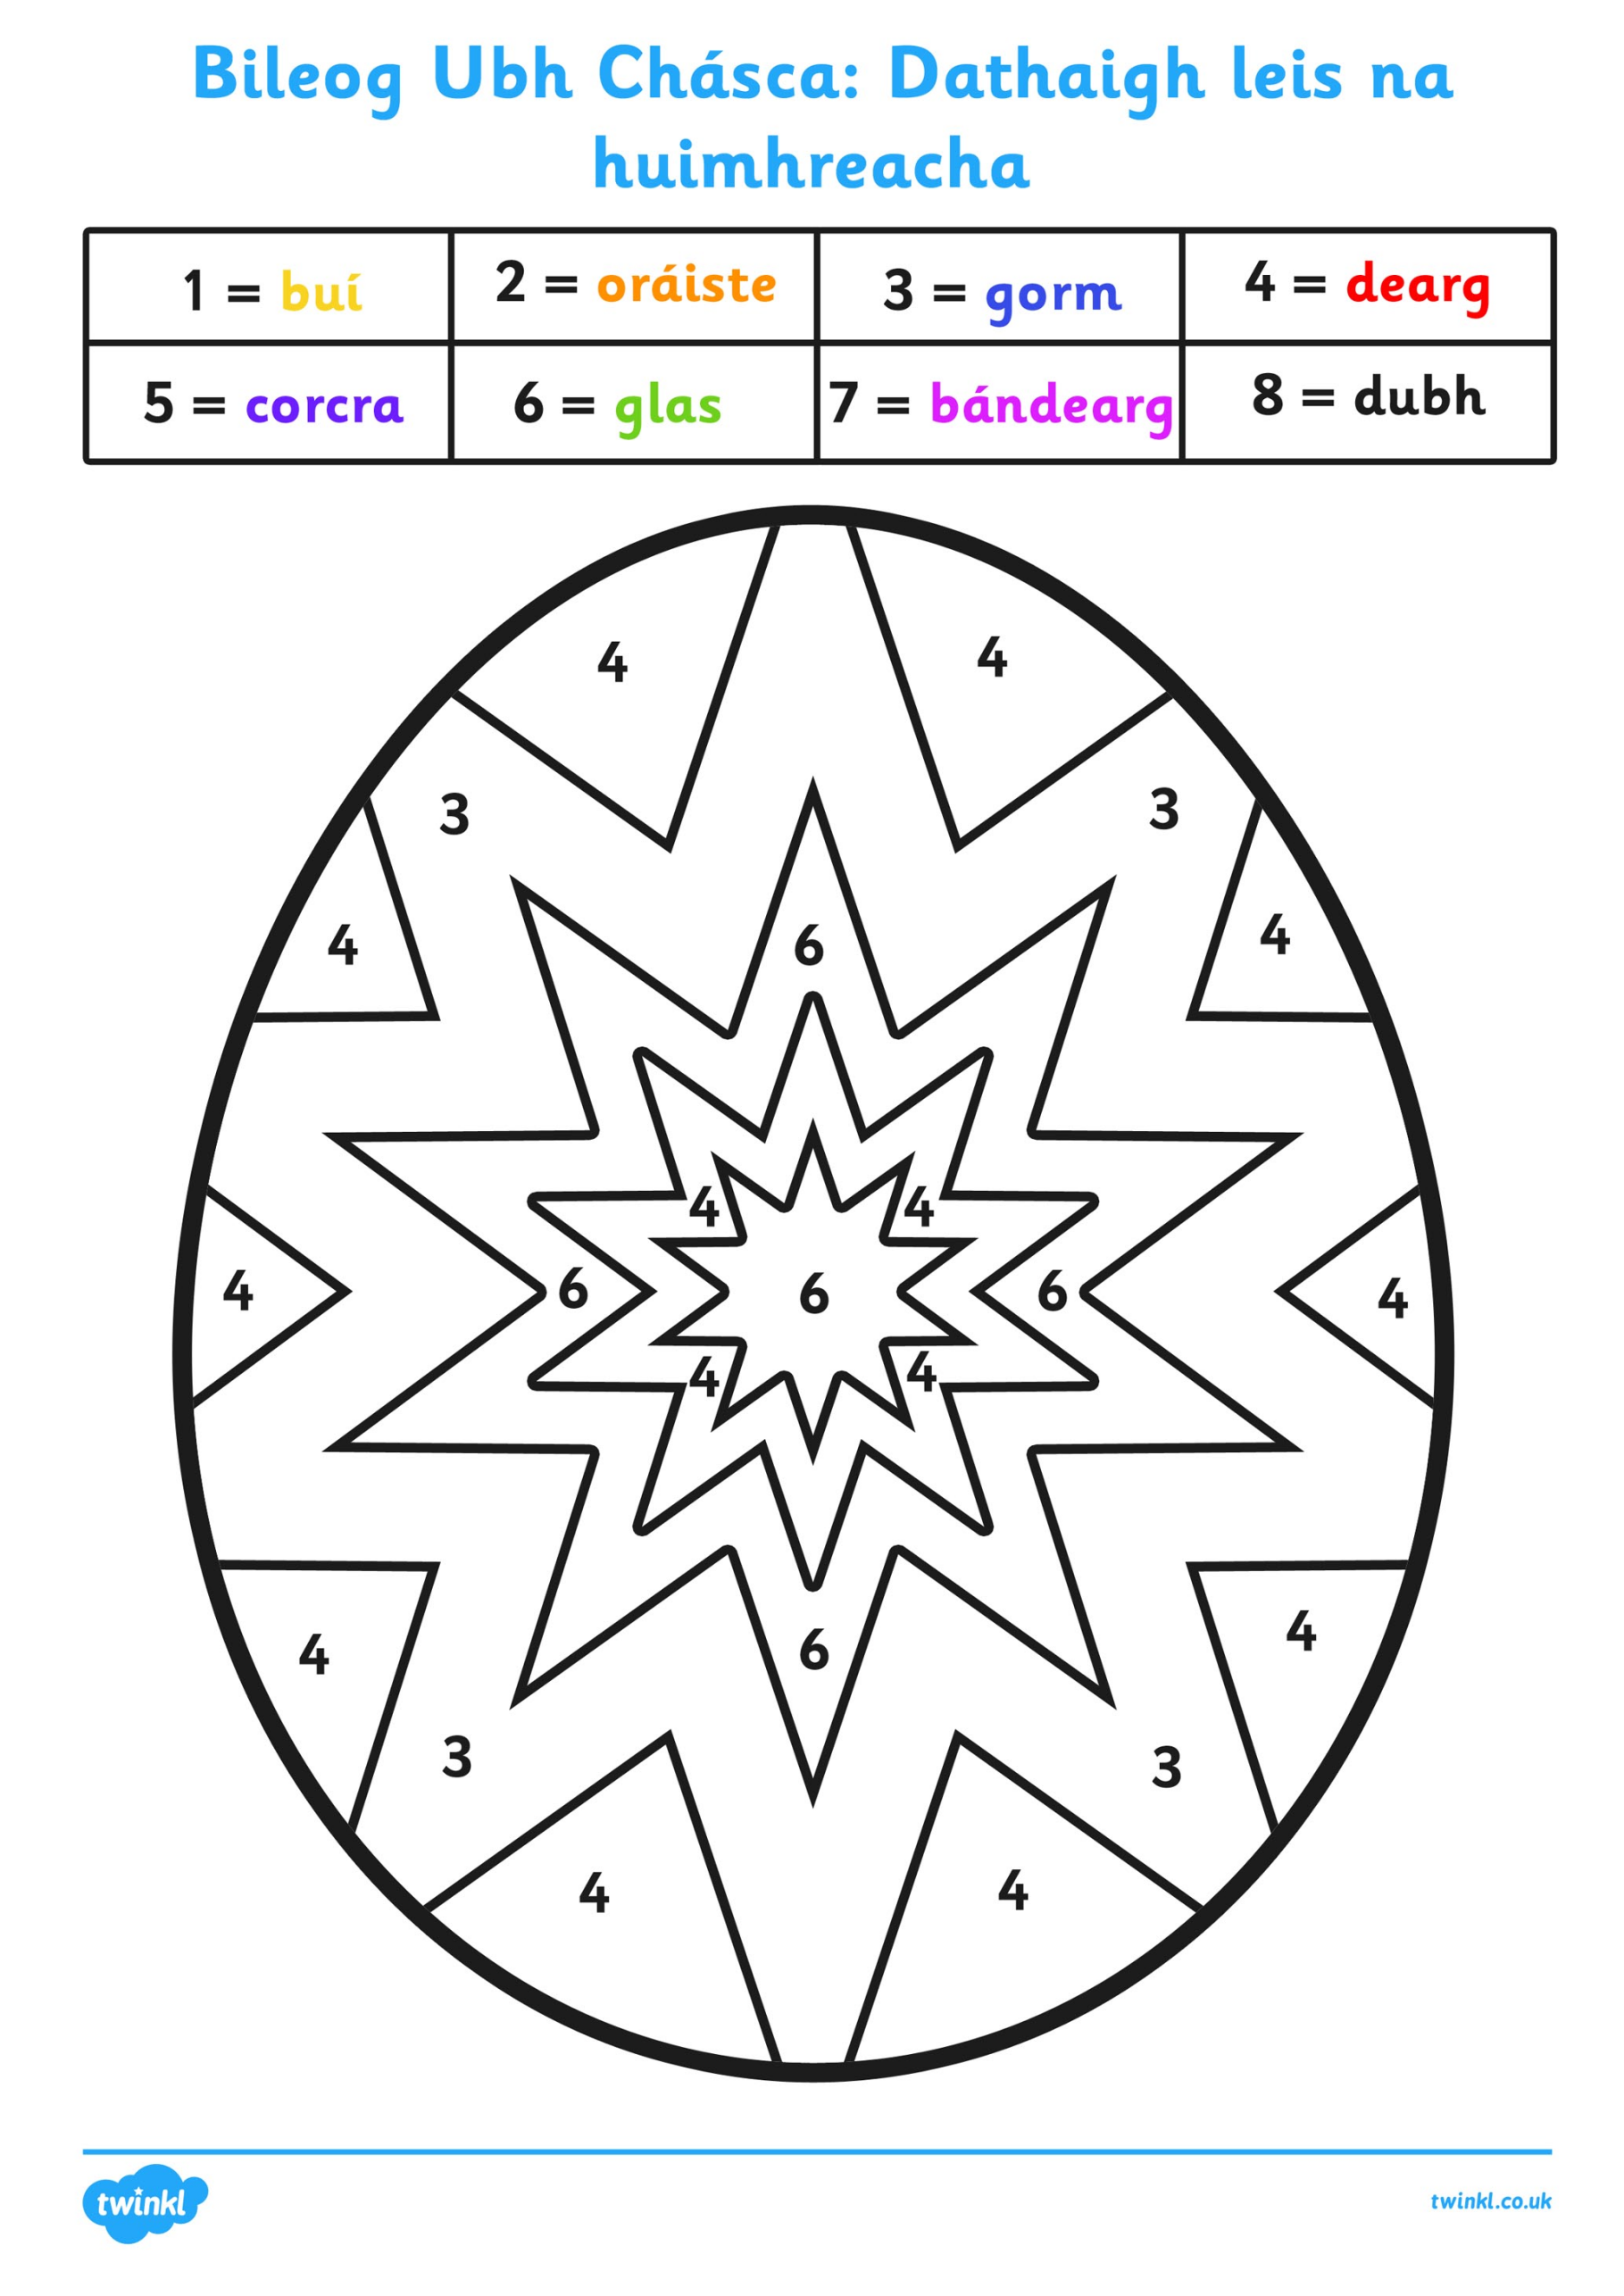

Just Cursive – Formation of the Letter ‘n’

________________________________________________________________________________________________________________________________________________________________________________________________________________________________________

________________________________________________________________________________________________________________________________________________________________________________________________________________________________________

________________________________________________________________________________________________________________________________________________________________________________________________________________________________________

________________________________________________________________________________________________________________________________________________________________________________________________________________________________________

________________________________________________________________________________________________________________________________________________________________________________________________________________________________________

________________________________________________________________________________________________________________________________________________________________________________________________________________________________________

