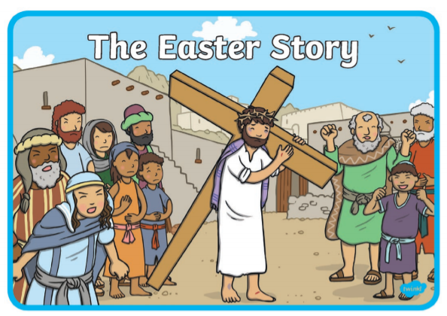

Please feel free to visit the Cathedral’s webcam site to join in with the services during the Holy Week.

<https://www.churchservices.tv/letterkenny>



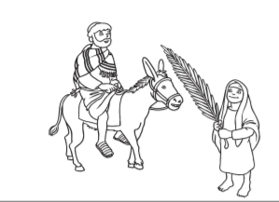Discuss how excited people are to welcome Jesus? Colour the picture.

You can add to the picture, draw the sun, clouds, the town, more people and more palm leaves.

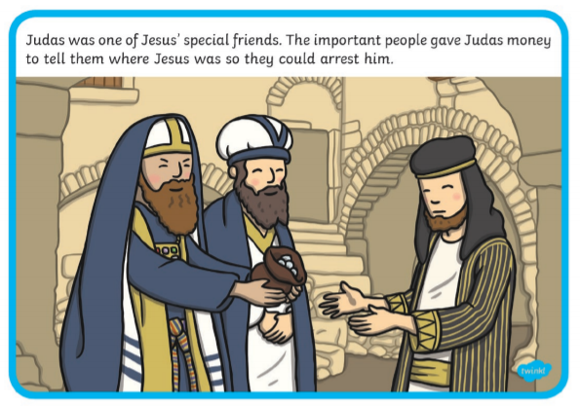

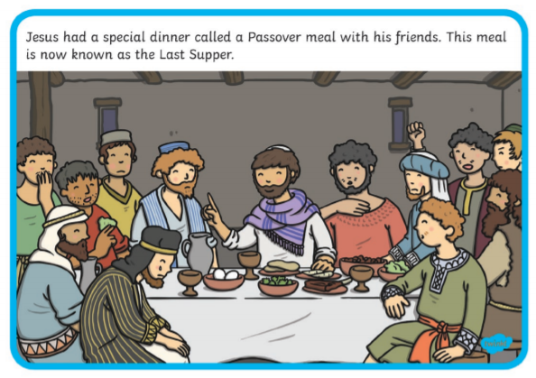

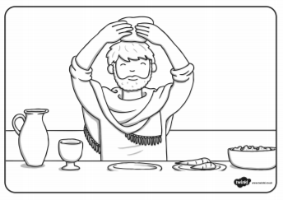At the Last Supper, Jesus took the bread, blessed it and gave it to his disciples saying, “This is My Body.”

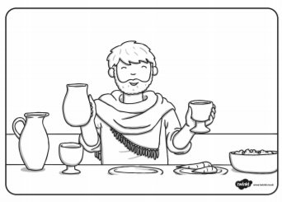At the Last Supper, Jesus took the wine, blessed it and gave it to his disciples saying, “This is My Blood.”

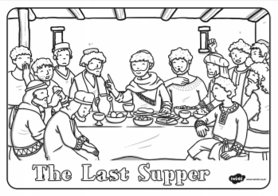

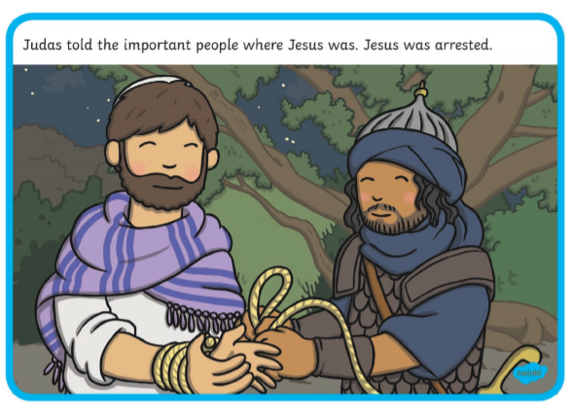

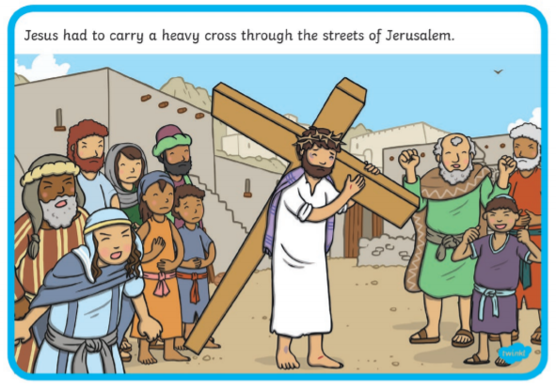

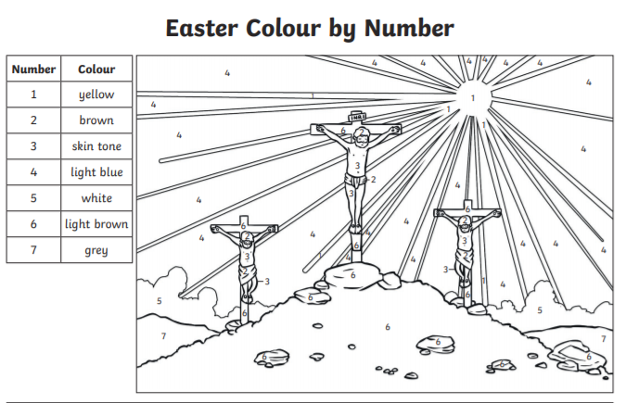Older children might visit the link below to learn about The Stations of the Cross <https://www.youtube.com/watch?v=KoQR30np5us>

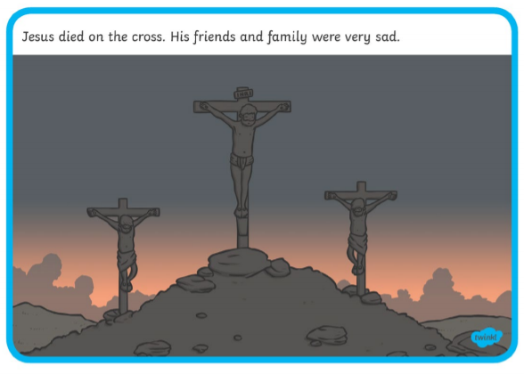

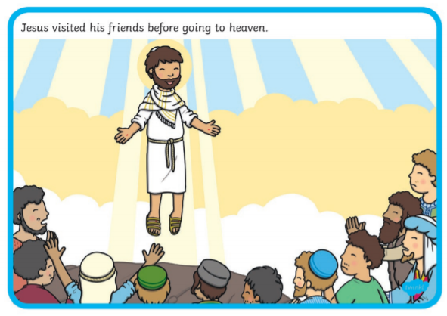

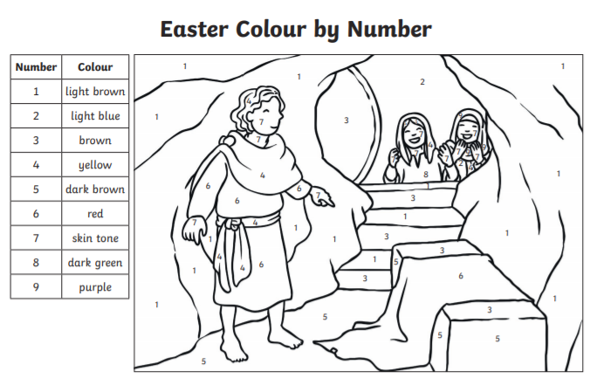His friends visit the tomb but they find the tomb empty.

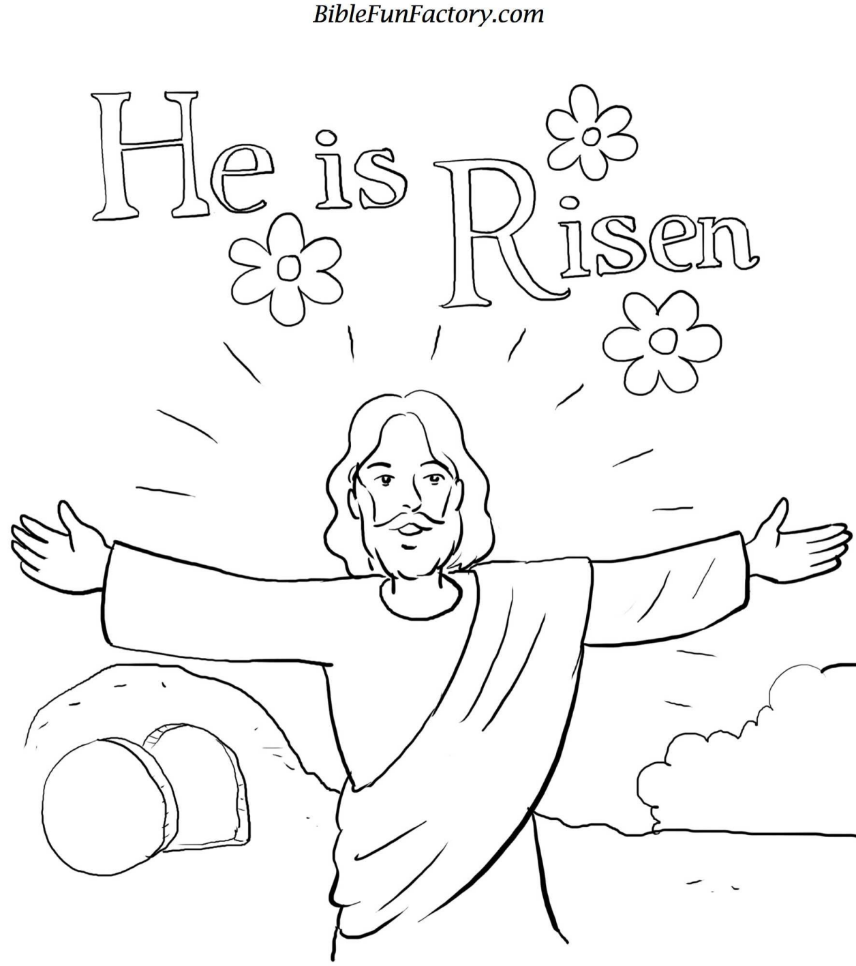Jesus is risen.