Mrs. Barron – S.E.T - Week 3 Closure and Easter Break
Below I have given a daily plan to complete with your child. Please be aware that this is only a set of ideas to be completed at a time / day that suits you. Given the current circumstances, parents are busy and these are ideas to help your child when you can. Please do not feel under pressure, as your child will also be receiving work from class teacher. Over the Easter holidays offer opportunities to read with your child. Discuss the cover of the book, the author, the illustrator etc and get them to predict what might happen next. If they are feeling creative get them to draw out an alternative ending to the story! Happy Easter and take care.

Monday | Tuesday | Wednesday | Thursday | Friday
- Word family-  “et” family (see words below)  Make words that end with “et” . Use the alphabet below to add “et” to each letter to see if your child can recognise the word. E.g. a-et, b-et, c-et, g-et. Get your child to give a thumbs up if it creates a word and thumbs down if it creates a nonsense word!  Dolch lists.  I am providing the Dolch Lists below for your reference in the coming weeks. Your child already has these in the folder I sent home but here is a copy if needs. We will revise Dolch List 1 this week (your child has a good grasp of most of the words so this is revision) Read the words with your child and highlight any words which you child may need to work on tomorrow….. | Word Family – “et”  Write out the words you created yesterday (on the back of a cereal box is fine!)  Cut out the words and place face down on the table. Allow your child to turn each word over and read the word.  Dolch Word Work  Focus on the words your child was unsure of yesterday. Use a highlighter pen and find these words in any paper, book or magazine you may have at home | Writing Day!  Use the letter strip I sent home in small folder and whiteboard marker provided to trace over the cursive script and practice writing!  Dolch Word Work  Use the back of the letter strip to write out the Dolch words you are focusing on this week | Reading  Read the story attached – Don’t Forget!  Cut and paste activity below | Revison of Jolly Phonics  https://www.youtube.com/watch?v=yVyry9jpVjI

Don’t Forget! New Word Families: - et
Sight Words used – I, in, my, the, will

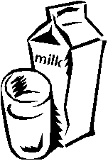
I will get milk at the store.

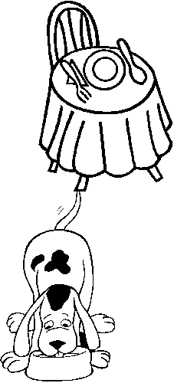
I will set the table.

I will feed my pet.

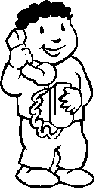
I will call the vet.

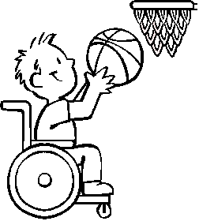
I will get the ball in the net.

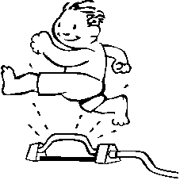
I will get wet!

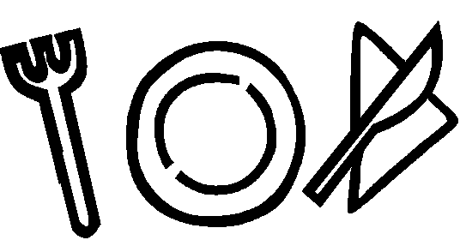
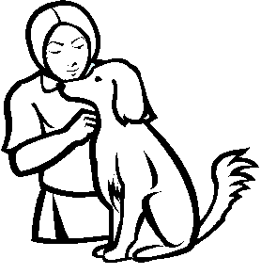
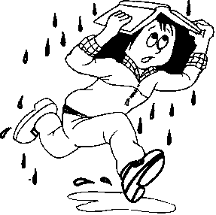
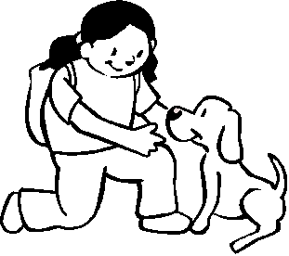
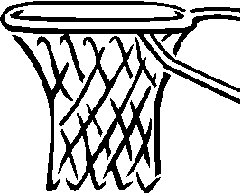
-et Word Family Practice
et
et
et
et
et

A Word Family Companion from www.hubbardscupboard.org © 2004 . Clipart Copyright @ Microsoft Corporation 1987-2001. All rights reserved.

Either write the letter needed to make the word that matches the picture or cut the boxes below and glue the correct letter to form the word!

n p s v w

Can you read these words from the –et word family?

-et

bet
get
jet
let
met
net
pet
set
vet
wet
yet

List 1
the | in
to | was
and | said
he | his
a | that
I | she
you | for
it | on
of | they
had | but

List 2
at | there
him | some
with | out
up | as
all | be
look | have
is | go
her | we
down | am
then | little

List 3
do | get
can | them
could | like
when | one
did | this
what | my
so | would
see | me
not | will
were | yes

List 4
big | ask
went | an
are | over
come | your
if | its
now | ride
long | into
no | just
came | blue
very | red

List 5
from | right
good | put
any | too
about | got
around | take
want | where
don’t | every
how | pretty
know | jump
four | green

List 6
away | call
old | help
by | make
their | going
here | ran
after | let
well | yellow
think | five
saw | six
brown | sleep

List 7
walk | stop
two | off
or | never
before | seven
eat | eight
again | cold
play | today
who | fly
been | myself
may | round

List 8
tell | black
much | white
keep | ten
give | does
work | bring
first | goes
try | write
new | always
must | drink
start | once

List 9
soon | better
made | hold
run | buy
gave | funny
open | warm
has | ate
find | full
only | those
us | done
three | our

List 10
use | sit
fast | which
say | fall
light | carry
pick | small
hurt | under
pull | read
cut | why
kind | own
both | found

List 11
wash | these
show | sing
hot | together
because | please
far | thank
live | wish
draw | many
clean | shall
grow | laugh
best
upon

