Hi Everyone,

I really hope you all had a lovely Easter break and got lots of chocolate eggs. I hope you are all staying safe at home. I will ring everyone during the week to ‘Check in’ and see how you all are doing.
Please use the email address and email me with any questions or concerns or issues you have. Or just to fill me in on your daily news. I would love to hear from you!
Mrs.emmamcmenamin@gmail.com
I am going to do out a plan of work for you for the week. It will include some exercises, literacy ideas and art ideas. Over the course of the week take a photo of one piece of work and email it to me, if u have access to a phone. I know you will be getting work from your class teachers as well, so please do not in any way panic about work I put up. These activities are fun, if you feel bored at home give them a go. The main think you should do is, if you are worried or stressed and feeling anxious talk to mum or dad, email me or write it down in your diary/journal.
I am still trying to do PE with Joe Wicks every day, on Youtube with Finn and Shea to keep me activity as I really miss our 1k a day. There are little lambs in the field beside me so I go look at them every day. They are so cute. Keep me updated with all your news.
Take care and Stay safe,
Mrs Emma McMenamin

Plan of Work – Week Beginning 20th March 2020
 | Exercise/Mindfulness | Literacy Ideas | Arts & Crafts
Monday | https://www.youtube.com/watch?v=ZME0JKiweL4 check out this mindfulness video  Exercises: run on the 1 minute, try increasing everyday by 20 seconds  20 jumping jacks, and 20 ninja kicks | Analyse Illustration (pictures)  Look closely at two different illustrations(pictures) from two different books. Decide or analyse how the illustrations (pictures) help make the text (story) clear or interesting. Tell me how are the illustrations the same or different | 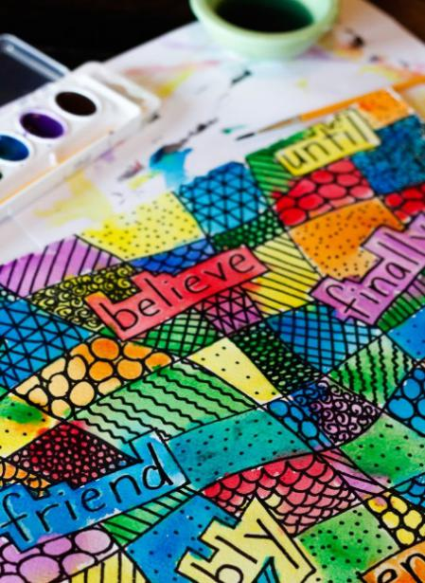  Doodle Spelling  DIRECTIONS:  Identify a few words that you frequently misspell.  Write the words in large letters. You can put them all on one large sheet of paper, or make smaller individual cards. Writing should be at least 2 inches tall so you have plenty of room for the next step…  Now it’s time to doodle. Notice the shape of each word as you doodle. You can underline vowels and/or outline the shape of the word. You can make random doodles or other doodles to remind you how the word is spelled. Doodle all around the shape and fill the page.  Add colour! Watercolours work well, but crayons are also great!  Hang your spelling poster someplace you can see it often. Practice your words frequently by tracing each letter with your finger, then close your eyes and picture the shape of the word.  VARIATIONS:  - Write words that all share the same rule or letter chunks, and make your doodles relate to the rule or chunk. For example, draw lots of circles to make oooo’s on a page with words that have the long u sound.  - Colour all words that share common spelling patterns the same colour.
Tuesday | 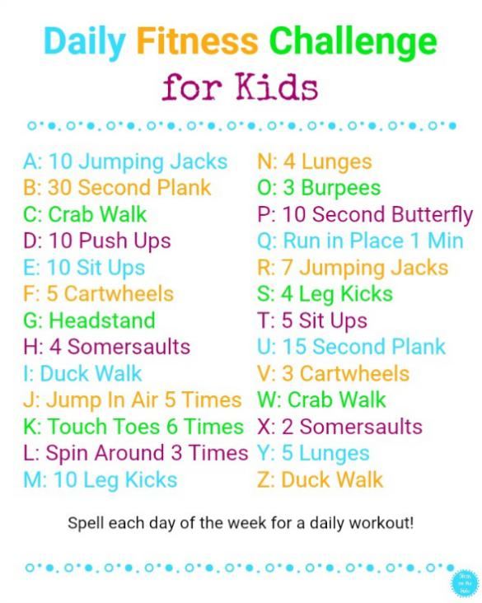 | Build Vocabulary  Find 2 words you don’t know. Learn the definition by asking someone or looking in a dictionary. Build or draw something to remind you of the meaning of the word. Get someone to test you on the words on Friday. | Handprint Art  Trace your hand or if you have access to paint, paint your hand and using your handprint as a template try and create an animal. Look at this example of a sloth.  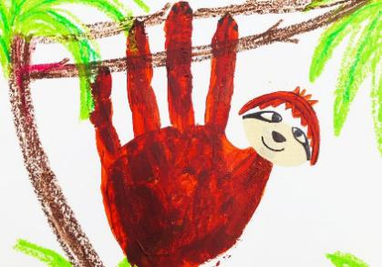
Wednesday | 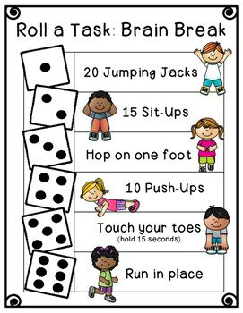 | Connect Characters  Think of two characters from two different books. How can you connect them? Do they share any similar traits? Do they have the same role in the stories? Pretend you are the author and explain to your parent how these characters are the same and an adventure they could go on together. Or if you prefer you could write it down and email it to me. | Toilet Roll Challenge  I know its not Halloween but I challenge you to take a toilet roll and turn it into a monster with whatever you have at home.  Check this out for inspiration: 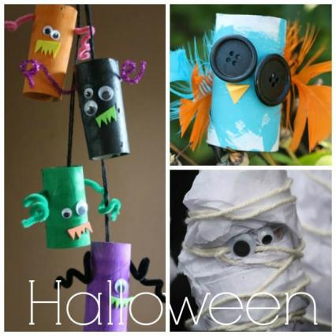
Thursday | 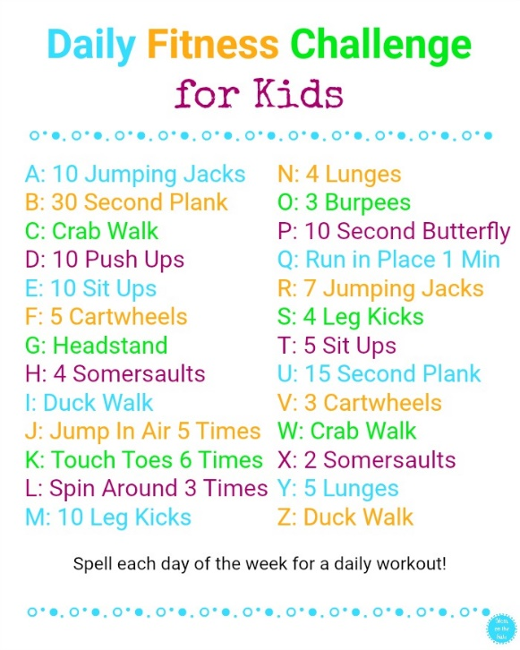 | Doodle Directions  Build something with Lego or paper or any materials you have (blocks, toys, cushions anything!!!) Then draw clear step by step instructions to explain exactly how you made your creation. See if someone else can follow your directions. | Free Art  Today take some time sit outside if you can, listen to what you hear and just doodle. You may be amazed at the end result
Friday | Today we will try a Zoom call if you have access to a phone or a computer. I am not really sure how it works but we will give it a go. If you all send me an email I will have your email address and I can send you and invite. We will aim for Friday at 2pm!!!

