Teacher’s Name or Teachers’ Names | Ms Mc Glynn / Ms McGroarty
Class level | EAL
Suggested work for week beginning | 27th April
Teachers email address | msmcgroartyeal@gmail.com
Correction of work | Work that I/we have highlighted should be submitted to the appropriate teacher’s e-mail address above. This can be a photograph of the copybook page or the answers can be typed into the e-mail. Please write your child’s name in the subject part of the e-mail.  Work that is not highlighted should be corrected by an adult/parent.
Message from teacher/s | You can also email me if you have any queries or questions. Please write your child’s name in the subject box of the email.  Hello everyone! I hope you are enjoying our new topic. I have seen some lovely pictures and great work from the boys and girls this week.  Please remember that these activities are suggested work. I understand that the children have work from their class teachers to do also.  If your child would like to do some extra reading practice please log onto www.oxfordowl.co.uk where there are many free ebooks available.  There are also lots of fun English games available on topmarks.co.uk  https://www.topmarks.co.uk/english-games/5-7-years/letters-and-sounds

Monday | Play - What am I?  Can you guess the mode of transport using the clues?  - I am big. I carry lots of passengers. I run on a rail way track.  - I fly in the sky. I have wings. I carry lots of passengers to other countries.  - I have a siren. I have a ladder. I help people where there are fires.  - I have a siren. I have flashing lights. I take sick people to the hospital.  - I am small. I have two wheels. I need to be pedalled to go.  - I have four wheels. Lots of people drive me to get around.  Now it’s your turn! Think of a mode of transport, give your family member some clues, can they guess which mode of transport you have described?  Complete work sheet attached below labelled Monday
Tuesday | Jr/Snr infants – I spy activity (attached below) – Look at the picture, can you see everything that is on the list?  1st/2nd class – Writing task (attached below) – What modes of transport can you see?
Wednesday | Oral Language activity – The school bus  Look at the picture and talk about the questions.
Thursday | Going to school https://learnenglishkids.britishcouncil.org/poems/going-school  Complete ‘preparation’ activity – Match the words with their meanings.  Read/listen to the poem ‘Going to school’. (Words for the poem are found under ‘transcript’)  Did you like the poem? How many different ways of travelling to school were mentioned? Would you like to take a zebra ride to school? What about a hot air balloon ride? How many wheels does a tricycle have? What way does the poet say is the best to travel?
Friday | Read our poem from yesterday again ‘Going to school’  https://learnenglishkids.britishcouncil.org/poems/going-school  Jr/Snr infants – Draw a picture in response to the poem. You can also try the games for the poem with an adult to help with some of the tricky words!  1st/2nd class - Complete two of the games, True or false, make sentences or the rhyming game.  These tasks can be done online or can be printed off using the link below  https://learnenglishkids.britishcouncil.org/sites/kids/files/attachment/poems-going-to-school-worksheet.pdf
Monday Jr & Snr Infants - Read the words, use your transport cards to help and draw pictures to illustrate them.

Tractor
Boat
Train
Hot air balloon
Bicycle
Car

1st/2nd class

Monday 1st/2nd class - Unscramble the letters to find the word, use your transport cards to help. Draw the pictures to illustrate them.

cleicyb
__________________
oatb
__________________

catrort
______________________
oht ari lobalon
__________________
tniar
________________
roaneplae
________________

Tuesday 1st & 2nd class
What Modes of Transport Can You See?
Write some sentences about the picture.

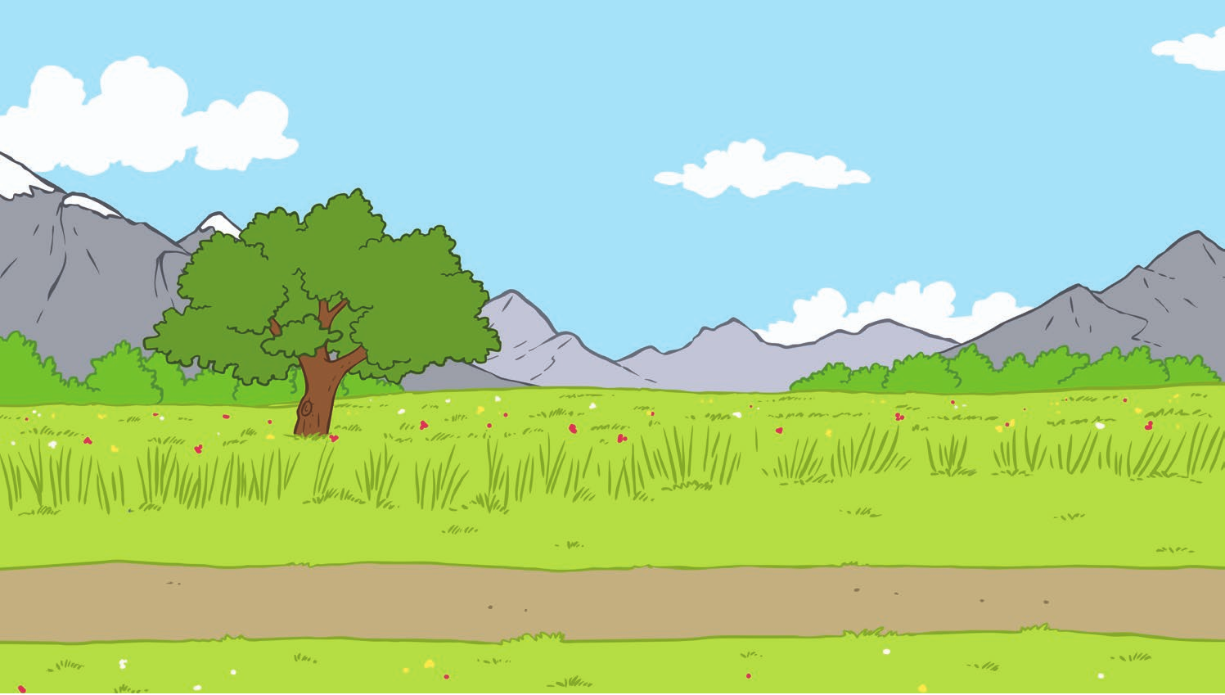
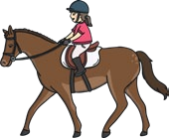
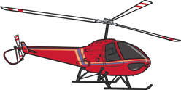

Example: The plane is flying high in the sky.

Tuesday - Jr/Snr infants I spy activity

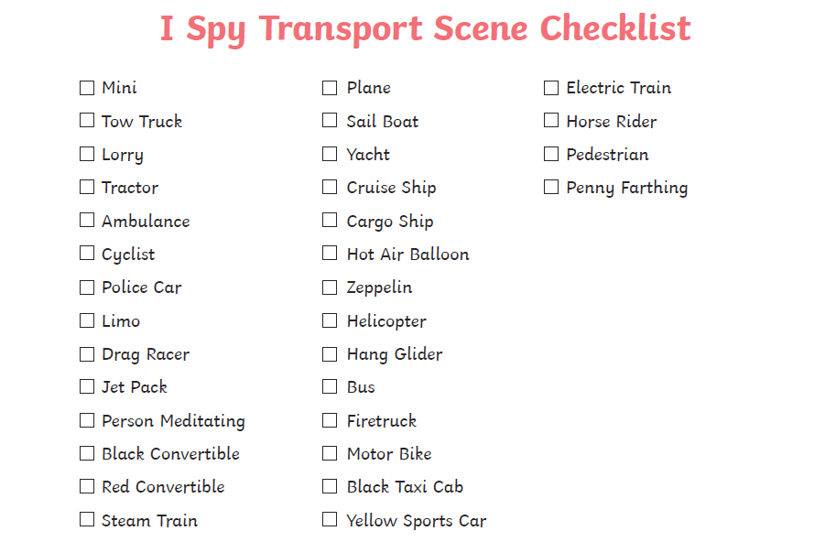

Wednesday Oral Language activity

