Teacher’s Name or Teachers’ Names | Ms Mc Glynn / Ms McGroarty
Class level | EAL
Suggested work for week beginning | 20th April
Teachers email address | msmcgroartyeal@gmail.com
Correction of work | Work that I/we have highlighted should be submitted to the appropriate teacher’s e-mail address above. This can be a photograph of the copybook page or the answers can be typed into the e-mail. Please write your child’s name in the subject part of the e-mail.  Work that is not highlighted should be corrected by an adult/parent.
Message from teacher/s | You can also email me if you have any queries or questions. Please write your child’s name in the subject box of the email.  Hi everyone! I hope you all had a lovely Easter break and are keeping safe.  Our new topic for the next few weeks is Transport and Travel. Please see below for some suggested activities on our new theme.

Monday | Discuss Transport and Travel  Do you like travel? Where have you travelled to? How did you get there?  What modes of transport have you used? What are the different types of transport you know?  What types of transport can you see outside your home?  Can you see cars, lorries, buses, bicycles?  Make a list or draw a picture of the types of transport you know.  Look at the transport word mat attached below. Talk about the different modes of transport. Who uses these types of transport?
Tuesday | Look at the transport word cards available from the link:  https://www.twinkl.ie/resource/t-t-533-transport-topic-word-cards  If you cannot access the link I can email it to you.  Talk about each of these modes of Transport.  Play ‘Take it away’ with someone in your family – Pick 4-6 cards, discuss the pictures/words, one person closes their eyes while the other person takes away one of the cards, can you identify which card was taken away?  Activity:  Jr/Snr Infants – Aistear Transport matching activity sheet (Attached below)  1st/2nd Class – Write 5 sentences using 5 different words from the word cards.
Wednesday | Discuss your journey to school  How do you get to school? What do you see on your journey to school? How do other children get to school?  Activity: Complete work sheet ‘My journey to school’ attached below.
Thursday | Talk about how transport can be classified as water transport, air transport or land transport. Can you think of examples of each type of transport?  Have a look at this quiz -  https://www.twinkl.ie/resource/t-t-9035-what-type-of-transport-powerpoint-quiz  Activity:  Jr/Snr Infants - https://www.twinkl.ie/resource/t-t-4901-transport-sorting-activity  1st/2nd class – Transport work sheet attached below
Friday | Transport in the future activity  Imagine you have travelled into the future and aliens have come to live on earth. People and aliens now travel around in a new mode of transport. It doesn’t look like any type of transport we have now. It doesn’t move like any transport we have now. It is your job to draw a picture of this new form of transport.  I would love to see some of your creations! Maybe an adult can take a picture of your drawing and email it to me. The boys and girls in 1st and 2nd class could also write a little bit about their new mode of transport.

Monday: Transport word mat

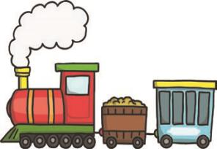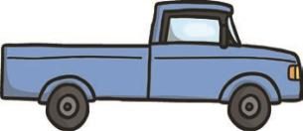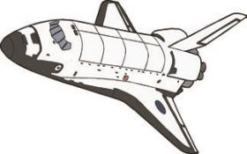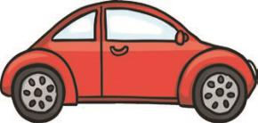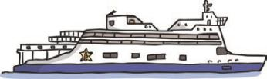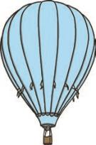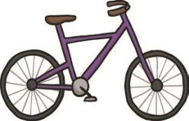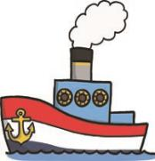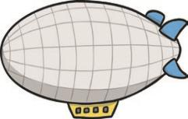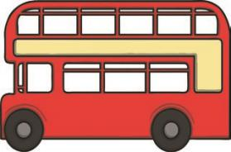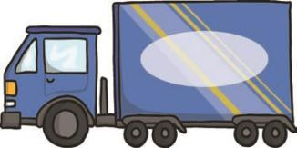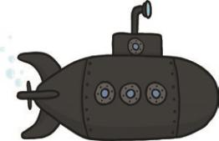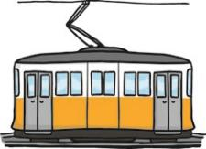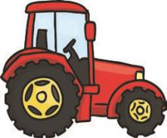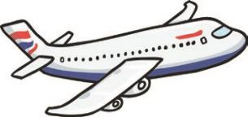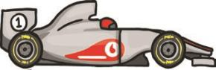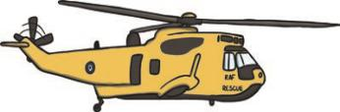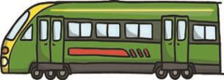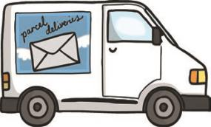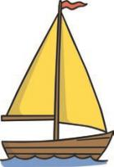
Transport
steam train
truck
space shuttle
car
ship
hot air balloon
bicycle
ferry
airship
bus
lorry
submarine
tram
tractor
aeroplane
racing car
helicopter
train
van
boat
visit twinkl.com
Tuesday: Transport matching activity sheet – Jr/Snr Infants

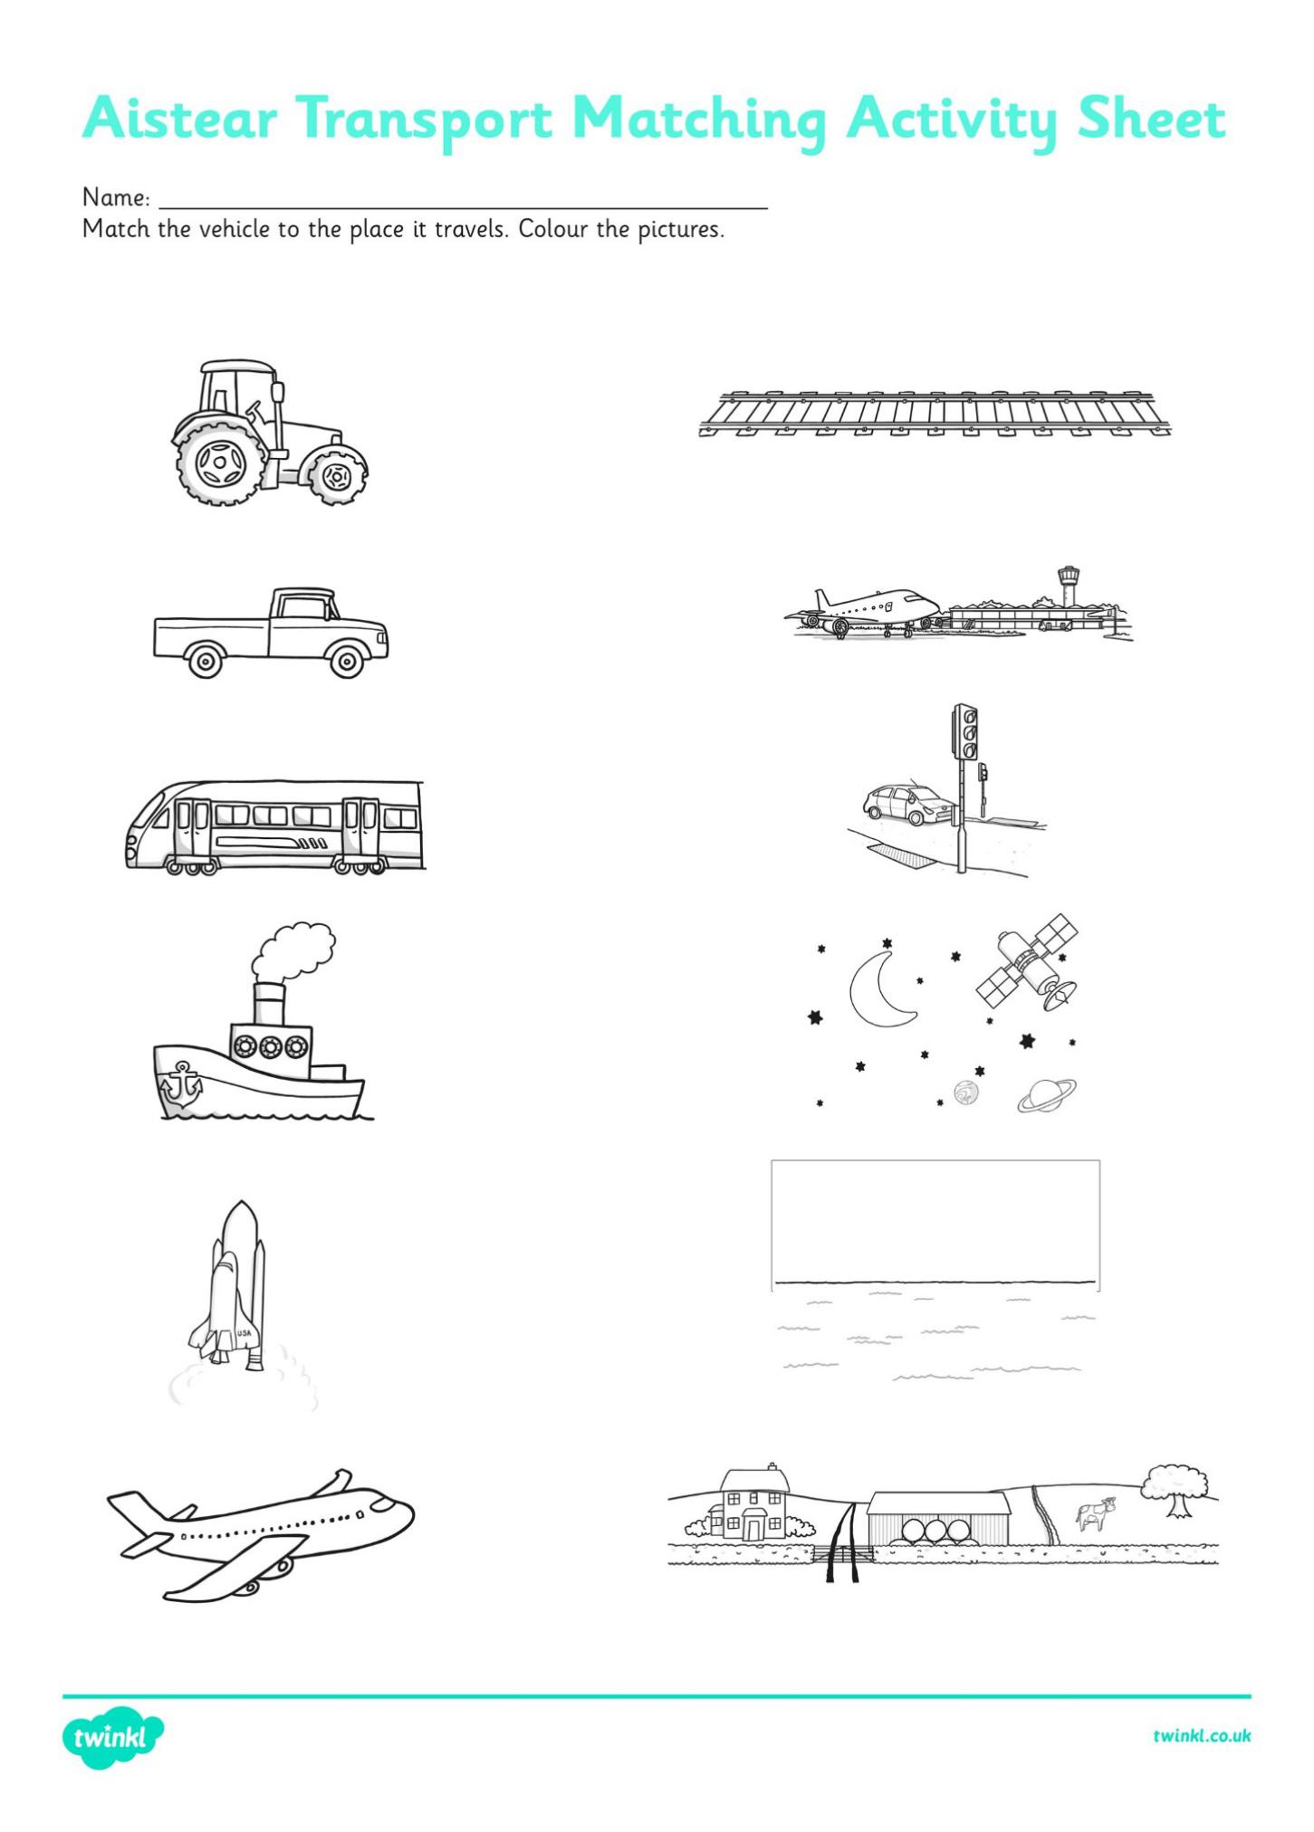
Wednesday: My journey to school activity sheet
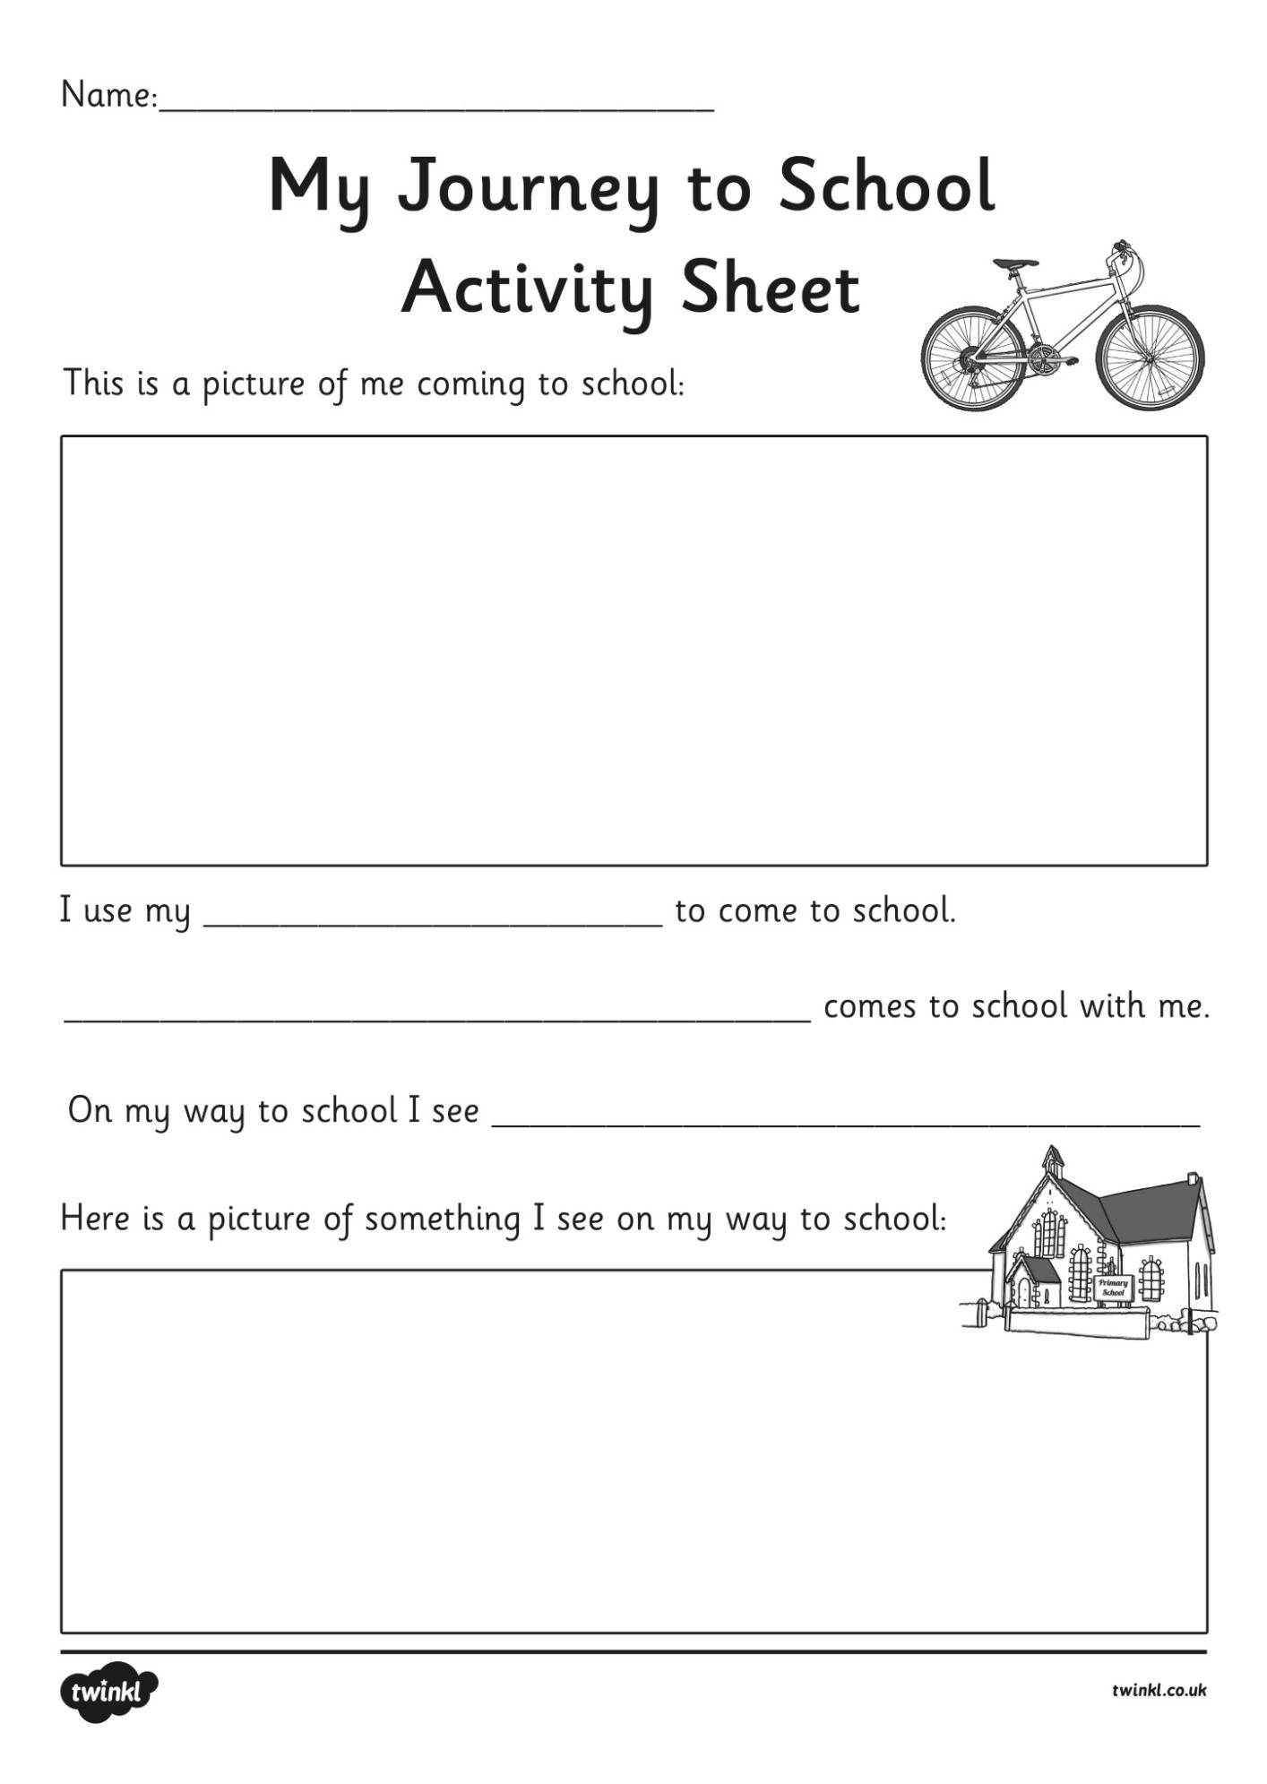
Thursday: Transport worksheet 1st/2nd class

Transport
What are the three types of Transport? 1. ____________________________
2.____________________________
3.____________________________

List 3 examples of each type of transport:

Water: Land: Air:
_______________ _______________ ______________
_______________ _______________ _______________
_______________ _______________ _______________

What type of Transport?
- Needs water to move? ________________________________
- Runs on rails? ________________________________________
- Can dig holes and move heavy objects? ___________________
- Has blades that make a circular shape? ____________________
- Might a farmer need to do his or her work? _________________
- Has a siren? ___________________________________________
- Has only two wheels? ___________________________________
- Can hold many people? _________________________________

