Mrs Mc Ginley- S.E.T- Week 3 Closure and Easter Break
Senior Infants- Fine Motor Group

Dear Parent(s) and Students,
I hope you are well during these difficult times. Below I have given a few fine motor activities to complete with your child. Please be aware that this is only a set of ideas to be completed at a time/ day that suits you. I understand that many of you may be working from home or on the front line so please do not feel under pressure to complete these activities, as your child will also be receiving work from class teacher. During the weeks ahead give your child lots of opportunities to play games with rules, e.g. Snakes and Ladders, card games, bingo, etc. Play language games which focus on literacy, e.g. Scrabble, word-searches. Support your child to engage in outdoor play, e.g. garden games, cycling etc.Offer opportunities to read with your child. Discuss the cover of the book, the title, the author and illustrator. If they are feeling creative get them to draw a character from the book or their favourite part of the story. Please see the school website for some excellent websites and resources that they may enjoy.

I am adding a link to the ncse.ie web-page. This has some very beneficial information for parents at this time.
https://ncse.ie/wp-content/uploads/2020/03/Fine-and-gross-motor-info-sheets-for-the-home.pdf

Happy Easter and take care,
Eilís Mc Ginley

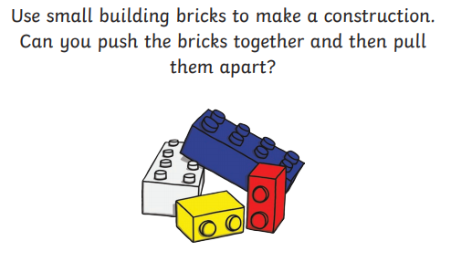
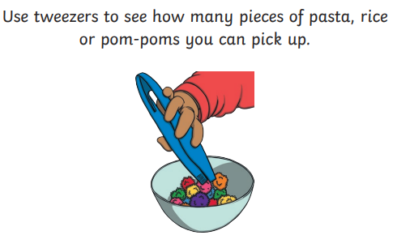
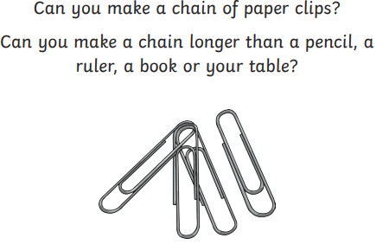
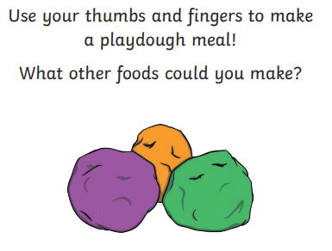
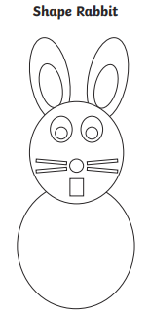Cutting Activity- cut the shapes below to make your Easter Rabbit.
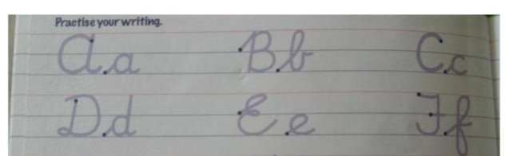
Practice your writing using the cursive font.

