Ms Mc Clafferty and Mrs Clarke
SEN
Week commencing 30th March 2020
The fourth class teachers have assigned work for pupils to do this week.
They should try their best and don’t worry if it becomes too difficult. Leave it and come back to it another time.
We have outlined some work for our numeracy and literacy pupils which they can do at home when they choose.
Fourth Class Literacy Group
This week An Post has sent two blank postcards to every household. They are called Sending love. It would be nice if pupils could use one of these to send a postcard to a friend or a member of your family that you miss while you are at home. We have included some ideas below for you to keep in mind when writing a postcard. The postage on the AN Post postcard is free.
If pupils don’t have the AN Post one then make a postcard and you can give it to someone when you see them again.
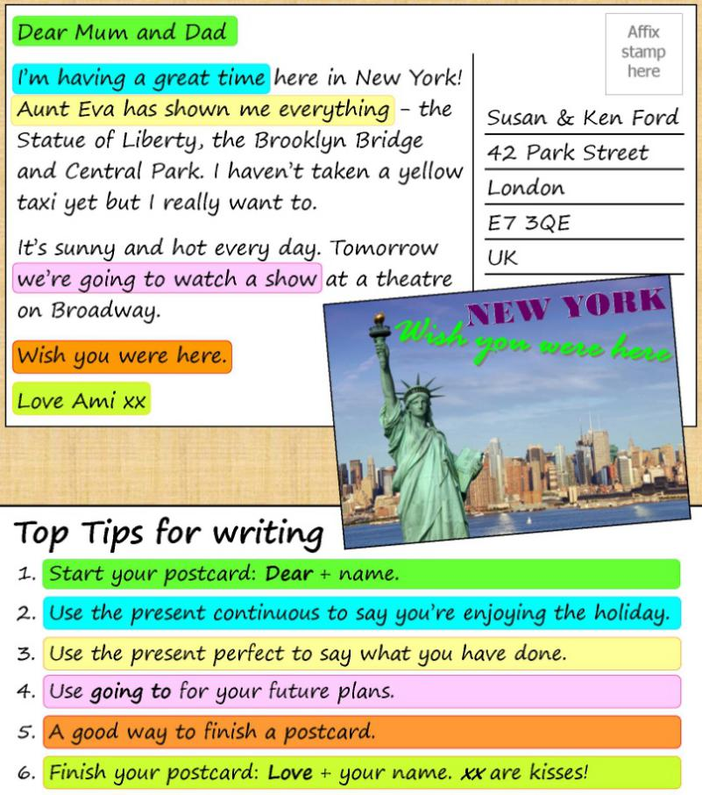
We think it is nice to play simple games at home where there is no need for technology such as cards or any board game.
Another fun game to enjoy is called
Stop The Bus!
This is a fun word game that will help your child improve their vocabulary, general knowledge, and critical thinking skills.
It involves selecting a letter of the alphabet and then trying to come up with unique answers starting with that letter for a set of pre-selected categories as quickly as possible.
Each person playing needs to write the six chosen categories at the top of a page. Such as Name, Place, Drink, Food, TV programme, Animal etc. Then one player will say the alphabet in their head. Another player will then stop them and the player will call out the letter that they stopped at.
They must then as fast as they can complete each category with a word starting with the chosen letter. The first to complete answers for each category shouts Stop the Bus. 10 points are awarded for each word if they are the only player who wrote it and 5 points if some other player wrote the same word.
Amazon has cancelled the subscription of books and audio stories for children and students of all ages as long as schools are closed, kids everywhere can instantly stream an incredible collection of stories, including titles across six different languages, that will help them continue dreaming, learning, and just being kids.

All stories are free to stream on your desktop, laptop, phone or tablet using the following link

https://stories.audible.com/start-listen

Fourth Class Maths Groups
Please follow the Maths which the class teacher has assigned. If pupils are finding any Mathematics too difficult do not worry and carry onto the next section.
You will find some games on this website to enhance the learning of these topics.
https://www.topmarks.co.uk/maths-games
It is important that we use this time to revise our tables.
Here are our times tables below.
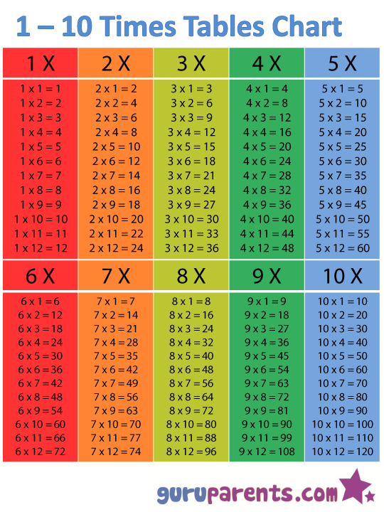

There are lots of ideas for literacy and numeracy and links to websites on our own school website.
https://m.youtube.com/watch?v=jKU1xzjCxWo

Fourth/Fifth Class Social Group
It is important to keep exercising while you are off school as this helps us feel better. Tina Higgins has a great family dance lesson on a Monday, Wednesday and Friday at 12pm. It is called Dance Fitness with Tina and is on facebook.
There is also a fun PE lesson called PE with Joe which is streamed at 9am everyday on youtube.
Myleene Klass has a music lesson on her you tube channel every day.
It is important to stay creative during these times. Every day on the RCC facebook page they announce an art challenge for the day based on a theme. You can even build lego using the theme as your inspiration.
This is a nice way of relaxing.
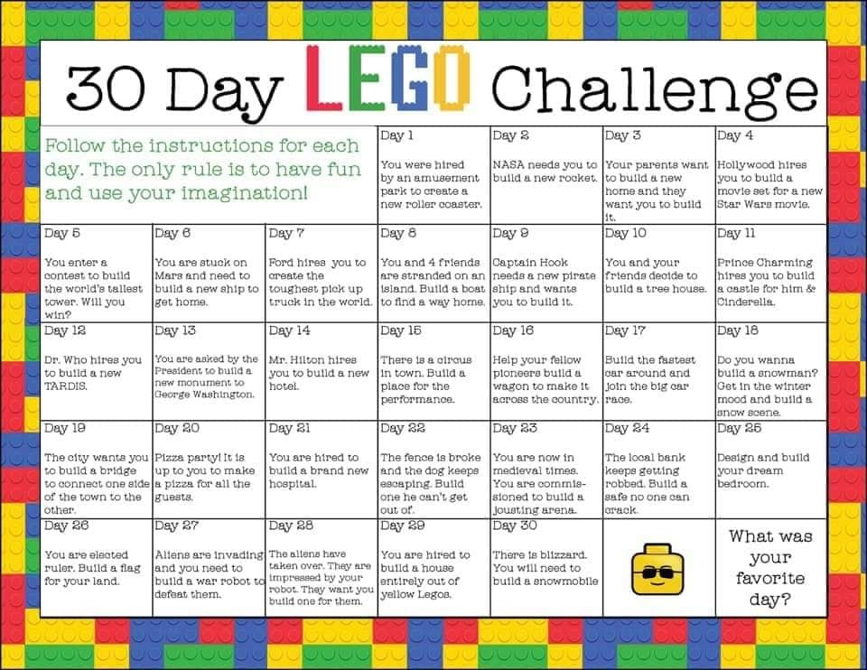

International week
This week was to be International week in
Illistrin NS. We would still like to celebrate this with our families
and the wider community. Children could research a country of
interest to your family, listen to music from a different culture
or do some artwork from another country. We are asking the
school community to send their artwork, a song or a piece of
writing under this theme to illistrininternational@gmail.com.
We will then compile the photos we receive to create a video
for our website and illistrin Pa facebook page.

Easter
Enjoy the Easter break. Remember to keep reading.
Maybe during the Easter Holidays it would be a nice time to write your own song or poem. Design an Easter card for family or friends. Have fun outside.
Maybe practice some mindful activities as a family. This may help everyone feel less anxious. It could be a walk in a quiet wood or a fun game of charades together. It is important that we all look after our families mental health and well being during these times and don’t ever feel stressed about school work. We totally understand how difficult it is.
Distant learning is new to everyone.
Thank you and take care.
Ms Mc Clafferty and Mrs Clarke.

