Teacher’s Name | Ms Horkan
Class level | SET
Suggested work for week beginning | 20th – 24th April 2020
Teachers email address | mshorkanset@gmail.com
Correction of work | Work that I have highlighted should be submitted to the e-mail address above. This can be a photograph of the copybook page or the answers can be typed into the e-mail. Please write your child’s name in the subject part of the e-mail.  Work that is not highlighted should be corrected by an adult/parent.
Message from teacher/s | You can also email me if you have any queries or questions. Please write your child’s name in the subject box of the email.
Remember to tune into the RTE Home School Hub every day at 11.00
Dear all,
I hope this correspondence finds you and your family well. I really hope you enjoyed your Easter break, had some nice Easter eggs and got plenty of sunshine!
As I explained in my earlier correspondence, I am not going to set you additional curriculum work. You will have plenty from your class teacher to keep you going. My email address is provided above and I will be available to support you in your work, in whatever way I can.
- I would however, love for you to email me a picture/copy of your COVID-19 Time Capsule. If you haven’t completed it yet, you can do so this week. Steps 1- 4 which I initially gave you can be found under Ms Horkan SET Week 3, on our school website. I have attached some templates below (to make it easier for completing) that I found online for doing this activity. You can choose as many or as little of the templates as you like for your time capsule.
- I have attached a Wellbeing Acrostic Poem template. You can email me your finished poem. I would love to read them!
- I have included a list of useful websites once again for your convenience.
Please remember to look after yourself, do as much as you can and don’t stress over schoolwork. Take breaks, bake, read, play on your PS4/Xbox, enjoy family time and exercise your mind and body. It’s all about a good balance! Keep helping out at home too.
Stay safe and stay well. I miss each and every one of you and look forward to seeing you all again soon. Remember the smile you send out returns to you; so keep smiling!
Kind regards,
Deborah Horkan

General websites
www.scoilnet.ie
www.schooldays.ie
www.twinkl.ie *This website is a fantastic resource and is now offered for free. Great PowerPoints for research ideas and information.
Most of the book companies have also added their textbooks free online.

Reading websites
https://stories.audible.com/start-listen
https://www.worldofdavidwalliams.com/elevenses/ * If you have a copy of any of his books you could read along too!

Mathematics websites
https://ie.ixl.com/
https://www.topmarks.co.uk/maths-games
https://www.khanacademy.org/ *This is fantastic as it covers all topics and levels. It also has a short video clip for each topic if you are having difficulty.
http://www.iseemaths.com/home-lessons/ *Gareth Metcalfe Maths lessons. Some great ideas and challenges with instructions. Select Y5-Y6 activities. New lessons will be posted from Mon 20th April.

Exercise websites:

Joe Wicks 30-minute sessions called “P.E. with Joe” are streamed live on Wicks’ YouTube channel at 9am every weekday morning. I know it’s early but if you aren’t up or ready, you can access it any time of the day. You don’t need any specialist equipment or large amounts of space. It’s really good!
www.gonoodle.com * Some good ideas for short movement breaks. Stay Calm; sometimes it may not be easy and we all need to take plenty of breaks. 20 minutes on an activity followed by a movement break is a good idea for everyone.
https://rtejr.rte.ie/10at10/
NCSE website

https://ncse.ie/online-resources-for-parents *This may be of particular interest to you and is a fantastic resource for you at home. Select For Parents in the tool bar at the top, and in the drop down menu select Online Resources for Parents.
Think about what well-being means to you. The first letter of each line is what you start your sentence/thought with. Remember, it doesn’t have to rhyme.
Now write your own acrostic poem on well-being.
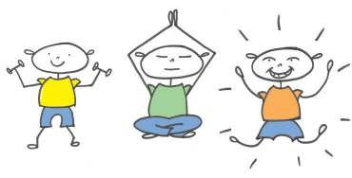

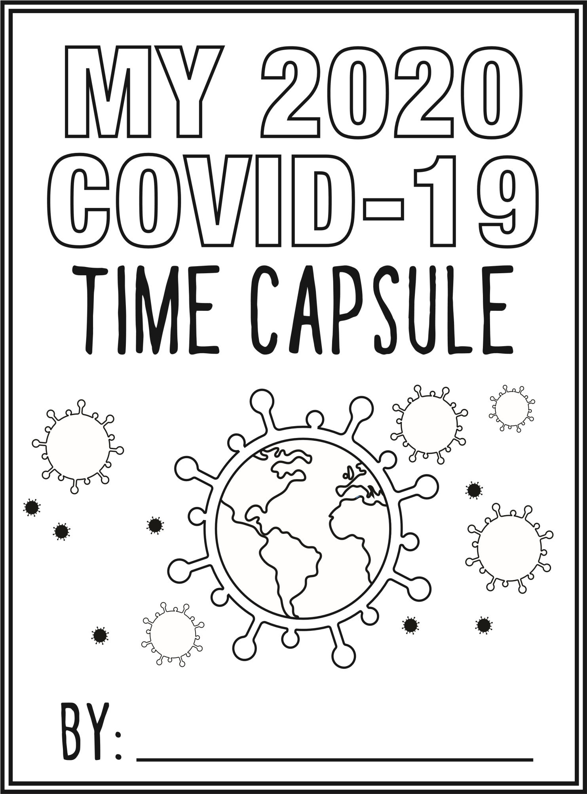

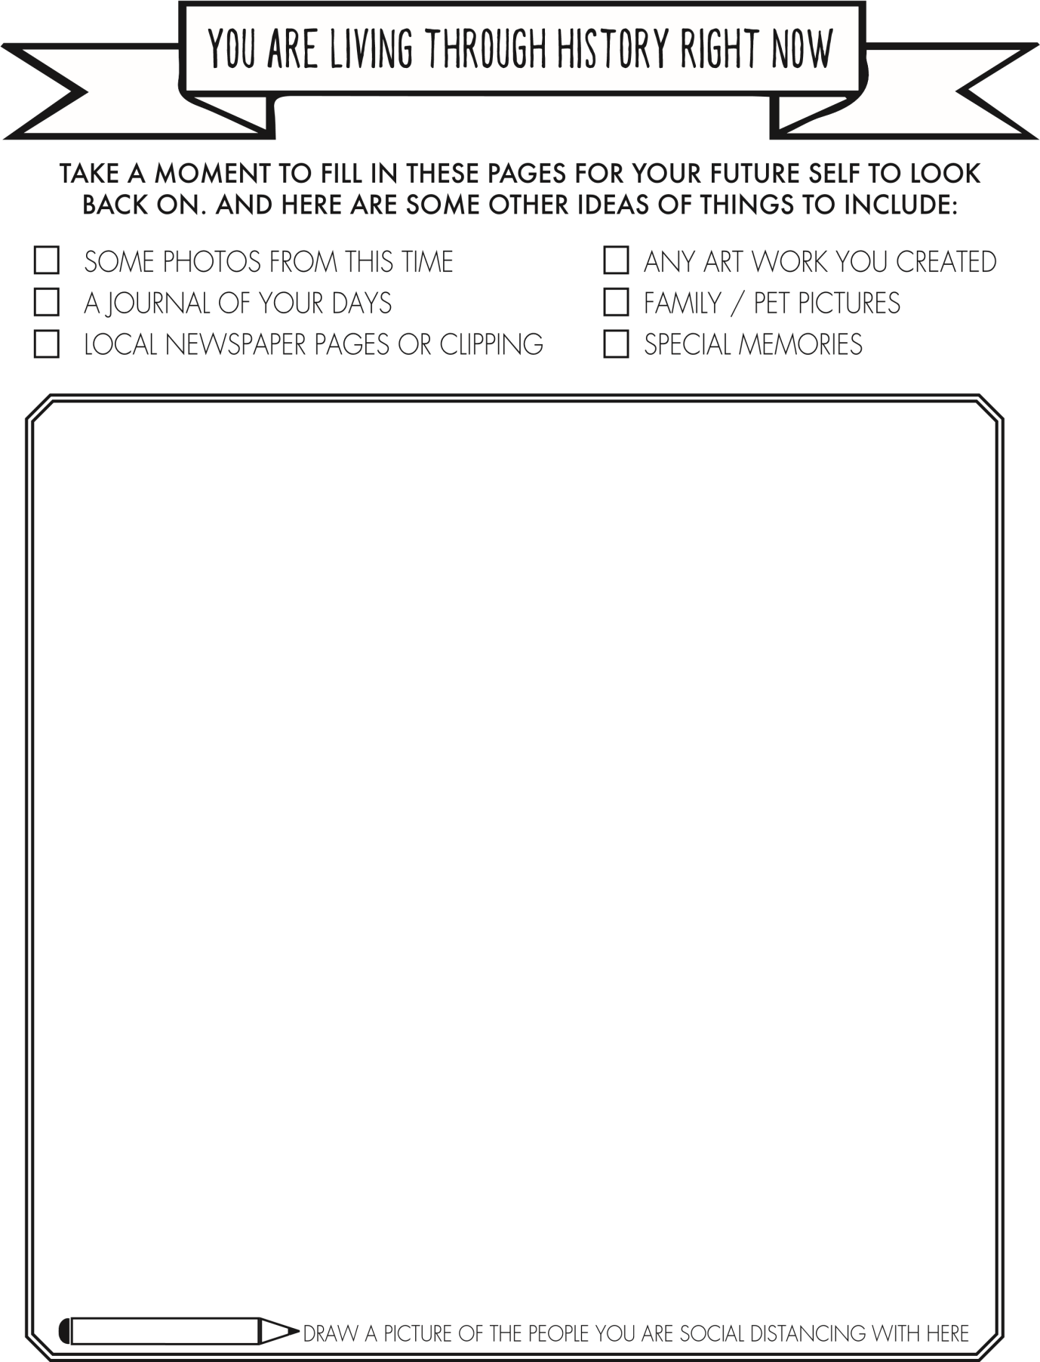

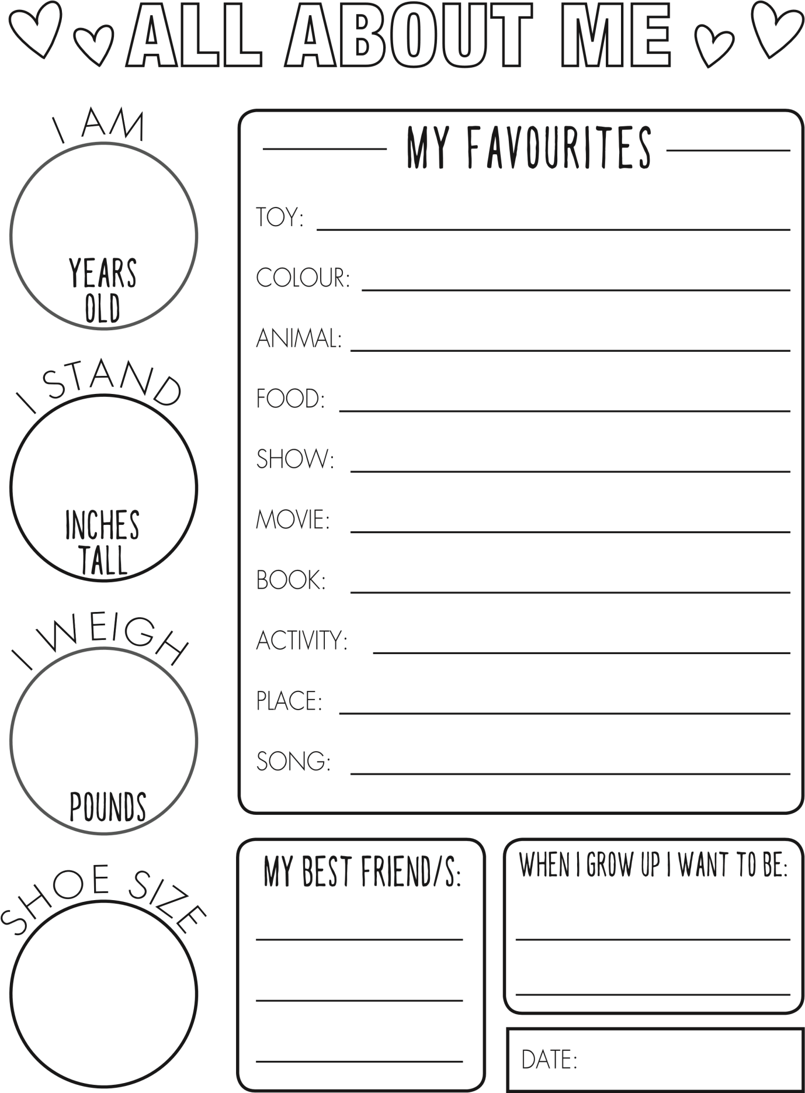

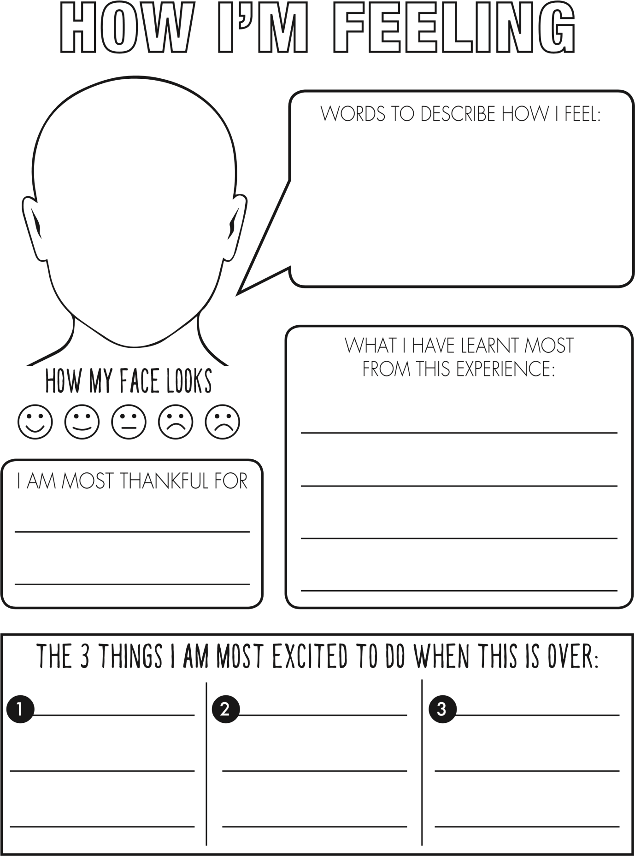

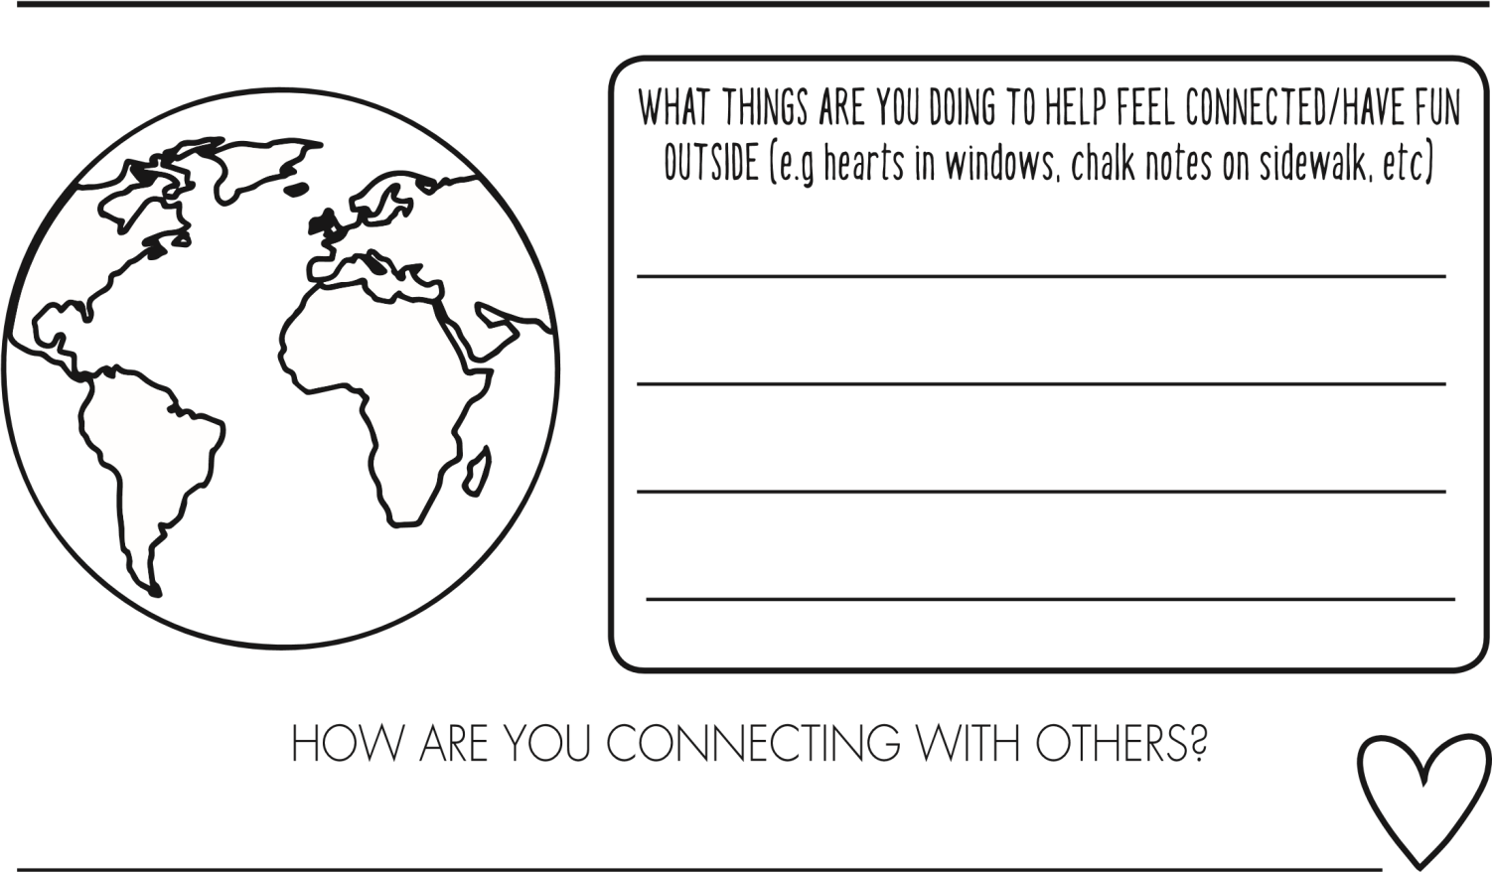

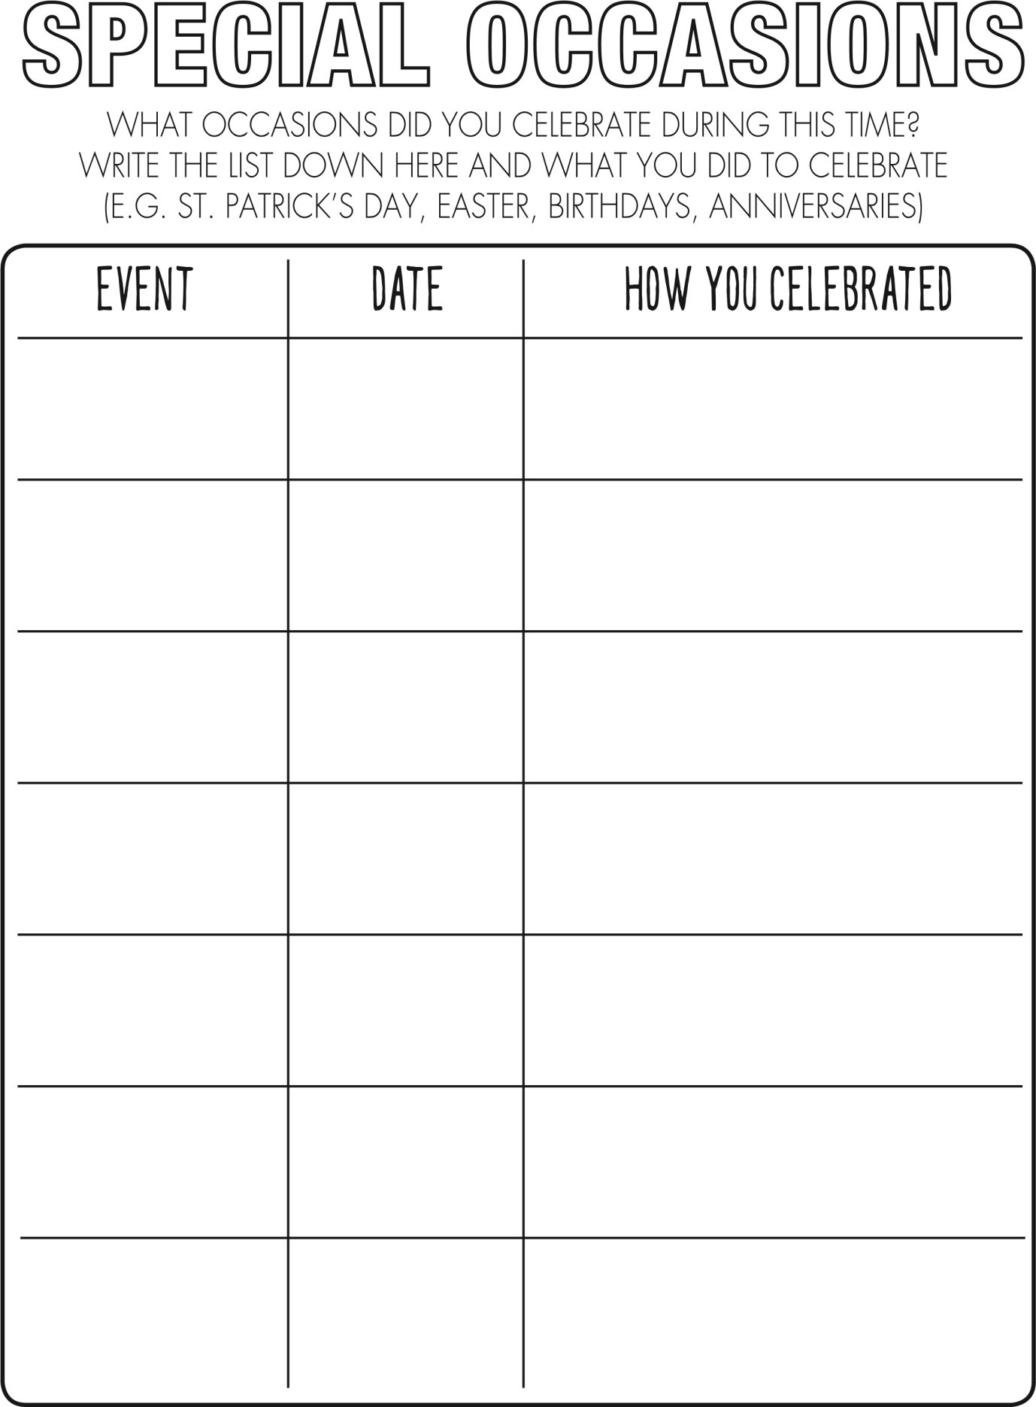

DEAR,

LOVE,

INTERVIEW YOUR PARENTS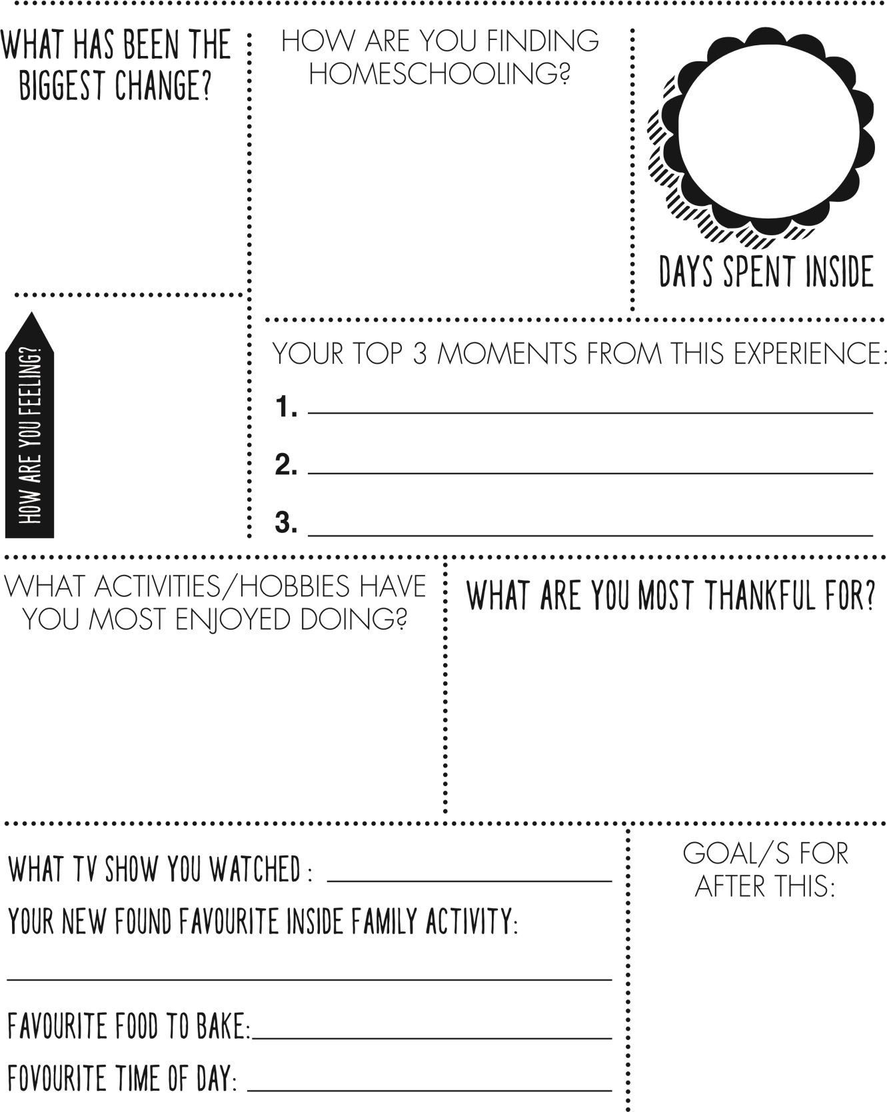

DEAR,

LOVE,

