Hi Everyone,

I hope you all got through another week. I was unable to get zoom organised. I am not the best at technology…lol.
I hope you all have been having fun outside in the amazing weather. We are so lucky. I have been Finn and Shea on walks to see the little lambs in the field next to us and Shea is trying to learn to cycle his bike without stabilisers. Please anyone who has not sent me an email yet try and do so this week. I would love to hear all your news.
Mrs.emmamcmenamin@gmail.com
I have a new plan of work for this week. I hope you had some fun last week doing work.
Over the course of the week take a photo of one piece of work and email it to me, if u have access to a phone.
I am still trying to do PE with Joe on YouTube.
Take care and Stay safe,
Mrs Emma McMenamin

Plan of Work – Week Beginning 27th April 2020
 | Exercise/Mindfulness | Literacy Ideas | Arts & Crafts
Monday | https://www.youtube.com/watch?v=sFSs_QKwdlc  1 minute kid veggie power exercises | Write an opposite poem  Think of a feeling write/say or draw a poem about it. Now think of the opposite feeling write/say or draw poem about the new feeling. | Design  Using a old box try and be creative and see what you can make. I would love to see pictures..
Tuesday | https://www.youtube.com/watch?v=KG3AO6lJ4BQ  Do the Bear Walk (Gross motor/Balance/Coordination/Self Regulation/ Brain Break) | YES YES YES  Make a list of questions that YES is the answer to. How many questions can you come up with in 3 minutes. | What is your favourite story?  Design a new front cover
Wednesday | https://www.youtube.com/watch?v=cyvuaL_2avY  Calming Exercises for Kids: Breathing and Stretching | Questioning a story  Think of a story you have read or read a new one. Pick one part that you wonder about. What would you change or make different? How would it affect the rest of the story? Draw or write about the new version of your story. | Design you own zoo  Take a sheet and create your on zoo with 2 real and 2 imaginary animals and give them all names.
Thursday | 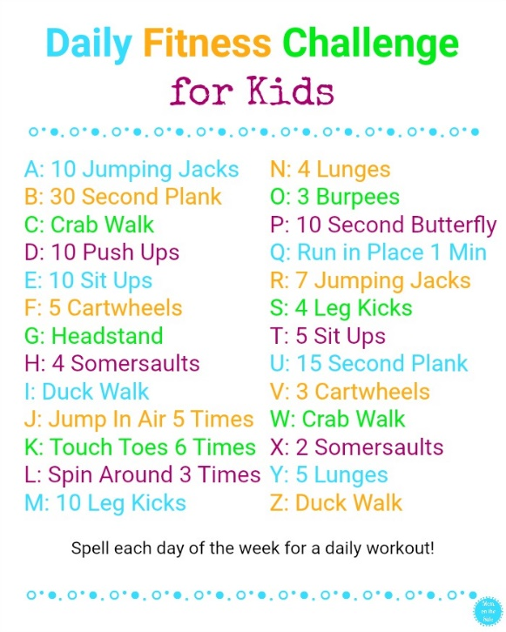 | Writing from Films​http://takingflightfilm.com/ takingflightfilm.com/.  Watch this short movie and when you are finished pretend that you are Dad and make up an adventure that he went on. You can draw it or write about it. | Free Art  On a blank page draw a line down the middle. Page should be horizontal. On one side I want you to draw a picture of all the things you are thankful for right now eg. Family/food/cosy house/garden/brothers/sisters/pets etc…On the other side draw a picture of all the things you will do/see once we can safely leave the house again! You can colour/paint your pictures and I would love to see them.
Friday | TODAY YOU IN CHARGE!!!  Design a set of 10 exercises. Write them down, now get your mum/dad/brother/sister to follow them. You are the coach. | Make a new world  Think of a brand new setting for a story. Make up a place that is totally different from anything you have read about before. Create your own world/country/city or town. Draw it and write about it. Tell me all the fun things that can happen in it. | Alien Name Monster  Fold a piece of paper in half lengthwise, and write your name along the folded edge. Use the scissors to carefully cut around the name along the non-folded edge. Unfold to reveal the symmetrical shape of the your alien monster creature – this part is SO much fun. Create you own monster.  