Mrs Mc Ginley- S.E.T- Week 3 Closure and Easter Break
Senior Infants- Literacy and Numeracy

Dear Parent(s) and Students,
I hope you are well during these difficult times. Below I have given a daily plan to complete with your child. Please be aware that this is only a set of ideas to be completed at a time/ day that suits you. I understand that many of you may be working from home or on the front line so please do not feel under pressure to complete these activities, as your child will also be receiving work from class teacher. During the weeks ahead give your child lots of opportunities to play games with rules, e.g. Snakes and Ladders, card games, bingo, etc. Play language games which focus on literacy, e.g. Scrabble, word-searches. Support your child to engage in outdoor play, e.g. garden games, cycling etc.Offer opportunities to read with your child. Discuss the cover of the book, the title, the author and illustrator. If they are feeling creative get them to draw a character from the book or their favourite part of the story. Please see the school website for some excellent websites and resources that they may enjoy.
I am also adding a link to the ncse.ie web-page. This has some very beneficial information for parents at this time.
https://ncse.ie/online-resources-for-parents

Happy Easter and take care,
Eilís Mc Ginley

Monday | Tuesday | Wednesday | Thursday | Friday
- Word family-  “et” family (see words below)  Make words that end with “et” . Use the alphabet below to add “et” to each letter to see if your child can recognise the word. E.g. a-et, b-et, c-et. Get your child to give a thumbs up if he/she creates a word and thumbs down if it creates a nonsense word.  - Dolch list  Practice 2 words. (See lists below. Continue with list your child has been working on with me) | Maths  Number concepts- Counting activities  Count objects in everyday concepts e.g. count the number of buttons on your coat as they button it, count the amount of plates needed when setting the table etc.  Number formation 1-8.  Salt tray (see photo)- count the amount of dots on the dice. Then write the number that the dot pattern shows in the salt. (f you don’t have a dice draw some dots on a piece of paper/ cereal box etc and ask your child to pick a card each time.)  Children can also use play dough to make numbers instead of salt.  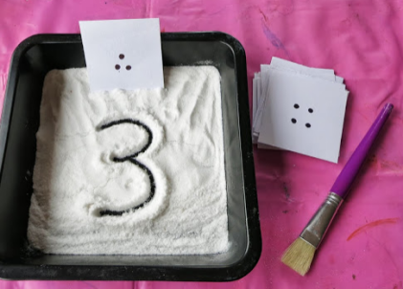  Write numbers on worksheet below. | - Word family  Think of 5 words from “et” family. (met, get, let, set, pet, jet, get, wet, vet, net). Sound out and write words independently. See cut and paste activity below.  - Dolch list  Practice 2 words- write out the 2 words you are working on this week. | Maths  Count objects in the house e.g. the amount of apples, oranges etc in the fruit bowl.  How many apples altogether?  How many oranges?  What is the biggest number?etc.  - Coat hanger and pegs addition machine. (see photo)  Use 8 pegs…. children use the pegs to make a sum that totals to 8. Write the sum on a page. Remove the pegs and make another sum.  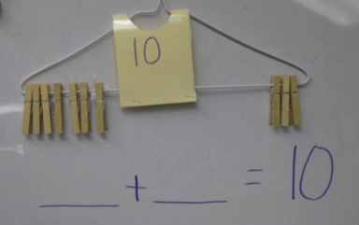 | Revise jolly phonics sounds and blends- Check out folens online. There is a great Phonics activity you can do at home with your child- practise all sounds in a fun way.  Use Prim20 for Roll Number.  https://www.folensonline.ie/registration/?r=t

a,b,c,d,e,f,g,h,i,j,k,l,m,n,o,p,q,r,s,t,u,v,w,x,y,z
-et

Encourage your child to sound out and read words from the ”et”family.

set | wet | met | vet | jet | get | let | net | pet

Dolch List 1

the | to | and | he | a | I | you | it | of | in
was | said | his | that | she | for | on | they | but | had

Dolch List 2

at | him | with | up | all | look | is | her | there | some
out | as | be | have | go | we | am | then | little | down

