Teacher’s Name | Eilís McGinley
Class Level | 4th Class
Suggested work for week beginning | 27th April 2020
Email address | mrsmcginleyset@gmail.com
Message from teacher | Thank you for sending me messages last week. It was lovely to hear from you all and see the great work you are doing… well done again. Please find the plan for this week below. Only do what you can and please email if you have any questions.  Take care and thanks again for all your hard work, Eilís

www.oxfordowl.co.uk is a great website which gives you free access to Oxford reading Tree readers in all levels which your child should read daily. (You can search by level or by age).

Please continue with your SNIP spelling programme if you are attending me for spellings-
Session 1

Activity 1 | Activity 2 | Activity 3
Recount writing- Genre Focus this week  Read the story attached called – A Day Out  Writing- Write a recount of a great day out that you had with your family or friends. Once you pick a day fill out the recount template below. You do not need to write full sentences as it’s only a draft! See worksheet below. | Using the recount plan you completed yesterday now I want you to write out your recount today…. A Day Out.  Use full sentences. Include your title at the top of the page. Remember to follow your draft and use paragraphs. Draw a picture at the end if you like. Screenshot it and send it to me, I would love to read about your day out. | Feeling Positive Emotions:  Complete each of the sentences about all the things that make you have/feel  positive emotions. Make sure that you do some of these every day! Then decorate  the frame around it!

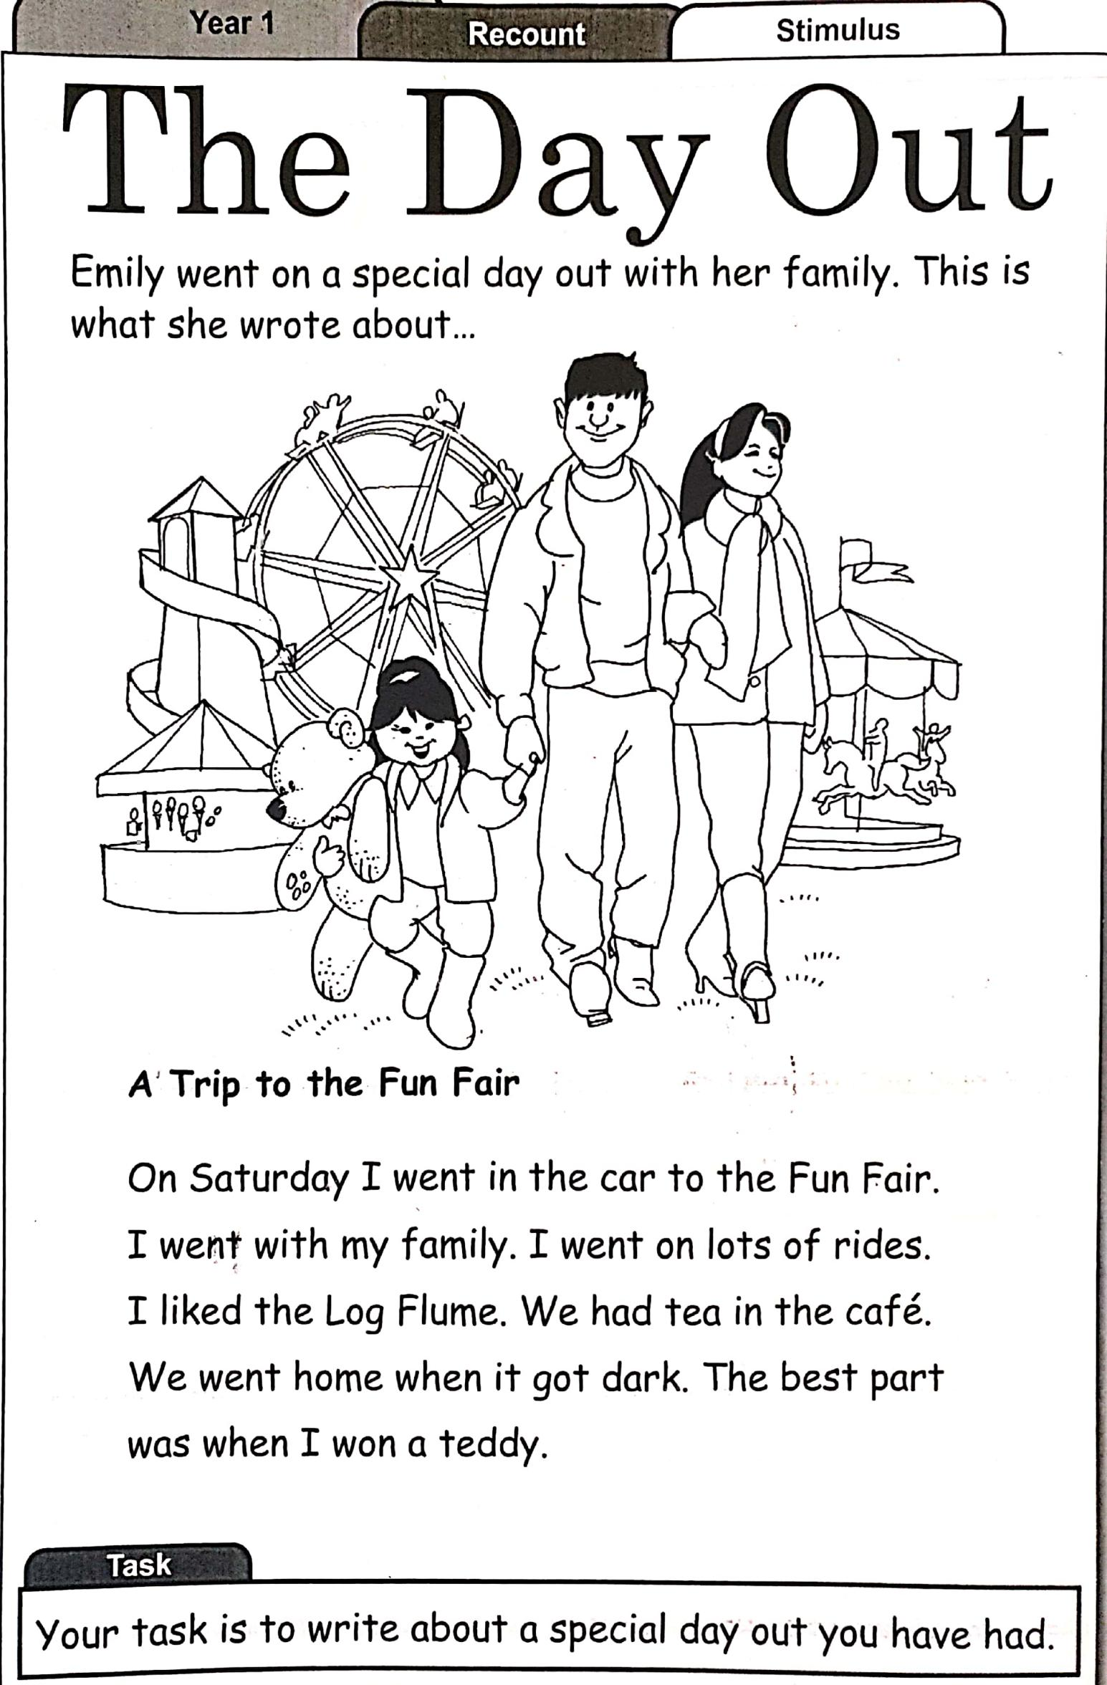
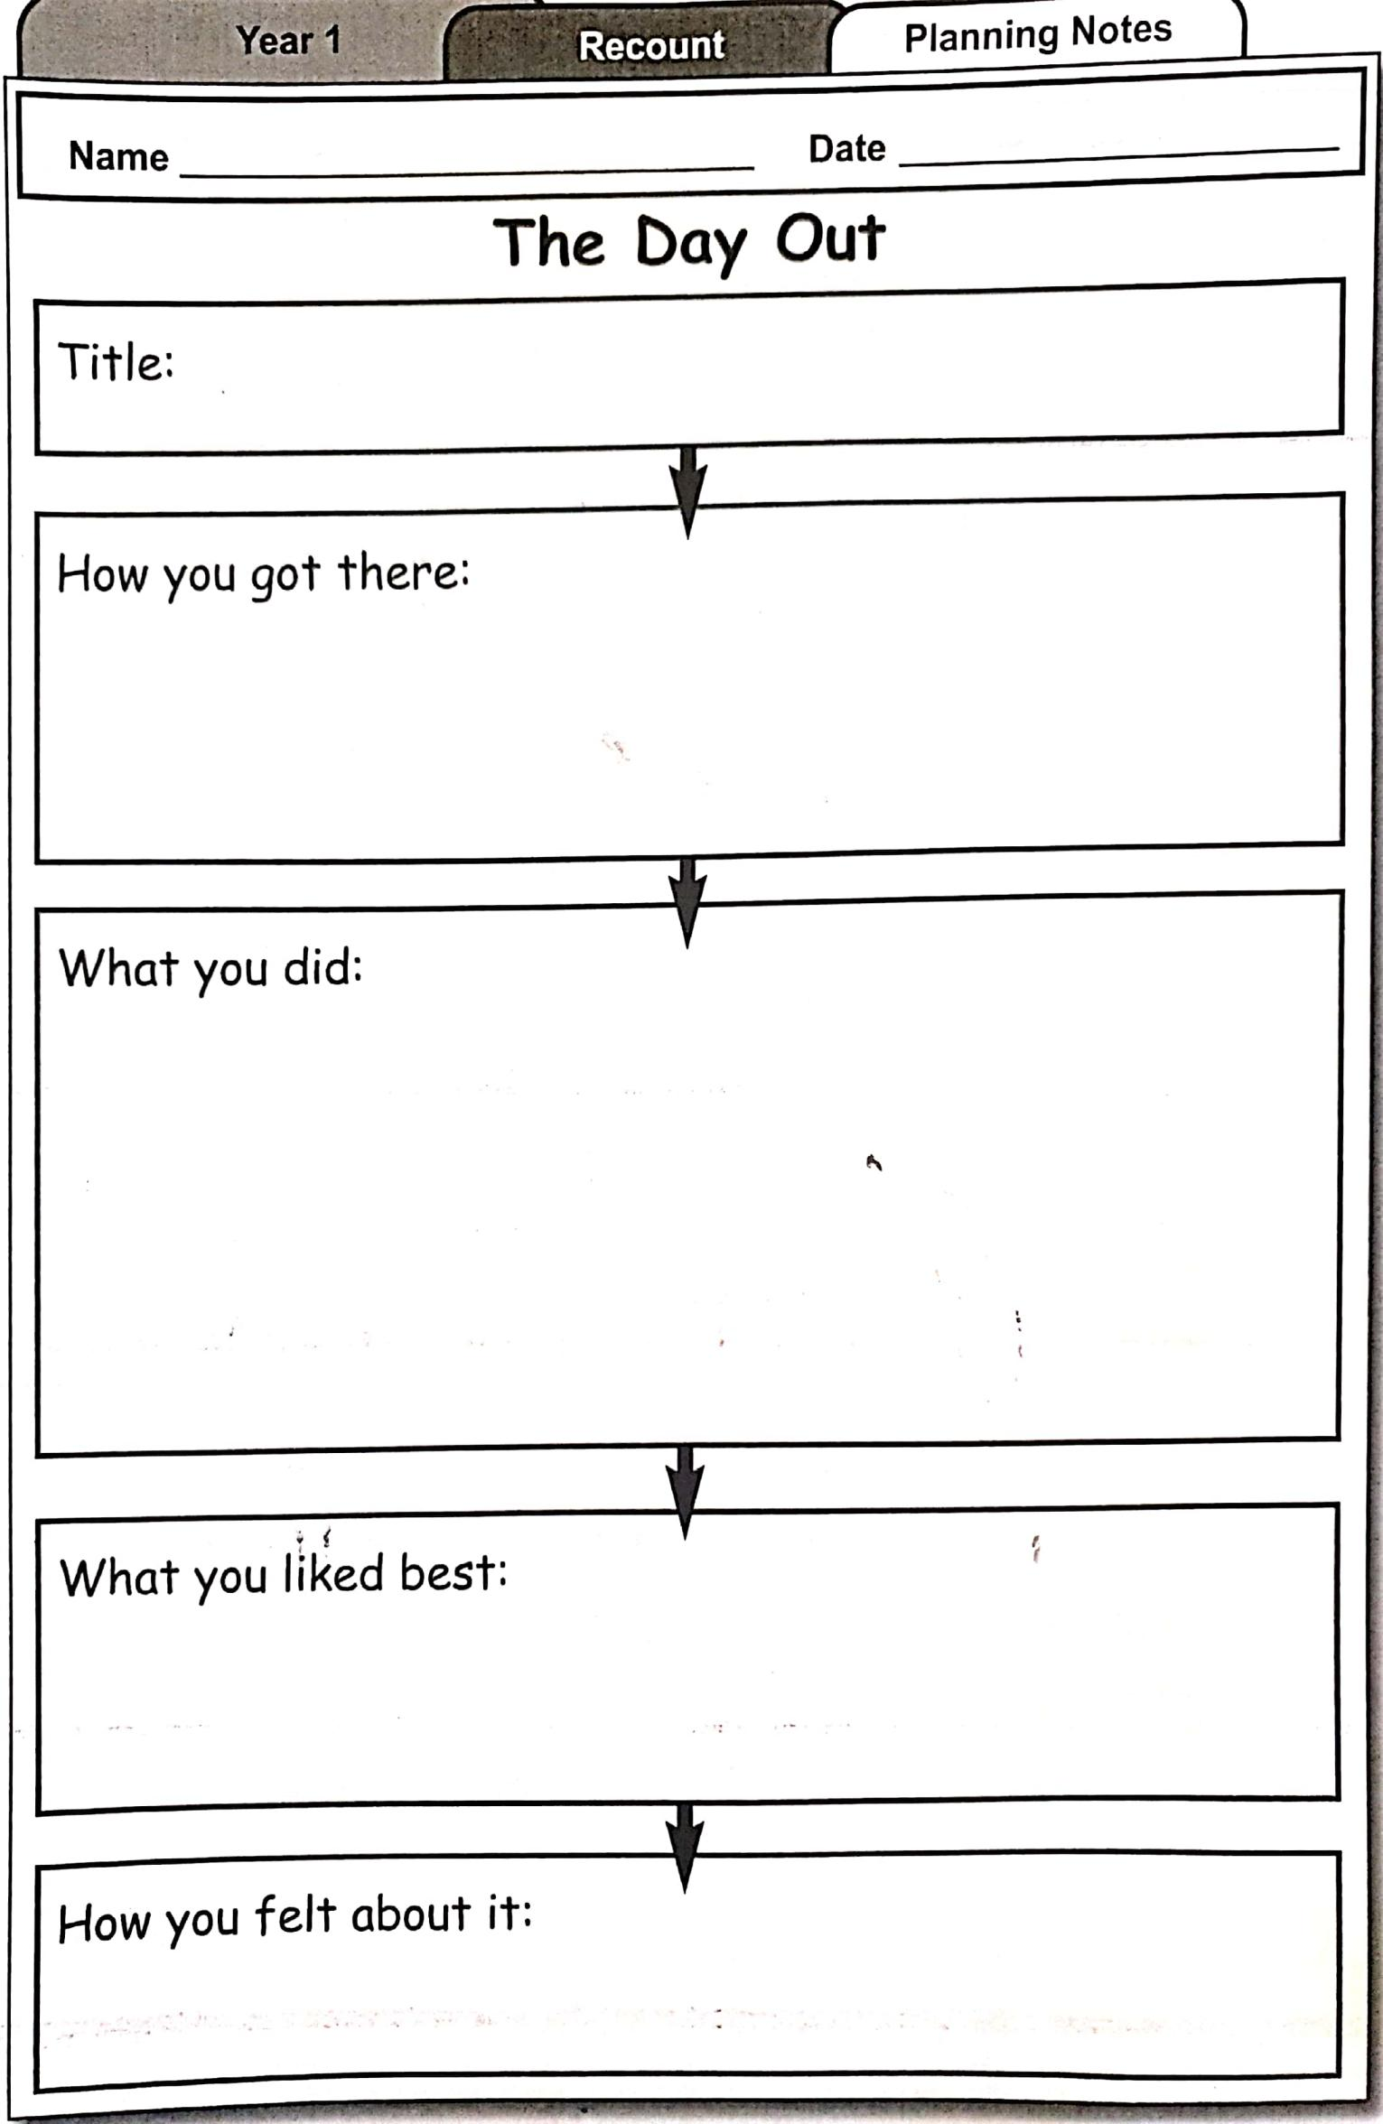

Feeling Positive Emotions

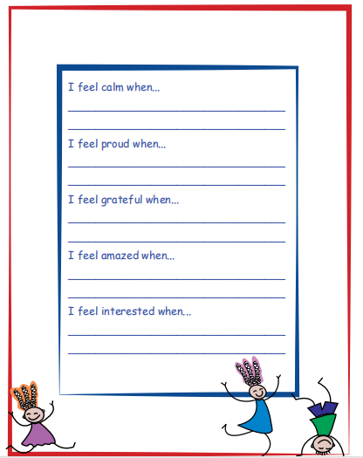
(This worksheet is from the Weaving Well- Being Programme)

