Hi all,
I hope you and your family are safe and well at home. I know that your child has been given lots of work to do by their class teacher so you can use this work as an extra if you feel like practicing your English a bit more.
I take students from Junior Infants to 6th class so I will divide my activities into Junior Infants-2nd class and 3rd class-6th class. I will be talking to the class teachers so I can tell them of the work you do for EAL. If you would like to send me work your child has done it can be sent to
mcbrideeal@gmail.com
If you have any questions or comments feel free to email me.

This work is enough for 2 weeks. I will add some websites and apps that may be helpful next week.
I divide up English learning into Oral Language(listening and speaking), Reading and Writing.
Theme this week: Travel and Transport
Oral Language
Junior Infants-2nd class  - Talk about:  Do you like travel?  Where have you travelled to?  How did you get there?  What modes of transport have you used? What are the different types of transport you know?  What types of transport can you see outside your home?  Can you see cars, lorries, buses, bicycles?  - Discuss your journey to school  How do you get to school? What do you see on your journey to school? How do other children get to school?  Activity: Complete work sheet ‘My journey to school’ attached below.  - Sorting Transport  Talk about how transport can be classified as water transport, air transport or land transport. Can you think of examples of each type of transport?  Complete the worksheet below | 3rd class-6th class  - Talk about  - A trip you have gone on with your family.  How did you get there?  What modes of transport did you see while there?  Are they in Ireland?  Compare the public transport system there and in Ireland.  - Is there somewhere you would like to go when Coronavirus is over?  You could talk, write or draw about a place you would like to go to.  Think about:  Who you would travel with,  How long it would take to get there.  What will you do when you get there?  Look at the weather forecast for that place.  - Do you like riding a bike?  How old were you when you learned to ride a bike?  What's your bike like?  How often do you ride your bike and where do you go?  Do you always wear a helmet?

Reading:
Junior Infants-2nd class  Read the postcard from London. Compete the activities.  https://learnenglishkids.britishcouncil.org/writing-practice/postcard-london  Listen to the story. There are activities underneath which can be completed.  https://learnenglishkids.britishcouncil.org/short-stories/one-moment-around-the-world | 3rd class-6th class  Use the internet to investigate:  What is the longest passenger train?  How long does it take to stop a long train?  What is the longest train journey in the world/  What is the steepest railway in the world?  Read about “La Bestia”, the train of death where migrants travel on top of the train from Mexico to the USA.  Maths:  Train timetables  See below some worksheets that you can complete. They are from Twinkl if you would like any more. I can also email them to you.  (email address above)

Writing
Junior Infants-2nd class  Look at the Talk About activities above.  Your child can draw a picture, write words or write sentences about what you have talked about.  1st/2nd class  You can do the 2 worksheets below.  Your Journey to School  Transport Worksheet | 3rd class-6th class  Write a postcard from Paris. Do some research first to see what you would like to visit in Paris.  Plan a trip to Australia.  - How will you get there?  - How much will it cost?  - How long will the journey take?  - 5 places you would like to visit when you arrive in Sydney

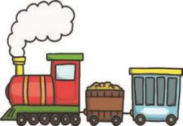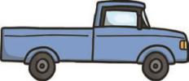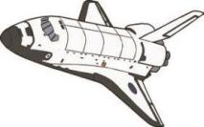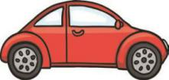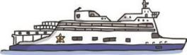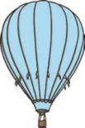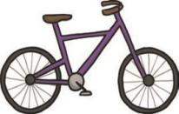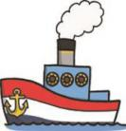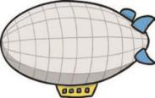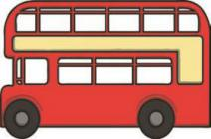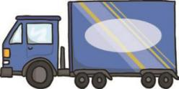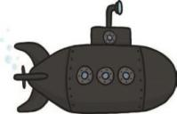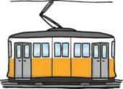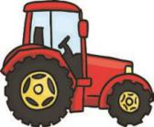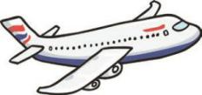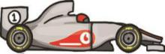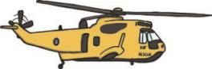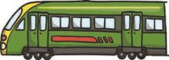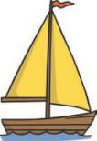
Transport
steam train
truck
space shuttle
car
ship
hot air balloon
bicycle
ferryy
airship
bus
lorry
submarine
tram
tractor
aeroplane
racing car
helicopter
train
van
boat
visit twinkl.com

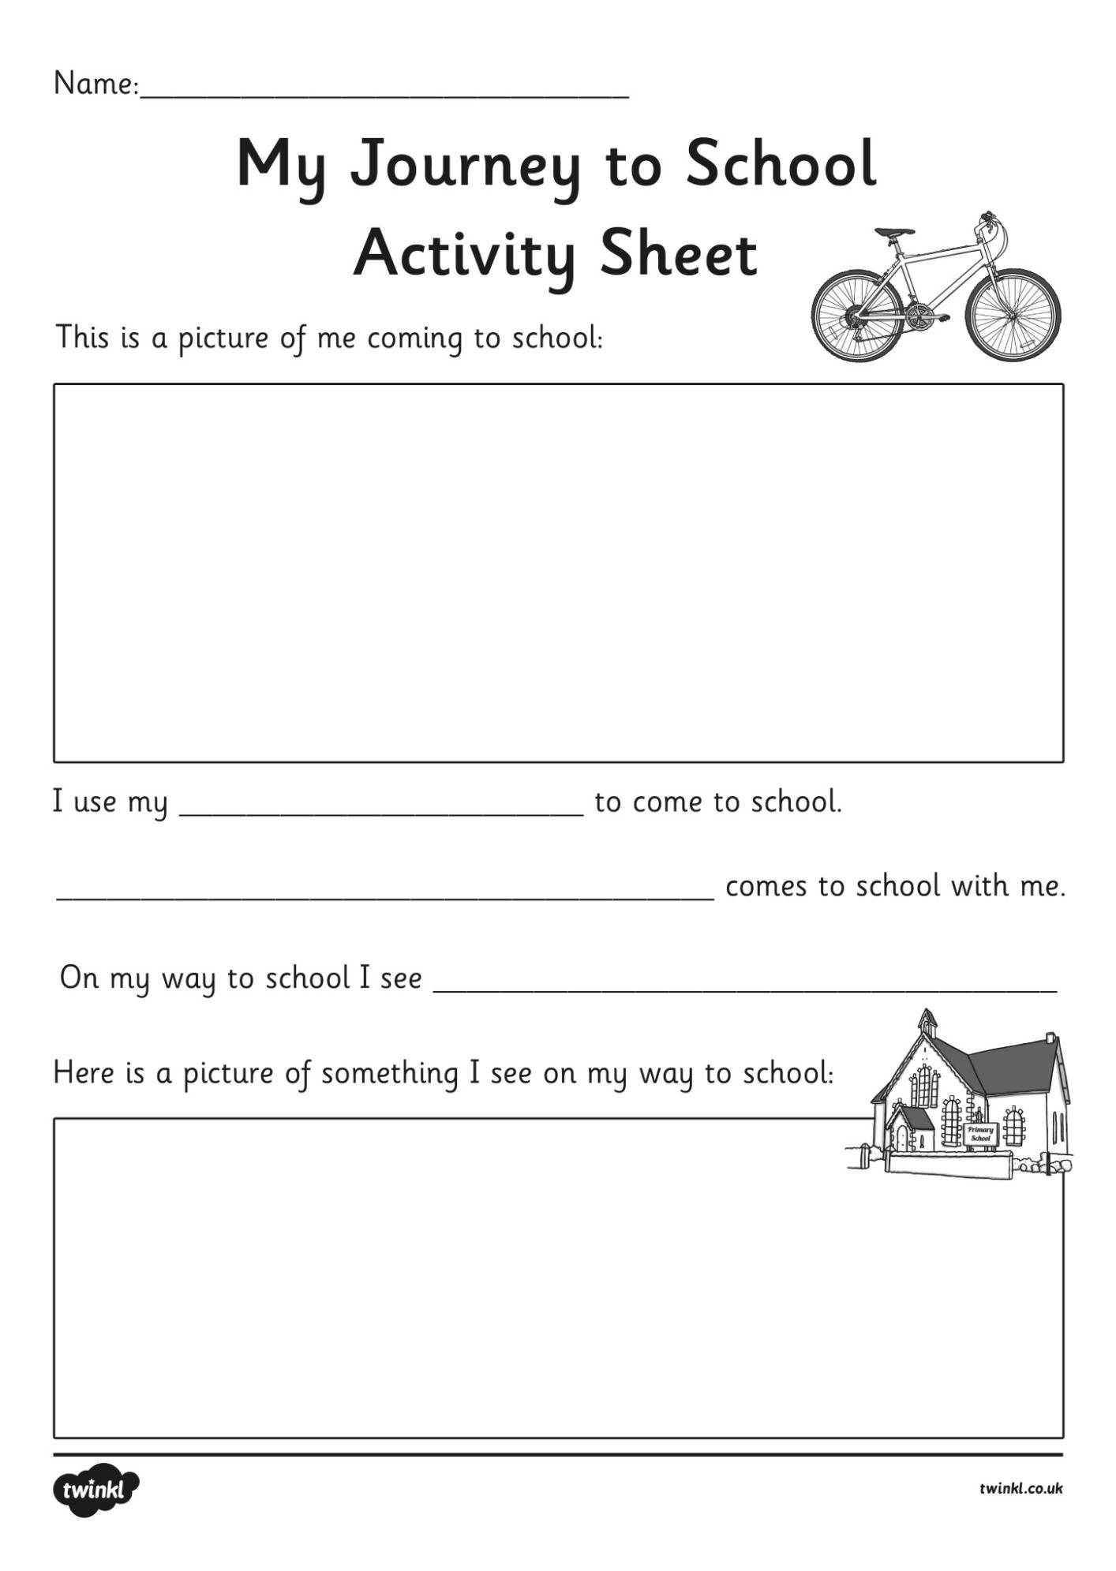

Transport: 1st/2nd class
What are the three types of Transport? 1. ____________________________
2.____________________________
3.____________________________

List 3 examples of each type of transport:

Water: Land: Air:
_______________ _______________ ______________
_______________ _______________ _______________
_______________ _______________ _______________

What type of Transport?
- Needs water to move? ________________________________
- Runs on rails? ________________________________________
- Can dig holes and move heavy objects? ___________________
- Has blades that make a circular shape? ____________________
- Might a farmer need to do his or her work? _________________
- Has a siren? ___________________________________________
- Has only two wheels? ___________________________________
Can hold many people? _________________________________

