Week Beginning – 20th April – Mrs. Barron – 2nd Class Numeracy
Teacher’s Name | Claire Barron
Class Level | 2nd Class
Week Beginning | 20th April
Email address | mrsbarronset@gmail.com

Dear Parent(s) / Guardians and children of course!
I hope you all had a lovely Easter and that everyone remains safe at home. I miss you all and look forward to seeing you all soon. In the meantime, Please do not hesitate to contact me via email address (provided above) if I can help you in any way.I am aware that your child will also be getting work from his/her class teacher so these are add-on activities if you wish. Do not feel under any pressure to complete work daily, as I am aware this is a very stressful time for parents who are working from home and caring for children of all ages! (I am getting many grey hairs myself!)
Continue to work daily on your tables. Pick one table each day and write it out.
Also, don’t forget to count in 2,s , 5’s and 10’s like we do in class. Set a timer on a phone and see can you beat your record counting to 100 each day. Keep a record each day and what how you improve.
This is a great game for revising maths concepts :
https://www.topmarks.co.uk/maths-games/daily10

Each week we will focus on one area of maths and I will include some activities to help with this. If I include worksheets – feel free to screen shot when complete and email to me for feedback!

Claire Barron

This week’s topic – TIME
Monday | Tuesday | Wednesday
Revision of the days of the week and months of the Year.  I will attach a print out of the days and months of the year. If you have no access to printer just write this on paper or back of a cereal box and cut out. Mix them up and place on table. Answer the following questions……  - Order the days of the week in the correct order.  - Order the months of the year in the correct order.  - What month comes before March?  - In what month do we celebrate Christmas?  - In what month do we celebrate St. Patrick’s Day?  - What two days are weekend days?  - Divide the months into spring, summer, autumn and winter.  - Challenge – Before school closed we learned a rhyme about how many days in each month…. See can you remember and group the months correctly. Put all the months with 30 days in one bundle, group the months with 31 in another. I will attach the rhyme to help you! | Complete worksheets below – Reading a Calendar and complete the sentences. Use your poem to help you! | Clocks  - Children will revise telling the time on analogue clock today. If you have the resources at home (even the back of a cereal box will do) you can draw around a plate, cut it out and make your own clock. Cut out 2 hands and place them on the clock to show different times. Your child should be able to tell – o’ clock, half past and quarter past.  - Complete the worksheet attached to revise the above.
Thursday | Friday
Children in 2nd class also learn how to tell the time using the digital clock for o’clock and half past intervals. This is a new concept this year so may be more difficult that the analogue clock. Please complete attached cut and paste worksheet today. Screenshot and send me a picture when completed if you can! | Here is a link to a good Youtube clip showing how to read time in digital and analogue clocks. Take a break from written worksheets today and watch the link!  https://www.youtube.com/watch?v=sAYiUZSRmk0  CHALLENGE – see can you work out this word problem today………  Tess picked 12 flowers on Monday morning. In the afternoon, she picked some more flowers. If Tess picked 27 flowers in all, how many did she pick in the afternoon?______________ Email me your answer if you can!

Days of the week and Months of the year – Cut out for Monday’s activity
Monday | January
Tuesday | February
Wednesday | March
Thursday | April
Friday | May
Saturday | June
Sunday | July
 | August
 | September
 | October
 | November
 | December

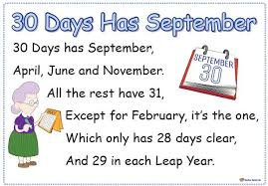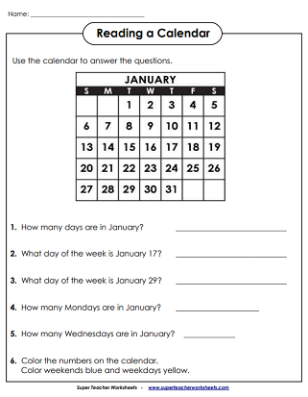

Tuesday’s Worksheet – Fill the blanks.

There are ______ days in a week.
There are ______ seasons in a year.
There are _______ months in a year.
In a leap year February has _______ days.
Usually February has _______ days.
There are ______ days in August.
How many months have only 30 days? _______.

Wednesday’s Activity
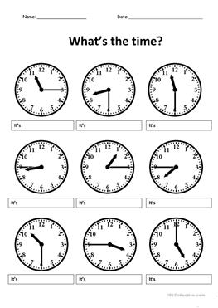
Thursday’s Activity
In Second class, we also learn how to tell digital time in o’clock and half past intervals. Here is a cut and stick activity where you must match the correct times together. Apologies for the quality of the print I could not manage to convert the file correctly.
