Teacher’s Name | Claire Barron
Class Level | 2nd Class
Week Beginning | 27th April
Email address | mrsbarronset@gmail.com
Message from Mrs. Barron | Thank you all for replying to emails last week. I am delighted that you are all keeping well and staying safe. This week we will focus on 2D shapes. I am aware that you are also getting work from your class teacher so just do what you can here! PLEASE DO NOT FORGET TO WORK DAILY ON YOUR TABLES AND COUNTING IN 2’s, 5’s and 10’s up to 100.

This week’s topic – 2D Shapes
Monday | Tuesday | Wednesday
- Revision of 2D shapes – circle , square, rectangle, semi-circle, oval  - Scavenger Hunt – Use the template attached to go around the house and see can you find examples of the shapes. E.g. bottle top =circle, lunchbox lid=rectangle | 1.Play the memory game attached.  2. Complete the worksheet attached which explores and revises how many sides and corners each shape has. | - Folding Shapes  Cut out the shapes attached and see can you fold them in half and quarters.  Following on from this, fill in the blanks on the attached worksheet.
Thursday | Friday
Symmetrical Shapes  - We found yesterday that some shapes can be folded equally. Today we will look at shapes and see can we divide them in half to make both sides equal – symmetrical. Some shapes can be divided in more than one way! | Here is a link to a fun song about Symmetry!  https://www.youtube.com/watch?v=SJlhywRfvh8  Find a plate in the shape of a circle. Add a treat to the plate and enjoy as it is Friday! Keep up the good work everybody!

Monday’s Activity – Go on a shape hunt! See can you find 3 examples of each shape in your home. (triangle and oval may be tricky!)
Circle | 1.  2.  3.
Rectangle | 1.  2.  3.
Semi-circle | 1.  2.  3.
Oval | 1.  2.  3.
Square | 1.  2.  3.
triangle | 1.  2.  3.

Tuesday’s Activity (play this memory game with someone at home) – cut up and place face down on the table. Pick 2 cards up. If the description matches the shape you can keep the cards. See can you match the shape to the correct description. Winner is the person who has the most pairs at the end of the game.

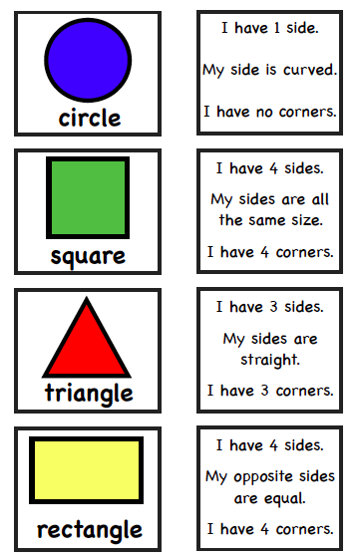
Tuesday’s Worksheet B – Complete the table
Shape | How many sides? | Are they equal – write yes or no | How many corners?
Oval

Square
Rectangle

Circle
Semi-circle
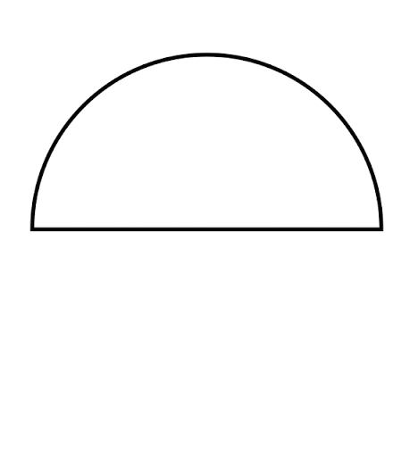

Triangle

Wednesday – Cut and Fold the following shapes as directed.
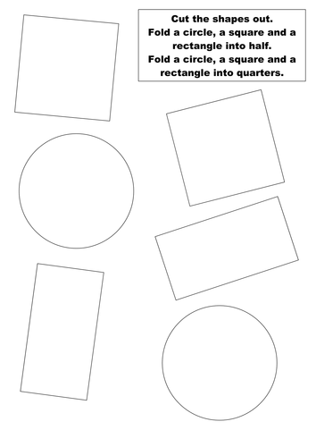
Wednesday – Fill in the blanks… ( you can print this page or just complete orally)

When a square is divided in half you get 2 equal _________ or 2 equal _________________.

When a square is divided in quarters you get 4 equal ________________ or 4 equal _________________.

When I join 2 triangles together I can make a _________________.

When I halve a circle I get 2 _________________________________.

Thursday’s Worksheet – Lines of Symmetry
Draw in the lines of symmetry that you can see.
