Teacher’s Name | Claire Barron
Class Level | 2nd class
Week Beginning | 27th April
Email address | mrsbarronset@gmail.com
Message from Mrs. Barron | Thank you for all your lovely emails during the week. I am glad that everyone is keeping well and staying safe. This week we will continue once again with Recount writing.  - SNIP LITERACY  If your child completes the class-spelling test on a Friday they do not need to do these activities. ( I have emailed all parents whose children do not need to do the SNIP programme). For the children doing SNIP there has been some confusion as some children do not have a copy of their spellings home with them and cannot access the programme. From this week on, I suggest that we all follow the same session. I will attach the session to the end of the activities. If your child has completed this session already it will still be a great way to revise and relearn.

Monday | Tuesday
SNIP LITERACY – Begin activities for this week’s spellings (see note above)  Fry words – continue reading through the Fry words with your child. This booklet should be an orange colour and is included in your child’s folder. These words are the most commonly used words used in English reading so it is important that your child can read many of these words from sight.  Once you have reached 5 words that you are unsure of…….write them out and find out the meaning of the word. Stick these words randomly around the house on the doors. Each time you open the door you must read the word on the door and put it into a sentence. Challenge – Every time you open the door, you must think of a different sentence! ( I have an email attachment of all the words if your child forgot to bring the orange words home. Please email me and I can send it to you. | RECOUNT WRITING  Genre Focus this week - RECOUNT  Read the story attached called – A Day out  WRITING  Write a recount of a great day out that you had with family and friends. Use the template attached
Wednesday  Continue with SNIP  Continue to practice the 5 words from your Fry words,  Revision – Read the two recounts attached and circle all the nouns. Remember a noun is a name of a person, place or thing! | Thursday  A Special Event – Read the recount of a special event attached.  Now, think of an event that happened in school and write a short recount about it. Email me the finished product if you can!
Friday
Pick an audio book with your parent from the link below. Sit back and enjoy!
https://www.worldbookday.com/world-of-stories/

Monday’s Activity – Write a draft recount of a great day out that you had.
The Day Out
Title

How you got there:

What you did:

What you liked best

How you felt about it:

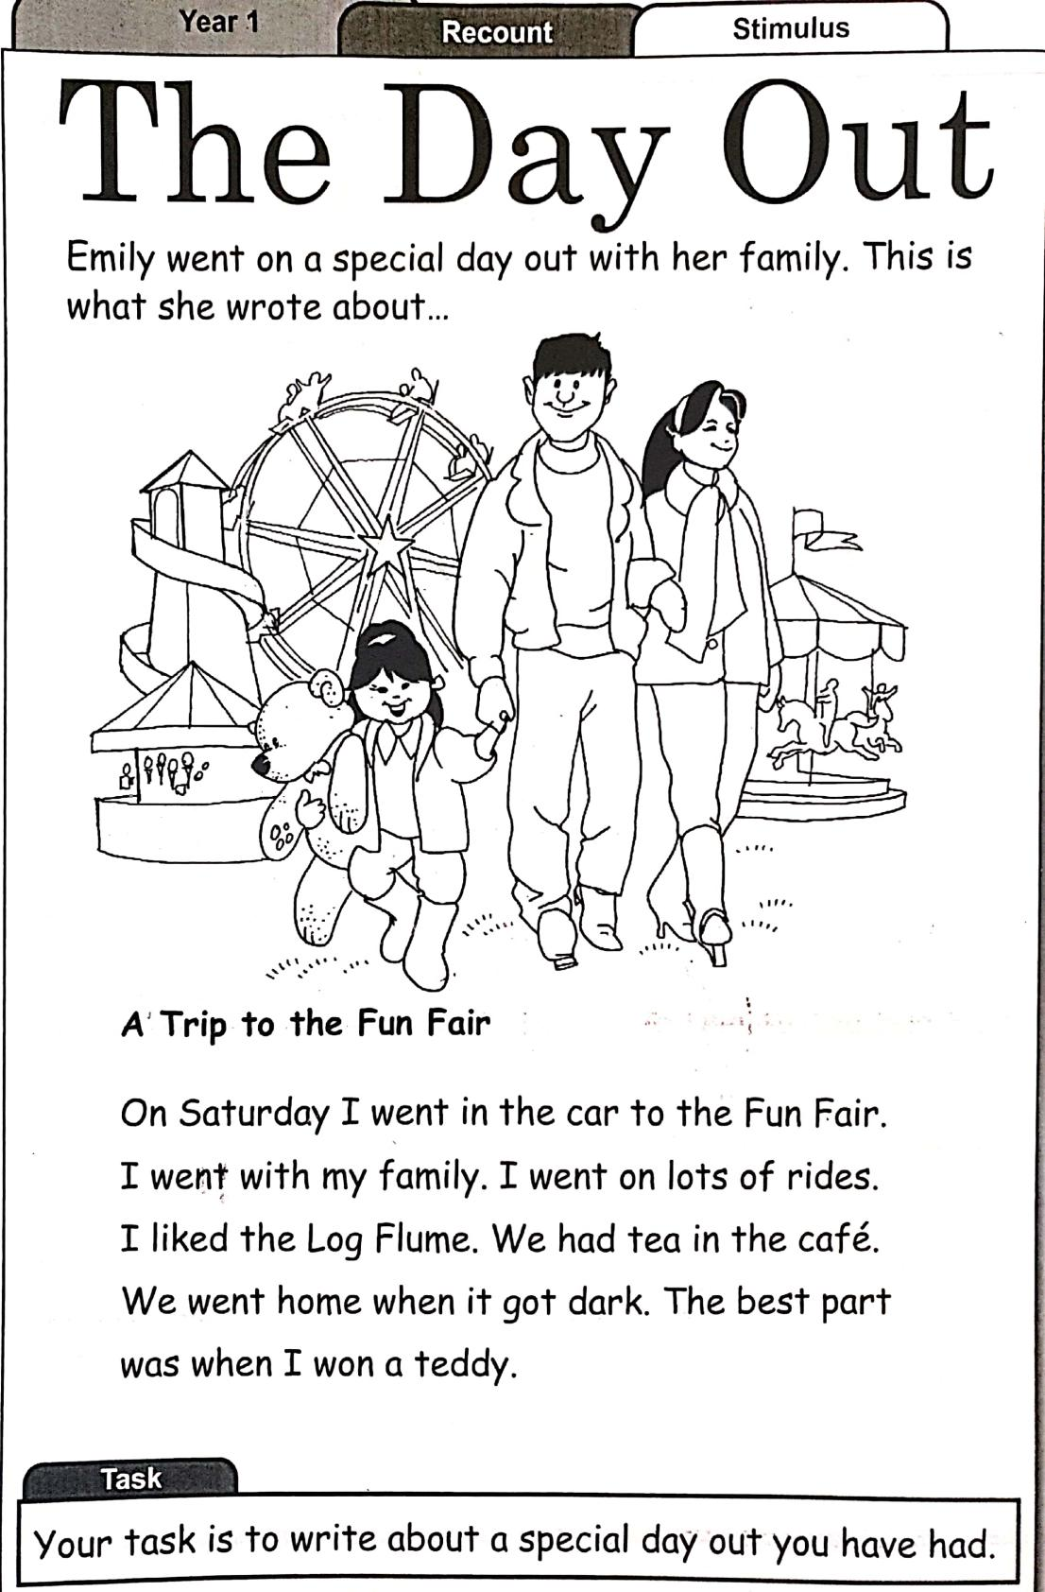

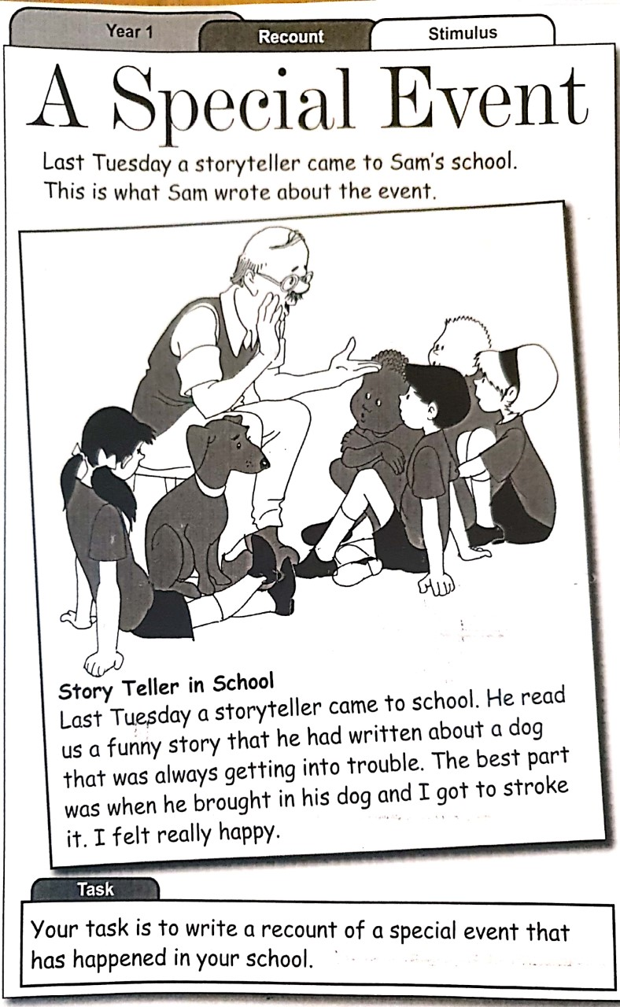

Thursday’s Activity – Write a draft recount of a special event that happened at school
The Special Event
Title

What happened?

The best part was:

How I felt:

Draw a picture to illustrate the special event

Here is a copy of Spellings for this week and the activities to match. Please complete a little each day.
Session 9

Look, say, cover, write and check - once a day

but
could
do
good
her
love
make
night
one

Tracking - can you find the words hidden twice in each line?
Say the letters out loud as you circle them - write them at the end

but acmgbolgenducsltplabuindmtyirit

could ydclouthledracakdiomiushtdltdrt

do sfgrioldarmcoftbfdahionskmtigh

good beigcoamourlbtdcrigeomlollditre

her ebsahelokicyvrlepbhmeolvtlrygio

love hgjleuornmvkapbejelourdmtvneit

make bmloianthakaedlrotmfiratfkoleyr

night nmriyrughehstnomjufiosgrhlenty

one floaftndouergasotlhailinkinefuhn

.........................

.........................

.........................

.........................

.........................

.........................

.........................

.........................

.........................

SNIP Literacy Programme 1 Session 9 http://www.snip-newsletter.co.uk

Read each sentence until you can remember it. Cover it with a card and write it out underneath.

Could we make another one?

Do we love her dog?

It was a good night.

Fill in the missing letters - time yourself.

but b _ t , b u _ , _ u t , _ u _ .........................

could c _ u l _ , c o _ l d , _ o u l d .........................

do d _ , _ o , _ _ .........................

good g _ o d , g o _ d , _ o _ d .........................

her h _ r , h _ _ , _ e _ .........................

love l o _ e , _ o v _ , l _ v _ .........................

make m _ k e , m a _ e , _ a k _ , .........................

night n i _ h t , n _ g _ t , _ i g _ t .........................

one _ n e , o _ e , o n _ .........................

SNIP Literacy Programme 1 Session 9 http://www.snip-newsletter.co.uk

Crossword
 |  |  | 1
 | 2
 | 3 | 4
 |  |  |  | 5
 |  | 6
 |  |  |  |  |  |  | 7
8 |  |  |  | 9

Across Down
3. One and _ _ _ make two. 1. We _ _ _ _ cakes at school.
6. Ten out of ten is a _ _ _ _ mark. 2. Our teacher asked us to _ _ our

8. All the class were here _ _ _ for Tom who was ill. 4.
work.
It is dark at _ _ _ _ _ .

9. We _ _ _ _ to take our dog for a 5. We _ _ _ _ _ go swimming at run. the baths.
7. The sheep called for _ _ _ lamb.

