Teacher’s Name | Claire Barron
Class Level | 1st CLass
Week Beginning | 27th April
Email address | mrsbarronset@gmail.com
Teacher Correspondence | Thank you all for sending messages last week. I have enjoyed hearing from you all. The plan for this week follows the same structure as last week. Do what you can!

This week’s maths focus is : 2D shapes
Monday | Tuesday | Wednesday
Literacy:  - Revision of the story “King Midas”. Please find attached page . Child must separate the words to majke proper sentences. Write the sentences correctly. Activity 2 – choose the write word (worksheet attached)  - Dolch Lists  Each child is on different levels on Dolch Lists. I provided Dolch Lists 1-11 in the pre-Easter lesson notes. Revise each list with your child until they come to words, which they are unsure of. Keep account of these words. When you get 5 of these words use these are your focus.  Game for Dolch words today – Open Sesame!!  Write out these words on sticky notes or pieces of paper. Stick them on random doors around the house. Every time you open the door today you must read the word and put it into a sentence orally. Every time you go to the door you must think of a different sentence! Get your family to join in!  NUMERACY  - This week we are focusing on 2D shapes.  - Activity – find example of 2D shapes at home (clock, lunchbox lid, window, book ) and around your home outside (door to shed, gate, basketball hoop) etc. | Word Family Focus  -ad, -ump, -ill and -ing  Please complete worksheet attached for Tuesday (This format is the same as last week)  Use the alphabet provided below to add the endings to each letter to see if your child can recognise the word. Your child to give thumbs up if it creates a word and thumbs down if it creates a nonsense word!  Write the words in copy or if possible print the sheet provided below. You can screenshot and sent to me when completed!  Please complete 2 columns today and 2 tomorrow.  NUMERACY  Shape Picture  Find some materials at home to trace around to make a 2D picture. Use your imagination and raid the cupboards (with permission of course!!) . You can find many shapes in the kitchen – the lid of a baby’s bottle will make a circle, your cereal box will make a rectangle, a bottle top will make a smaller circle. I am looking forward to seeing some creative pictures! | Complete the 2nd half of yesterday’s page.  Read the words on Wednesday’s page (attached) These are words using the endings we have already revised.  Sentence Dictation – Read the sentence aloud to your child and see can they write the sentence correctly.  - I will get the ring.  - Get the cat off the wall.  - We play in the hall.  - The rat is on top of the bin.  - Let me go into the hall.  NUMERACY  Cut out a square, semi-circle, circle, rectangle and triangle out of an old cereal box. Place on the table. Ask your child to listen and point to the correct shape –  - A shape with 4 equal sides (square)  - A shape with 1 curved side and 1 straight side (semi-circle)  - A shape with one curved side (circle)  - A shape with 2 equal long sides and 2 equal short sides (rectangle)  - Describe the remaining shape
Thursday | Friday – ICT day!
Magic e with a.  Revise magic e by listening to this new Youtube clip: https://www.youtube.com/watch?v=c3oA4wfUBak  Complete the Magic e with o worksheet attached.  NUMERACY  Worksheet attached – Shape Man | Read one of the stories on oxfordowl.co.uk ( the link to sign up was provided last week.  Cut and paste activity – magic e with o (attached)  NUMERACY  Here is a link to an online geoboard (this is a board with pegs that you add elastic bands to and stretch to make shapes) Your child can play with this and make their own 2d shapes!  https://apps.mathlearningcenter.org/geoboard/

Monday’s Activity - Separate the words to read and write the sentence correctly. Don’t forget your cursive writing!

KingMidaswasnothappy.

KingMidashadlotsandlotsofgold.

TheKinglovedgold.
_____________________________________________

Hedreamsofgold.

KingMidaswantedmoregold.

Activity 2 – circle the correct word.
The (King,kick) ____________was sad.
King Midas (loved, liked)____________gold.
He had (lost,lots)________ of gold.
King Midas wanted (more, most)__________ gold

Tuesday and Wednesday (complete 2 columns each day)
a b c d e f g h i j k l m n o p q r s t u v w x y z
-ad | -ump | -ill | -ing

Reading List for Wednesday. You can use twistable to highlight the endings if you wish. As an added activity why don’t you use one colour for each ending e.g. colour all –ad words green, -ill words red etc.
- Had
- Bump
- Till
- Sack
- Ring
- Top
- Hill
- Fill
- Bat
- Lump
- Sent
- Mad
- Pill
- Back
- King
- Tall
- Dump
- Bad
- say

Thursday’s worksheet
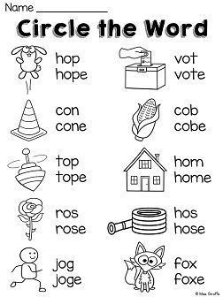

Friday’s worksheet
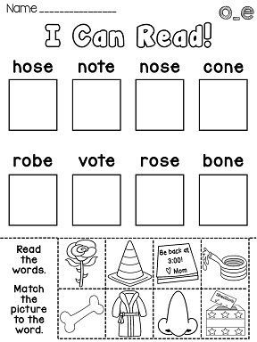

Thursday Maths Activity
