Mrs Mahoney
Thursday & Friday
Group of 3 boys 5th/4th class

SET

Suggested work for:- week beginning 27th April

Teachers email address mrsmahoney1@icloud.com

Correction of work;-
work that has been highlighted should be submitted to my e-mail address above. This can be done by taking a photograph of the work or answers can be typed into an email and then emailed to me. Please make sure that the child’s name is in the subject part of the e-mail. Work that is not highlighted can be marked by an adult, parent or carer.

Messages from Mrs Mahoney:- Hi there I am aware that over the last couple of weeks I have planned a lot of work for your child on top of the work that they have received from their class teacher .So I am going to give them a little less. I am also going to leave it to your child to decide which piece of English they would like to submit. Please could you submit one of the maths tasks too. Thank you for taking the time to work with your child and helping to continue their education during these difficult times. But please remember that you and your child are not excepted to work the same hours as normal school hours. Enjoy the good weather whilst it is still here.

DON’T FORGET tune into the RTE Home School Hub every day at 11:00

LITERACY

Pre reading and Reading THURSDAY

Read how to play Pilolo

- Look at Genre Analysis and answer questions 1,2, and 5
- Look at comprehension activities and questions 1-3 in Remember
- Look at comprehension activities and questions 1, 3, and 4 in Think

Writing FRIDAY

Research a children’s game from another country and using the writing frame below tell me about the game
Title
How to play
- Players:
- Equipment:
- How to play:
Additional information

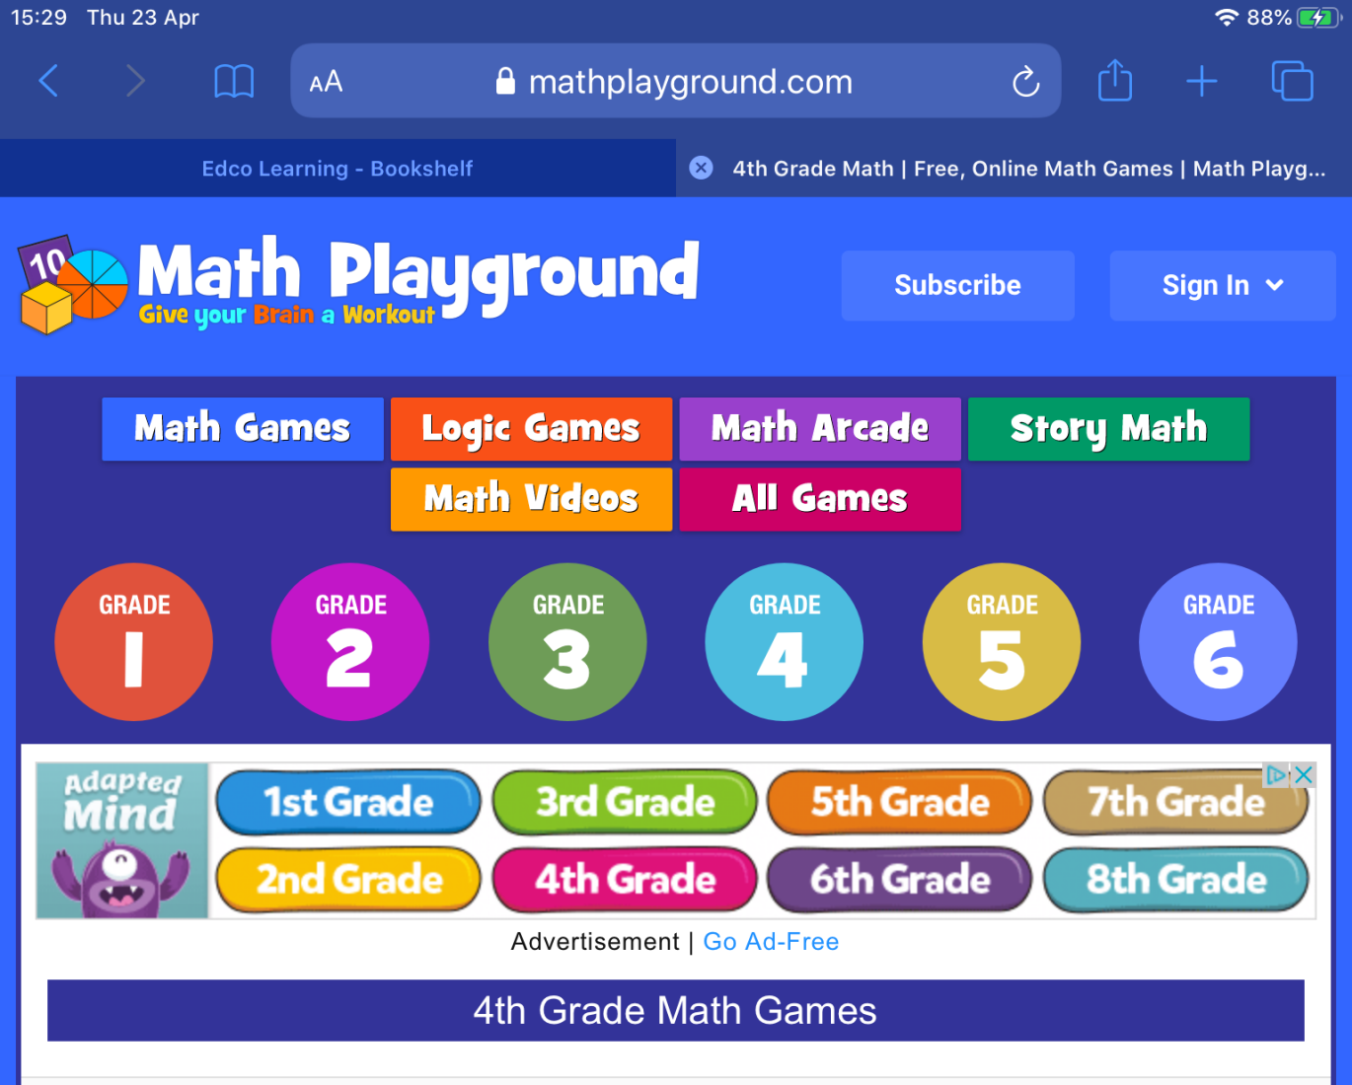

A LITTLE NUMERACY PRACTISE

Go to website mathsplayround.com
click on grade 4 circle
then scroll down and you will see a range of games
please select

Monday – Make a number
Tuesday – multiplication lots of coloured squares with numbers
Wednesday – alien angle
Thursday – math monster fraction
Friday – identify coordinates

