Mr. Mac Mathúna 6th Class Work for week 3 and Easter
MATHS-
WEEK 3. Mental Maths Week 23, p.68-70. Planet Maths , Topic-The Circle p.141-145. Activity Sheet-Topic 23 p.167. Planet Maths, The Virtual World of Quest p.146/147.
ENGLISH-
WEEK 3 English in Practice Day 65-69.
Treasury-Read p.37. Answer A,B and C. Read p.38. Answer A and B.
Novel Holes-Read Chapters 45-50 and do worksheets.
Watch Holes, the movie on Youtube.
Fireworks- Lights, Camera Action Read p.66-70 and Do A,B,C and D.
GEOGRAPHY
WEEK 3 Geography Quest Chapter 15, Rivers of the World. Do Activity A 1-5. Activity B 1-6. Activity D 1-7. Activity E 1-8.
HISTORY
Do Activity D, E and F p.102 and 103 History Quest 6

Hi everyone. I hope you are all keeping well. Enclosed in this document, I’ve included some work for Week 3 & some Easter ideas. FEEL FREE TO COMPLETE WHAT YOU CAN AND DON’T BE PUTTING PRESSURE ON YOUR PARENTS. I’ve attached quite a bit, but pick and choose what you are able to cope with.
Below are details for all of the book companies, who have given free access to their books online.
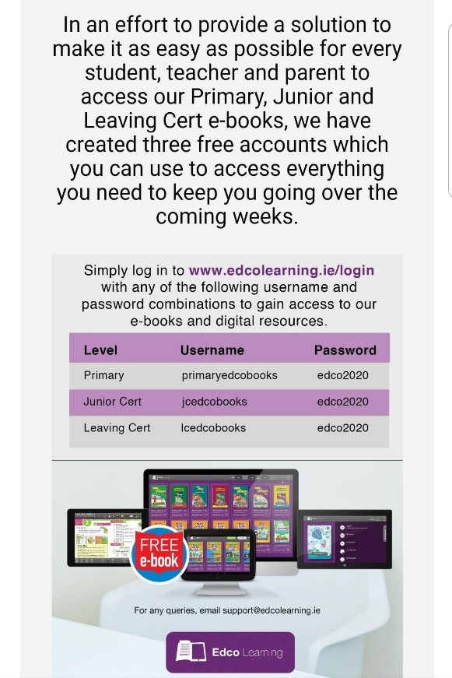
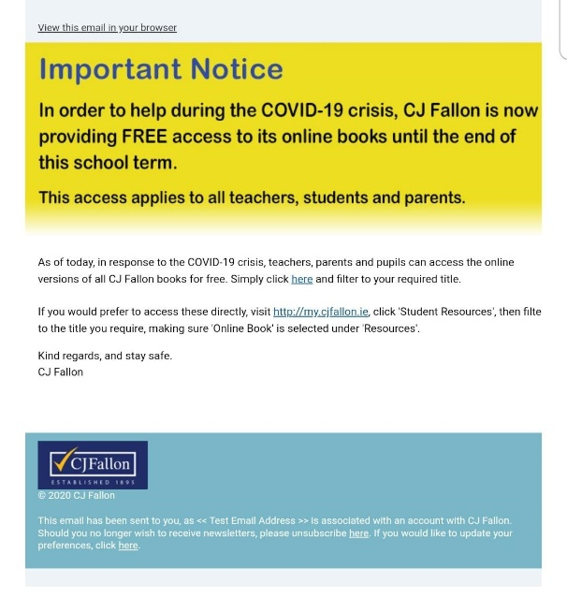

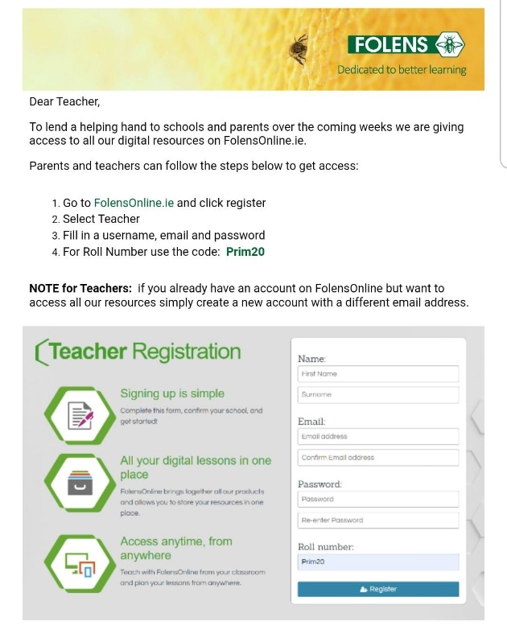

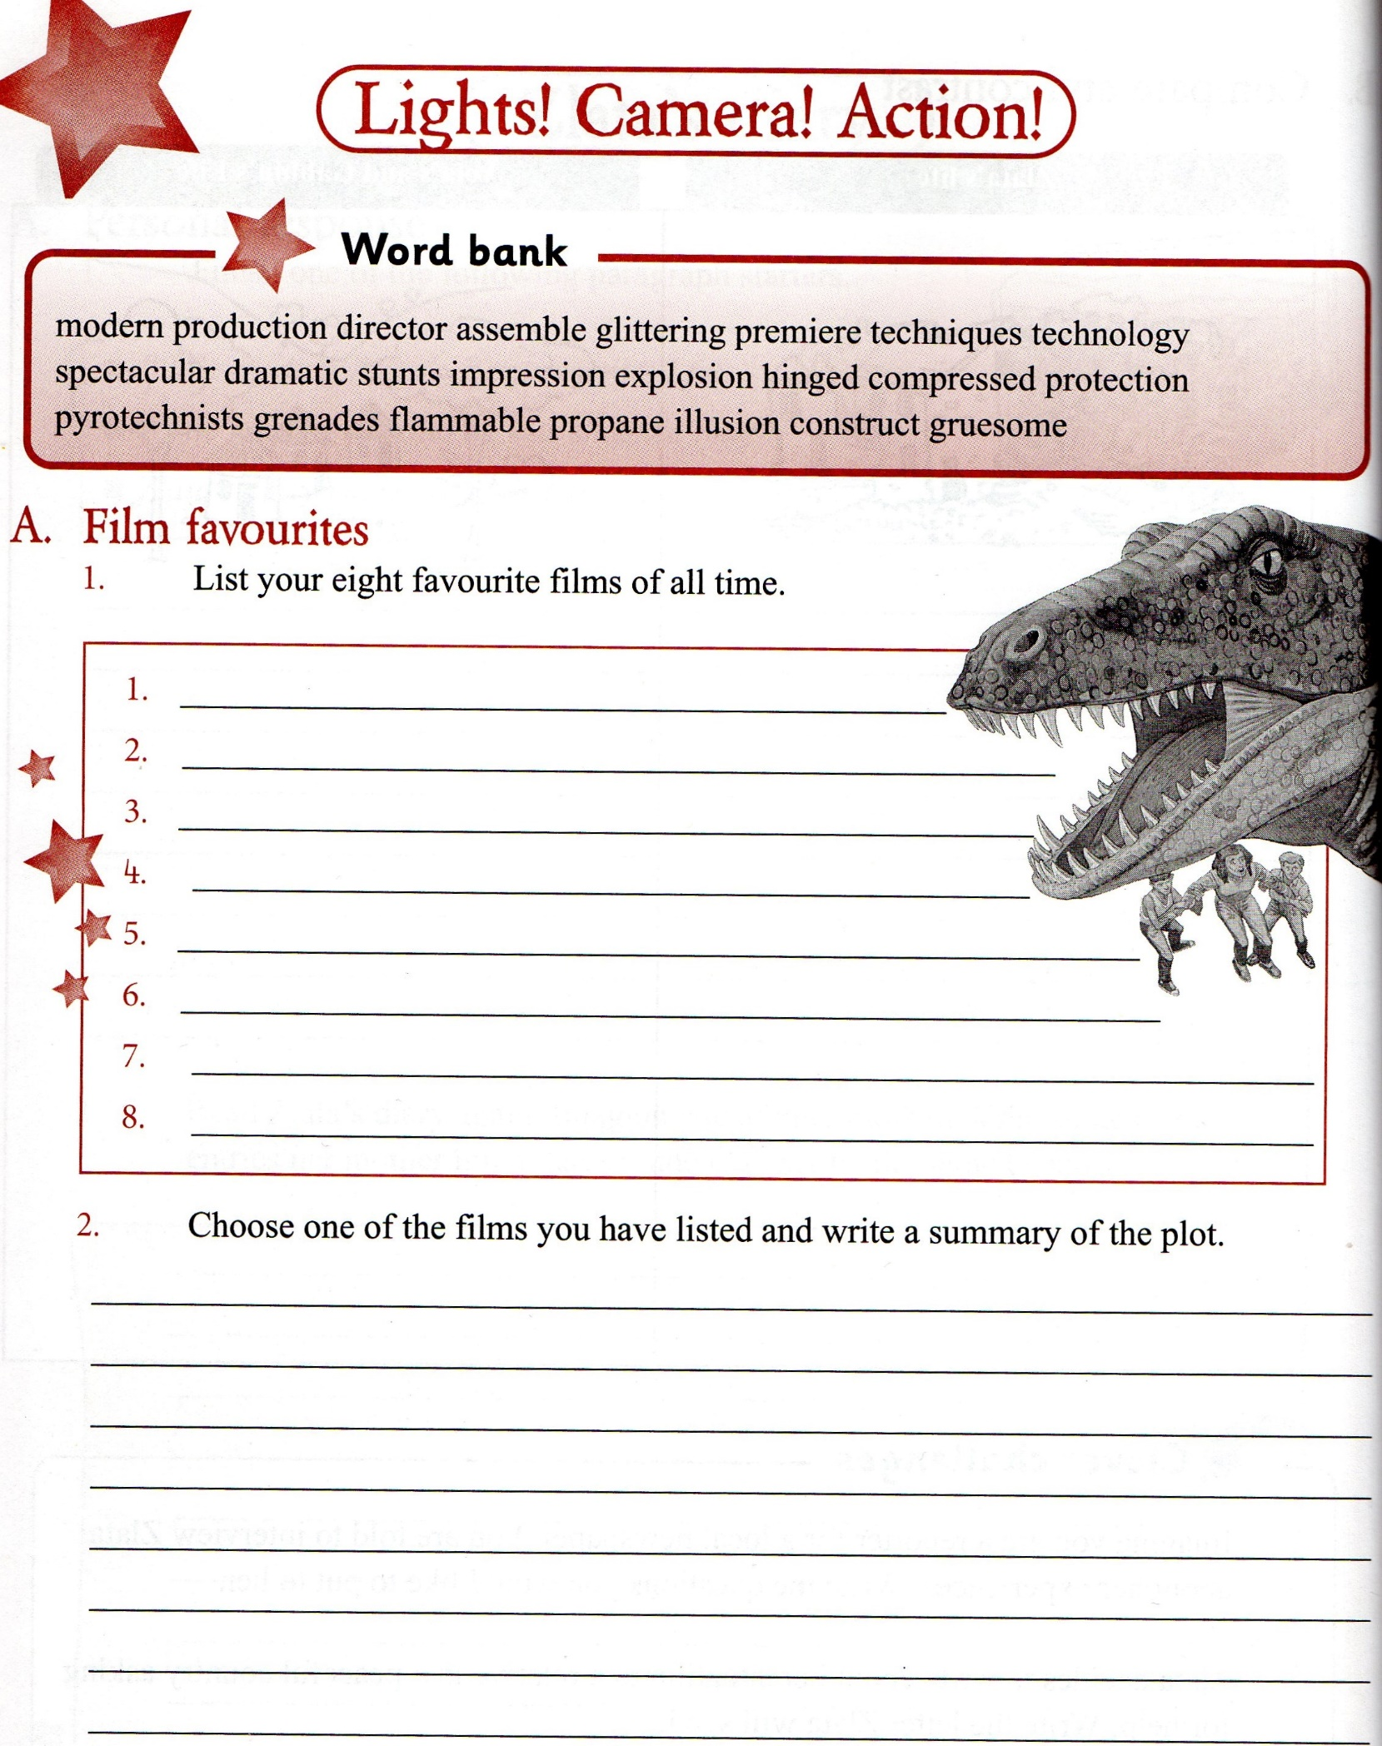

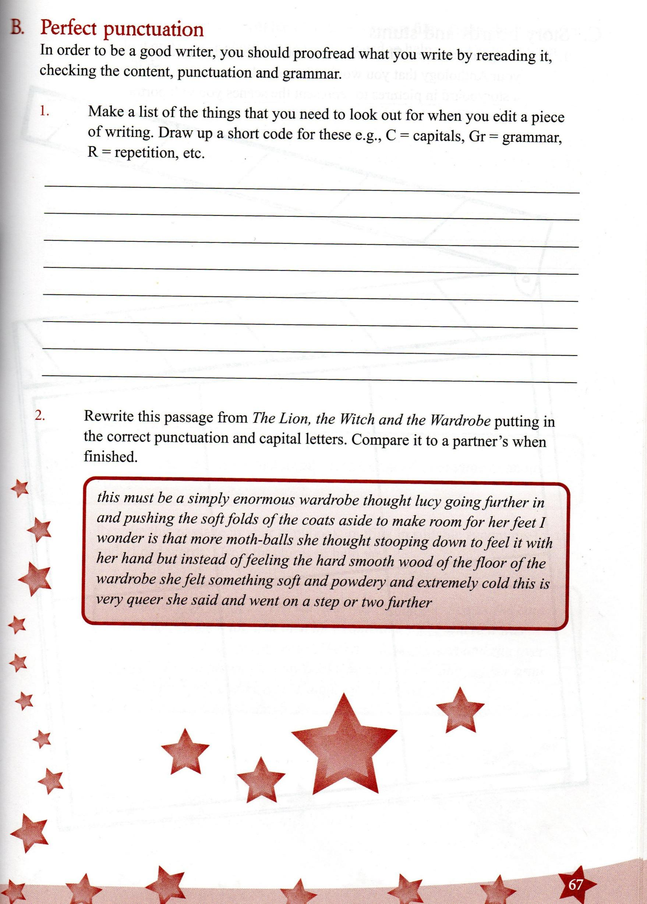

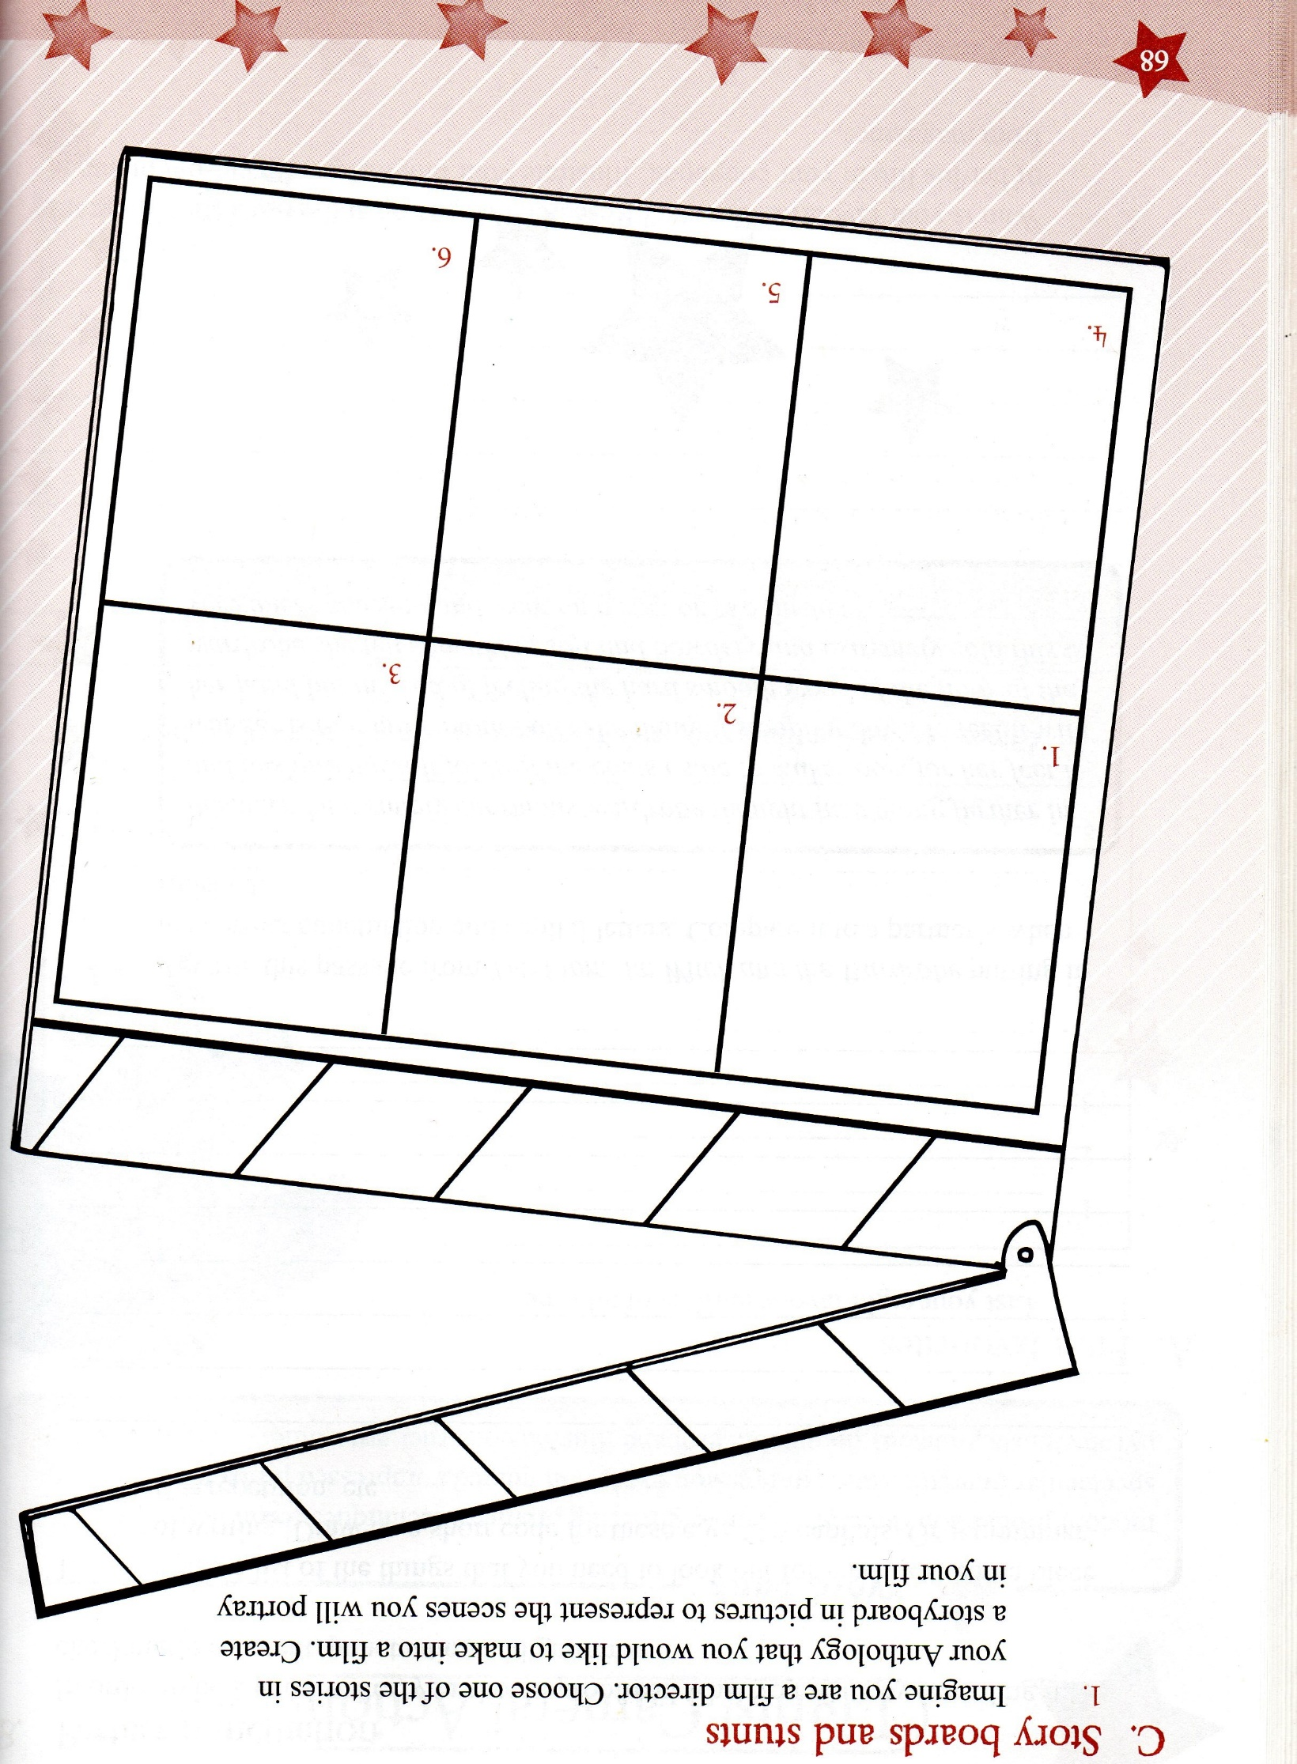

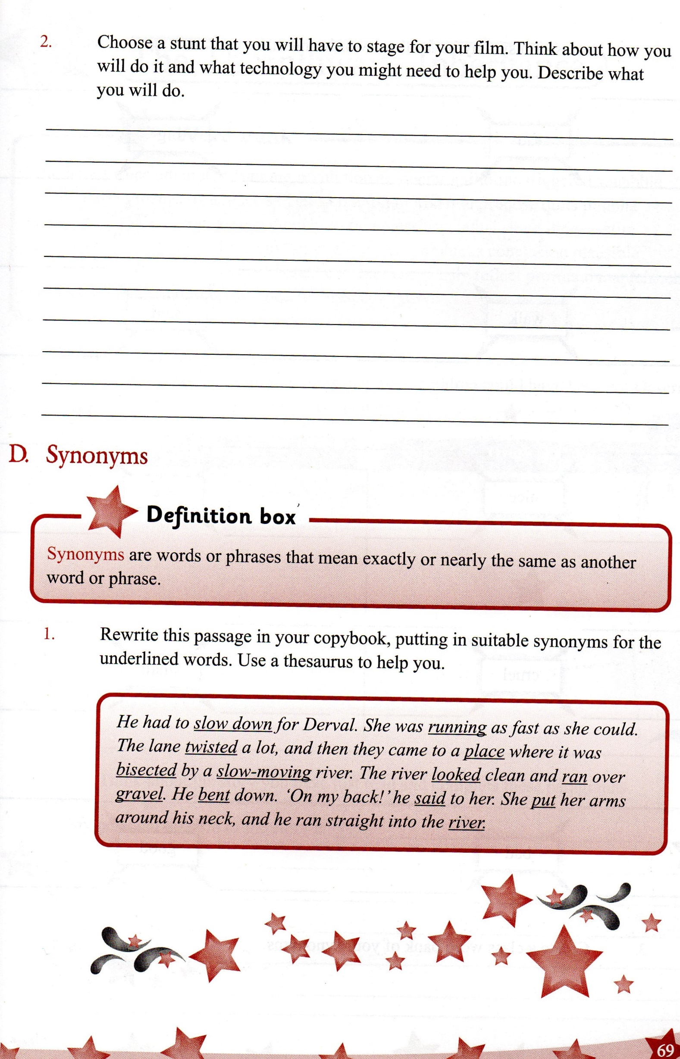

Art/Project Work/PE

- Design a motivational poster for kids. Make it colourful and encouraging!!
Check out the following link for help, or run with your own idea
https://www.google.com/search?q=motivational+posters+kids&rlz=1C1SQJL_enIE800IE800&sxsrf=ALeKk02aofNJZmbYjyiwNSYr7JjcUQs7gA:1585310210791&source=lnms&tbm=isch&sa=X&ved=2ahUKEwiK--PfzLroAhWxWhUIHYPrDuwQ_AUoAXoECAwQAw&biw=1920&bih=888

- Make an Easter egg hunt around your house for your family. Think of clues (make some nice and hard for your parents!!!) and hide them in various rooms. If you have any younger brothers/sisters, they will love this.

- This week was to be International Week in Illistrin NS. We would still like to celebrate this with our families and the wider community. Maybe you could include a lesson on a country of interest to your family, listen to music from a different culture or so some art work from another country.
We are asking the school community to send some artwork, a song or piece of written work under this theme to illistrininternational@gmail.com. We will then compile the photos we receive to create a video for our website and Illistrin PA Facebook page. Let's work together to celebrate our school while staying apart!

- I’ve attached some Mindfulness Easter eggs for you to colour, if you feel like relaxing (Next few pages)

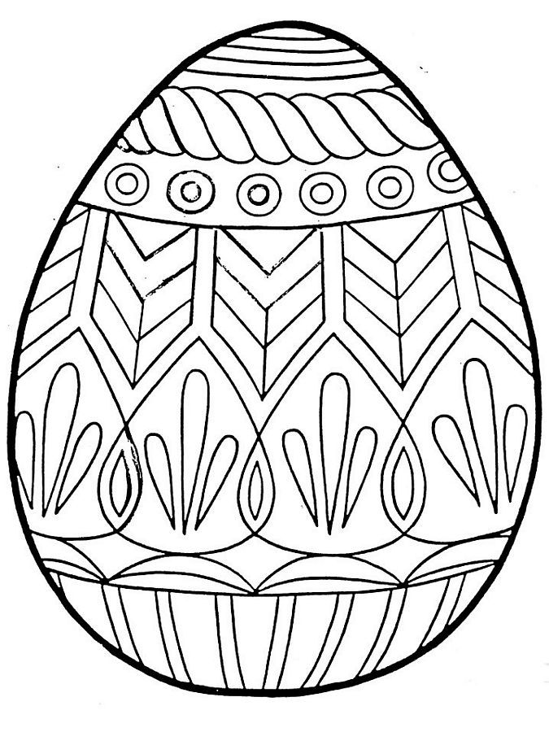

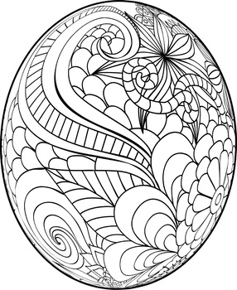
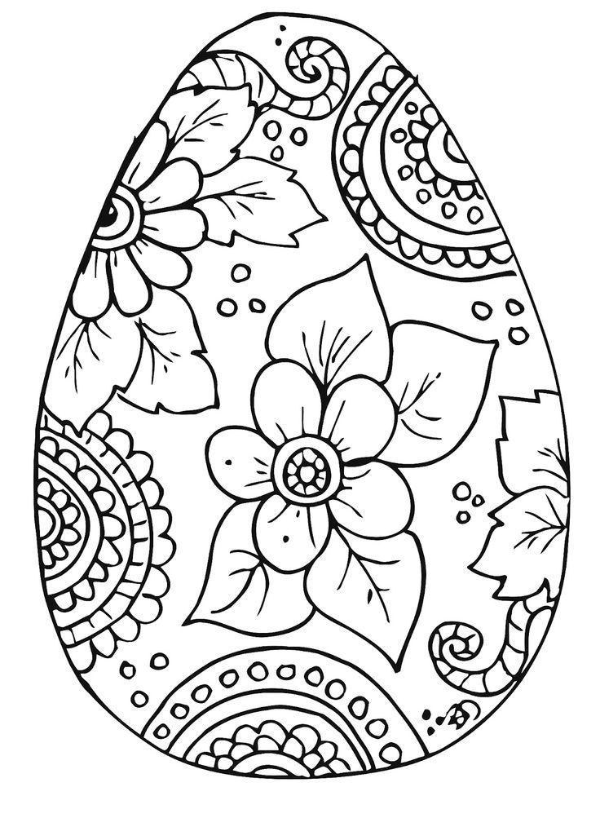

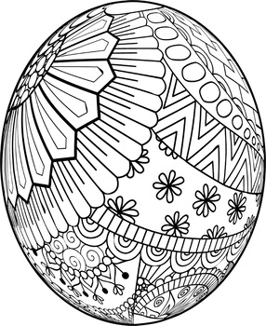

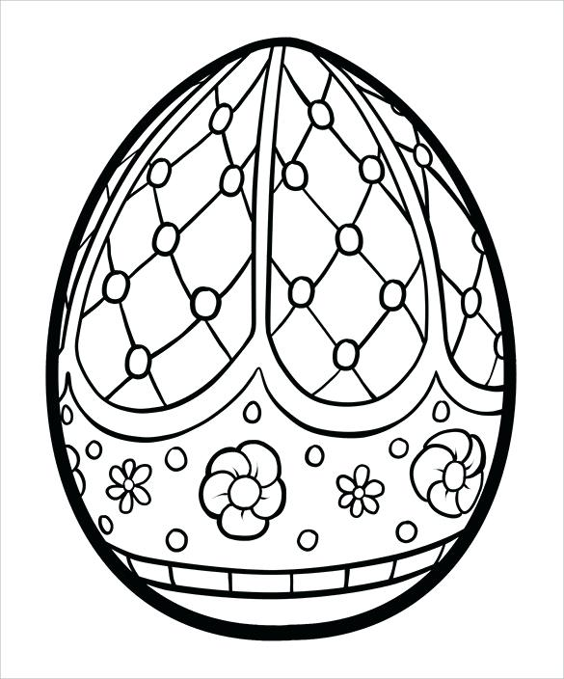

Free Online activities
9.00am - PE with Joe Wicks https://youtu.be/6v-a_dpwhro
10.00am - Maths with Carol Vorderman www.themathsfactor.com
11.00am - English with David Walliams https://www.worldofdavidwalliams.com/elevenses/
12.00pm - Lunch (cooking with Jamie Oliver) https://www.jamieoliver.com/feat…/category/get-kids-cooking/
1.00pm - Music with Myleene Klass https://www.youtube.com/channel/UCQh2wgJ5tOrixYBn6jFXsXQ
1.30pm - Dance with Darcey Bussel https://twitter.com/diversedance…/status/1241098264373592065
2.00pm - History with Dan Snow (free for 30-days) https://tv.historyhit.com/signup/package
4.00pm - Home Economics with Theo Michaels (Mon/Wed/Fri) https://www.instagram.com/theocooks
Non-daily events include:
Science with Professor Brian Cox, Robin Ince & Guests https://cosmicshambles.com/stayathome/upcoming-schedule
9.30am Wednesday 25 March - Geography with Steve Backshall https://twitter.com/SteveBacksha…/status/1242058846941712385
2pm Mon-Fri this week only; Animal Talks from Dartmoor Zoo https://www.facebook.com/252987758563/posts/10157595491153564/

