Teacher’s Name | Martin Kenny
Class level | 6th
Suggested work for  Week beginning | Monday 20th April
Teachers email address | mrkenny6thclass@gmail.com
Correction of work | Work that I have highlighted should be submitted to the appropriate teacher’s e-mail address above. This can be a photograph of the copybook page or the answers can be typed into the e-mail. Please write your child’s name in the subject part of the e-mail.  Work that is not highlighted should be corrected by an adult/parent.
Message from teacher/s | Hi everyone.  I hope you all had a lovely Easter and heaps of Easter Eggs!!  The weather is brilliant at the minute, so I hope you all are getting out in the sun. I’m sure you all have the potential to become brilliant fence painters/garden weeders/flower growers/car washers etc!!!  I’ve attached everything you need for the next week on this document. I’ve put in day by day work, to help give the kids a bit of structure. You can let me know if it’s too little/too much work for them by emailing me at the address above and we’ll adjust as best we can. As I said last time, FEEL FREE TO COMPLETE WHAT YOU CAN AND DON’T BE PUTTING PRESSURE ON YOUR PARENTS. Also make sure to help out at home as much as you can. Play with your brothers/sisters and help mum/dad out with any wee chores that you can do.  You can also email me if you have any queries or questions. Please write your child’s name in the subject box of the email.  I’d love to see some of your motivational posters for kids that you made before Easter. I might be able to get them up on the school website for all to see, if you don’t mind. I know you all will have made a fantastic job of them!!  I’m aware that not everyone has books/copies home with them due to the last minute nature of the closure, but all books are available online, if you have decent internet. I’ve attached the links to this document as well. I’ll try scan/photo relevant pages too where possible. Please don’t print out loads and loads of pages. There is no need to. Take turns to share computers/tablets with your brothers/sisters during the day and hopefully you’ll have time to get  Bye for now. Mr Kenny

Remember to tune into the RTE Home School Hub every day at 11.00

Monday | Tuesday | Wednesday | Thursday | Friday
Maths  Mental Maths  Week 29  Monday  Planet Maths  Chapter 24  Pg 150 B 1 2  Pg 150 C 1 2 3 | Maths  Mental Maths  Week 29  Tuesday  Planet Maths  Chapter 24  Pg 151 A  Pg 151 B (Calculator work)  Pg151 D | Maths  Mental Maths  Week 29  Wednesday  Planet Maths  Chapter 24  Pg 152 A 1 2  Pg 152 B 1  Pg 152 C | Maths  Mental Maths  Week 29  Thursday  Planet Maths  Chapter 24  Pg 153 A 1  Pg 153 B 1  Pg 153 C 1 | Maths  Mental Maths  Week 29  Problem Solving & Friday  Planet Maths  Chapter 24 Worksheet  Attached (You can answer on document and save it, use your copy, or print and answer and photograph it)
English  Holes  Chapters 41-43  Answer the questions | English  Holes  Chapters 44-45  Grammar  The Past Participle  Pg 67 Treasury F  (Page attached) | English  Holes  Chapters 46-47  Answer the questions | English  Holes  Chapters 48-49  Grammar  Similes  Pg 69 Treasury F  (Page attached)  Take a photo or save a Word Document if you want to type it | English  Holes  Chapter 50  Answer the questions
Irish  (A) Léígh an Scéal  Ag Sciáil san Iodáil  Pg: 106/107  Ceart nó Mícheart  See Below | Irish  (B) Cúpla Ceist  Pg: 108  Take a photo or save a Word Document if you want to type it | Irish  (D) Nathanna Nua  Pg: 109 | Irish  (I) Críochnaigh na habairtí 1-9  Cad a dúirt Colm?  Pg 110 | Irish  (K) Líon na Bearnaí  Pg: 111  Use English/Irish dictionary to help you  www.potafocal.com is also brilliant
Music/P.E.  See Note Below | Music/P.E.  See Note Below | Music/P.E.  See Note Below | Music/P.E.  See Note Below | Music/P.E.  See Note Below
Mini Project  Create a Bucket List Collage  Think of things you would like to do in your life, places you would like to go, people you would like to meet etc and get some picture/make some drawings of these things all on 1 page  (I’ve attached some suggestions, but feel free to go it alone. The sky’s the limit) | Geography  Read the 2 pages on Rivers & Waterways (Pgs 106-107 attached)  Answer questions 1-10 | History  Fill in the blanks in Activity D on World War 2 | Geography  Answer the worksheet on Rivers & Waterways  (Pg 66 attached) | Mini Project  Create a Bucket List Collage  Think of things you would like to do in your life, places you would like to go, people you would like to meet etc and get some picture/make some drawings of these things all on 1 page  (I’ve attached some suggestions, but feel free to go it alone. The sky’s the limit)

Below are details for all of the book companies, who have given free access to their books online.
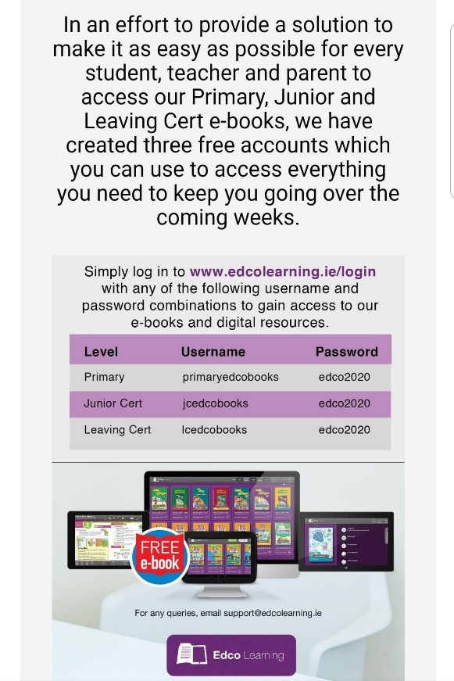
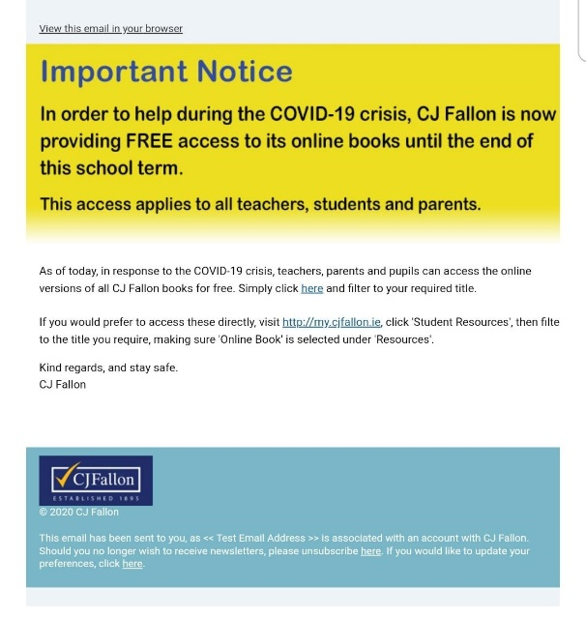

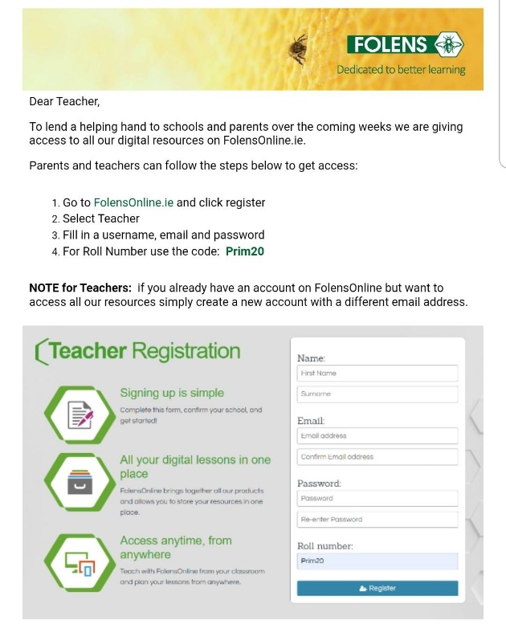

Maths
Planet Maths is available on https://www.folensonline.ie/
Planet Maths Pg 150/151 (Help Sheet)
Finding Percentage Profit or Percentage Loss

When you buy something and you intend to sell it, you can either make a profit (extra money) or a loss (less money). Obviously you would like to sell at a profit but it isn’t always the case.

So if I bought something for €10 (COST PRICE) and sold it later for €15, I’ve made an extra €5 (PROFIT).
I could also say I made a Percentage Profit of 50% by using the formula

Percentage Profit = $\frac{Profit}{Cost Price}$ = $\frac{€5}{€10}$ = $\frac{1}{2}$ = 50%

By finding how much extra money you have made, and dividing it by what it cost you, you can figure out your Percentage Profit

However, something might not work out and you end up selling an item for less than it cost you. Then we need to work out the Percentage Loss.

So if I bought something for €10 (COST PRICE) and sold it later for €8, I’m down €2 (LOSS).
I could also say I made a Percentage Loss of 20% by using the formula

Percentage Loss = $\frac{Loss}{Cost Price}$ = $\frac{€2}{€10}$ = $\frac{1}{5}$ = 20%

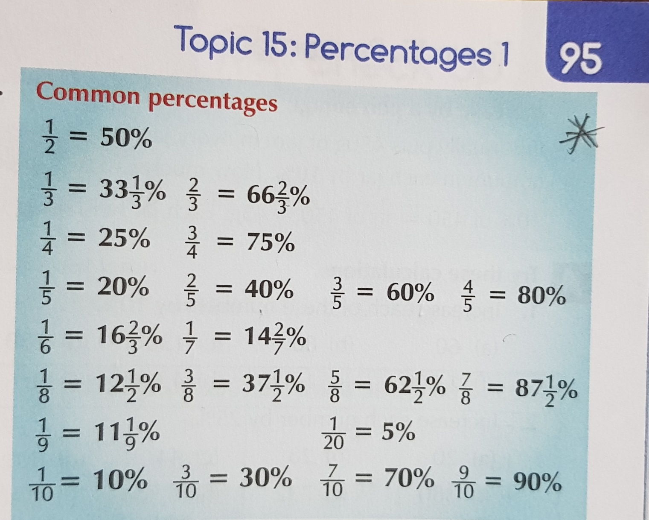
Planet Maths Pg 152 (Help Sheet)
Simplifying Fractions (Part A)
When you are presented with a fraction and it looks quite tricky, try and find smaller numbers (factors) that will divide into a number on top of the fraction (numerator) and the bottom of the fraction (denominator). It has to be the same number.
Look at this following example
$$\frac{12 x 15}{5 x 4}$$
You should notice that 5 will divide into both the top line and the bottom line, so let’s do that (15÷5=3 and 5÷5=1)
$$\frac{12 x 3}{1 x 4}$$
You might also notice that 4 will divide into the top and bottom lines as well. (12÷4=3 and 4÷4=1). So now our sum looks like this
$\frac{3 x 3}{1 x 1}$ = $\frac{9}{1}$ = 9

Planet Maths Pg 152 (Help Sheet)
Finding the cost price of an item, when you’ve been given the selling price and the percentage profit or percentage loss
The cost price of something is 100%.
If you make a profit, you will add to the 100%.
If you make a loss you will subtract from the 100%

Example 1 (PART B)
I sold an item for €40 which gave me a percentage profit of 25%
Cost Price + Profit = Selling Price
100% + 25% =€40
125% = €40
What I need to find is how much money is 100 worth.
I divide my €40 by 125, which gives me 1%,
Next I multiply by 100 to get 100%
€40÷125 =0.32 (1%)
0.32 x 100 = €32 (100%) which is my COST PRICE (This is what I paid for the item in the beginning)

Example 2 (PART C)
I sold an item for €45 which gave me a percentage loss of 10%
Cost Price + Profit = Selling Price
100% - 10% =€45
90% = €45
What I need to find is how much money is 100 worth.
I divide my €45 by 90, which gives me 1%,
Next I multiply by 100 to get 100%
€45÷90 =0.50 (1%)
0.50 x 100 = €50 (100%) which is my COST PRICE (This is what I paid for the item in the beginning)

Planet Maths Pg 153 (Help Sheet)
Interest
(Note to Parents: We only deal with simple interest at this stage. We don’t expect the children to work out compound interest, which involves paying/getting interest on the loan/deposit as well as interest on the actual interest in the second and following years.)

If you decide to save money in the bank/credit union/post office etc, they will add a small amount of interest each year to your money. The interest amount that you will get is called the Interest Rate.

For example, if you have €100 in a bank and the interest rate is 2%, at the end of 1 year, you will have €102 in the bank

Example 1
If the interest rate is 5% and I have €100 euro in the bank.
5% of €100 is €5
After 1 year I will have €105
After 2 years I will have €110

Example 2
If the interest rate is 4% and I have €160 in the bank
4% of 160 is €6.40
After 1 year I will have €166.40
After 2 years I will have €172.80

Chapter 24 Work Sheet
1. Calculate the profit in money and as a percentage on each item.
Cost Price | €48 | €20 | €35 | €60 | €21 | €80 | €63 | €66
Selling Price | €54 | €25 | €42 | €90 | €28 | €88 | €70 | €77
Profit € | €54 - €48 = €6
Profit % | $\frac{6}{48}$ = $\frac{1}{8}$ = $12\frac{1}{12}$%

2. Calculate the loss in money and as a percentage on each item.
Cost Price | €72 | €48 | €88 | €72 | €40 | €36 | €90 | €75
Selling Price | €60 | €36 | €77 | €36 | €36 | €24 | €81 | €60
Loss € | €72- €60 = €12
Loss % | $\frac{12}{72}$ = $\frac{1}{6}$ = $16\frac{2}{3}$%

3. Simplify these.
(a) $\frac{4 x 9}{15 x 8}$ __________ | (b) $\frac{2 x 10}{25 x 4}$ __________ | (c) $\frac{6 x 7}{35 x 6}$ __________
d) $\frac{8 x 5}{10 x 16}$ __________ | (e) $\frac{9 x 2}{8 x 27}$ __________ | (f) $\frac{10x 12}{12 x 10}$ __________

4. Sports Goods Bought and Sold. Fill the blanks in the table.
 | Bought for | Sold For | € Profit / Loss | % Profit / Loss
Tennis Racquet | €60 | €72 | € | %
Surf Board | €40 | €60 | € | %
Badminton Racquet | €20 | €18 | € | %
Sail Board | €150 | €180 | € | %
Golf Clubs | €220 | €231 | € | %
Wet Suit | €30 | €27 | € | %
Squash Racquet | €98 | €112 | € | %
Fishing Rod | €117 | €130 | € | %
Racing Bicycle | €260 | €292.50 | € | %
Set of Jerseys | €72 | €99 | € | %

English

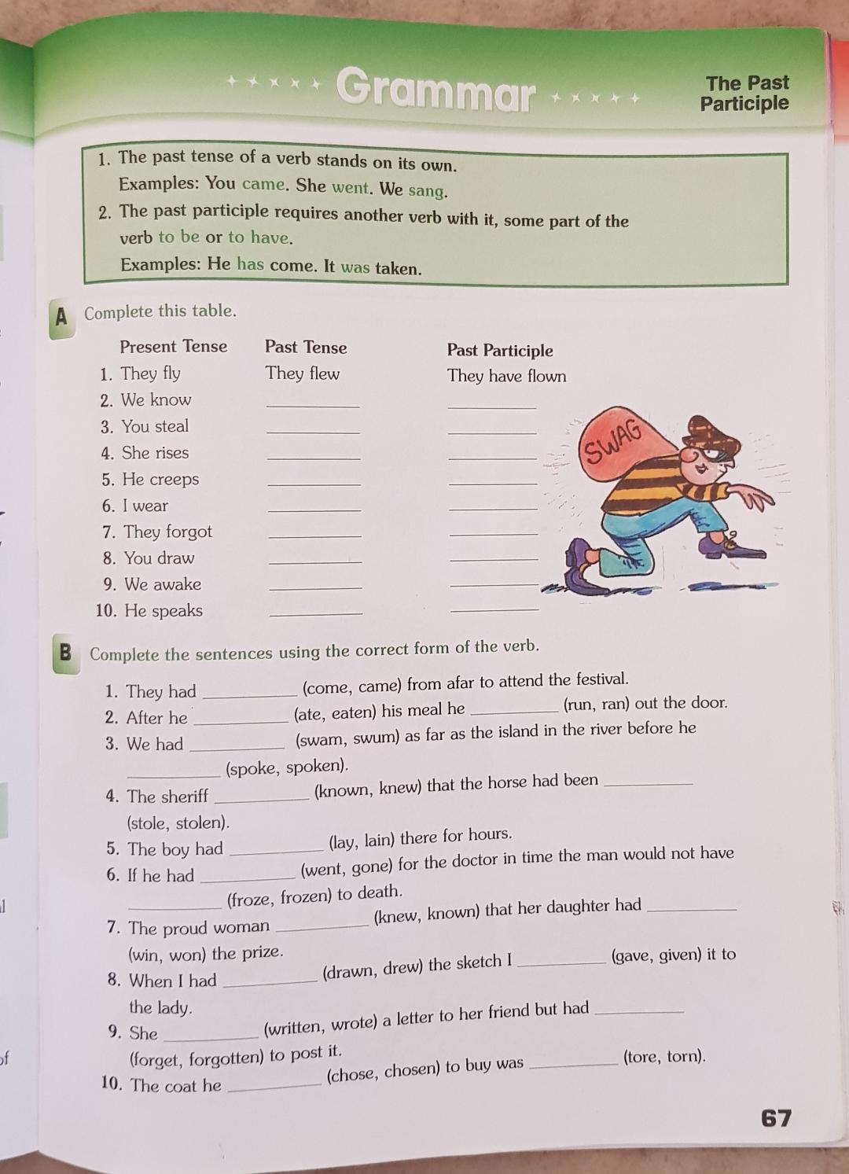

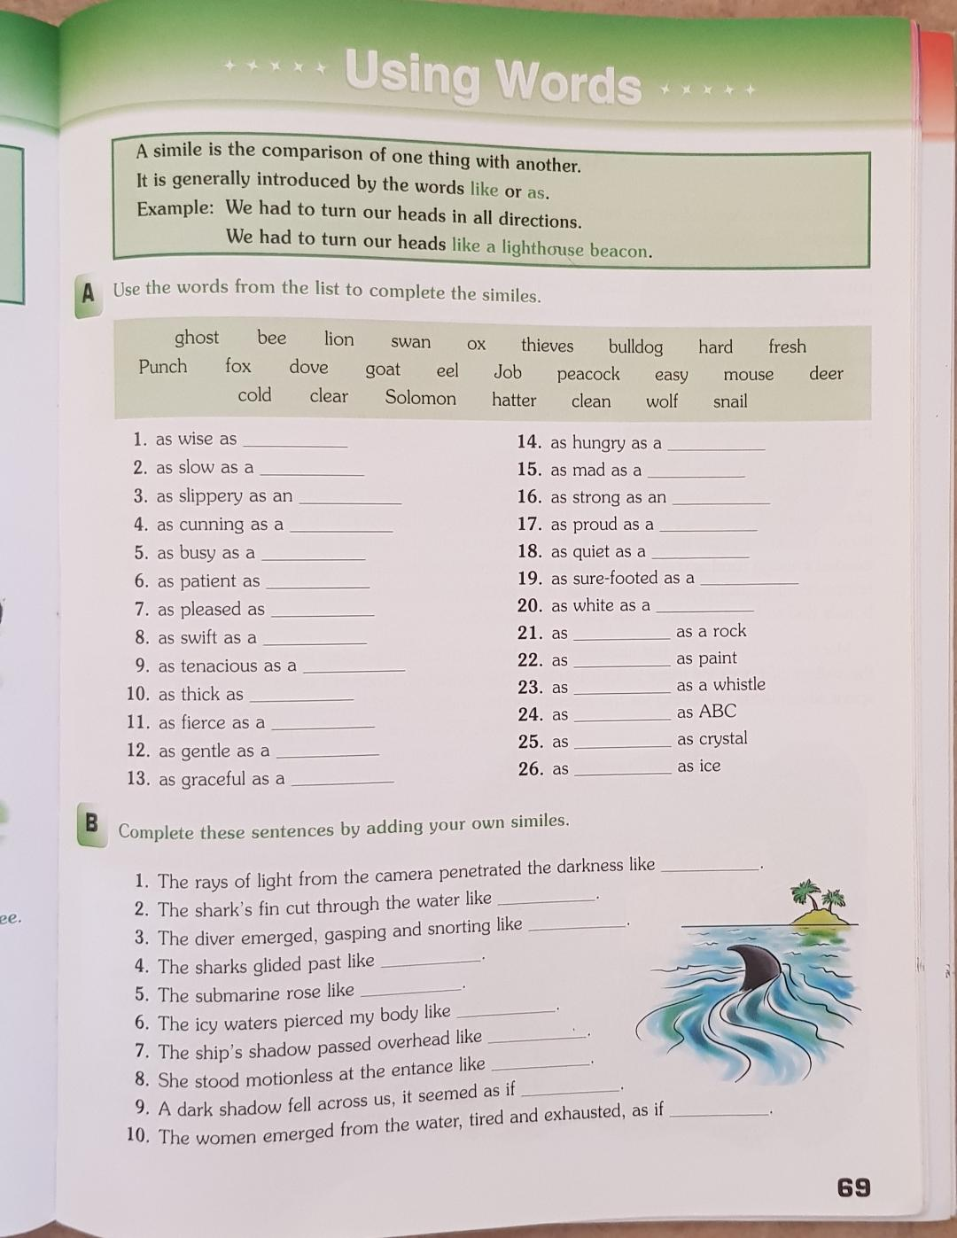

Irish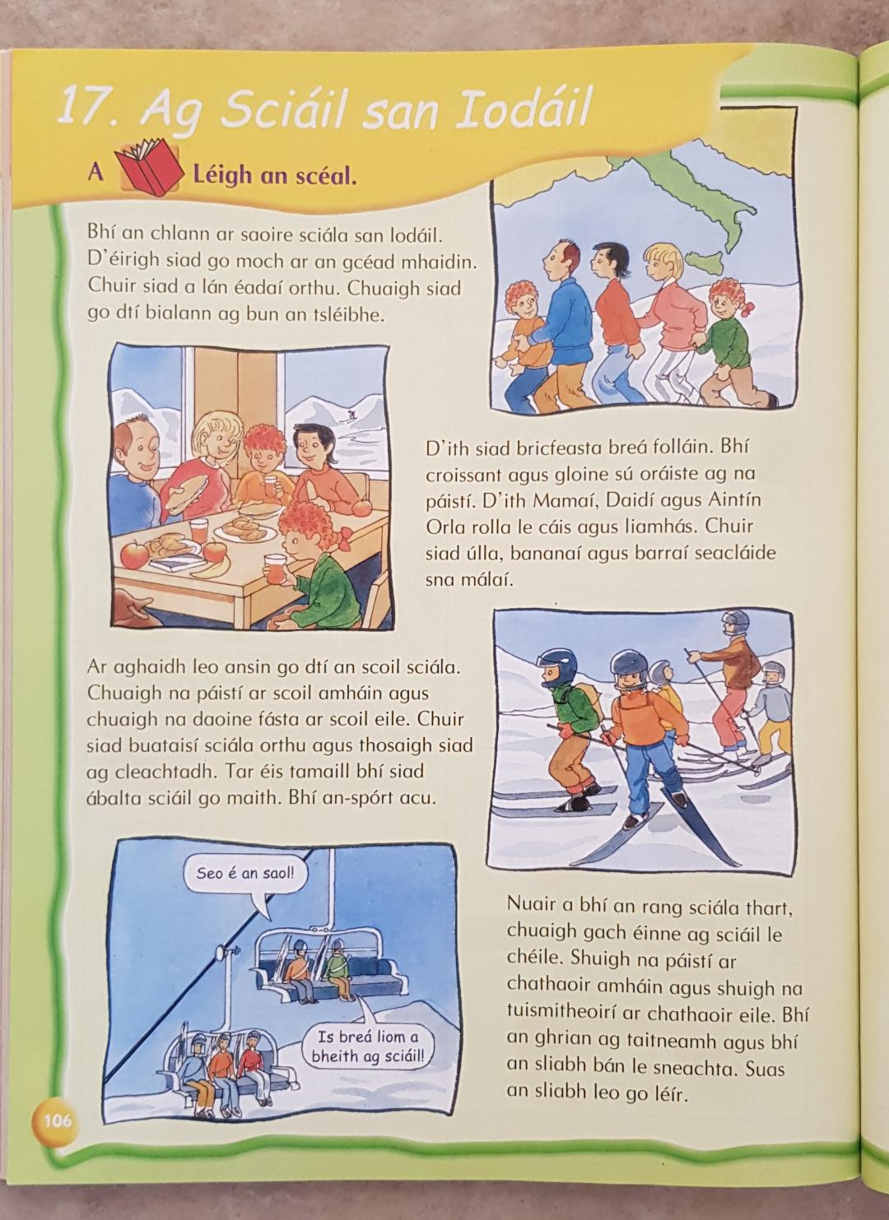
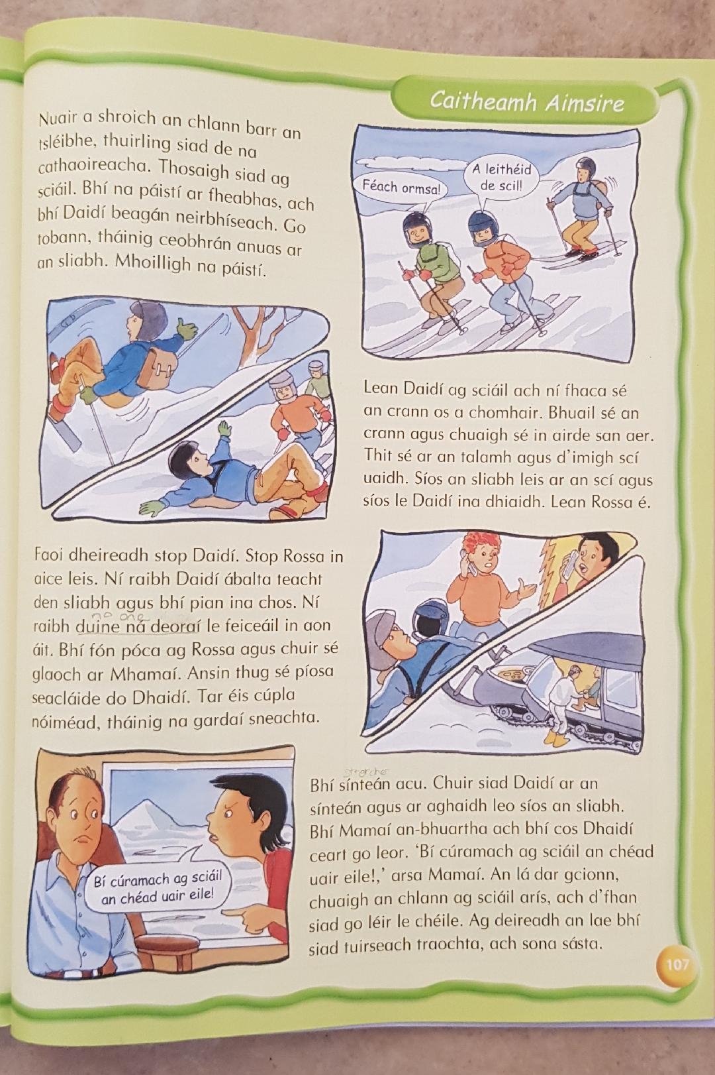 Ag Sciáil san Iodáil
Féach ar leathanaigh 106 agus 107.
Ansin, abair an bhfuil na habairtí seo ceart nó mícheart
Ceart nó Mícheart
True/False
Bhí an chlann ar saoire sciála sa Fhrainc.

Chuaigh siad go dtí an bhialann ag barr an tsléibhe.

D’ith Aintín Orla rolla le cáis agus seacláid.

Chuir siad torthaí sna málaí.

Nuair a bhí an rang sciála thart, chuaigh siad abhaile.

Bhí Daidí beagán neirbhíseach.

Ní fhaca Daidí an crann os a chomhair.

Bhí fón póca ag Neasa.

Thug Daidí píosa seacláide do Rossa.

Chuir na gardaí sneachta Daidí ar an sínteán.

An lá dar gcionn, chuaigh an chlann ag sciáil le chéile arís.

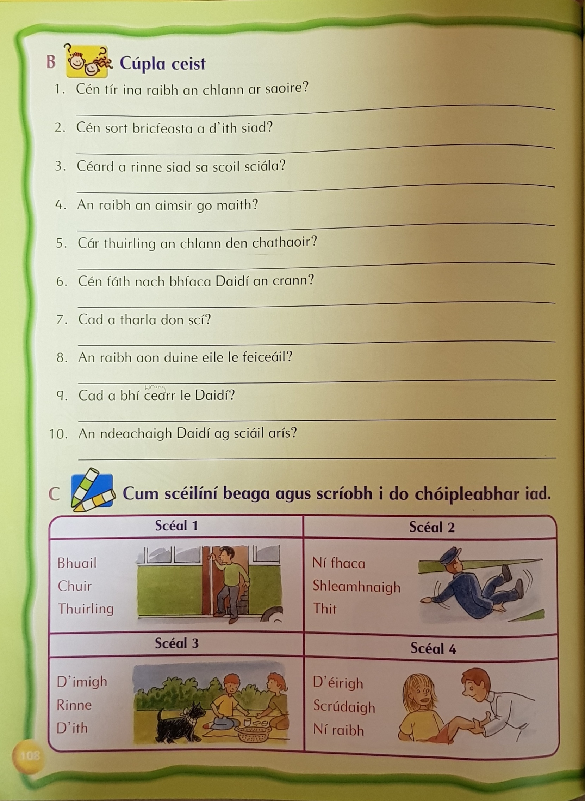
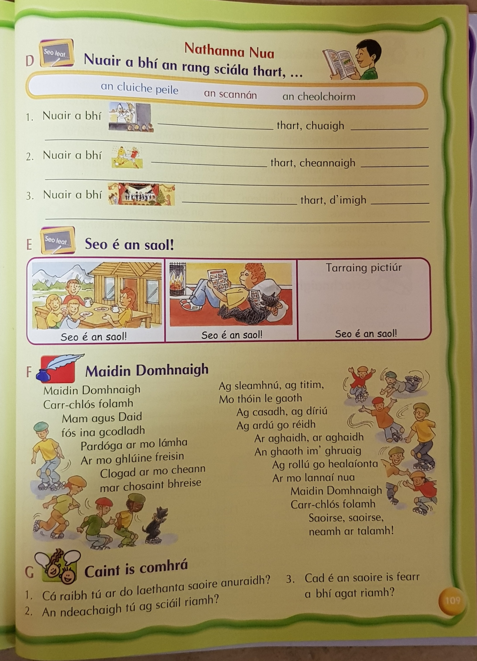
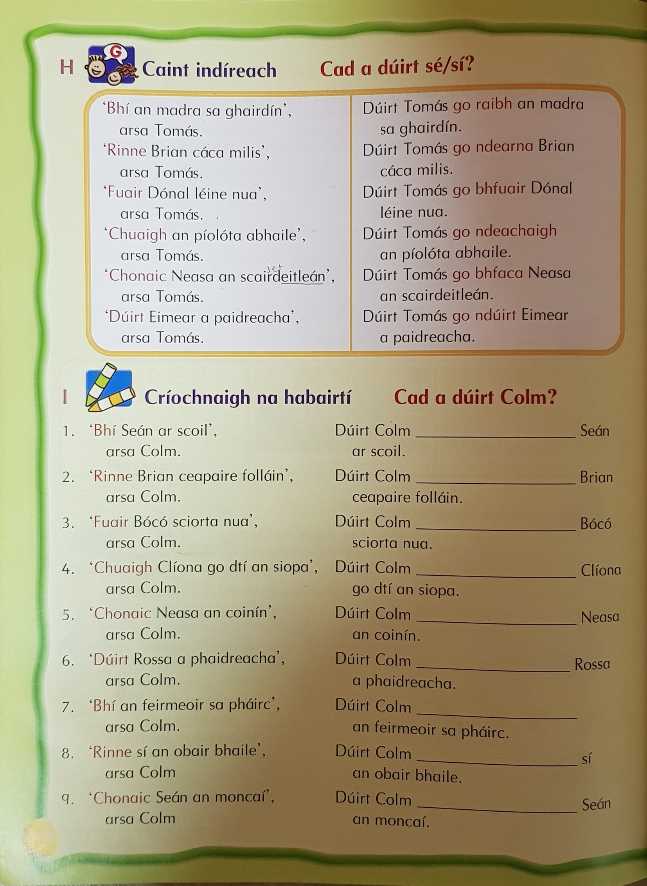
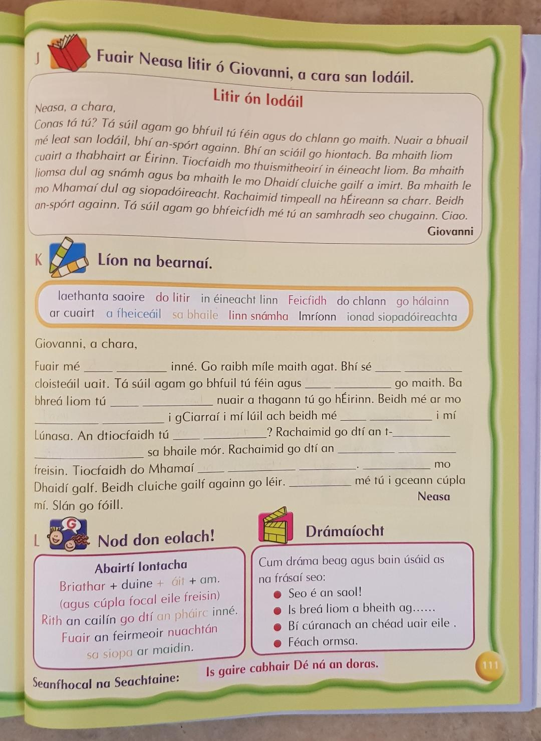
Geography
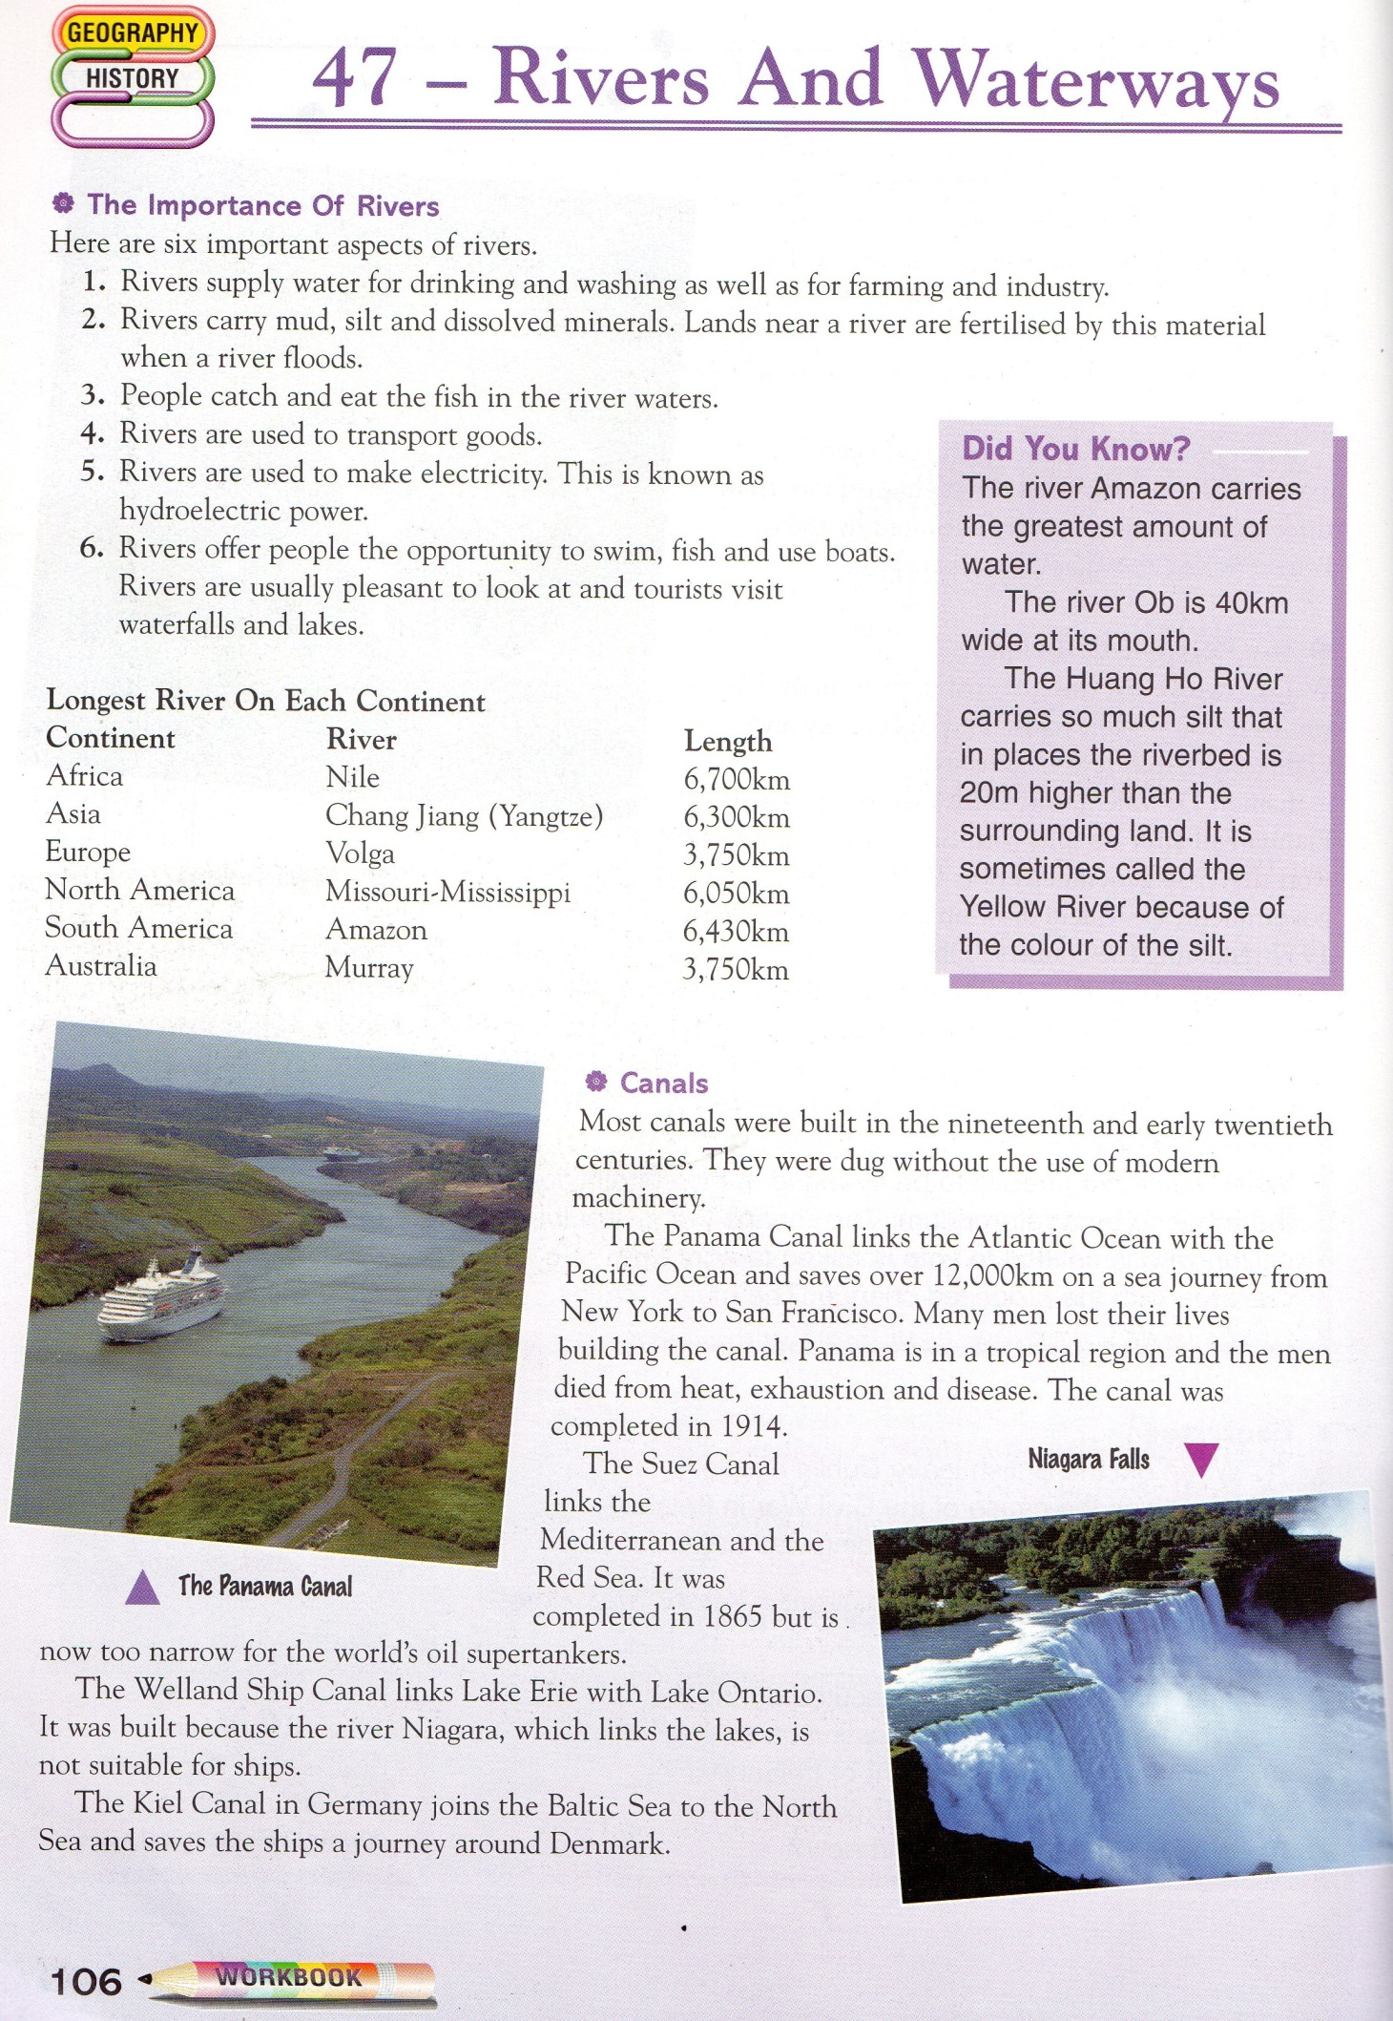

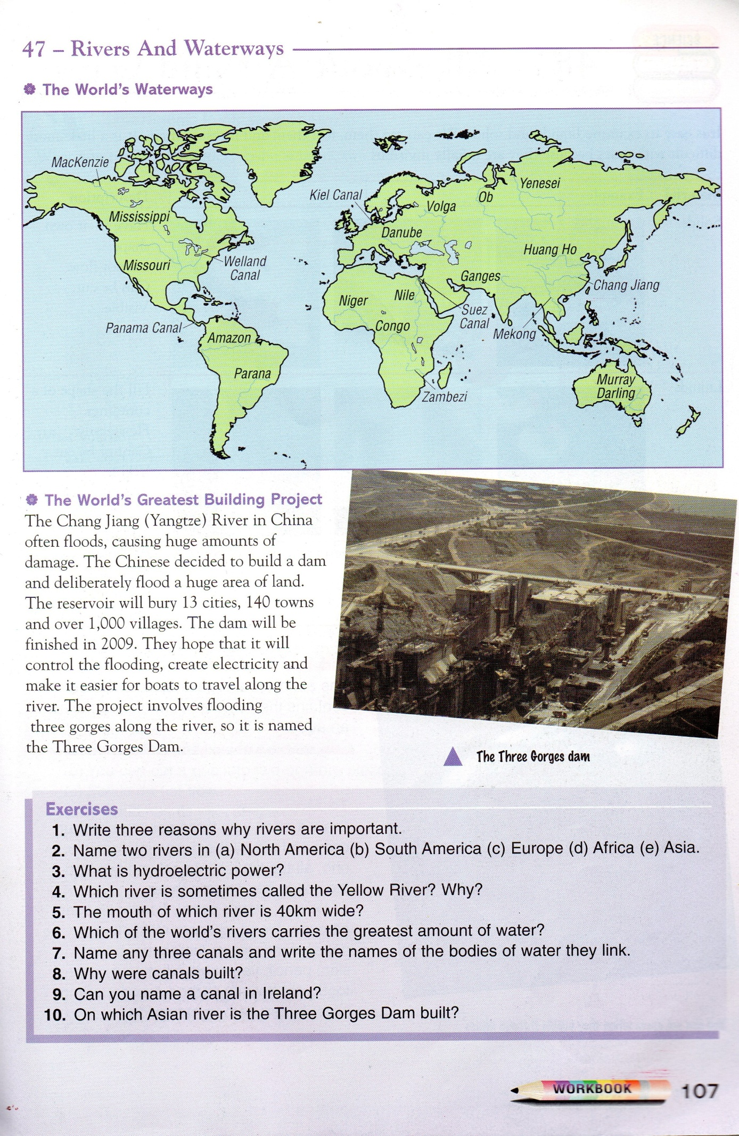
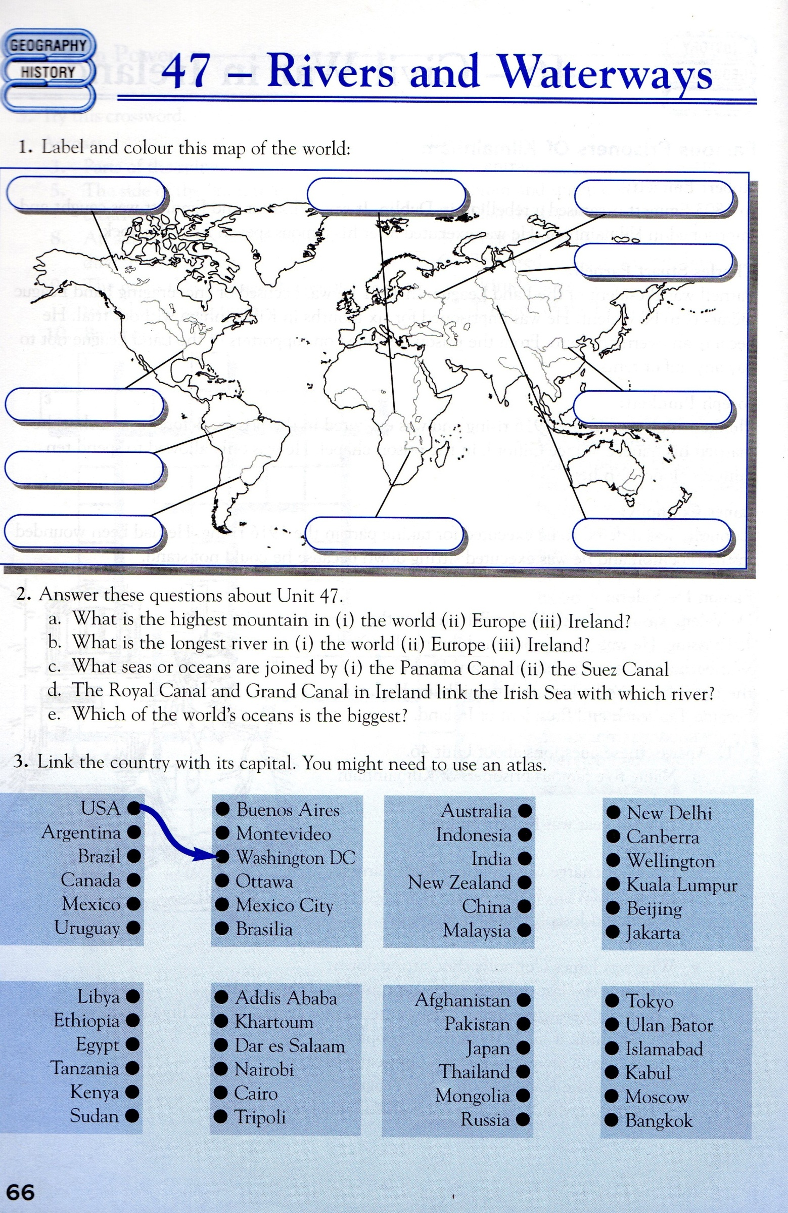
History

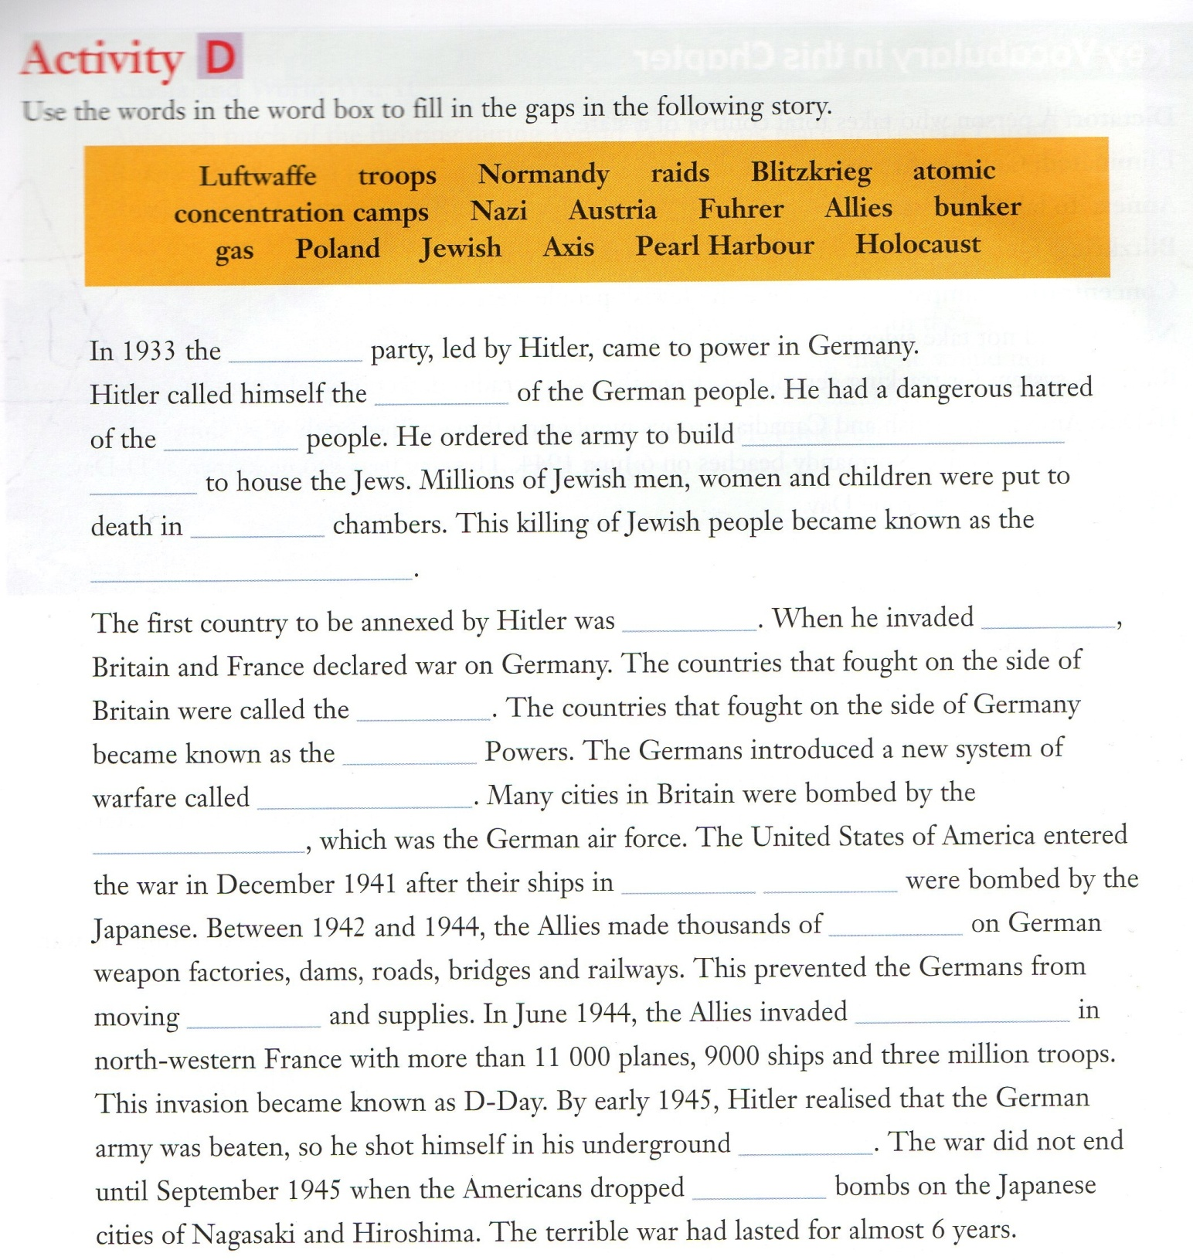

Mini Project
Bucket List Suggestions
- Swim in each of the four major oceans
- Visit at least three out of the seven new Wonders of the World
- Touch six out of the seven continents (Antarctica is optional!)
- Journey to the Grand Canyon
- Road trip across the entire United States
- Go on a week-long cruise
- Experience the Northern Lights
- Dive at the Great Barrier Reef
- Hike through the Himalayas
- Go on a wildlife safari
- Ride horses on the beach
- Go bungee jumping
- Take a hot air balloon ride
- Visit an elephant sanctuary
- Attend the Olympics
- Be in a parade float
- Ride a mechanical bull
- Write a love letter
- Make a video that goes viral
- Learn to play chess
- Run a marathon, half marathon, or 5k
- Conquer a lifelong fear
- Learn how to cook an extravagant dish
- Finish a classic novel
- Paint a piece of art for your home
- Learn how to drive a car
- Take a two-week vacation by yourself
- Set a Guinness world record
- Work on giving up any negative feelings you’ve been holding on to
- Find something to laugh at every day
- Take time to appreciate nature
- Make time for yourself every day
- Organize your home and workspace — an organized life leads to an organized mind!
- Spend time with people who make you happy
- Learn to stand up for yourself
- Start a business or side gig for something you are passionate about
- Have a positive work attitude every day
But you might think of loads of others!! Be ambitious!

Music/P.E
Check out this lady called Oti Mabuse and her husband Marius Iepure, who have been choreographing dance routines each day to various musicals. There are quite a few on her YouTube page for you to try out on your own, or with members of your family!! They are about 30 minutes long and they will take you through the whole routine. Have a go for any 2 days this week. There is a new routine every day
https://www.youtube.com/user/mosetsanagape/videos?view=0&sort=p&shelf_id=2
OR
If dancing isn’t your thing, and you fancy a good workout, check out Joe Wick’s P.E. lessons on YouTube. Again they are about 30 minutes long and should have you tired and sore at the end!!! Have a drink handy. You can reply to him via YouTube and he might give you a “Shout Out”. Have a go for any 2 days this week. There is a new routine every day.
https://www.youtube.com/watch?v=4hdR8Mlib3M

