Teacher’s Name | Martin Kenny
Class level | 6th
Suggested work for  Week beginning | Monday 27th April – Friday 1st May
Teachers email address | mrkenny6thclass@gmail.com
Correction of work | Work that I have highlighted should be submitted to the appropriate teacher’s e-mail address above. This can be a photograph of the copybook page or the answers can be typed into the e-mail. Please write your child’s name in the subject part of the e-mail.  Work that is not highlighted should be corrected by an adult/parent.  I will email answer sheets to parents shortly to everyone who has been in contact. The pupils can use them to correct workbooks and some other tasks.
Message from teacher/s | Hi everyone,  I’ve attached everything you need for the next week on this document. As I said last time, FEEL FREE TO COMPLETE WHAT YOU CAN AND DON’T BE PUTTING PRESSURE ON YOUR PARENTS. Also make sure to help out at home as much as you can. Play with your brothers/sisters and help mum/dad out with any wee chores that you can do.  You can also email me if you have any queries or questions. Please write your child’s name in the subject box of the email.  I’m aware that not everyone, but all books are available online, if you have decent internet. I’ve attached the links to this document as well. I’ll try scan/photo relevant pages too where possible. Please don’t print out loads and loads of pages. There is no need to. Take turns to share computers/tablets with your brothers/sisters during the day and hopefully you’ll have time to get work completed. I realise there might be a queue in some households for access.  I’ve attached some podcast ideas and apps that you might like to try out at the end of the document. These are entirely optional but you might stumble across something you like.  Bye for now. Mr Kenny

Remember to tune into the RTE Home School Hub every day at 11.00

Monday | Tuesday | Wednesday | Thursday | Friday
Maths  Mental Maths  Week 30  Monday  Planet Maths  Chapter 25 3D Shapes  Pg 155 B, C, D | Maths  Mental Maths  Week 30  Tuesday  Planet Maths  Chapter 25 3D Shapes  Pg 156 A 3,8,12,18,22,25  Use the squares of copy book to help you to draw) | Maths  Mental Maths  Week 30  Wednesday  Planet Maths  Chapter 25 3D Shapes  Pg 157 A | Maths  Mental Maths  Week 30  Thursday  Planet Maths  Chapter 25 3D Shapes  Pg 159 A, C, D | Maths  Mental Maths  Week 30  Problem Solving & Friday  Planet Maths  Chapter 25 Worksheet  Attached  Questions 1 2 3
English  English in Practice  113/114  Treasury F (attached)  Pg 70 Read Story  Pg 71 A 1-10 | English  English in Practice  115/116  Treasury F (attached)  Pg 73 A B | English  English in Practice  117/118  New Treasury 6 (Attached and also at www.folensonline.ie)  Pg 66 Read “Balance Argument”  Pg 67 A 1 5,6,7,8  Pg 67 Vocabulary- Match the words and definitions | English  English in Practice  119/120 | English  English in Practice  Revision Test 111-120
New Treasury 6 (Attached and also at www.folensonline.ie)
Pg 71
Choose a topic from question 1 and compose a balanced argument for it. (You can type it if you like)
Use the green boxes to help you, and the numbers 2,3,4,5 as a guide to making it balanced.
Irish  Abair Liom H (Attached and also at www.folensonline.ie)  Pg 6/7 Léigh an Scéal  Pg 7 B 1-7  (Translation attached to help) | Irish  Abair Liom H (Attached and also at www.folensonline.ie)  Pg 8 C Léigh an Cómhra  Pg 8 D Cén sórt duine thú?  (Use the cómhra and phrases at top of page 6 to help) | Irish  Abair Liom H (Attached and also at www.folensonline.ie)  Pg 11 Na Céimeanna Comparáide  Big, Bigger Biggest  Tall, Taller, Tallest etc  Abairtí 1-10  (Print off or write in copy) | Irish  Sin É 6 (Attached and also at www.edcolearning.ie)  Pg 19 Na Céimeanna Comparáide  Big, Bigger Biggest etc  Líon na bearnaí  (Print off, type or write in copy)
Music/P.E.  See Note Below | Music/P.E.  See Note Below | Music/P.E.  See Note Below | Music/P.E.  See Note Below | Music/P.E.  See Note Below
Mini Project (All Week)  Photography  Your task this week is to try and capture a “stunning” photograph. It might be a beautiful sunset, a close up of a ladybug/flower etc. You might stumble across something by pure accident. Get creative and play around with different settings | Geography History  (All pages attached to this document)  Pg 130/131 Read & Questions 1-6  Pg 136/137 READ ONLY  Pg 81 READ ONLY  Pg 84 Read and Questions 1 a,b,c,d,e,f  Atlas Holds up the World READ ONLY |  |  | Mini Project  Photography  Decide on your best photograph. Get Mum/Dad to email it to me, and I’ll put together a little PowerPoint of them all for next week

Below are details for all of the book companies, who have given free access to their books online.
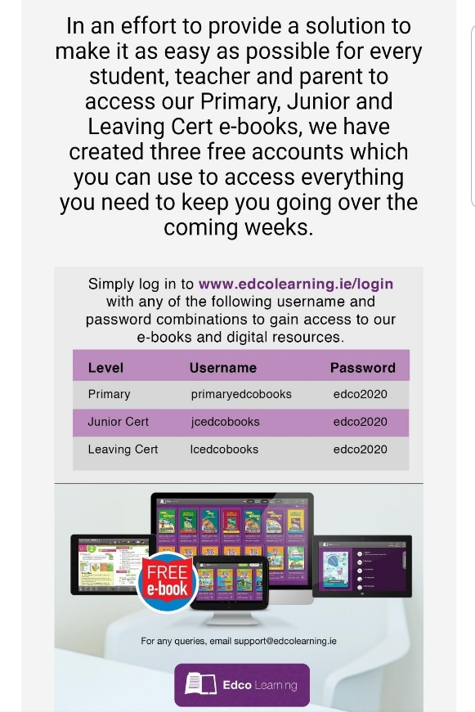
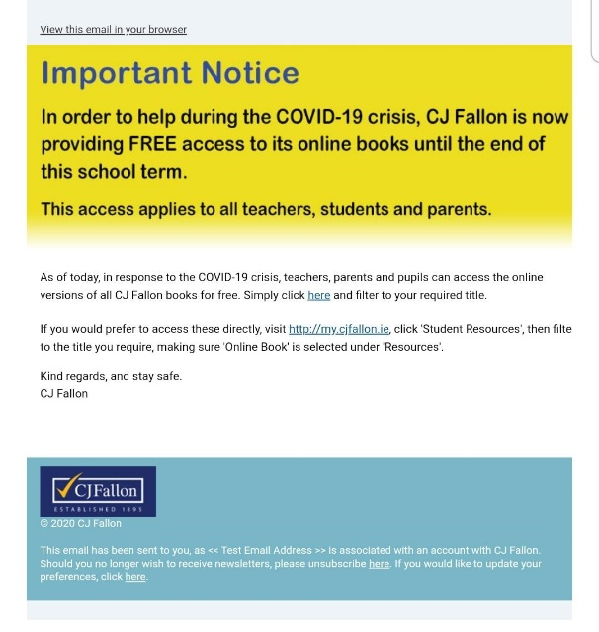

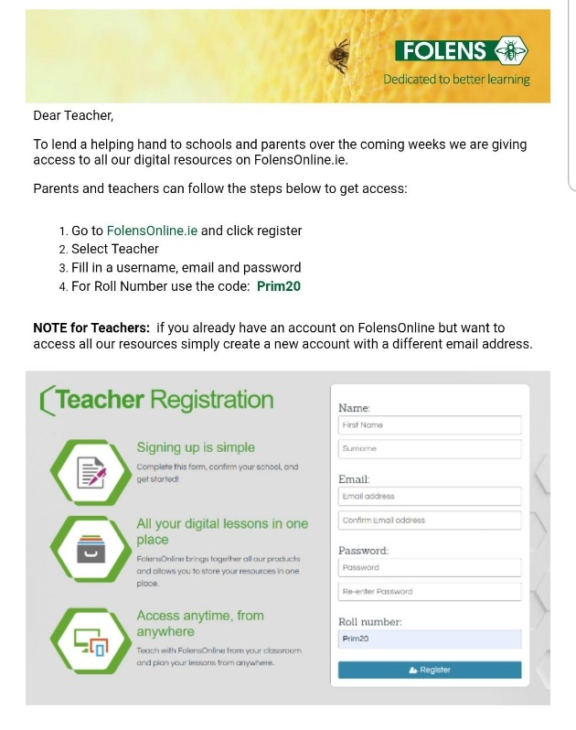

Maths
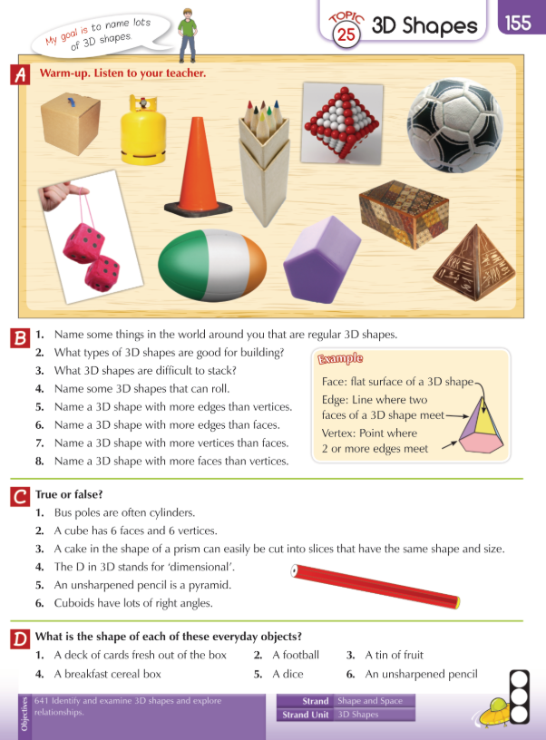
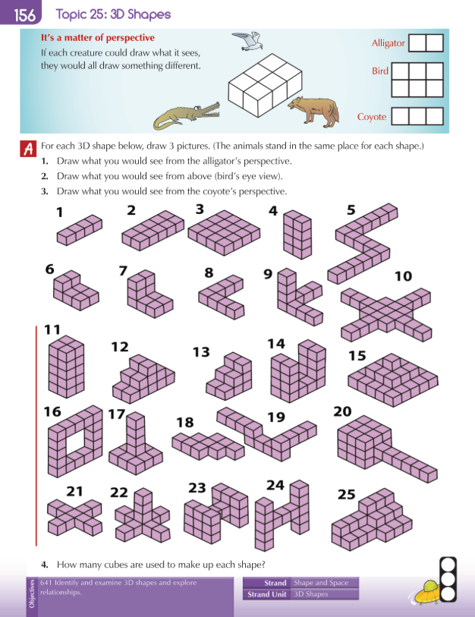

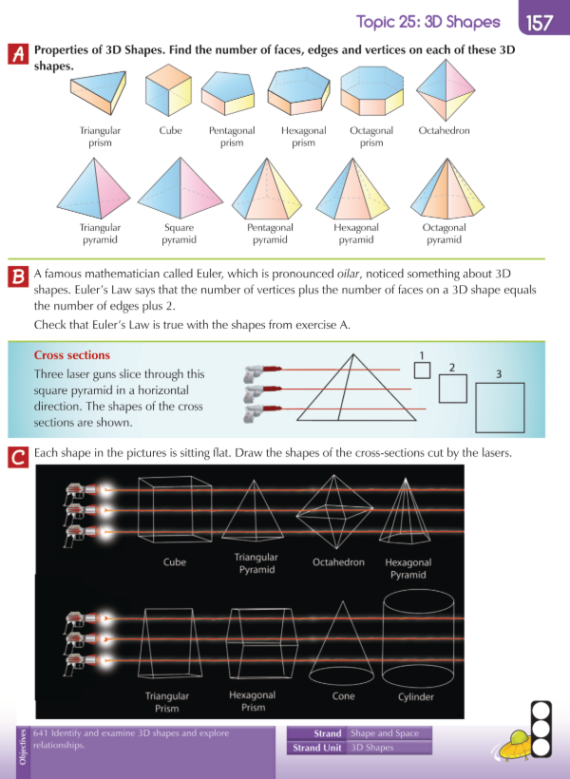

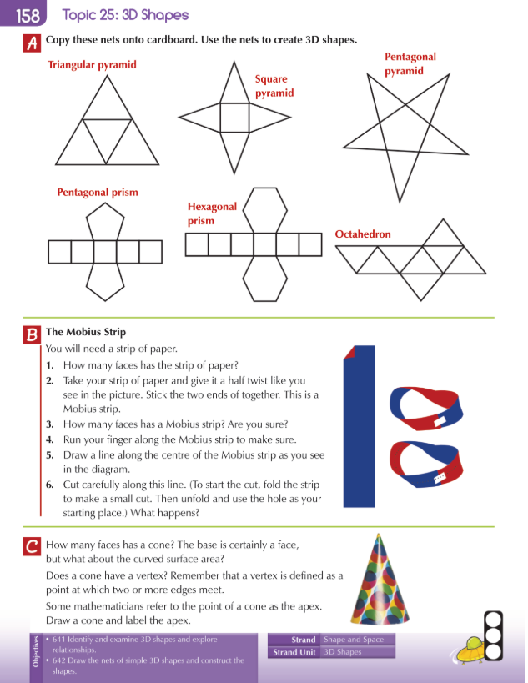

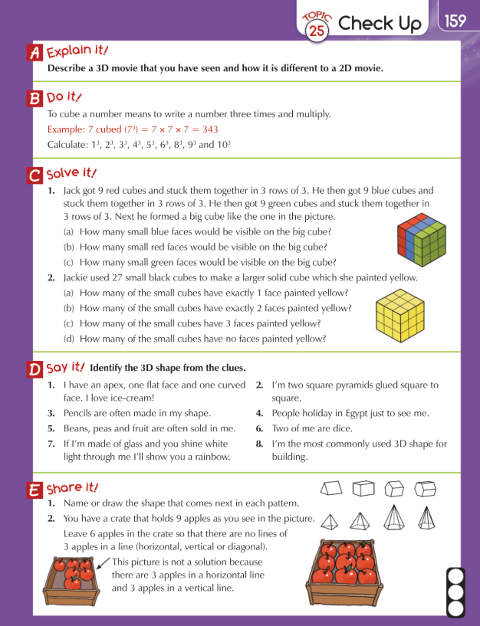

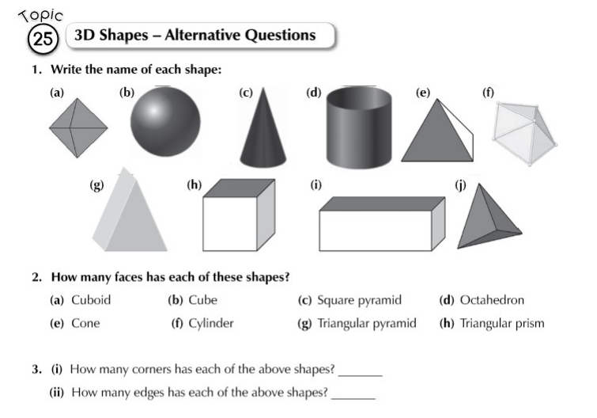

English
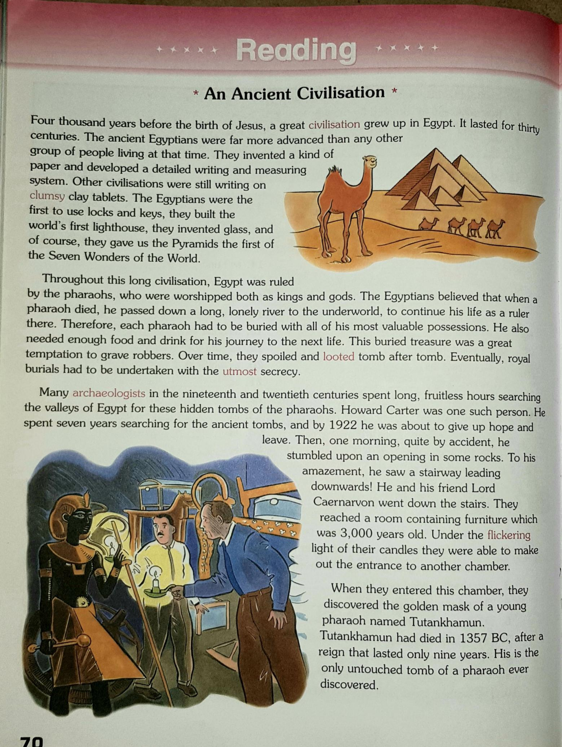
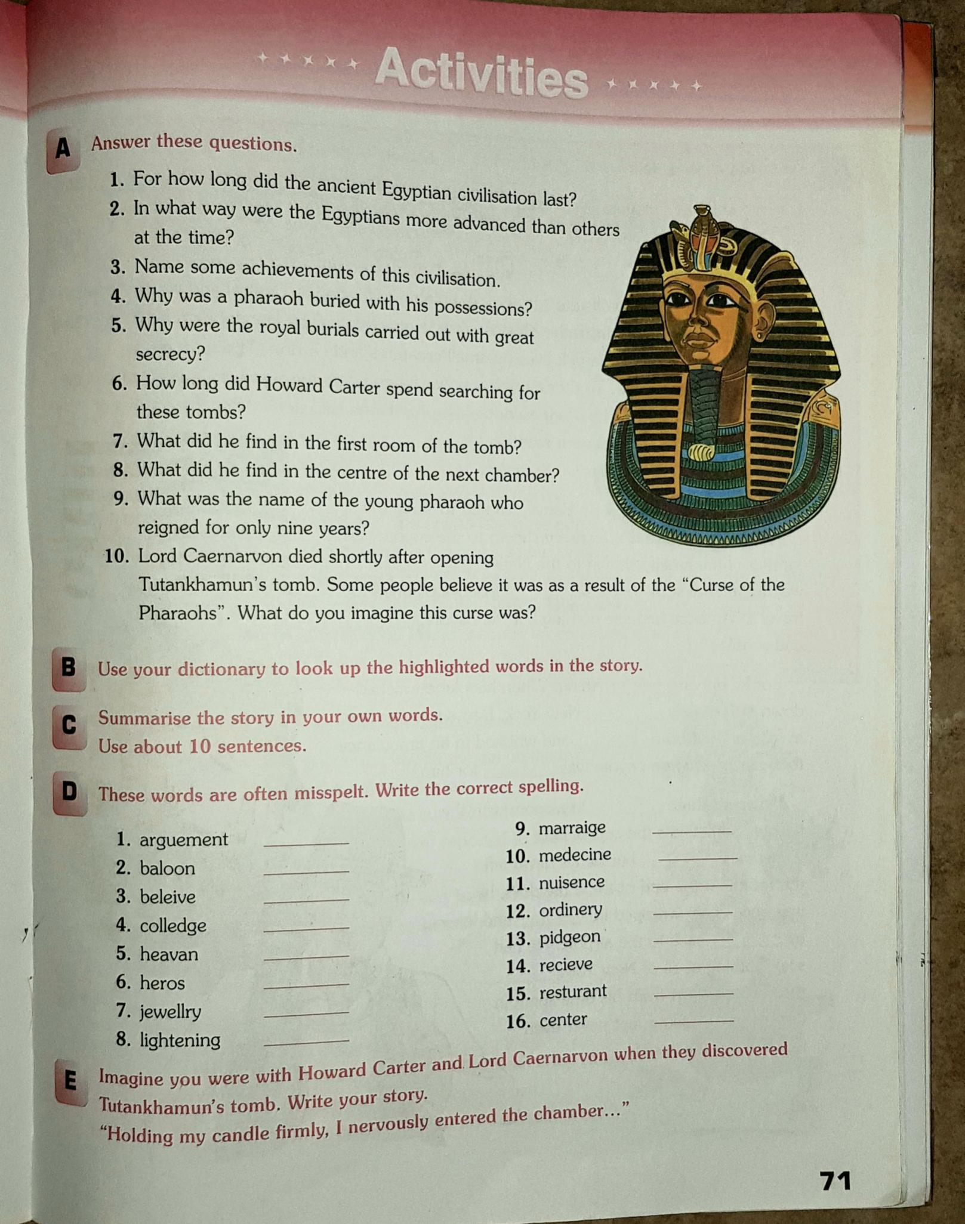

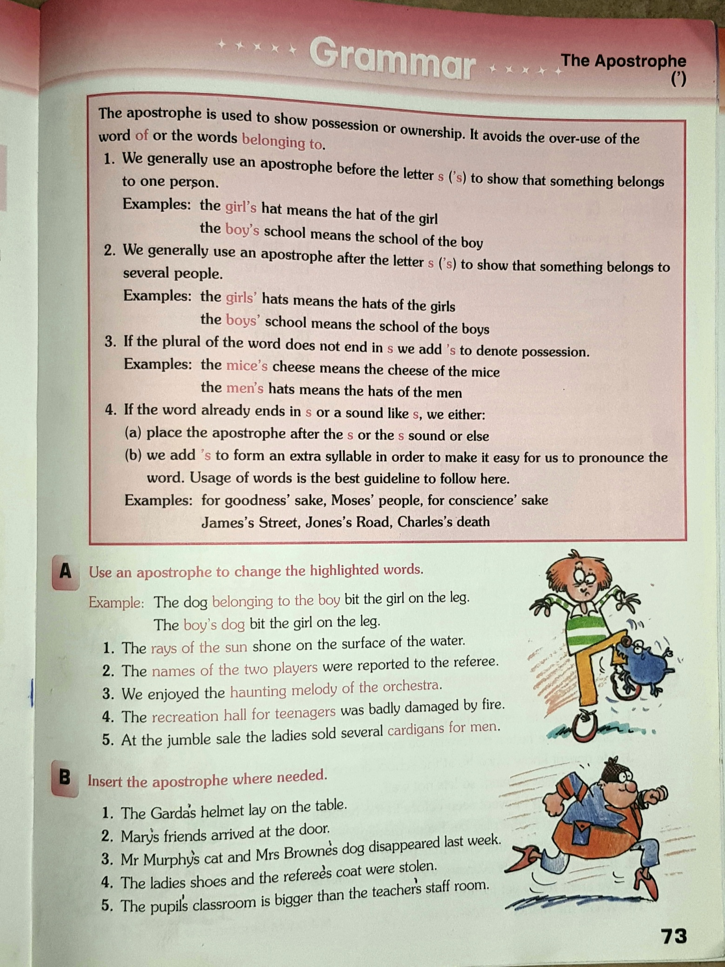

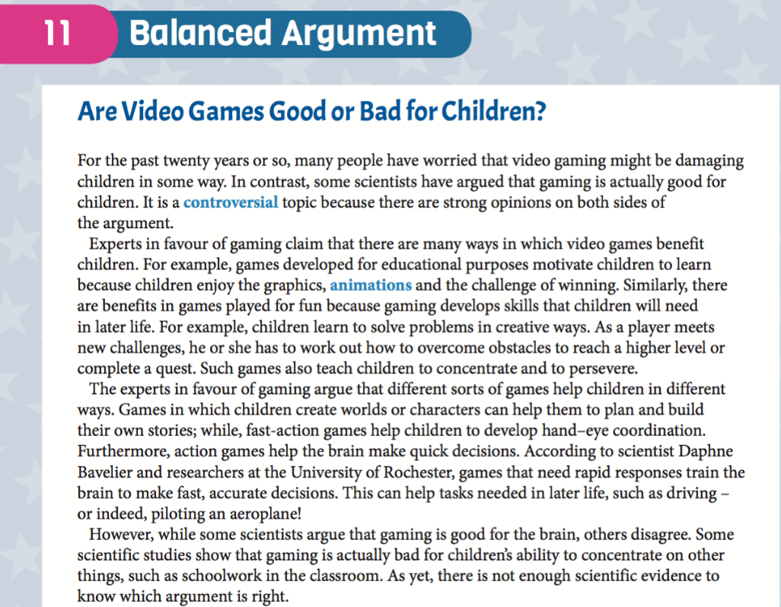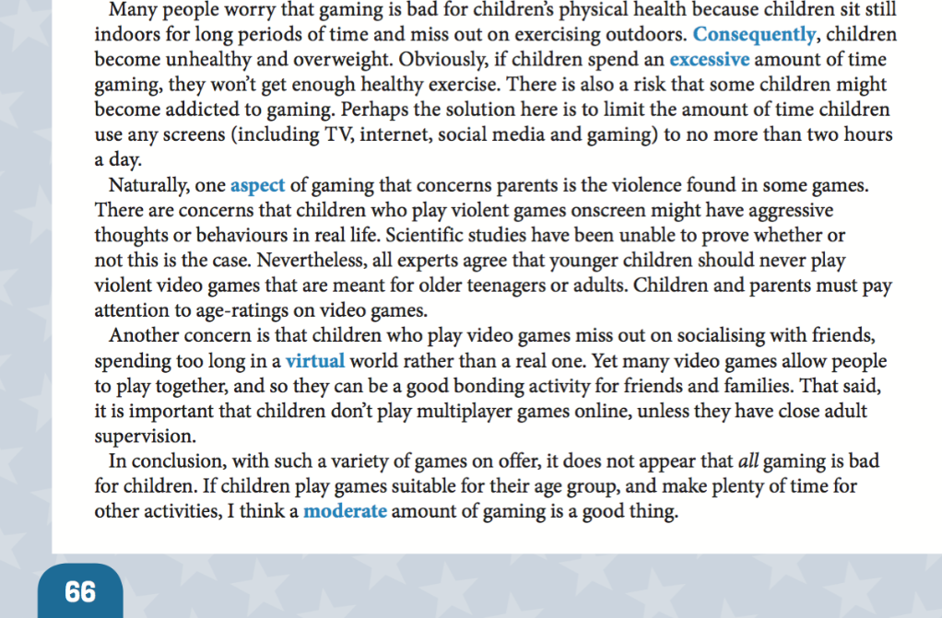
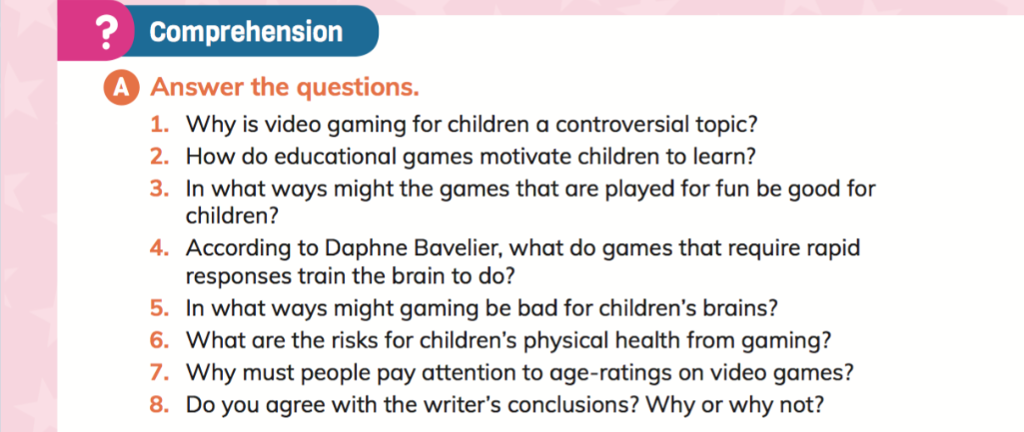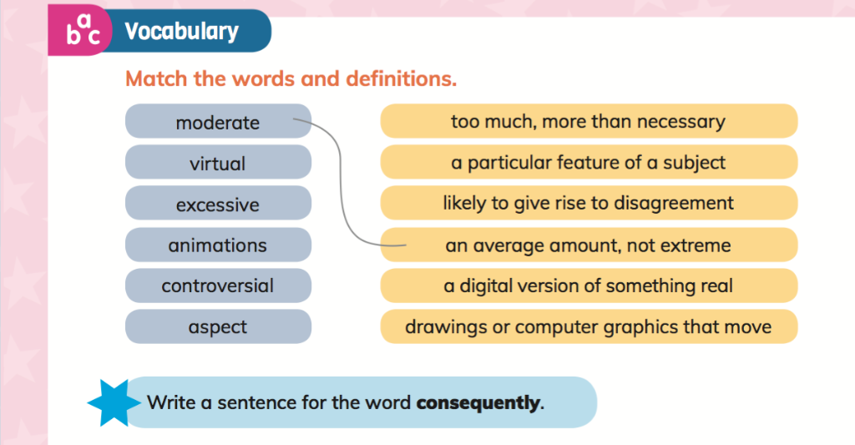

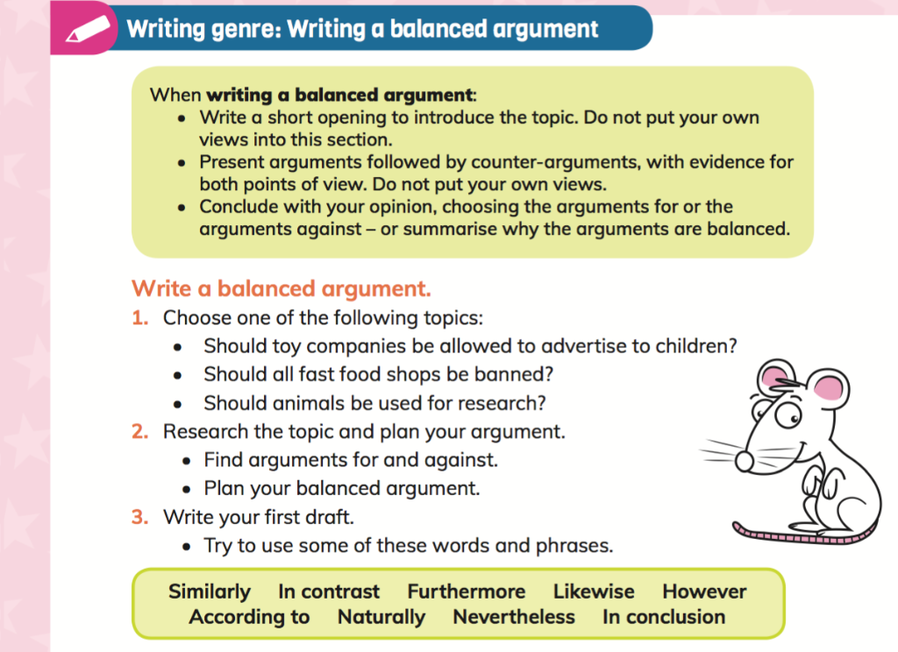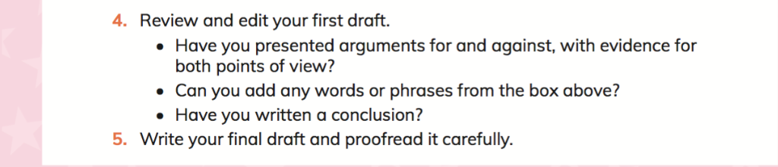

Irish
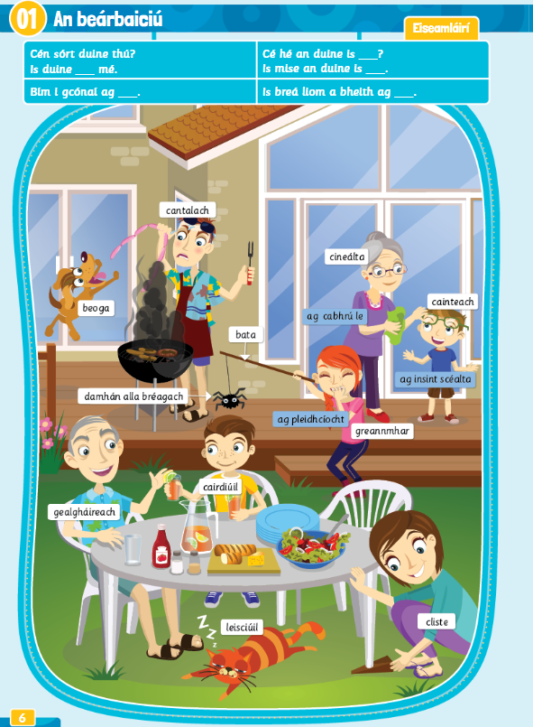
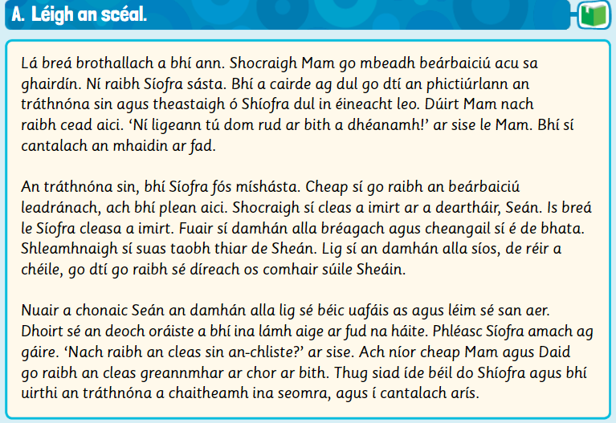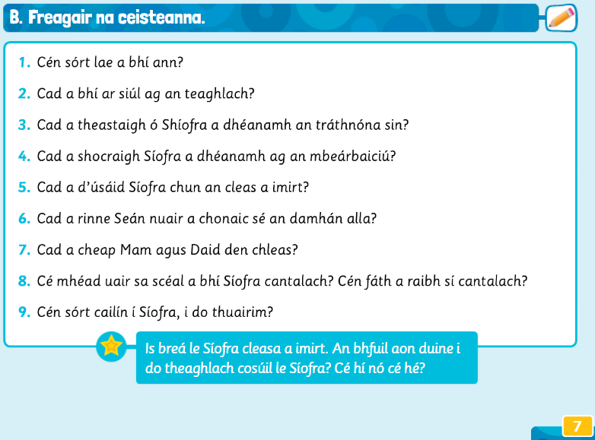
An Beárbaiciú – The Barbecue
It was a fine sultry day. Mum decided the they would have a barbecue in the garden. Síofa wasn’t happy. Her friends were going to the cinema that evening and Síofra wanted to go with them. Mum said she wasn’t allowed. “You don’t let me do anything!” she said to Mum. She was cross/grumpy all morning.
That evening, Síofra was still unhappy. She thought the barbecue was boring, but she had a plan. She decided to play a trick on her brother, Seán. Síofra loves playing tricks. She got a pretend spider and she tied it to a stick. She crept up behind Seán. She let the spider down, gradually, until it was directly opposite Seáns eyes.
When Seán saw the spider he let a scream of horror out of him and he jumped in the air. He spilled the orange drink that he had in his hand all over the place. Síofra burst out laughing. “Wasn’t that trick very clever?” she said. But Mum and Dad didn’t think the trick was funny at all. They told Síofra off and she had to spend the evening in her room, and she was again cross/grumpy.

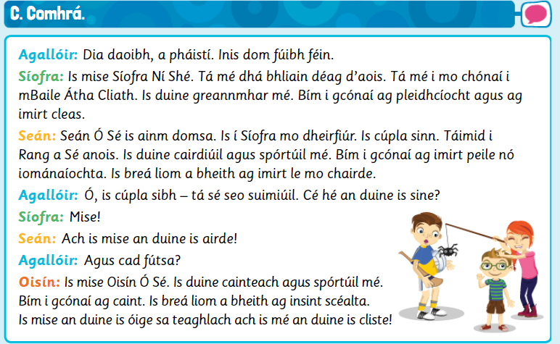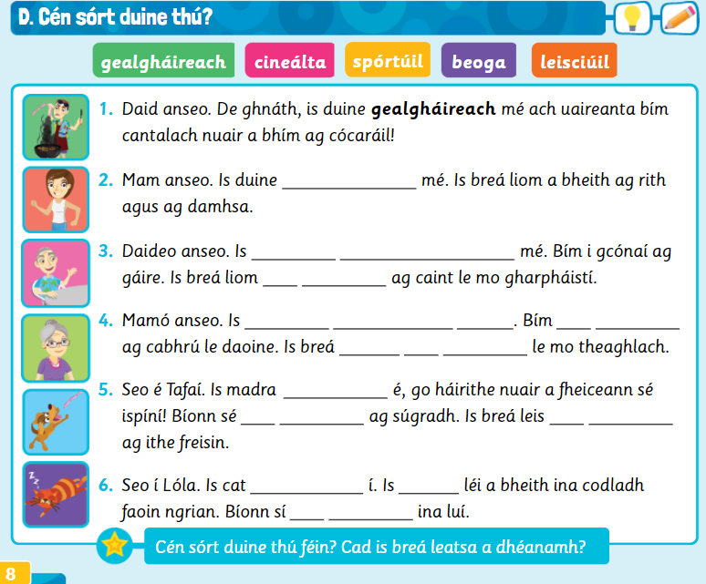
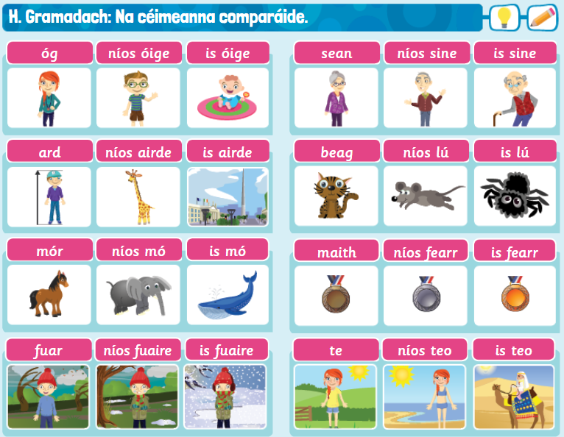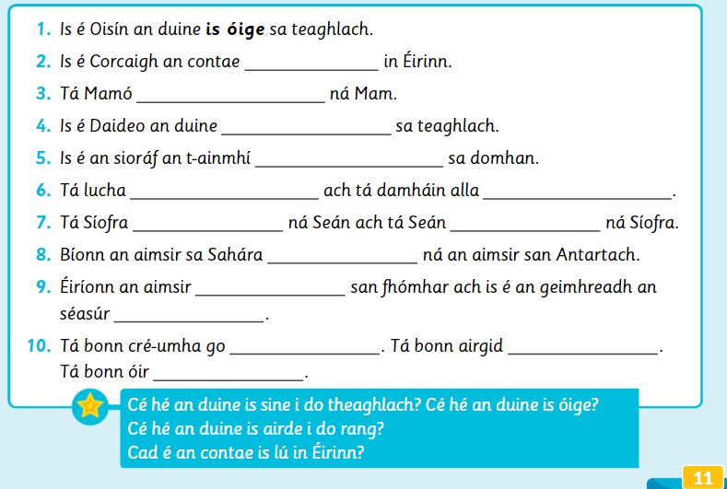
Geography/History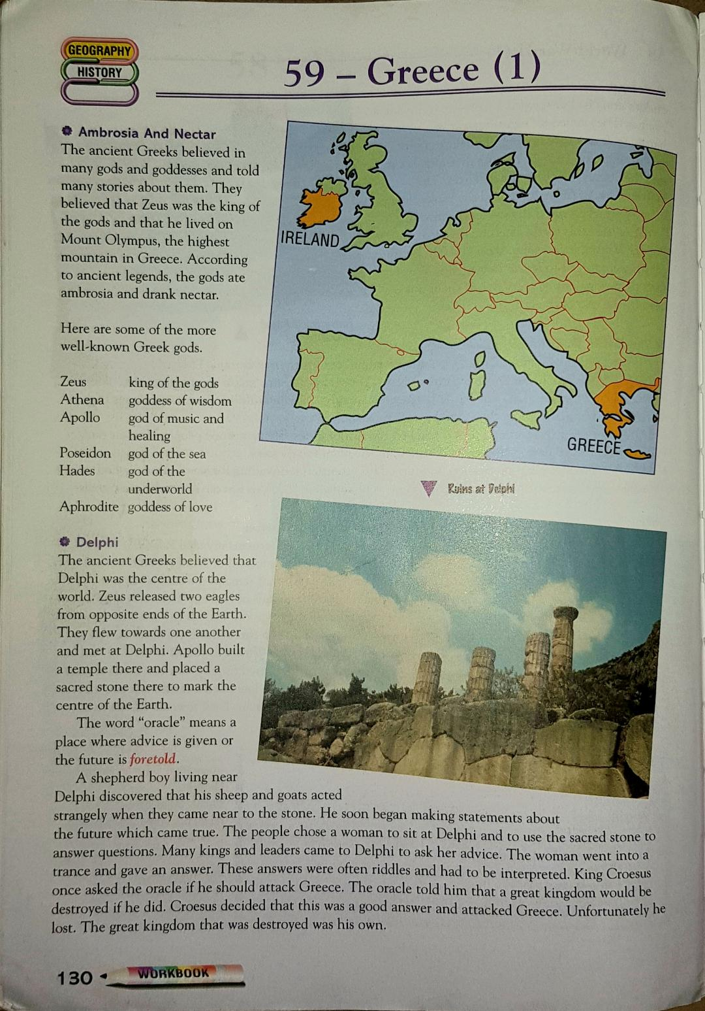
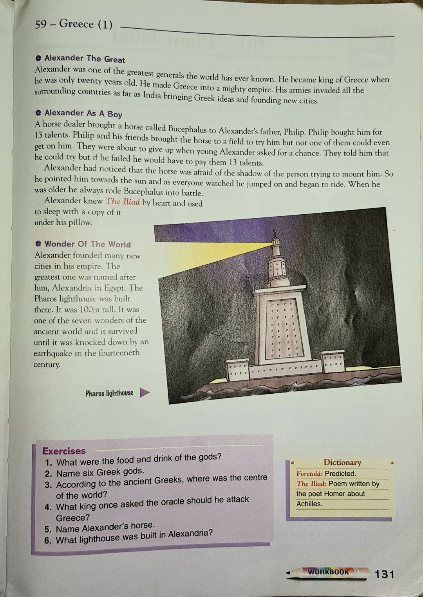
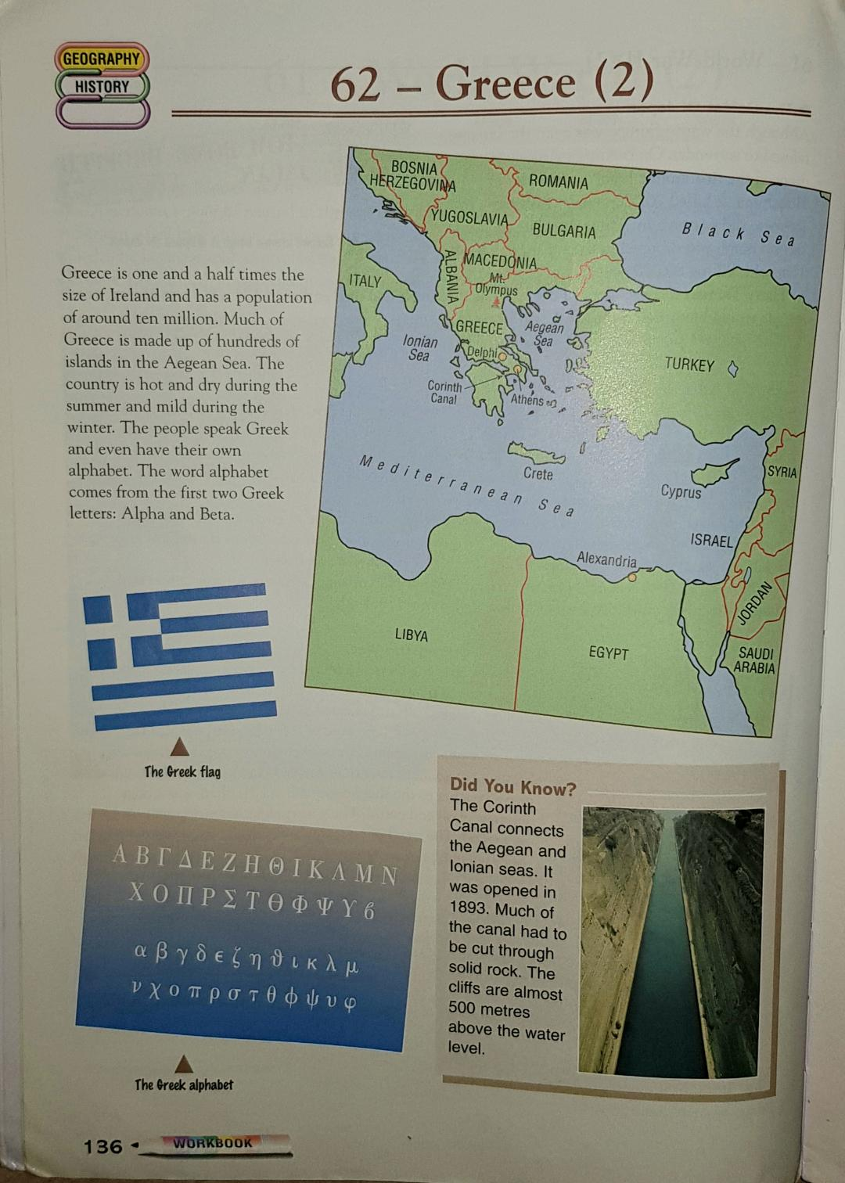
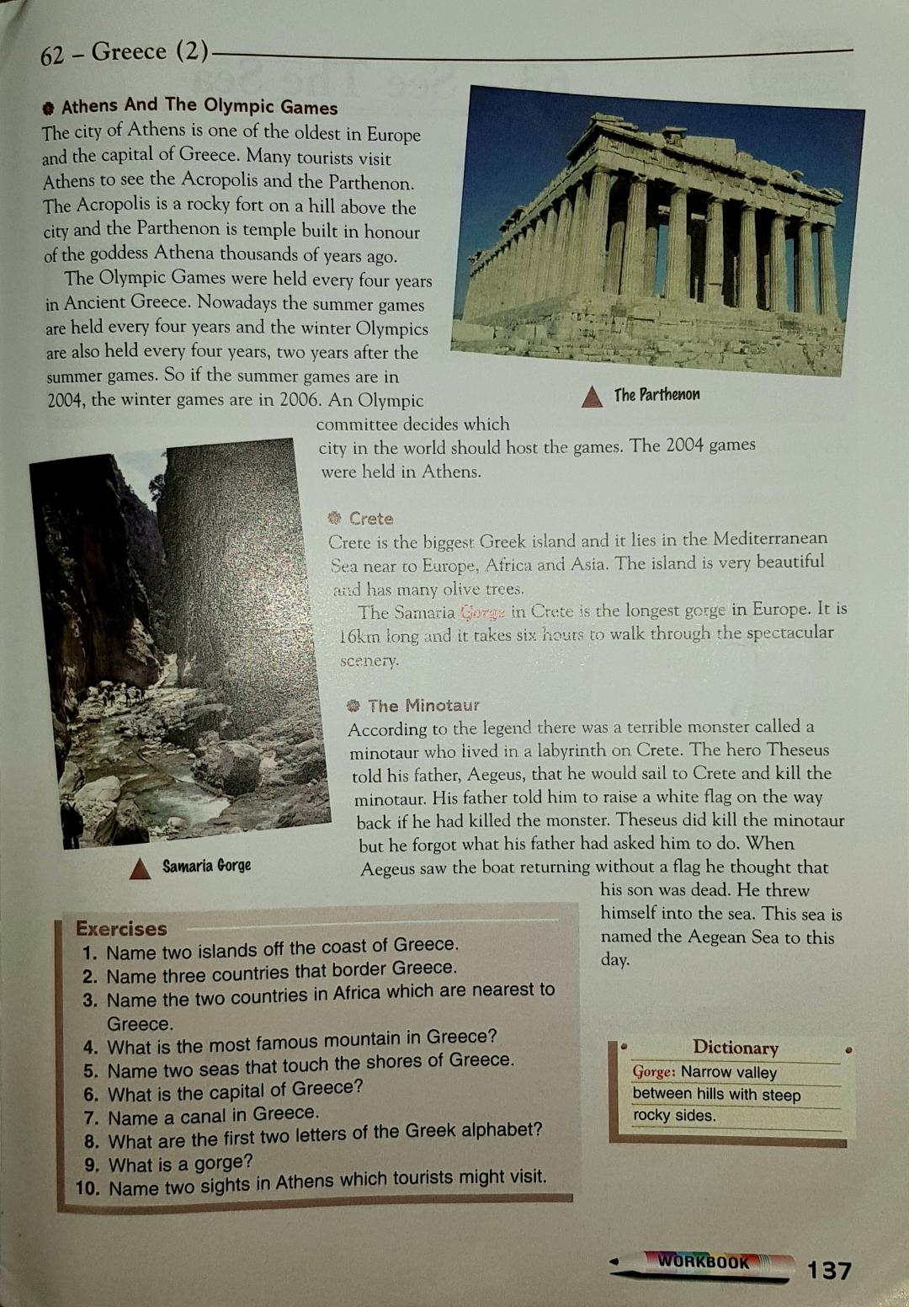
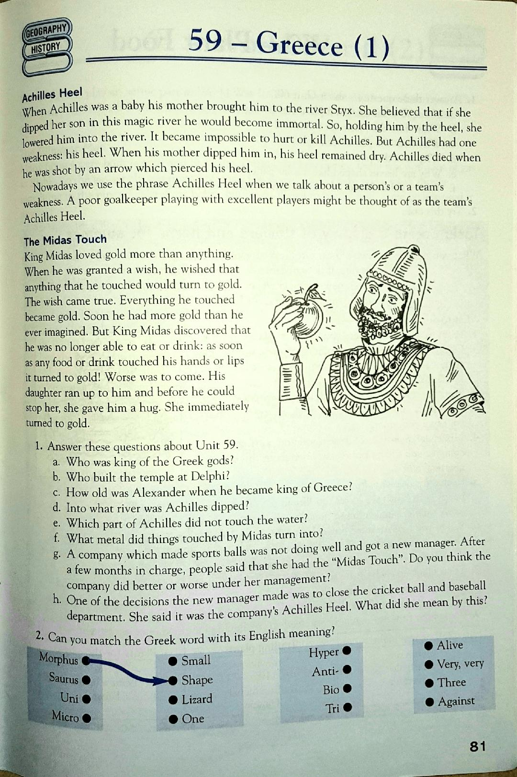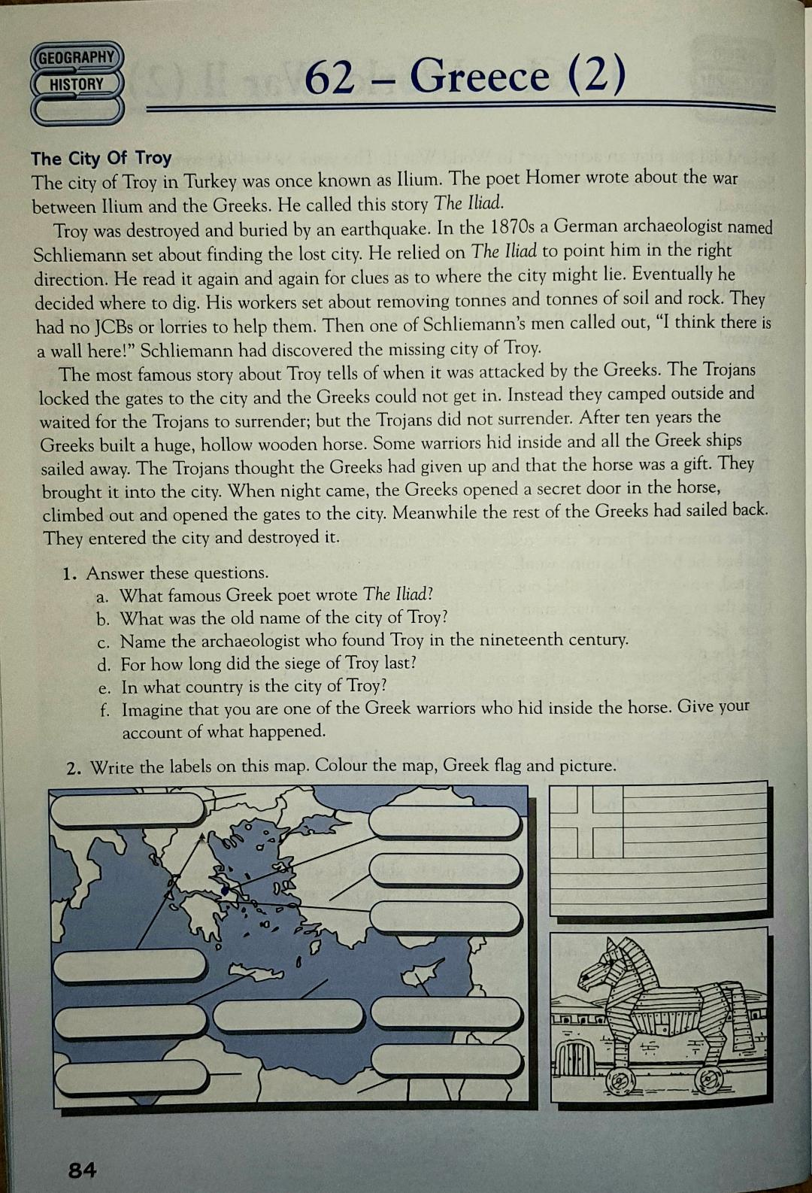
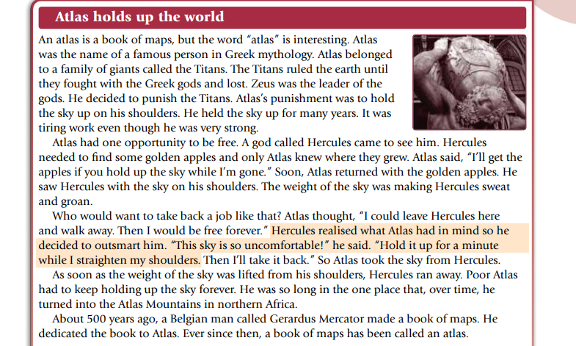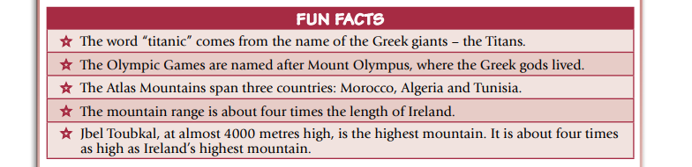

Music/P.E
Check out this lady called Oti Mabuse and her husband Marius Iepure, who have been choreographing dance routines each day to various musicals. There are quite a few on her YouTube page for you to try out on your own, or with members of your family!! They are about 30 minutes long and they will take you through the whole routine. Have a go for any 2 days this week. There is a new routine every day
https://www.youtube.com/user/mosetsanagape/videos?view=0&sort=p&shelf_id=2

OR
If dancing isn’t your thing, and you fancy a good workout, check out Joe Wick’s P.E. lessons on YouTube. Again they are about 30 minutes long and should have you tired and sore at the end!!! Have a drink handy. You can reply to him via YouTube and he might give you a “Shout Out”. Have a go for any 2 days this week. There is a new routine every day.
https://www.youtube.com/watch?v=4hdR8Mlib3M

