+Teacher’s Name or Teachers’ Names | Mr. Mac Mathuna
Class level | 6th class
Suggested work for week beginning | 20th -24th April 2020
Teachers email address | Cmacmathuna6thclass@gmail.com
Correction of work | Work that I/we have highlighted should be submitted to the appropriate teacher’s e-mail address above. This can be a photograph of the copybook page or the answers can be typed into the e-mail. Please write your child’s name in the subject part of the e-mail.  Work that is not highlighted should be corrected by an adult/parent.
Message from teacher/s | Hello to all the parents and guardians. I trust you are all keeping well during these extraordinary times. I am sending the answers to some of the work which i have attached. You can also email me if you have any queries or questions. Please write your child’s name in the subject box of the email.  A big hi to everybody in Rang a 6! I hope you are all safe and well and in good spirits, despite the present circumstances. I am sending you some work which will hopefully keep you on a learning curve. Some pieces of work you may find difficult. Just do your best. Hopefully, we will be back to normal soon. Mr. Mac Mathuna

Monday | Tuesday | Wednesday | Thursday | Friday
Maths  Mental Maths Book, week 26, Mon. p.77  (answer sheet attached)  Planet Maths  Read p.150 and answer Q. B. 1-2 and C 1-3  (Answer sheet attached)  English  Read Snakes, Eyeballs and Indians,179-184. Answer Q’s 1-2 on p.179. Q’s 1-8 on p.180. Q’s 1-6 on p. 181 and Q’s 1-3 on p.184  Irish  Read Bun go Barr p.86 and p.87. Read and translate orally the story. Write down the meanings of any new words or phrases, using your dictionary. (Translation of p. 86 and 87 attached)  Spellings  Unit 4. Learn spellings and complete exercise 1 and 2, p.14.  (spelling sheet attached) | Maths  Mental Maths Book, week 26, Tues. p.77  Planet Maths  Read p.151 and answer Q’s A, B and C, 1-2 (Answer sheet attached)  English  Read Treasury p.34 and answer Q’s A 1-10 and B.  Irish  Read p.86 and 87 again and answer B. Q’s 1-10.  (Answers attached)  Spellings  Unit 4. Complete exercises 3 and 4, p.15.  (spelling sheet attached) | Maths  Mental Maths Book, week 26, Wed. p.78  Planet Maths  Read p. 151 and answer D, 1-3. Read p.152 and answer Q’s A 1-3, B 1-2 and C. (Answer sheet attached)  English  Read Treasury p.35  Answer Q’s C, D 1-10 (orally)  and E. Read p.36 and answer Q’s A 1-10, B 1-10, and C 1-10  Irish  Read Bun go Barr p.88 and answer C 1-6 and D 1-5, E 1-5, and F 1-4.  (Answers attached)  Spellings  Unit 4. Complete exercises 5 and 6, p.16.  (spelling sheet attached) | Maths  Mental Maths  Book, week 26, Thur. p.78  Planet Maths  Read p.153 and answer Q’s A 1-3 and B 1-2.  (Answer sheet attached)  English  English in Practice Book  Answer Q’s on Day 70 and 71  Irish  Read Bun go Barr p.90 and 91. Learn the meanings of the words in H. Fill in the gaps in I. Learn the meanings of the words in J. Finish the sentences in K 1-6.  (Answers attached)  Spellings  Unit 4.  Complete exercises 7 and 8, p.16/17  (spelling sheet attached) | Maths  Mental Maths Book, week 26, Fri. p.79  Planet Maths  Read p.153 and answer Q. C 1-2.  Read p.154 and answer B  (Answer sheet attached)  English  Answer Q’s A. 1 and A.2 (1-10) about 19 Railway Street (worksheet p. 110 and 111 attached)  Irish  Read the article called BIA and answer the Q’s 1-7  (translation of BIA attached)  Spellings  Unit 4. Complete exercises 9 and 10, p.17  (spelling sheet attached)

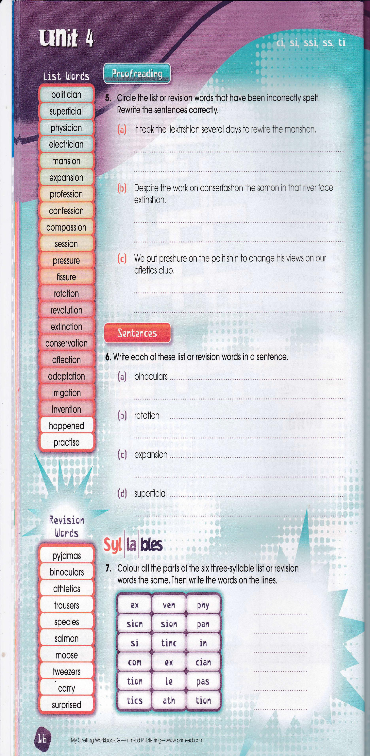
Remember to tune into the RTE Home School Hub every day at 11.00

