Ms Rodgers, Mrs Smith & Ms Gormley
Senior Infants - Week 27^{h} April 2020

Teachers’ Names | Ms. Rodgers Ms. Gormley & Mrs Smith
Class level | Senior Infants
Suggested work for week beginning | 27th April 2020
Teachers email address | - missrodgersseniorinfants@gmail.com  - missgormleyseniorinfants@gmail.com  - mrssmithseniorinfants@gmail.com
Correction of work | Work that we have highlighted should be submitted to the appropriate teacher’s e-mail address above. This can be a photograph of the copybook page or the answers can be typed into the e-mail. Please write your child’s name in the subject part of the e-mail. Work that is not highlighted should be corrected by an adult/parent.
Message from teacher/s | Dear Parents,  Sincere thanks for all your emails and the work you are submitting to us. We are so happy to receive the work and we are so proud of all our Senior Infants. We advise you to set a time limit for school work each day and when the time is up, please leave the rest of the work. You do not need to replicate the school day as we are aware of all the challenges you maybe facing at home. We understand you are doing the very best you can under the circumstances. Please note you can email the work daily or weekly or whenever you get the chance as some of you may have toddlers running about or have 2 or more children completing school work daily, so we understand. Please be under no pressure and email us at any time if you need any support.  Thanking you,  Ms Rodgers, Ms Gormley & Mrs Smith

LINK TO PADLET: https://padlet.com/gormleyeimear/8uk0t73j4psvhhr3

Ms Rodgers, Mrs Smith & Ms Gormley
Senior Infants - Week 27^{h} April 2020

Monday 27th April | Tuesday 28th April | Wednesday 29th April | Thursday 30th April | Friday 1st of May
P.E: GAA skills – see padlet  Reading: Stop that Dog words  Handwriting: Letter ‘I’ (page from Just Cursive). Please get your child to write their name and surname too, once a day on worksheets.  Maths: Monday Mental Maths Page 42  Gaeilge: ‘Sa Bhaile phrases’ on the  Padlet-Altram  Music: (see link on padlet)  https://www.youtube.com/watch?v=uYVeul1gSTA  -Do you think it’s a fast/slow song?  -Can you move along to the music like a pony?  -try saying the words “jig jog,jig,jog,jig-a-jog-jig”  -Get a wooden spoon and a pot and tap along to the music. | Reading: Stop that Dog words (jumping activity – see below)  Phonics: ‘ug’ Family  Listen to:  https://www.youtube.com/watch?v=ByHwuuAsEmo  Write out 6 words in the ‘ug’ family e.g. jug, mug, slug, rug, bug, snug. Draw a picture for each word or write a sentence.  Maths:  - Video on padlet  - Worksheet 1: How much money is in each set?  Art: Do some art from things you can find in your garden. You could use some leaves, flowers, twigs, stones and whatever you can find. We would love if you used your imagination as to what you could make with all these beautiful things we have in our environment. Here is a very simple sample of what you could do!  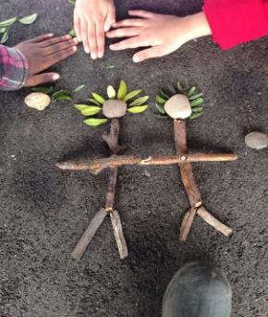 | Reading: Stop that Dog words (Nerf gun activity – see below)  Literacy: Write out 6 words that start with ‘gr’ – grass, grab, grow, grape, green,  grill etc. Challenge: write a sentence with them.  Maths:  Wednesday Mental Maths Page 43  Gaeilge: ‘Sa Bhaile’  Video on padlet  Worksheet (see below) will be completed while listening to padlet  History:  Listen to story The Salmon of Knowledge on padlet  - Answer questions orally  - Retell story to another family member  Religion: Theme: 8 Lesson 1.  Worksheets (see below and also on padlet) | Reading: Stop that Dog words – pick 5 words and write them out 3 times each.  Literacy:  Listening activity-  Honey Bear: see sheet below  Read out each of the instructions twice.  1.Write your name and surname beside the honey-pot.  2.Colour the bear’s trousers blue.  3.Put a circle around the bee who wants to share the bear’s honey.  4.Colour the bear’s body yellow.  5.Find some honey which has spilt on the ground and put a line under it.  6.If you think the bear has a pocket on his trousers, put a large circle around the picture, but if you think he doesn’t, just put a line under your name.  Maths: Money  - Video on padlet  - Worksheet 2: Add and write  Gaeilge: ‘Sa Bhaile’  Video on padlet ‘Sa chistin’  Geography – Water  Link on padlet  - Listen to the following story about the pond:  - Draw 4 things you would find there. | Reading: Stop that Dog words – play bingo using your words (see below)  Handwriting:  Practice writing capital letter ‘J’ (page from Just Cursive).  Maths:  Count to 30. Ask an adult to pick a number between 0-30 and name number that comes before/after/in between.  Science -Floating and Sinking  Make a boat with playdough. See does it sink/float. Add some figurines or frozen peas as passengers and test the boat to see what happens (If you have no playdough, you could just design a boat on paper)  SPHE:  Talk to your child about how they feel during covid-19.  The 5 senses scavenger hunt (send them outside while you have a well – deserved coffee break!!!)  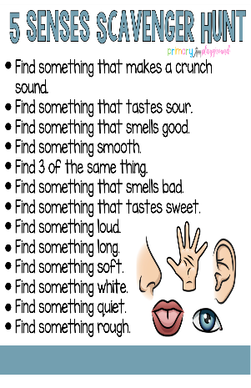

-The children need to know how to write their surnames. Please practice writing this daily on top of worksheets just as your child would do at school.
-Don’t forget to write in CURSIVE, use capital letters, full stops, finger spaces, write on line, tall letters and small letters.
-Read, read, read as much as possible. Read storybooks together with your siblings, parents, independently and even to your dolls, teddies and superheroes.
-Bingo: Play bingo with your older siblings/parents – each person chooses 8 words from ‘Stop that Dog’ word list and writes one word in each box. The caller calls out a word and the player colours in/puts an x on that word. First person to colour all their words wins. Woohoo!!!!!!
-Nerf gun activity: If you have a nerf gun or even use a ball – write the words on post it notes and put them on a wall. Ask an adult to call out the word and shoot/throw the ball to the word on the wall.
-Jumping activity: Write words on pieces of paper or on ground outside using chalk. Throw an object (e.g. lego, sock, small stone) on to a word. Name the word. Can you put that word into a sentence?
MATHS: When adding coins put small dots above the coin to match its value. This will help them when adding the amounts, eg, 2c – put two dots above coin.
RESOURCES

Please note that all worksheets, resources, online games are on the senior infants padlet https://padlet.com/gormleyeimear/8uk0t73j4psvhhr3

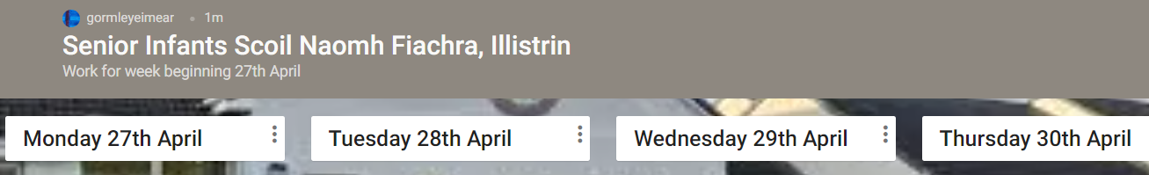

Please not this is a NEW padlet for this week’s work.

However, if some of you prefer, the worksheets are also attached to this letter.

Cursive Handwriting
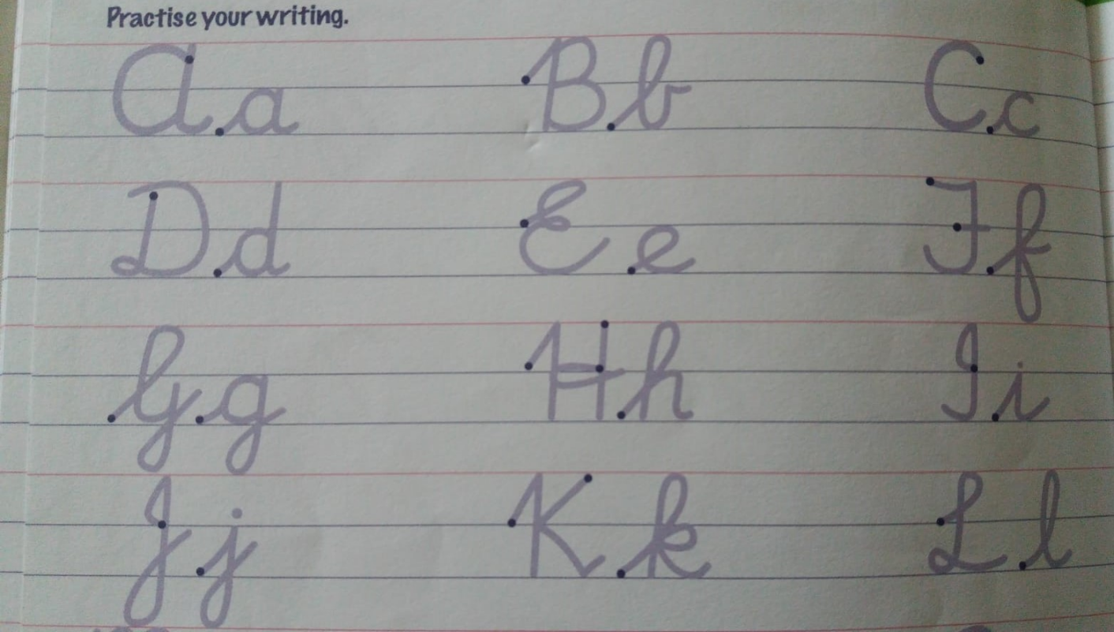

Maths Money
Tuesday 28th April

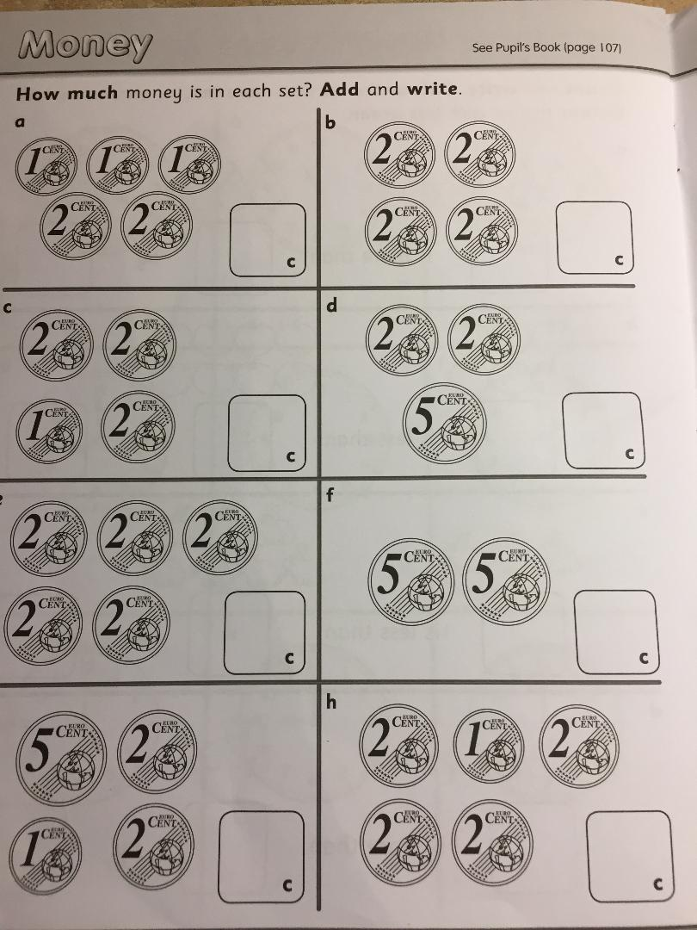

Maths Money
Thursday 30th April

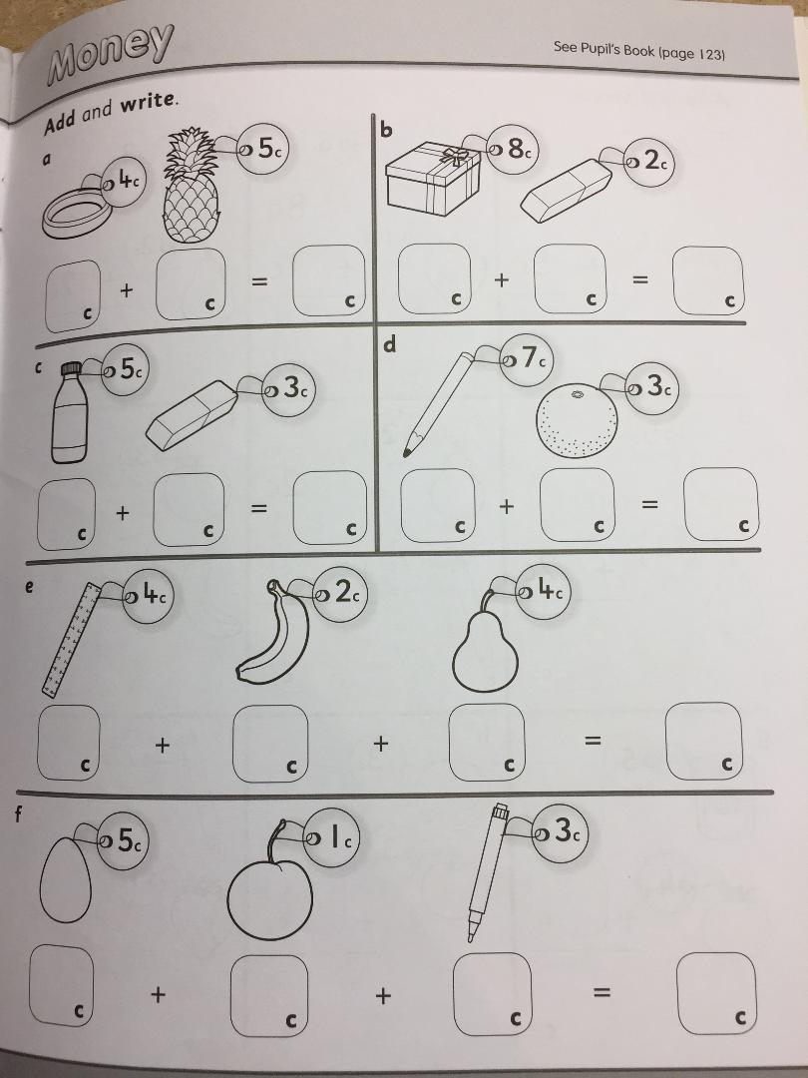
Listening Activity
Thursday 30th April
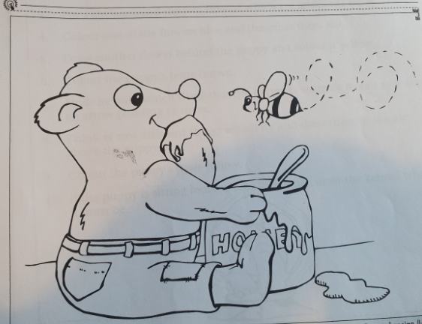

Geography - The Pond
Thursday 28th April

Draw 4 things you would find in a pond.

Religion Wednesday 29th April
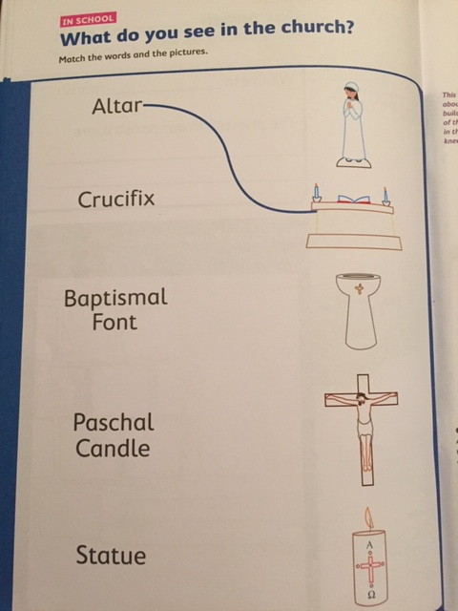

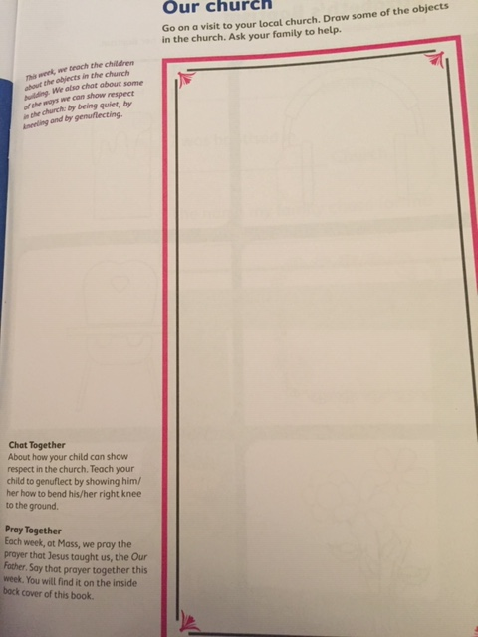
You won’t be able to visit your local Church. However, you will be able to see the Cathedral on their live stream. https://www.churchservices.tv/letterkenny. They have daily mass at 8am, 10am and 6pm. The Church of the Irish Martyrs have mass every day on their Facebook page at 12 noon.

Stop that Dog words
Monday 27th April | Tuesday 28th April | Wednesday 29th April | Thursday 30th April | Friday 1st May
likes  dog  again  come  away  him | holds  ladder  top  stop  paint  garden | ring  go  like  hold  Mum’s  digs | stopped  flowers  coming  walking  lead  pool | market  stopped  cross  kicking  after  muddy
These are the words for our next reader ‘Stop that Dog’. Try and revise over the previous day’s words also. e.g. On Wednesday, go back over Monday and Tuesday words.
When you get very good at the words, you could try and make up sentences with the word in the sentence. Next week, we will be starting the book Stop that Dog!

Gaeilge
Wednesday 28th April

- Tá mé ag caint ar an bhfón | - Tá mé ag obair ar an ríomhaire
- Tá mé ag caoineadh | - Tá mé ag imirt ar an spraoistaisiún

Friday 1st May
Scavenger Hunt

Mental Maths
Monday 27th and Wednesday 29th April

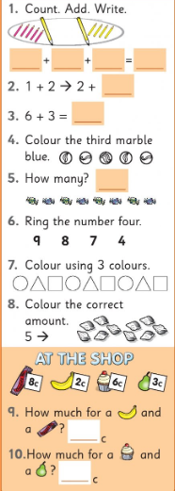
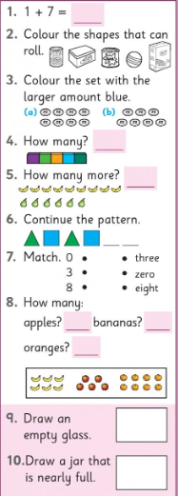
Monday 27th April Wednesday 29th April

Handwriting
Monday 27th April

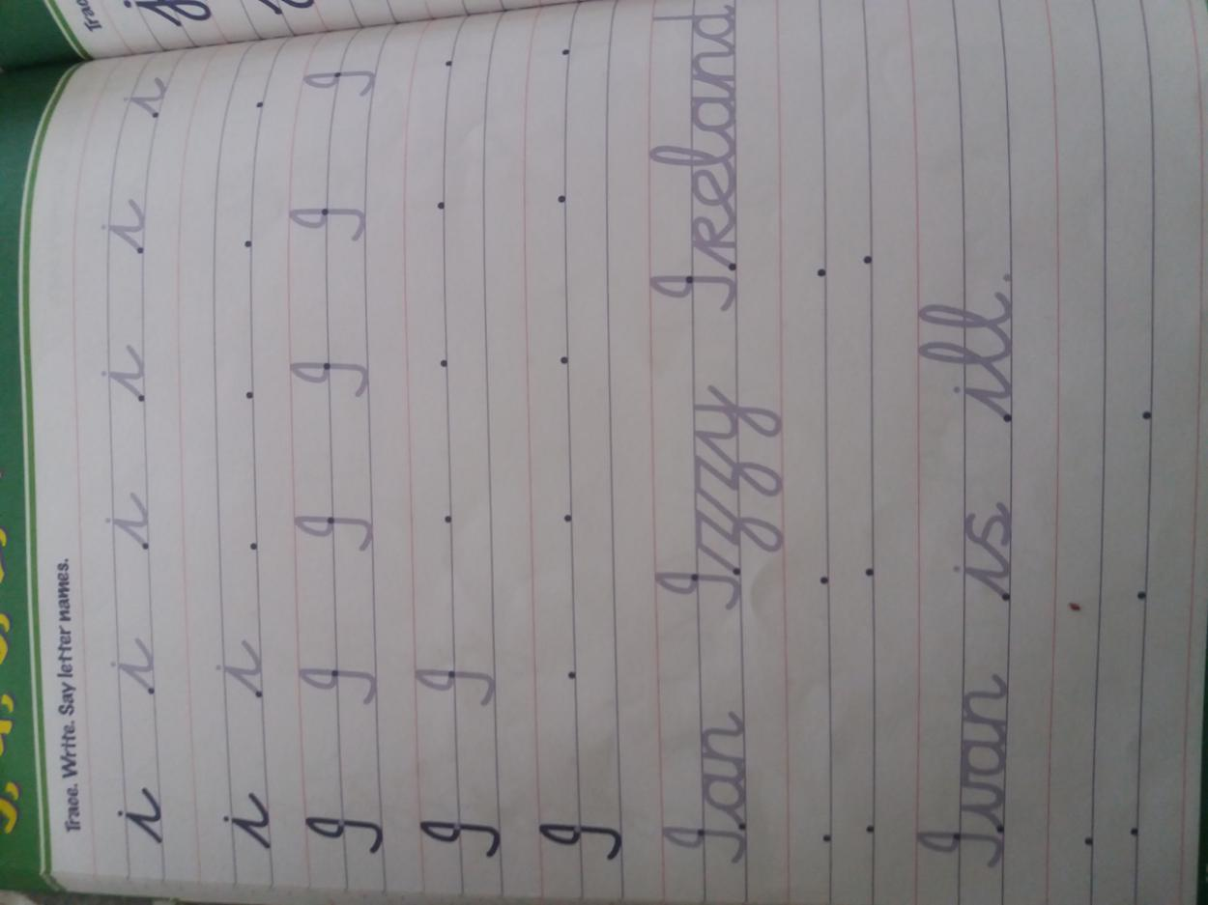

Handwriting
Friday 1st May

