Mr J Gallagher & Ms Dunne 2nd Class
Week 3 and Easter Break Work

Encourage your child to spend some time each day at school work. Encourage them to do some mental maths and reading each day.
There is no pressure to complete all the work, only spent a set amount of time each day at their school work.

Stay safe

My Read at Home Book 2 https://www.cjfallon.ie/ Week 24 pages 93-96
See document Using cjfallons for Read at Home
Ask your child to read a story each day and discuss the answers with a parent

Master your Maths Week week 27
€1 subtraction worksheet
€2 subtraction worksheet
Busy at Maths pages126-131
Small World 2 pages 68,68,70,71

Grow in Love pages 34,35,40,41,42,43
https://www.youtube.com/watch?v=HnUs5s33iqw
ask your child to watch and join in and say/sing the prayer
https://www.youtube.com/watch?v=0PSgoPdKQFQ
Watch this video with your child and help them to understand the Easter Story

Encourage your child to read,read,read
Encourage your child to be active and continue to exercise
https://youtu.be/6v-a_dpwhro or Google PE with Joe Wicks
Encourage your child to try out some of the science sheets
Encourage your child to be creative, art projects, lego, gardening, baking etc

This week was to be International week in Illistrin NS. We would still like to celebrate this with our families and the wider community. Maybe you could include a lesson on a country of interest to your family, listen to music from a different culture or do some art work from another country. We are asking the school community to send a some artwork, a song or piece of written work to illistrininternational@gmail.com We will then compile the photos we receive to create a video for our website and illistrinpa facebook page. Let's work together to celebrate our school while staying apart!! We hope you and your families are keeping safe and well.

Using cjfallons for Read at Home 2
Open the link below
https://www.cjfallon.ie/
The screen below opens
Click here
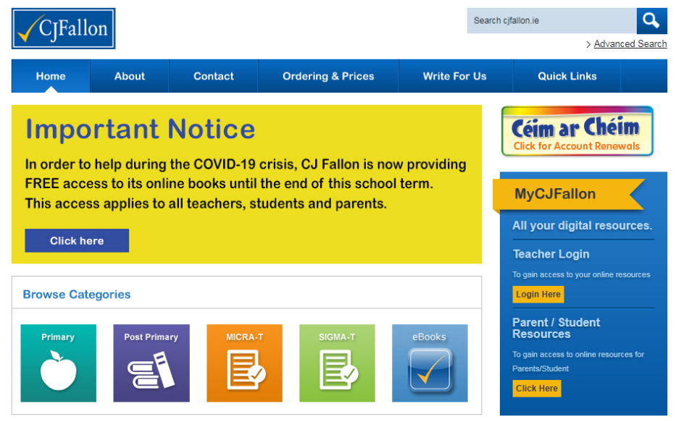
The screen below opens
Click each section as follows
Primary - 2nd class -English -My read at Home -My read at home Book 2
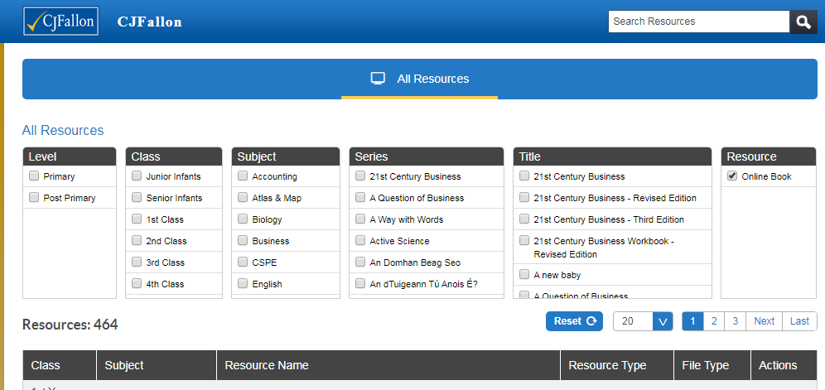
The screen below is displayed
Click to open
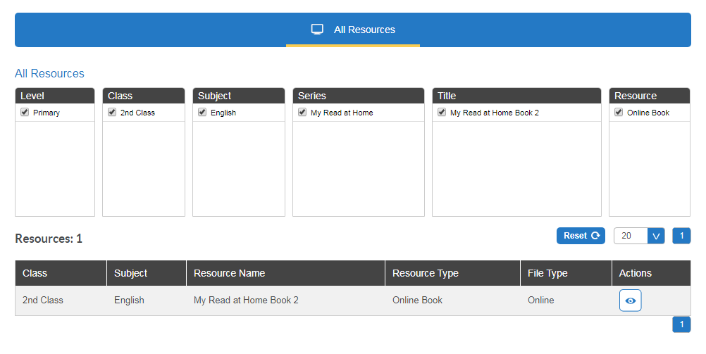
Fill in the details and this should bring you to the book
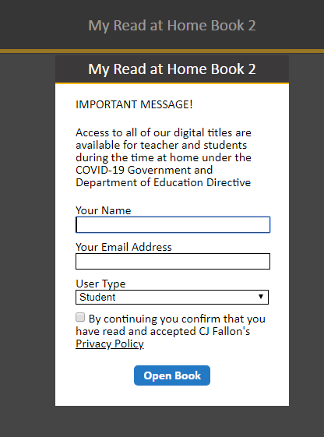

I had €1 |  |  |  |  |  |  |  |  | I spent | change
50c | 20c | 10c | 10c | 5c | 2c | 2c | 1c |  | 85c
I spent 85c, cross out the coins that makeup 85c
50c | 20c | 10c | 10c | 5c | 2c | 2c | 1c
Count the remaining coins, this is your change.
50c | 20c | 10c | 10c | 5c | 2c | 2c | 1c |  |  | 15c
I had |  |  |  |  |  |  |  |  | I spent | change
50c | 20c | 10c | 10c | 5c | 2c | 2c | 1c |  | 35c
50c | 20c | 10c | 10c | 5c | 2c | 2c | 1c |  | 68c
50c | 20c | 10c | 10c | 5c | 2c | 2c | 1c |  | 49c
50c | 20c | 10c | 10c | 5c | 2c | 2c | 1c |  | 72c
50c | 20c | 10c | 10c | 5c | 2c | 2c | 1c |  | 66c
50c | 20c | 10c | 10c | 5c | 2c | 2c | 1c |  | 19c
I had €2 |  |  |  |  |  |  |  |  | I spent | change
€1 | 50c | 20c | 10c | 10c | 5c | 2c | 2c | 1c | 85c
I spent 85c, cross out the coins that makeup 85c
€1 | 50c | 20c | 10c | 10c | 5c | 2c | 2c | 1c
Count the remaining coins, this is your change.
€1 | 50c | 20c | 10c | 10c | 5c | 2c | 2c | 1c |  | €1.15
I had |  |  |  |  |  |  |  |  | I spent | change
€1 | 50c | 20c | 10c | 10c | 5c | 2c | 2c | 1c | €1.12
€1 | 50c | 20c | 10c | 10c | 5c | 2c | 2c | 1c | €0.63
€1 | 50c | 20c | 10c | 10c | 5c | 2c | 2c | 1c | €0.95
€1 | 50c | 20c | 10c | 10c | 5c | 2c | 2c | 1c | €1.33
€1 | 50c | 20c | 10c | 10c | 5c | 2c | 2c | 1c | €1.67
€1 | 50c | 20c | 10c | 10c | 5c | 2c | 2c | 1c | €0.82
