**Ms Dunne and Mr Gallagher 2nd Class 27thApril- 30th May**

|  |  |
| --- | --- |
| **Teachers’Names** | Ms K Dunne and Mr J Gallagher |
| **Class level** | 2nd class |
| **Suggested work for week beginning** | 27th April –1st May |
| **Teachers email address** | [msdunne2ndclass@gmail.com](mailto:msdunne2ndclass@gmail.com)  [illistrinjgallagher2nd@gmail.com](mailto:illistrinjgallagher2nd@gmail.com) |
| **Correction of work** | If you would like to send work back to us to look at or correct please do. |
| **Message from teacher/s** | You can also email us if you have any queries or questions. Please write your child’s name in the *subject* box of the email.  (see below for note to children and parents) |

**Remember to tune into the RTE Home School Hub every day at 11.00**

Hi Children

We hope that you are enjoying your time off school. We are so lucky to have all of this lovely weather. We have been in contact with your parents and they have been telling us how hard you all have been working. We are so proud of you for being so good during this time at home. Some of you have been video calling your friends and talking to your friends from a safe social distance. It is important that you not only do this but help your parents around the house with chores and with your little brothers and sisters. Some of your parents are working so you need to be extra helpful here.

Parents it was great to hear from you all. Thank you for your emails. Please continue to email us with your queries. We are only too happy to help. Thank you for all the hard work you are doing at home with your child. Please do not feel under pressure to do all the work below. Do some Maths and English over the week. These are the most important subject areas. Many of you are working and have smaller children at home so don’t be putting yourself under too much pressure.

Remember this is a time that you want your child to remember positively so bake, do art, play board games, read to them or get them to read aloud simple books to their siblings and try to make their learning fun and meaningful for them.

Also with regard to different subject areas we have the following information:

**Irish**:

Go to www.foclóir.ie for pronunciation of words.

Orally practise some questions every day, such as:

* Cad is ainm duit? = What is your name?
* \_\_\_\_\_ is ainm dom= \_\_\_\_ is my name
* Cén aois thú?= What age are you?
* Tá mé ocht/naoi mbliana d’aois= I am 8/9 years of age
* Cén rang in a bhfuil tú? = What class are you in?
* Tá mé i rang a dó= I am in second class.
* New question: An maith leat cáca/milseáin/ criospaí ? = Do you like cake/sweets/crisps? Is maith liom \_\_\_/ Ní maith liom =I like\_\_ /I don’t like\_\_

As children don’t have their Irish books at home you can access the Irish programme through Edco (publisher for the Irish book for Bua naCainte 2) go to [www.edcolearning.ie/login](http://www.edcolearning.ie/login) level: Primary Username: primaryedcobooks Password: edco2020 Select topic : An Teilifís. We have attached the sheets from this link below anyhow.

**Activity on Monday**

Practise some oral Irish with your child: using the questions above.

Complete activity on page 91

Inniu = Today

Inné = Yesterday

Amárach = tomorrow

An Luan = Monday An Mháirt =Tuesday An Chéadaoin = Wednesday

An Déardaoin = Thursday An Aoine = Friday An Satharn =Saturday

An Domhnach = Sunday

So if the day is Monday you would write fill in Inniu an Luan

Chuaigh mé go dtí an \_\_\_\_\_ = I went to the \_\_\_\_\_

Chuaigh mé = I went go dtí = to

Sorcas = circus

Chonaic mé \_\_\_ agus \_\_\_ = I saw \_\_\_ and \_\_\_\_

Write about the things you saw at the circus. Pictures are beside the animals etc.

Bhí \_\_\_ agam = I had \_\_\_

an-spórt = great fun

An Aimsir = the weather

Fuar = cold te agus tirim = hot and dry fliuch = wet

Gaofar = windy scamallach = cloudy geal =bright

Geal = bright dorcha = dark

Bhí an lá \_\_\_\_ inné = the day was \_\_\_ yesterday (choose weather above)

Bhí = was/were (pronounced like letter ‘v’) an lá = the day inné = yesterday

Tá an lá \_\_\_ inniu = the day was \_\_\_\_ yesterday (choose weather above)

Tá =is/are an lá = the day inniu = today

Beidh an lá \_\_\_\_ amárach = the day will be \_\_\_ tomorrow (choose weather above)

Beidh (pronounced like ‘bay’) = will be an lá = the day amárach = tomorrow

**Activity on Tuesday**

**Practise oral questions above**

Ar cheannaigh tú = Did you buy?

* Cheannaigh mé = I bought
* Níor cheannaigh mé = I didn’t buy

Practise questions: Ar cheannaigh tú milseáin inné= Did you buy sweets yesterday?

Cheannaigh mé milseáin = I bought sweets

Níor cheannaigh mé milseáin = I didn’t buy sweets

Use different words: arán = bread, seacláid = chocolate, bainne = milk, criospaí =crisps etc.

Ar cheannaigh Daidí prátaí? = Did Daddy buy potatoes?

Cheannaigh Daidí = Daddy bought Níor cheannaigh Daidí = Daddy didn’t buy

Cheannaigh= bought Níor cheannaigh =didn’t buy

tornapa= turnips píseanna = peas bagún = bacon

cabáiste = cabbage cairéid = carrots pónairí = beans

Complete page 93.

**Activity on Wednesday:**

Uaidh = He wants (pronounced ‘oo-ig’ as in soon)

Uaithi = She wants (pronounced ‘oo-he)

Tá leitís uaidh = He wants lettuce

Tá prátaí uaithi = She wants potatoes

Cad atá uait? =what do you want? (uait is pronounced ‘oo-it’)

Tá milseáin uaim = I want sweets (uaim is pronounced ‘oo-im’)

Tá criospaí uaim = I want crisps

**Activity on Thursday translated below.**

Cé mhéad? = How much/ How many?

Cent amháin = 1 cent Dhá cent = 2 cent trí cent = 3 cent

Ceithre cent = 4 cent cúig cent = 5 cent sé cent = 6 cent

Seacht cent = 7 cent ocht cent = 8 cent naoi cent =9 cent

Deich cent = 10 cent aon cent déag = 11cent dhá cent déag = 12 cent

Trí cent déag = 13 cent ceithre cent céag = 14 cent cúig cent déag =15 cent

Sé cent déag = 16 cent seacht cent déag = 17 cent ocht cent déag = 18 cent

Naoi cent déag = 19 cent fiche cent = 20 cent

Story : Dia Duit (see sheet attached below)

Dia Duit = Hello

Molly is ainm don chailín seo = Molly is the name of this girl.

Tá sí seacht mbliana d’aois = She is seven years of age.

Tá sí i rang a dó = She is in 2nd class

Tá ceathrar ina clann = There are 4 in her family

**Activity on Friday**

**Picnic**

Is maith liom úlla = I like apples

Ní maith liom criospaí = I don’t like crisps

Ní maith liom banana = I don’t like bananas

Is maith liom uachtar reoite = I like ice-cream

Is maith le Daidí ...= Daddy likes...

Ní maith le Daidí... =Daddy doesn’t like

You change liom to le when you put in the person’s name.

Is maith liom = I like Is maith le Síle = Síle likes

Ní maith liom = I don’t like Ní maith le Daidí = Daddy doesn’t like

If you are stuck with the pronunciation of words go to [www.foclóir.ie](http://www.foclóir.ie) and type in the Irish word and click on U for Ulster Irish pronunciation. Also please email us with anything that we can help you with here.

**Religion:** Children will complete activities in their Grow in Love book. There is free access to the online resources which we use in school. Go to [www.growinlove.ie/en](http://www.growinlove.ie/en) click on login and your log in is: [trial@growinlove.ie](mailto:trial@growinlove.ie) and password is growinlove and choose the book 2nd class. Go the theme 8, We can live as Jesus asked and go to Lesson 2; I will send a helper. Here you can access the story on two clips, Pentecost and other resources such as songs: This is the Day, Quiet and still etc. Please revise the prayers before and after Communion and mass responses. These can be found at the back of your Grow in Love book.

**DEAR(drop everything and read)** : This a great activity to do daily with your child for 10-15 mins.

**For additional work (some parents have been asking for some extra English or Maths.**

**Additional Maths:** You can access other maths books online from the website [www.cjfallon.ie](http://www.cjfallon.ie)

Click here where the yellow box says ‘Important notice about Covid 19’.

For class tab click 2nd, for subject tab click Maths and for series tab click Figure it Out .

Under actions tab, click view resources icon.

Complete the box that says important message filling in your name, email etc.

Then you will be able to access the Figure it Out book digitally. Go to pages 35, 36, 37, 38, 39, 40 for work related to the topic of subtraction with renaming which we are covering this week.

Brainteasers is another book which is excellent for mental maths and problem solving activities

This time under series tab click Brainteasers and under actions tab click view resources icon. Do pages 27, 28, 29, 36, 37, 39, 40, 41 as they are related to the topics of money and renaming with subtraction also. Also any of the pages from this book are great for revision of topics.

**Additional English** Please go to the same website [www.cjfallon.ie](http://www.cjfallon.ie" \t "_blank)

Go 2nd under class tab and go to English under the subject tab and go to Read at Home under series tab.

Then under actions tab click view resources icon.

Do pages 1-7 from this book

Also go to website [https://educateplus.ie/homestudy-primary](https://educateplus.ie/homestudy-primary" \t "_blank)

Click 2nd under class tab and Better English under subject tab.

There are nice short comprehensions in this book if you wish also.

Note: The class book, Just English and the novel, Dr Dolittle can be gotten here if any of you are missing it. Answers for these activities can be gotten here too.

**Additional SESE:** Do a project on Ethiopia

Stay safe during this uncertain time.

Thanking you all for your continued help and co-operation. It is much appreciated.

Warm Regards

Ms K Dunne and Mr J Gallagher `

|  |
| --- |
| **Monday .**  **Maths:** Warm up activities: Practise counting in 4s 4, 8, 12, 16, 20, 24, 28, 32, 36, 40. Make up word problems orally using the word altogether. E.g. Jim has 30 stamps and Alan has 22 stamps. How many stamps have they altogether?  Practise renaming using tens and units. You rename by taking one ten and bringing it over to the units side and breaking it in to ten units and adding to the units that are already there.  Complete page 136 in Busy at Maths book.  Master your Maths: Go to the next week 29 and do Monday  Tables -5  **English:** Read Dr Dolittle chapter 4 and answer questions orally. Answer questions pg. 33 of Just English this can be done over two days.  DEAR each day. (see note above)  **SESE:**Small World: Ethiopia: show your child where Ethiopia is in relation to Ireland on a map. Explain that it is on the continent of Africa. Explain that a continent is a discrete area of land that is large and continuous and separated by a body of water. Ireland is on the continent of Europe.  Link to some quick facts about Ethiopia:  <https://www.kids-world-travel-guide.com/ethiopia-facts.html>  Link with song about Ethiopia that tells facts about it.  <https://www.youtube.com/watch?v=Ud2OmhgdiHk&vl=en>  Complete activity on page 76  **Irish:** Practise some questions orally such as Cad is ainm duit? etc (see above for ideas  See ideas above and complete activity attached page 91  **Religion**: Practise prayers before and after Communion. Listen to story ‘Pentecost’ (This can be accessed on the Grow in Love website under theme 8, lesson 2. For details about how to login see notes above)  Grow in Love page 48 |
| **Tuesday**  **Maths :** Practise warm up activities: counting in 4s and making up word problems using the word altogether.  Link on you tube which explains renaming. Renaming is called regrouping and units are called ones in the clip. Hope this helps a little to explain it further.  <https://www.youtube.com/watch?v=DL915w2DsPA>  Renaming: Busy at Maths book page 137. Explain question 1(a)(52-4) by getting your child to hold up 2 fingers and asking them can they take 4 away from this. They will say no and then tell them they need to go next door and take bring over a ten which will become 10 units and add this to 2 units which makes 12 units. Don’t forget to reduce the number 5 tens to 4 tens. Then when you have done this (renamed a ten as units etc) do your subtraction.  Master your Maths: do Tuesday  Tables -5  **English:** Read Dr Dolittle chapter 4. Answer questions pg. 33 of Just English this can be done over two days.  DEAR (see note above)  **PE**: Google PE with Joe Wicks, create an obstacle course in the garden, practise reaction sprints, go noodle on youtube or create an account for go noodle, treasure hunts around the house or garden, etc.  For footballers practise skills that GAA coach, Jim has taught you and also you tube has some great videos of soccer skills you can do inside if it’s raining outside.  **Irish:** See ideas above and complete activity attached page 93  **Religion:** Practise prayers and do activity from Grow in Love workbook pg 49 |
| **Wednesday**  **Maths**: Warm up activity: Practise counting in 4s. Make up word problems using the word total. Eg. I have 10 sweets and my friend has 8 sweets. What is the total number of sweets? Etc.  Subtraction with renaming: More subtraction with renaming do activity in Busy at Maths book page 138.  Master your Maths: do Wednesday  Tables -5  **English:** Just English page 59 (verbs) Revise what is a verb? (It is a doing or action word e.g think, eat, read, skip etc) Get your child to give examples etc.  Dear time (see note above)  **SESE:** Small World: Ethiopia : Compare your life to that of a child from Ethiopia. What things are different/the same? Etc. Complete activity on page 77  **Irish:** Practise some questions orally such as Cad is ainm duit? etc (see above for ideas  See ideas above and complete activity attached page 94  **Religion**: Practise Mass responses and prayer (at back of Grow in Love book) |
| Thursday  **Maths:** Warm up activity: Practise counting in 4s and 3s.  Revise making up word problems using the words total and altogether.  Revision page 139 Busy at Maths  Master your Maths do Thursday  Tables -5  **English:**  Just English page 60. Revise what homophones are; words that sound the same but mean different things and are spelt differently. ‘Their’ is used when something belongs to a person or animal. E.g The children put on their coats,( the coats belong to the children) There refers to place and it is used when something is over here (it has ‘here’ in it) and to say if something exists. e.g. There is a tree in the garden etc.  <https://www.youtube.com/watch?v=3ekjpbRZSlM>  To, too and two are homophones also. We use ‘to’ when we are going to do something or going to a place e.g I went to Dublin. Too is used when you mean as well or also e.g. I like sweets and Sam likes sweets too. Too is also used when there is too much of something e.g. That room is too hot/messy, I have too many toys etc.  Two refers to the number 2. E.g. I have two hands.  DEAR time  **Religion:** Practise prayers and mass responses (at the back of the Grow in Love activity book)  **Irish:** Practise some questions orally such as Cad is ainm duit? etc (see above for ideas  See ideas above and complete activity attached page 95  Reading and questions which can be done orally. See story Dia Duit attached. |
| Friday  **Maths:**  Master Your Maths: do Test on Friday.  Tables -5 do a written or oral test  **English**: Just English pg. 61. Talk about the different cardinal points of the compass, north, south, east, and west. Teach the mnemonic when reading the points in a clockwise direction. (Never Eat Shredded Wheat: North, East, South, West)  Handwriting sheet (attached below)  **Visual Arts:** Look at the you tube clip (below) that tells you about Pablo Picasso and his abstract art in the style of cubism. Talk about his use of colours and shapes in his art. What colours would you use to show happiness/anger/sadness etc. Then do a self portrait in the style of cubism.  <https://www.youtube.com/watch?v=RlNf5XZDcQs>  **Religion**: Practise mass responses and prayers  **Irish:** Read story Picnic and answer questions orally. |

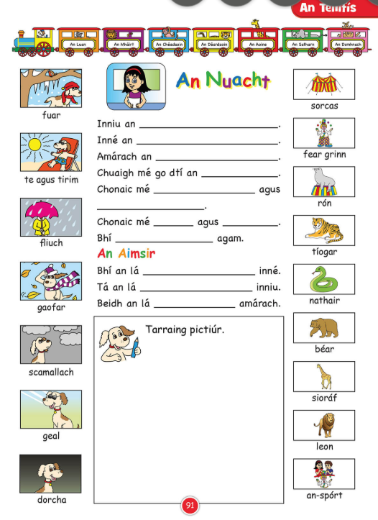

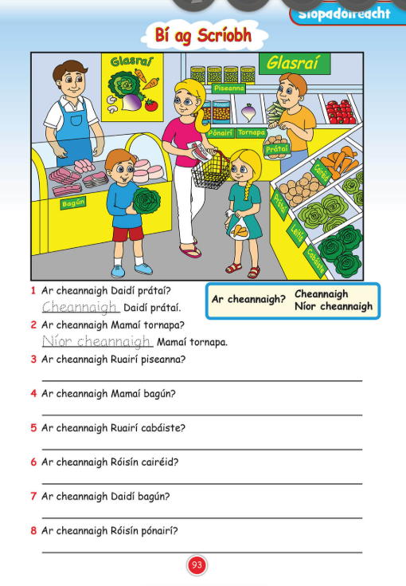

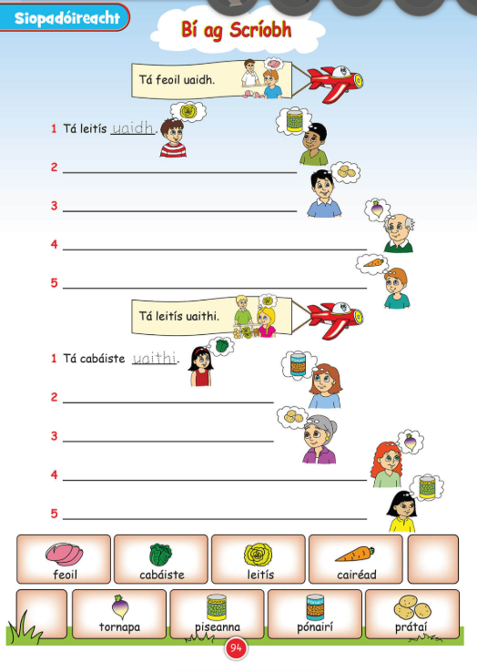

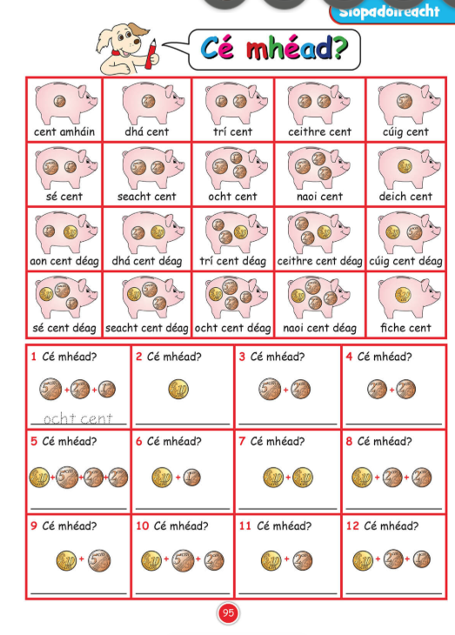

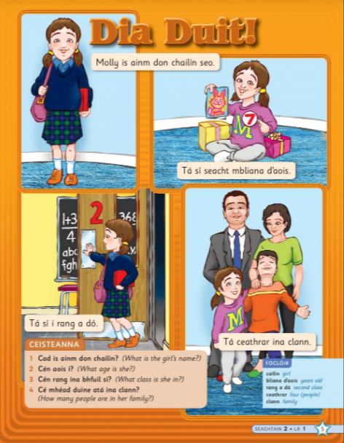

**Double click** on the mp3 below to listen to page 5



