Scoil Naomh Fiachra, Illistrin
Junior Infant Parents
Dear Parents and Students,
Well done on completing all of the work last week. You have all done fantastic work and we are looking forward to seeing more samples of work this week. We hope you are all enjoying the good weather and getting plenty of exercise outdoors.
We would advise that you would set a time limit for school work each week day and when the time is up, leave the work. You do not need to replicate the school day as children are working in a different learning environment and you are already doing your very best under the circumstances. Keep up the good work at home.
We have prepared a Junior Infants Padlet where there are links to all resources needed to support your child in the programme of work outlined below.
Padlet link for Junior Infants –
https://padlet.com/rachaelstewart2020/scd55zm3nlctkmdk
Best Wishes to you all,
Mrs Doyle, Mrs Lafferty, Mrs Stewart.
Teachers’ Names | Ms Lafferty  Ms Stewart  Ms Doyle
Class level | Junior Infants
Suggested work for week beginning | 27th April 2020
Teachers email address | louiselaffertyjuniorinfants@gmail.com  rachaelstewart2020@gmail.com  mrsdoylejuniorinfants@gmail.com
Correction of work | Work that we have highlighted should be submitted to the appropriate teacher’s e-mail address above. This can be a photograph of the copybook page or the answers can be typed into the e-mail. Please write your child’s name in the subject part of the e-mail.  Work that is not highlighted should be corrected by an adult/parent.
Message from teacher/s | You can also email us if you have any queries or questions. Please write your child’s name in the subject box of the email.

Junior Infant’s Weekly Plan Monday 27th April – Friday 1st May 2020
Monday 27th April 2020
- Jolly Phonics – Listen to the song for the sound ‘oo’ and practice sounding it out along with the action. Complete the phonics worksheet for this little ‘oo’ sound.
- Just Cursive – Practice writing the letter ‘e’. There is a video provided on the padlet to support children when forming the letter ‘e’. Complete 2 lines of the practice page on the letter ‘e’.
- Reading: Splash pages 1-2
- Additional Reading: “Big Pig” pages 1-3
- Maths – Time – Revise the nursery rhymes ‘Humpty Dumpty’ and ‘Little Miss Muffet’ with your child. Discuss what happened first, next, last? Number the pictures in the correct order. Colour the pictures.
Tuesday 28th April 2020
- Jolly Phonics – Listen to the song for the sound ‘oo’ and practice sounding it out along with the action. Complete the phonics worksheet for this long ‘00’ sound.
- Just Cursive – Complete 2 lines of the practice page on the letter ‘e’.
- Reading: Splash pages 3-4
- Additional Reading: “Big Pig” Pages 4-5
- SESE – Theme: Water - Talk about water use at home. What activities need water at home?
- P.E. – Enjoy some physical movement with the body coach Joe Wicks. There is a link provided on the padlet, and/or check out some of the games overleaf.
Wednesday 29th April 2020
- Jolly Phonics – Revise all the sounds in group 5 (z, w, ng, v, oo, 00) and listen to the songs and practice sounding it out along with the action. Play a game of ‘I Spy’ using words that make these sounds.
- Gaeilge – Leamh an dán, Mo Mhadra (Read the poem about My Dog).
- Just Cursive – Practice writing the letter ‘l’. There is a video provided on the padlet to support children when forming the letter ‘l’. Complete 2 lines of the practice page on the letter ‘l’.
- Reading: Splash pages 5-6
- Additional Reading: “Big Pig” Pages 6-7
- Grow in Love – Theme 8 – Week 1 ‘Everything Needs Water’. Complete pages 46 & 47.
- Maths – Time – Days of the Week – Draw what you like to do each day and trace the words (page 33). There is a video linked on the padlet to help children learn the days of the week.
Thursday 30th April 2020
- Jolly Phonics – Revise all the sounds in group 5 (z, w, ng, v, oo, 00). Play a game of ‘I Spy’ using words that make these sounds.
- Just Cursive – Complete 2 lines of the practice page on the letter ‘l’.
- CVC Worksheet: Draw a line from the word to the matching picture.
- Reading: Splash pages 7-8.
- Additional Reading: “Big Pig” Revise story in full.
- Maths – Time - Days of the Week – Draw what you like to do each day and trace the words (page 34).
- SESE – Theme Water: Discuss floating and sinking when in the bath. Test with bath toys.
Useful websites . www.water.ie/conservation/community/why-value-water
www.georgiebadielfoundation.org
www.marine.ie/Home/site-area/areas-activity/education-outreach/music
Friday 1st May 2020
- Jolly Phonics – Revise all the sounds in Group 5 (z, w, ng, v, oo, 00)
- Reading – Splash revise pages 1- 8
- Gaeilge – Is maith liom = I do like. Ní maith liom = I don’t like. Draw what they like/don’t like to eat in the boxes provided on the worksheet.
- SPHE- Listen to the Story ‘Rainbow Fish’ linked on the padlet. Discuss Friendship with the children and ways they should treat friends. Discuss with your child the importance of sharing with others relating back to the story.
- Music – Listen to the song on the padlet “Supercalifragilisticexpialidocious”.

Activity Worksheets to Support Your Child’s Learning
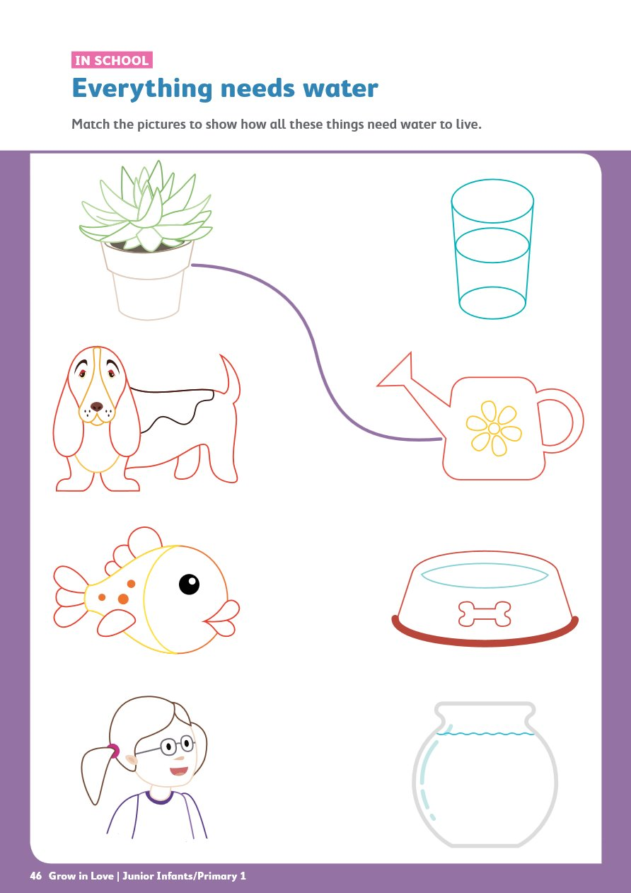
Grow in Love Worksheet 1
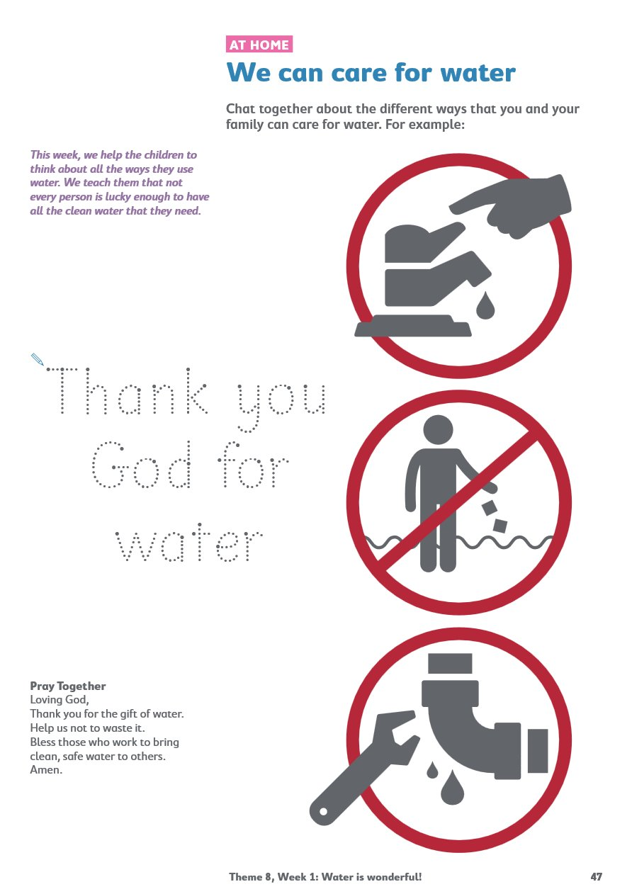
Grow in Love Worksheet 2
Art Template of the Rainbow Fish

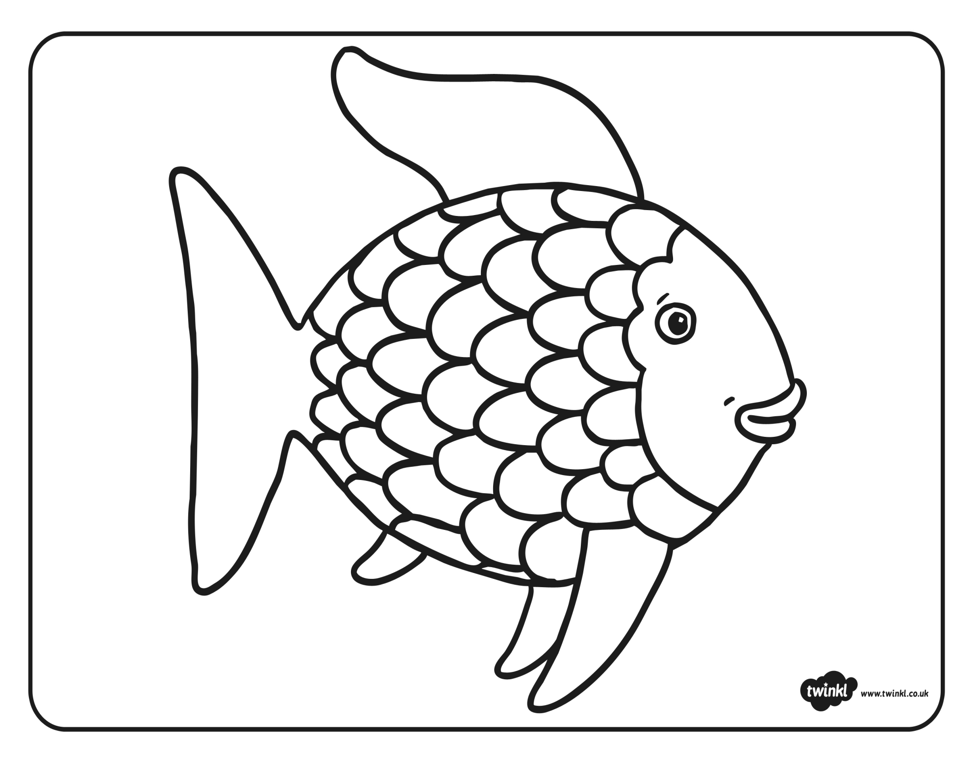

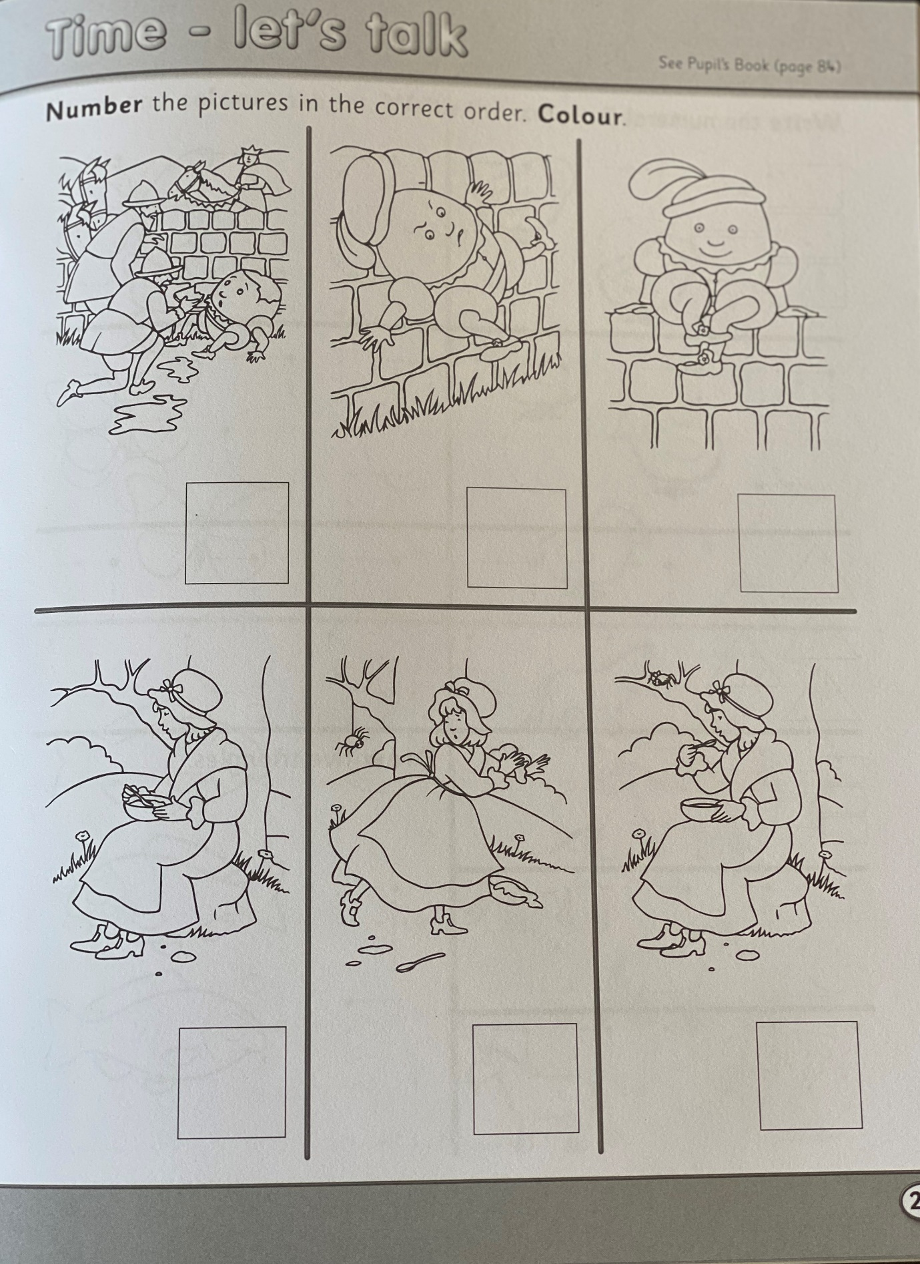
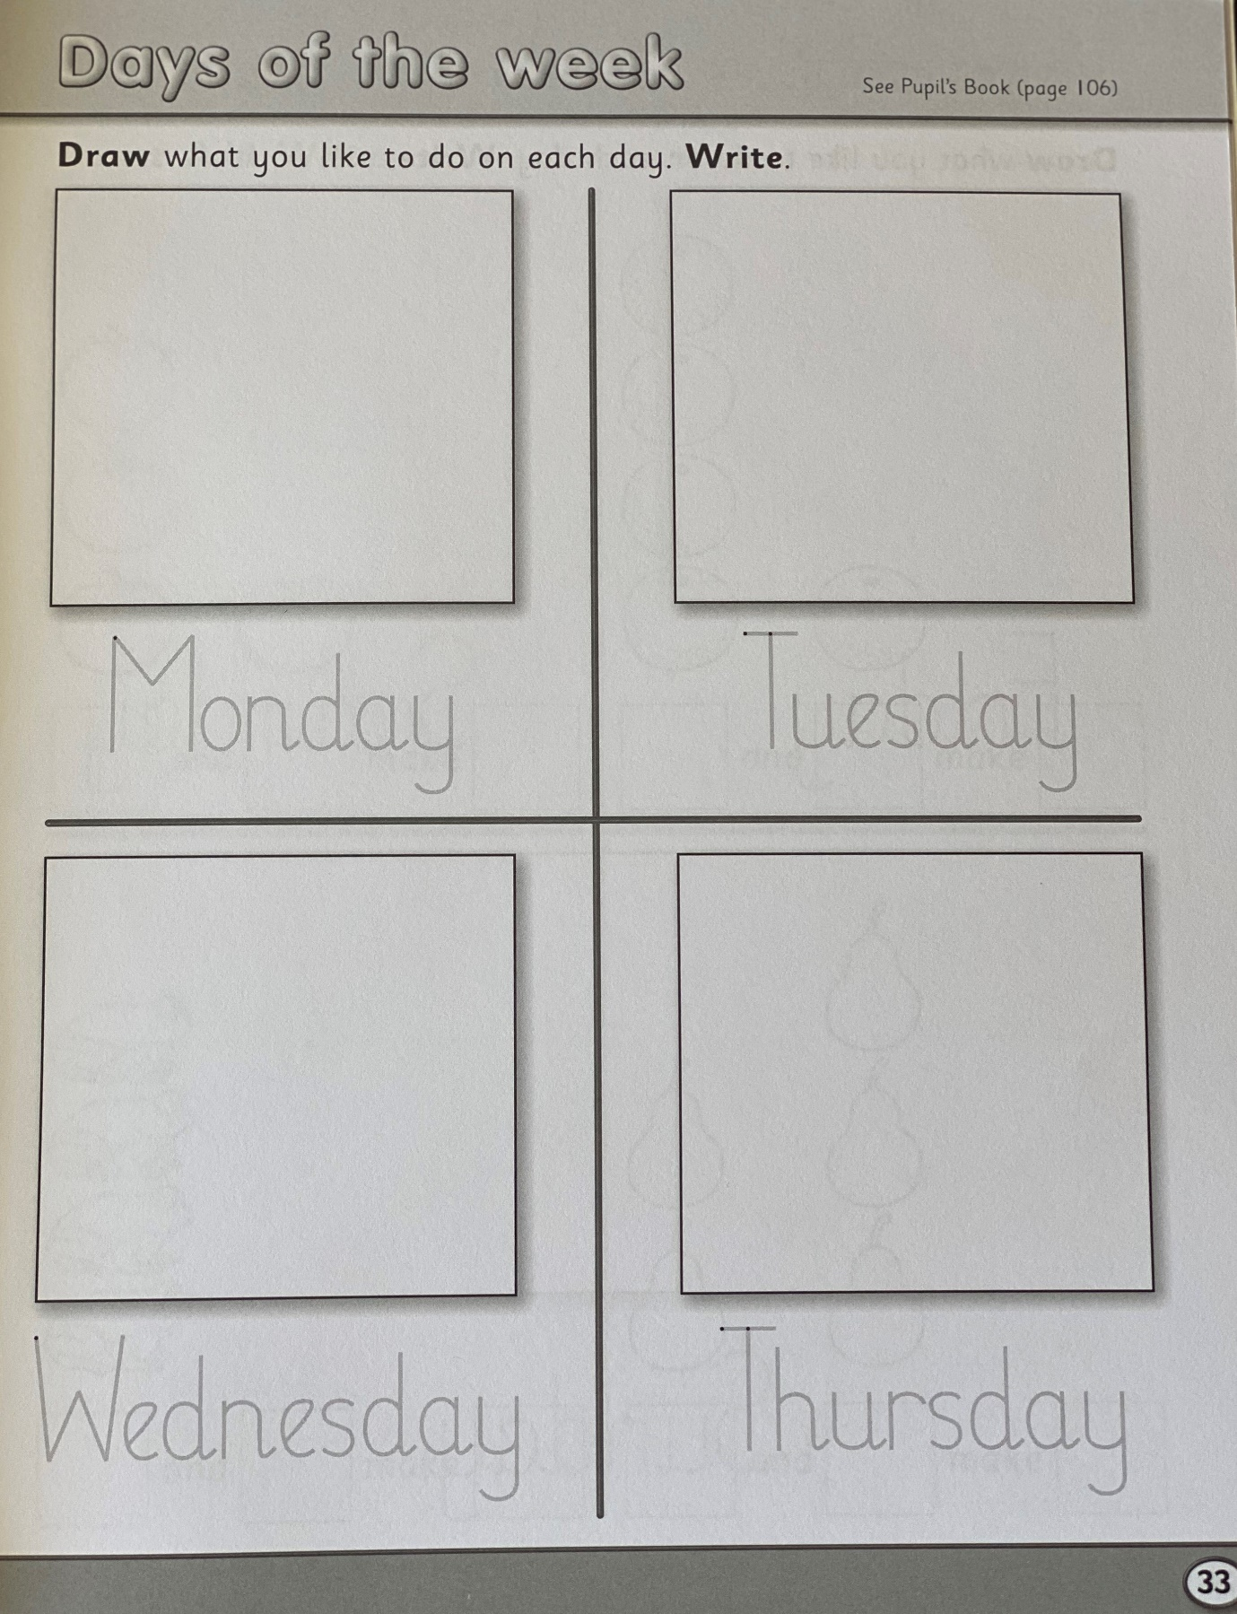
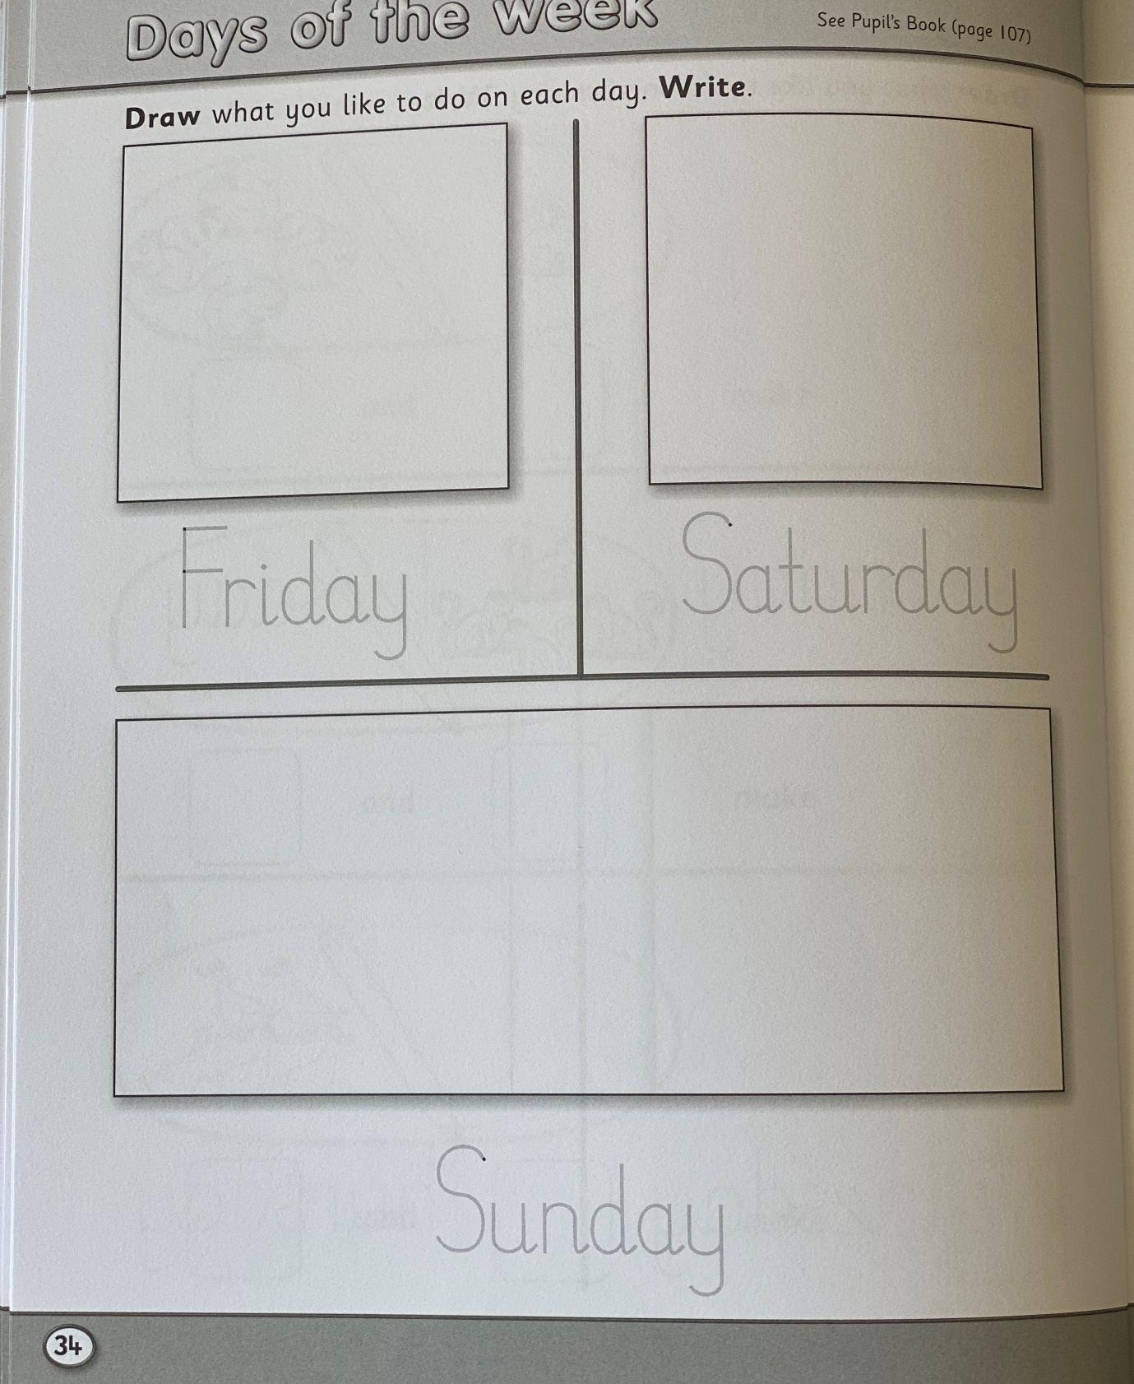
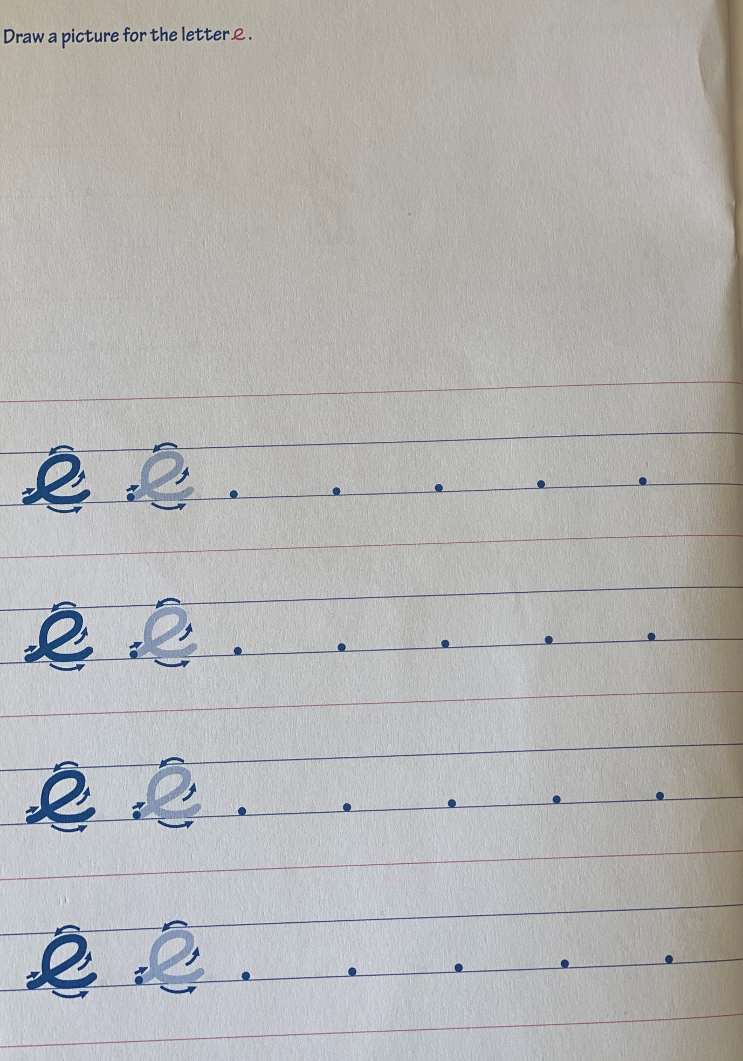
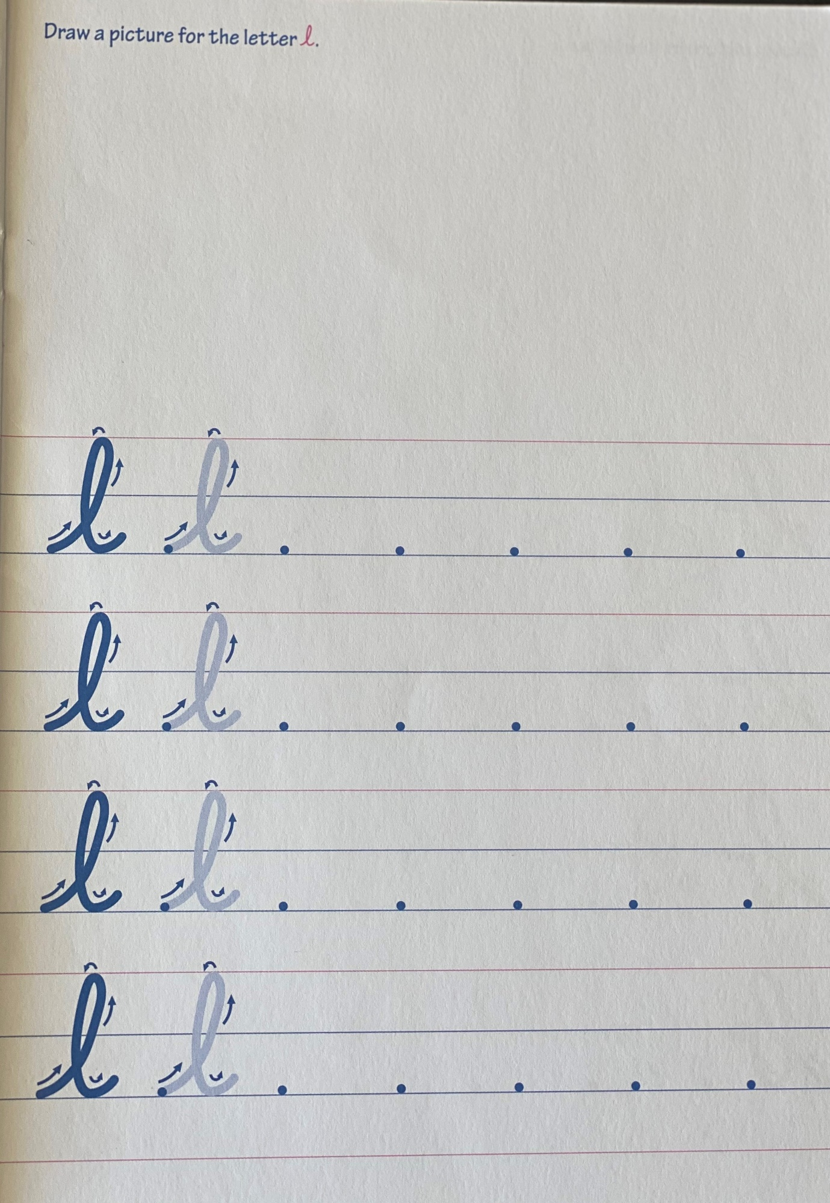
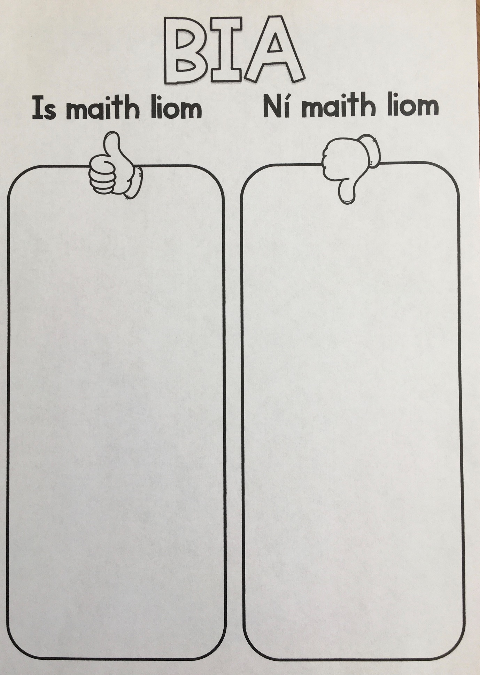
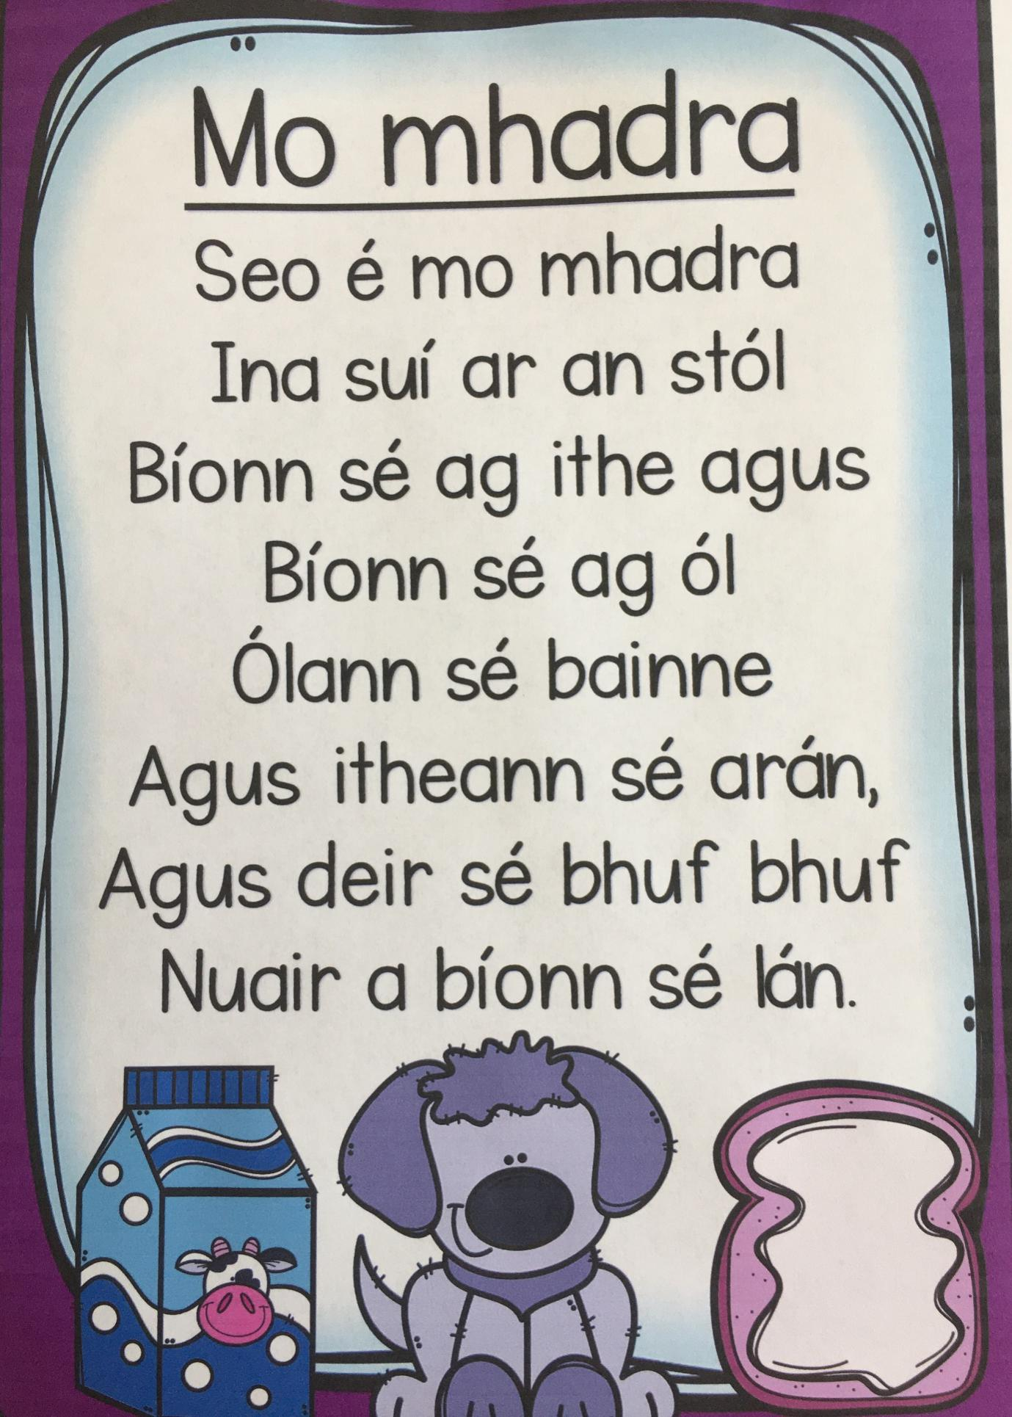
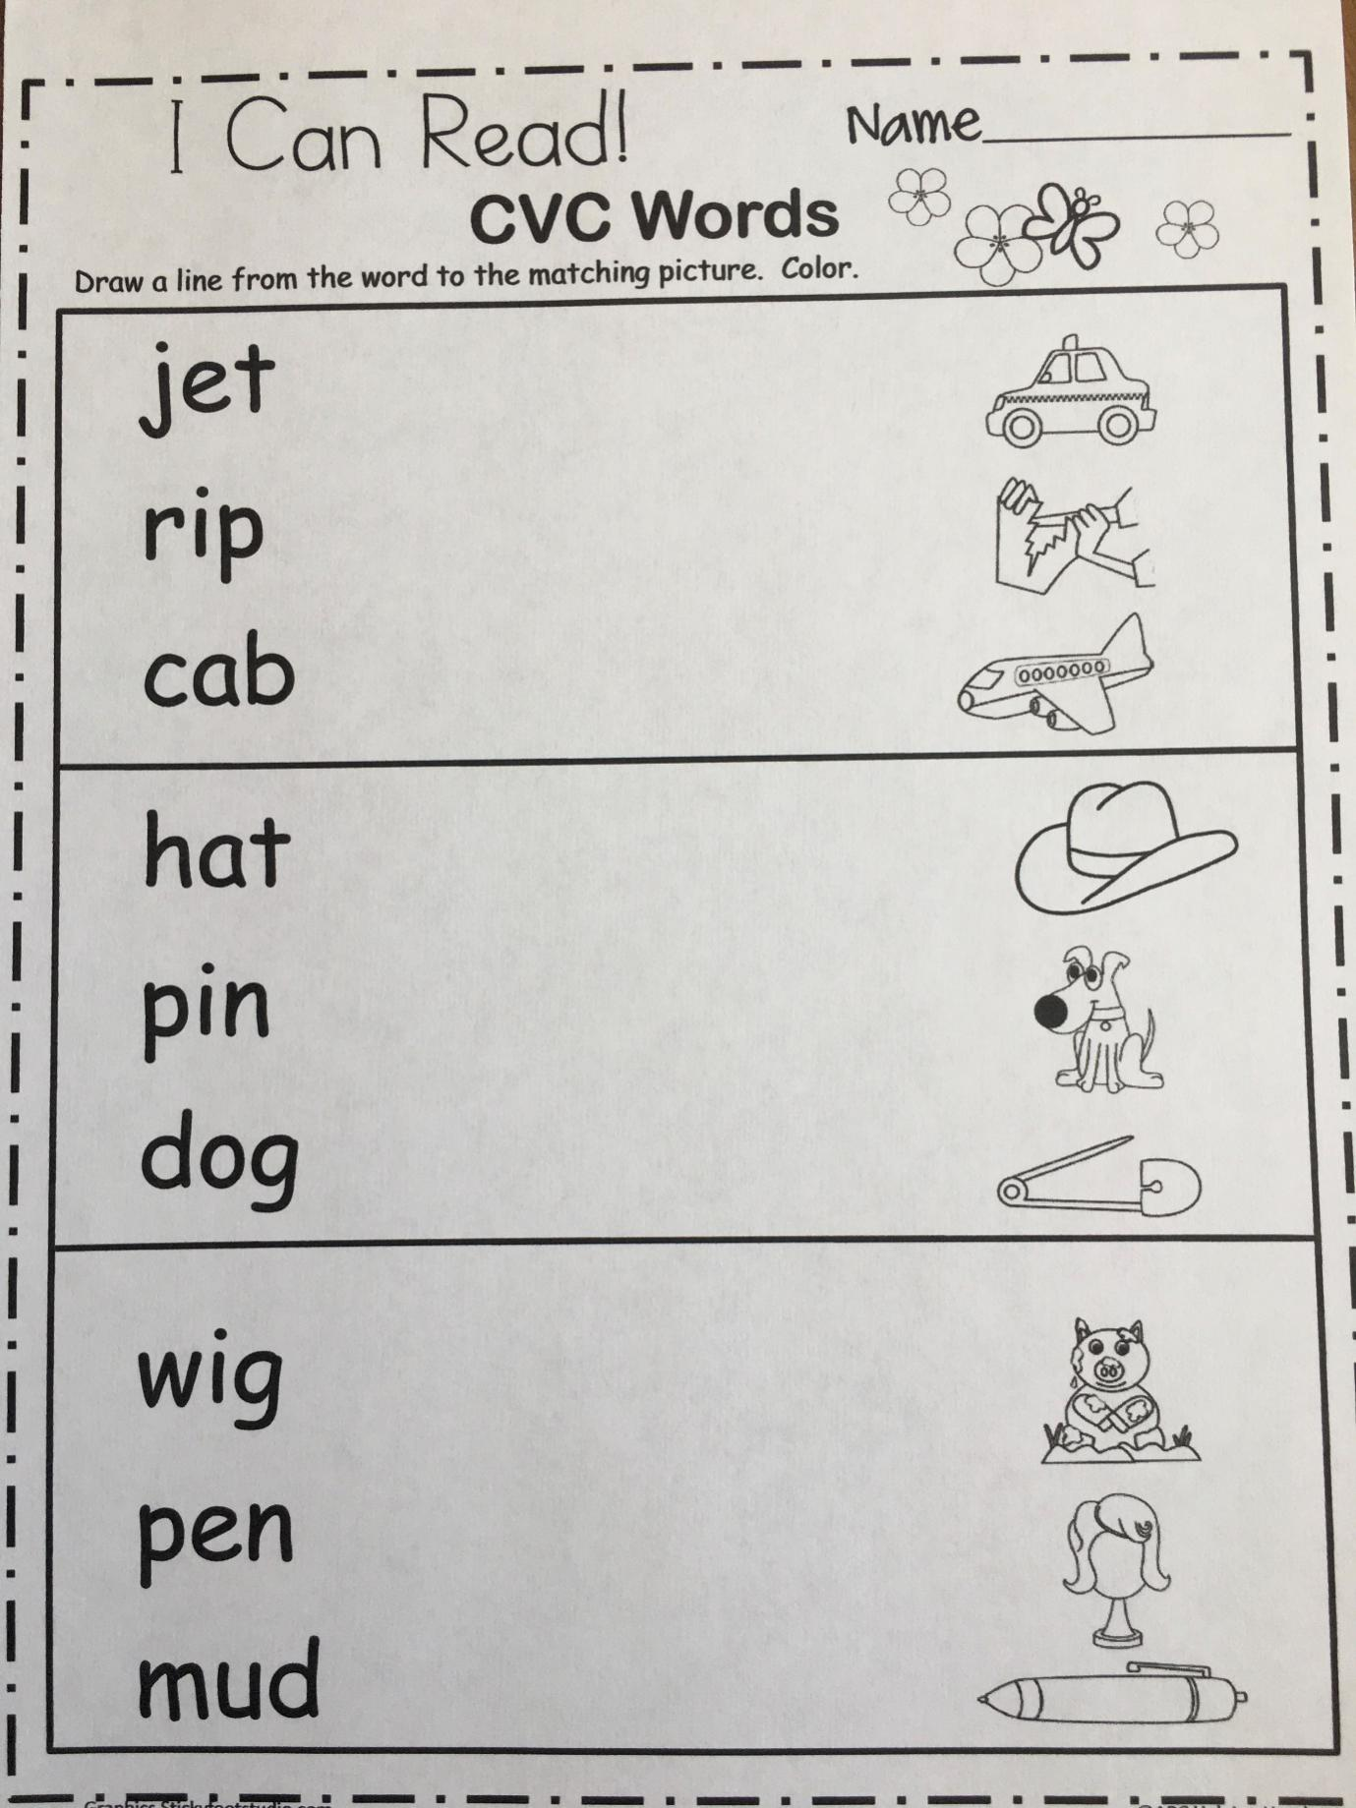

Jolly Phonics little ‘oo’ sound worksheet

Jolly Phonics long ‘oo’ sound worksheet

