Scoil Naomh Fiachra, Illistrin
Junior Infant Parents
Dear Parents and Students,
We hope you are all keeping well and had a nice Easter despite these strange and difficult times. We are missing all our junior infants’ kids so much and think of you all every day. We hope the Easter Bunny was very good to you all!
We as teachers are trying our best to adapt to supporting you all in your learning from a distance in what is now becoming our new normal. The following document is a guided weekly plan of work along with the required worksheets for you to follow with your child at home.
We have also prepared a Junior Infants Padlet where there are links to all resources needed to support your child in the programme of work outlined below.
Padlet link for Junior Infants - https://padlet.com/rachaelstewart2020/dr7vtapza006
We understand many of you may be juggling working from home or on the front line, whilst also trying to home school, so please only complete what you can. We have no doubt, the children are already learning many new skills at home and are spending lots of time outside during this great weather. We cannot wait to hear all their stories upon their return to school.
Best wishes to you all, stay safe and well,
Mrs Lafferty, Mrs Stewart, Mrs Doyle

Teachers’ Names | Ms Lafferty  Ms Stewart  Ms Doyle
Class level | Junior Infants
Suggested work for week beginning | 20th April 2020
Teachers email address | louiselaffertyjuniorinfants@gmail.com  rachaelstewart2020@gmail.com  mrsdoylejuniorinfants@gmail.com
Correction of work | Work that we have highlighted should be submitted to the appropriate teacher’s e-mail address above. This can be a photograph of the copybook page or the answers can be typed into the e-mail. Please write your child’s name in the subject part of the e-mail.  Work that is not highlighted should be corrected by an adult/parent.
Message from teacher/s | You can also email us if you have any queries or questions. Please write your child’s name in the subject box of the email.

Junior Infant’s Weekly Plan Monday 20th April – Friday 24th April 2020

Monday 20th April 2020
- Jolly Phonics – Listen to the song for the sound ‘ng’ and practice sounding it out along with the action. Draw/find 3 things that make the ‘ng’ sound.
- Just Cursive – Practice writing the letter ‘m’. There is a video provided on the padlet to support children when forming the letter ‘m’. Complete 2 lines of the practice page on the letter ‘m’.
- Sight Words – Practice the following words from the Splash Word Box; Mum, into, at, can.
- Reading: “A Bag” Pages 2/3
- Maths – How Many - (count, colour and write)
Tuesday 21st April 2020
- Jolly Phonics – Listen to the song for the sound ‘ng’ and practice sounding it out along with the action. Draw/find 3 things that make the ‘ng’ sound.
- Just Cursive – Complete 2 lines of the practice page on the letter ‘m’.
- Sight Words – Practice the following words from the Splash Word Box; sees, looks, Yes, on.
- Reading: “A Bag” Pages 4/5
- SESE – Theme: Water - Talk about water use at home. What activities need water at home?
- P.E. – Enjoy some physical movement with the body coach Joe Wicks. There is a link provided on the padlet, and/or check out some of the games overleaf.
Wednesday 22nd April 2020
- Jolly Phonics – Listen to the song for the sound ‘v’ and practice sounding it out along with the action. Play a game of ‘I Spy’ using words that make the ‘v’ sound.
- Gaeilge – Leamh an dán, 1,2,3 (Read the poem 1,2,3).
- Just Cursive – Complete 2 lines of the practice page on the letter ‘r’.
- Sight Words – Practice the following words from the Splash Word Box; water, jumps, it, you.
- Reading: “A Bag” Pages 6/7
- Grow in Love – Theme 7 – ‘The Church’. Complete pages 44 & 45.
- Maths – Count the number in each set, add them and write the total.
Thursday 23rd April 2020
- Jolly Phonics – Listen to the song for the sound ‘v’ and practice sounding it out along with the action. Play a game of ‘I Spy’ using words that make the ‘v’ sound.
- Sight words – Practice the following words from the Splash Word Box; jump, me, Zack, dad.
- Reading: “A Bag” Revise story in full.
- Maths – Count the number in each set, add them and write the total.
- SESE – Theme Water: Discuss floating and sinking when in the bath. Test with bath toys.
Useful websites . www.water.ie/conservation/community/why-value-water
www.georgiebadielfoundation.org
www.marine.ie/Home/site-area/areas-activity/education-outreach/music
Friday 24th April 2020
- Jolly Phonics – Revise the sounds ‘ng and v’.
- Reading – Practice the following words from the Splash Word Box; I, splashes, little, see, Splashes.
- Gaeilge - Dathaigh an Bia - (Colour the food)
- Literacy - The Water Princess by Susan Verde, Georgie Badiel and Peter Reynolds. See story on the padlet link above.
- SPHE- Explore how we use water to take care of our bodies (e.g. washing hands, brushing teeth, drinking).
- Music – Listen to the song on the padlet “Down in the Deep Blue Sea”.

Activity Worksheets to Support Your Child’s Learning
Grow in Love: Worksheet
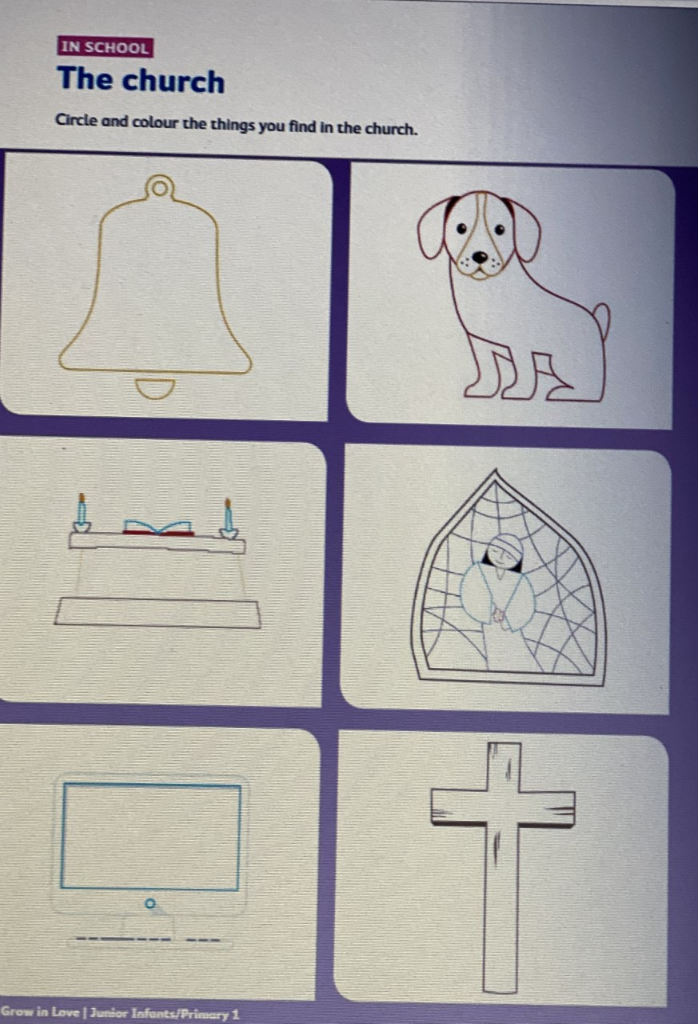
Grow in Love: Worksheet
2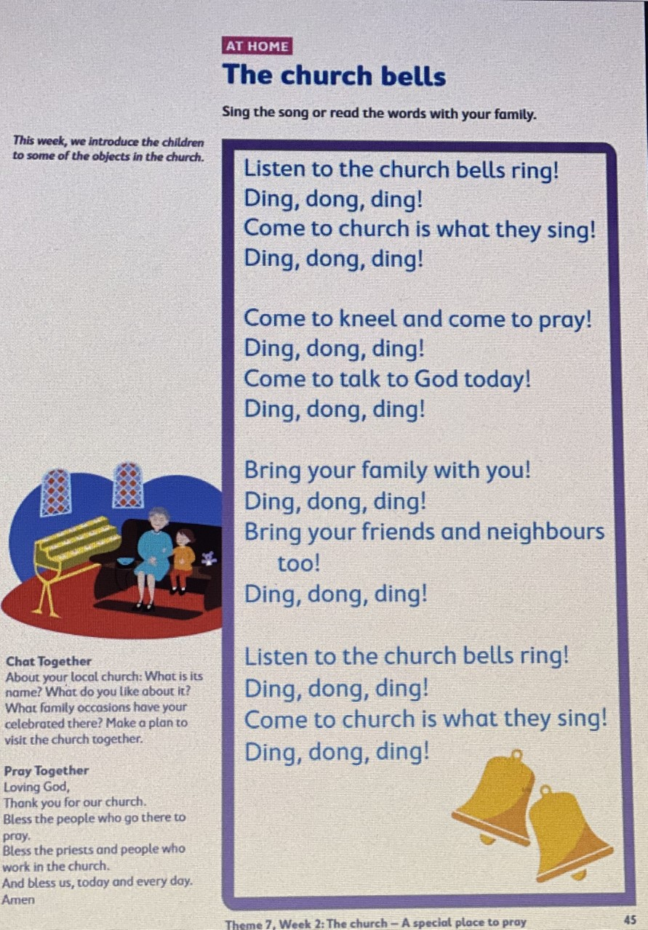
Cursive Writing Worksheet 1: Letter m
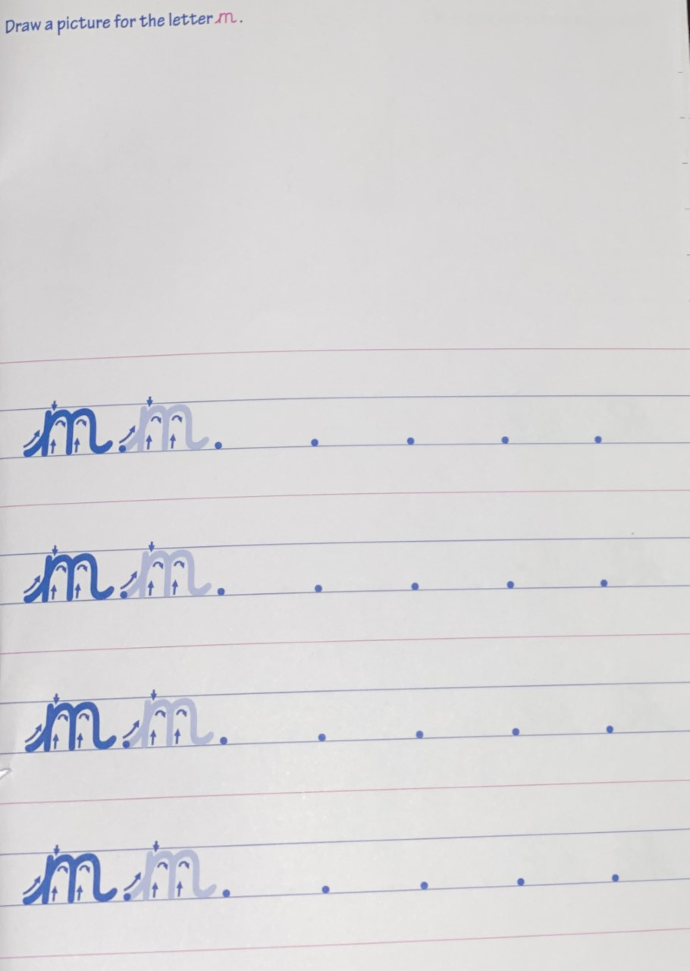

Cursive Writing Worksheet 2
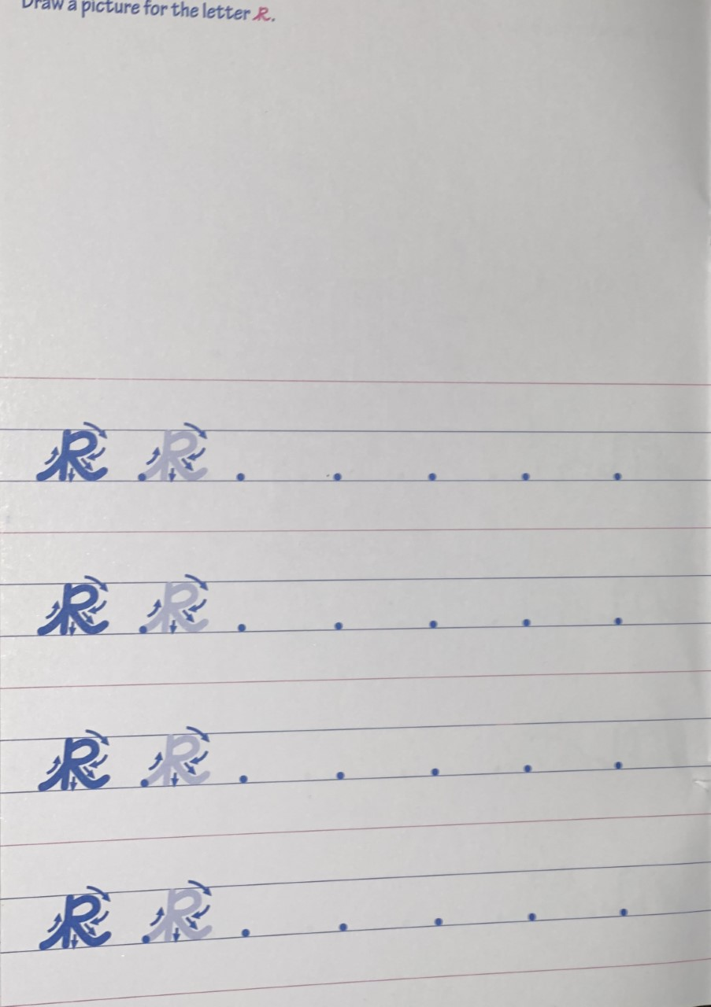
Irish Worksheet 1

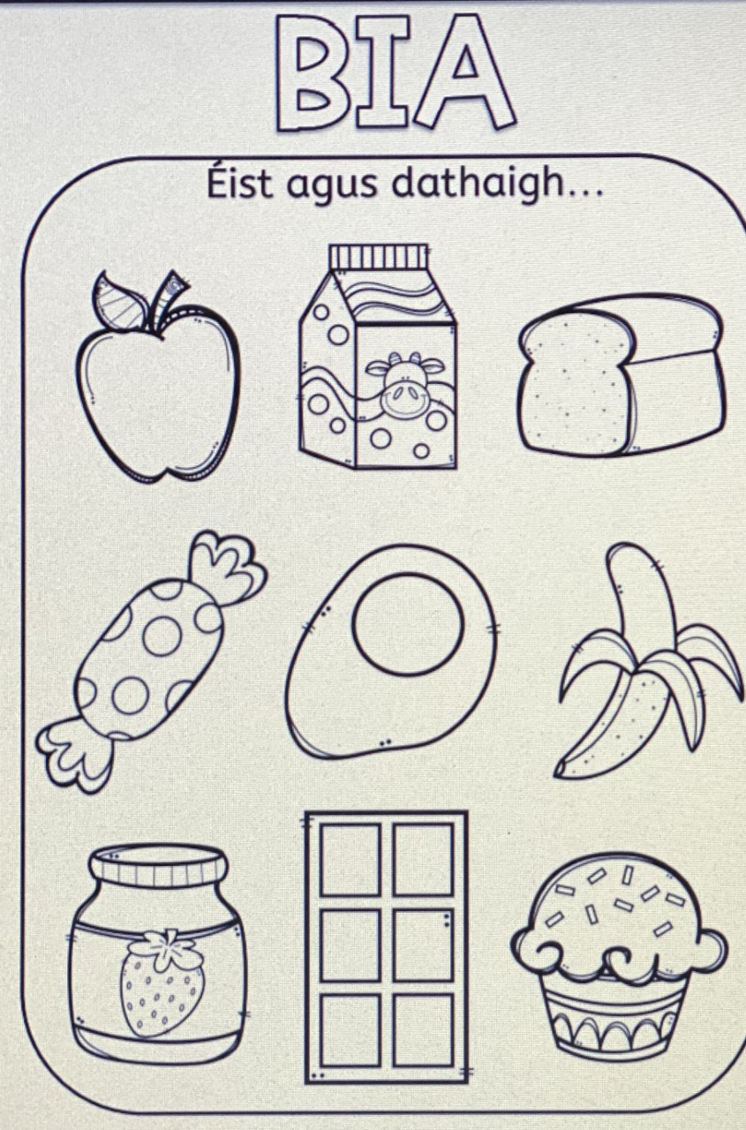
Irish Worksheet 2

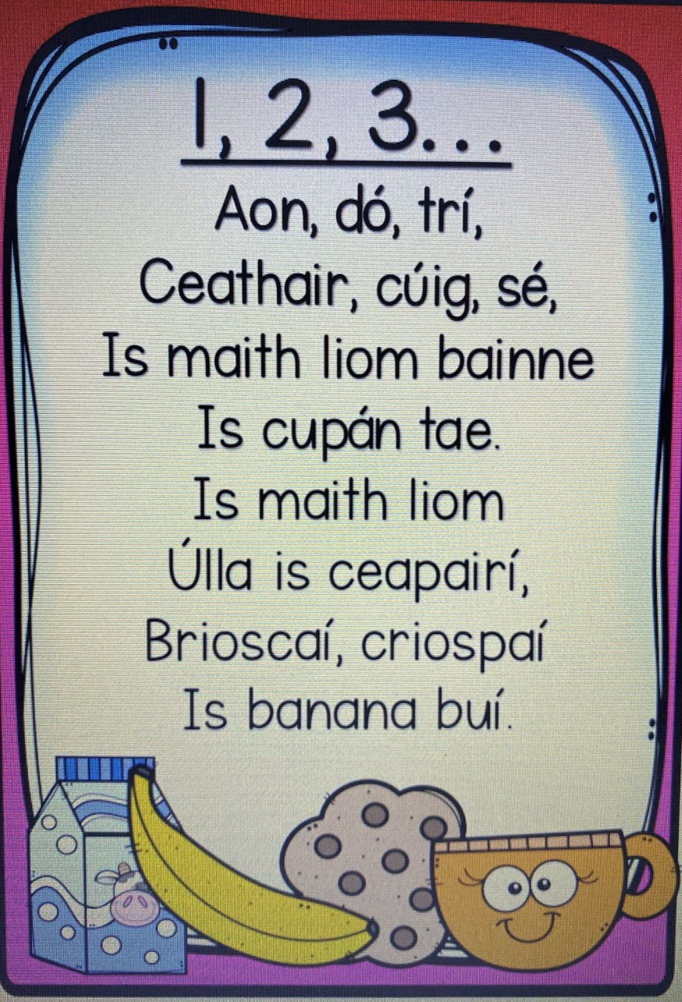
Maths Worksheet 1: How many?
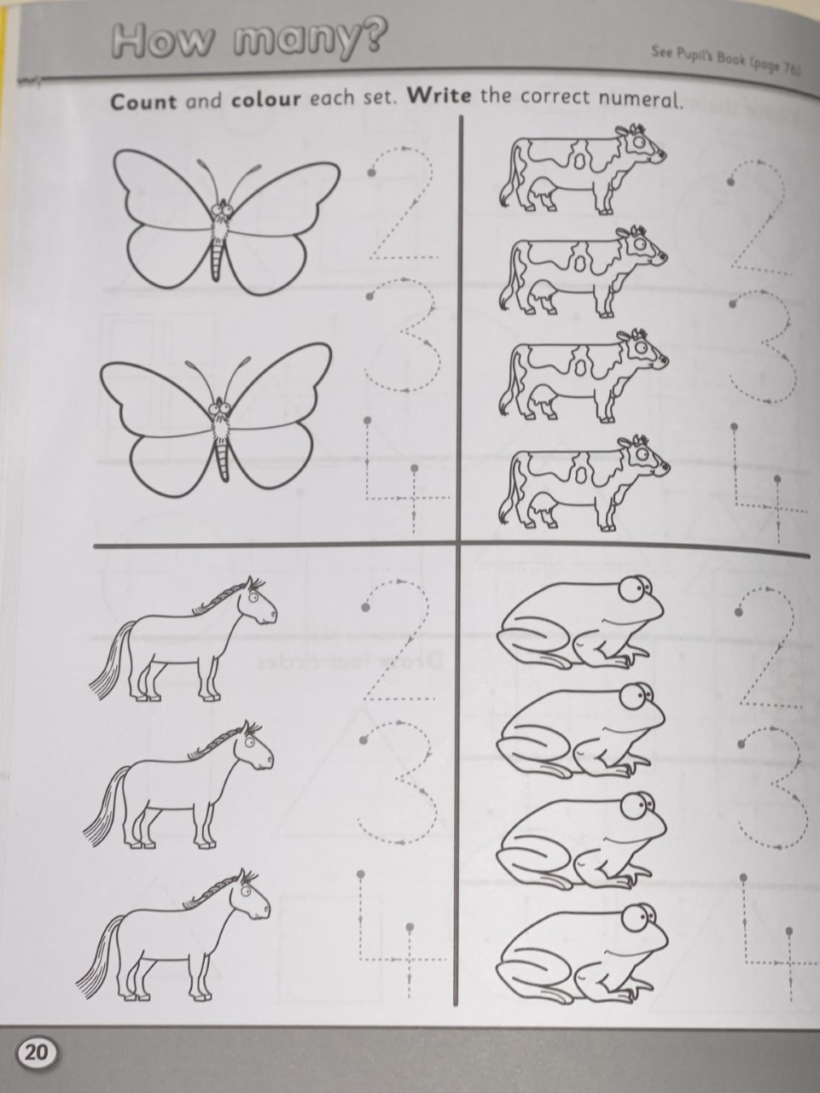
Maths Worksheet 2: Count the number in each set. Add. Write
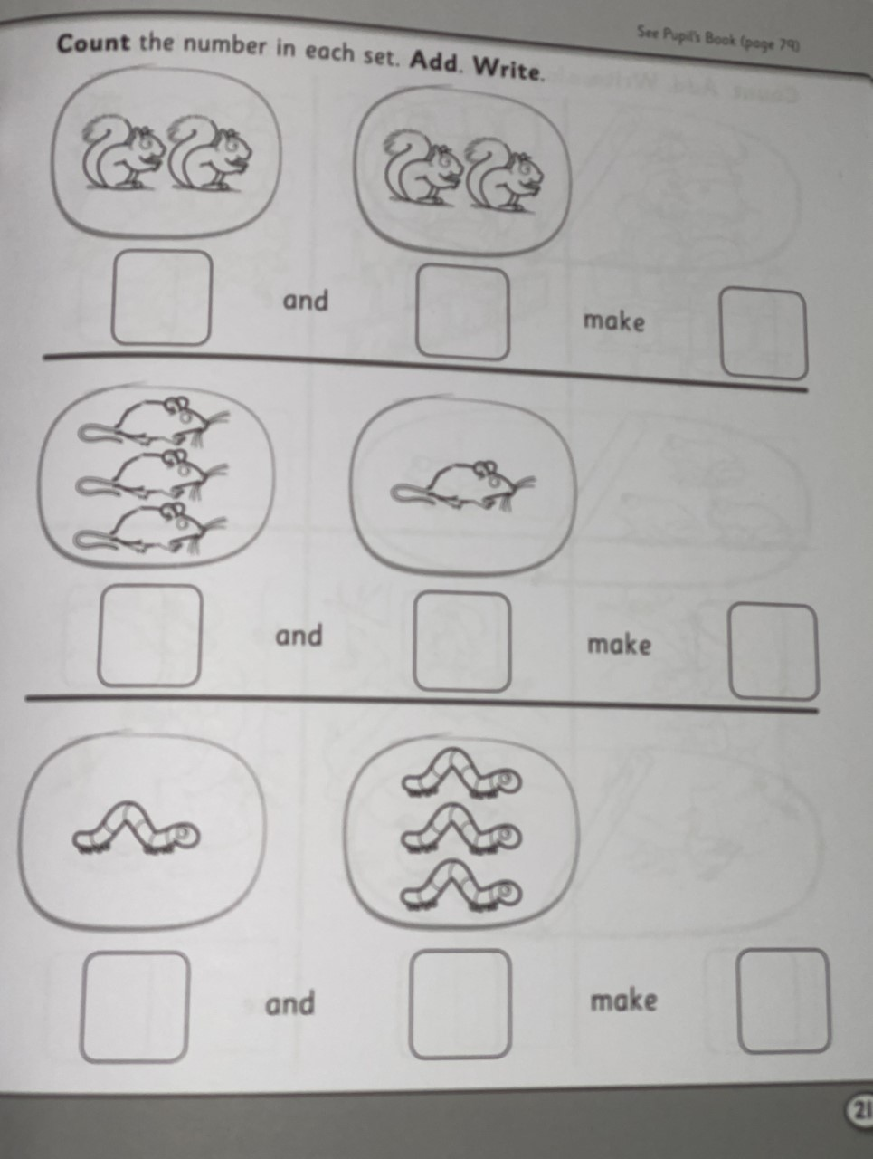

Maths Worksheet 2: Count. Add. Write
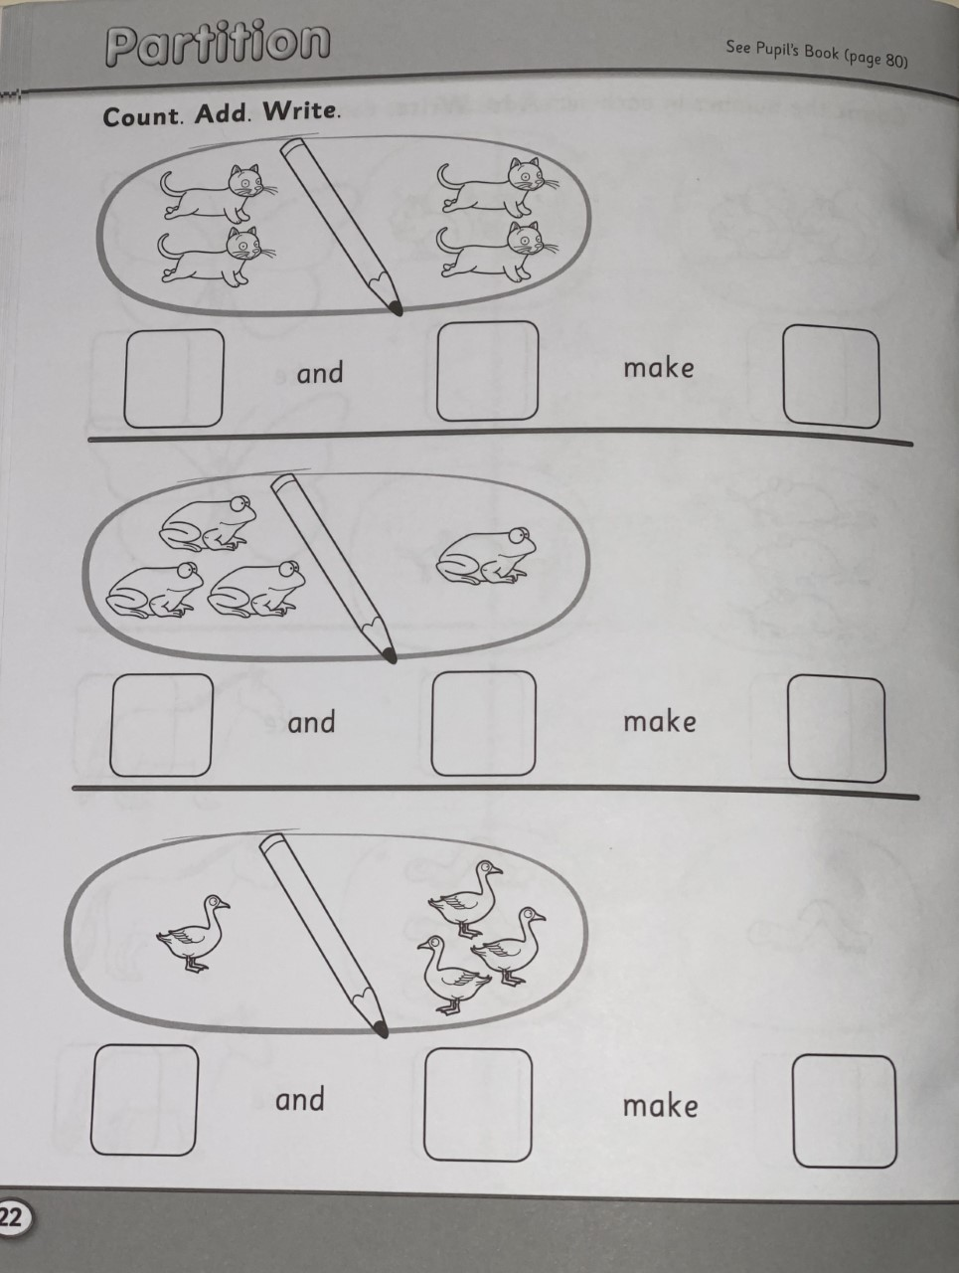

Reading: Decodable Reader: A Bag
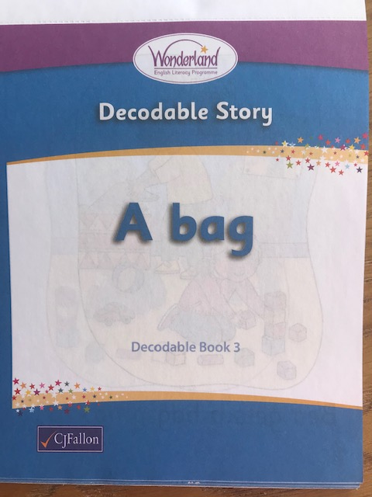

Page 1

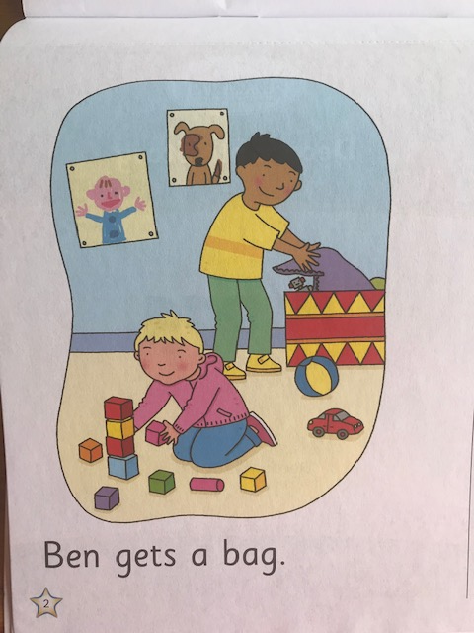

Page 2

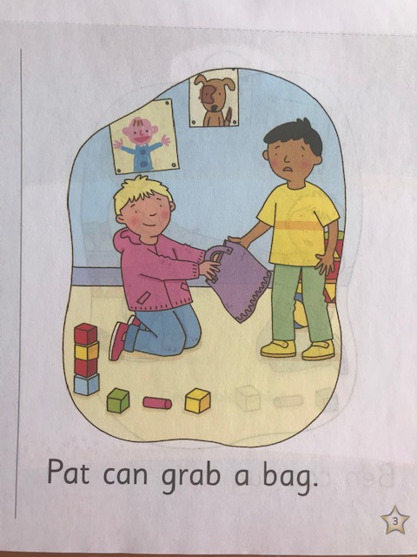

Page 3

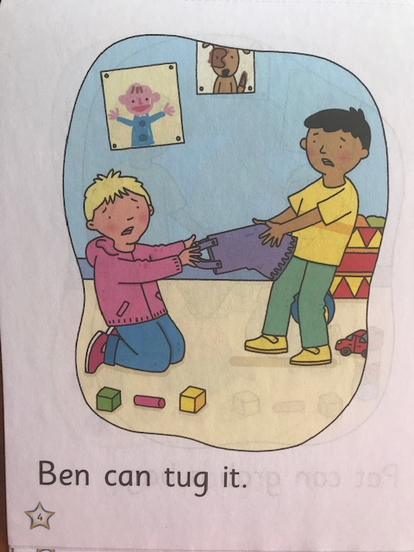

Page 4

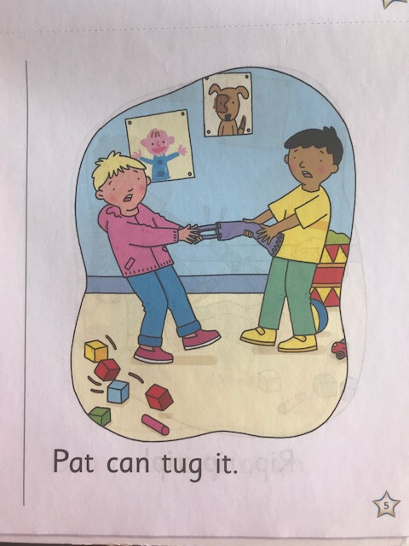

Page 5

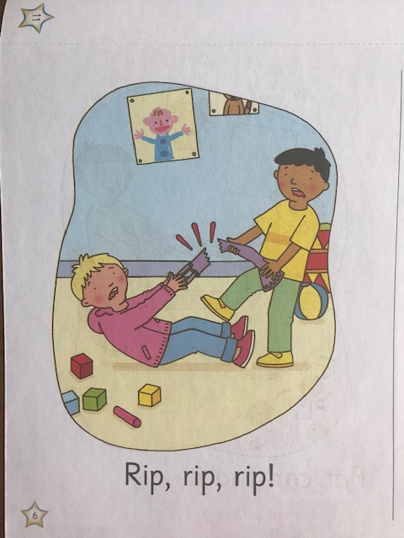

Page 6

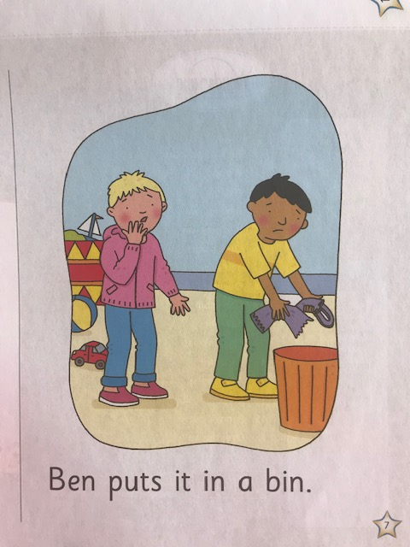

Page 7

