4th Class – Ms Dunne & Ms Lynch
Week 3 & Easter Break

Dear Parents,
We hope you and your families are keeping well. This is a challenging time for a lot of families so we don’t want children to worry or feel under pressure to complete all activities- do as little or as much suits your child. We hope you stay safe and let the children know we miss them and we’ll hopefully see them all very soon.
Week 3 of school closure
Spellings: next week
Read, read, read!
Treasury D p 68-74

Planet maths- Capacity: p157-160 and online resources. Log on to www.folensonline.ie –planet maths4-resourses-topic-26. Capacity ( will send out answers on Monday)
Practise division tables 1-5
Master your maths – next week
(answers below)

Gaeilge:
a) Abair liom : p.69 and 70
b) Léigh sa Bhaile leabhar D e-book- go to www.cjfallon.ie to access online book (see below)
page 1-4 (read and answer questions in copies)
https://my.cjfallon.ie/dashboard/resources
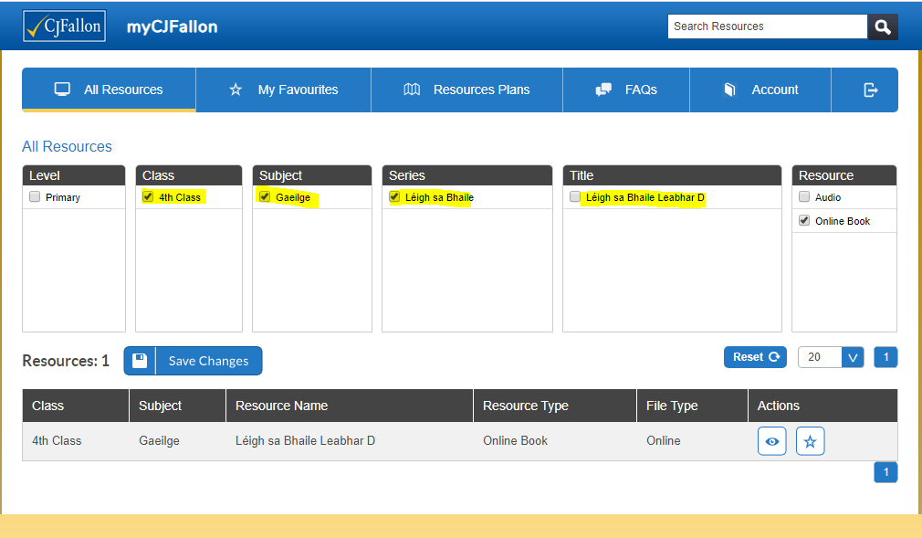
Figure 1
www.seideansi.ie (aimed at Irish medium schools so children could start at ranga 1/ 2)
Small world Geography and Science-
Unit 4: People At Work

International week-This week was to be International week in Illistrin NS. We would still like to celebrate this with our families and the wider community. Children could research a country of interest to your family, listen to music from a different culture or do some artwork from another country. We are asking the school community to send their artwork, a song or a piece of writing under this theme to illistrininternational@gmail.com. We will then compile the photos we receive to create a video for our website and Illistrin Pa facebook page.
Free Online activities
9.00am - PE with Joe Wicks https://youtu.be/6v-a_dpwhro
10.00am - Maths with Carol Vorderman www.themathsfactor.com
11.00am - English with David Walliams https://www.worldofdavidwalliams.com/elevenses/
12.00pm - Lunch (cooking with Jamie Oliver) https://www.jamieoliver.com/feat…/category/get-kids-cooking/
1.00pm - Music with Myleene Klass https://www.youtube.com/channel/UCQh2wgJ5tOrixYBn6jFXsXQ
1.30pm - Dance with Darcey Bussel https://twitter.com/diversedance…/status/1241098264373592065
2.00pm - History with Dan Snow (free for 30-days) https://tv.historyhit.com/signup/package
4.00pm - Home Economics with Theo Michaels (Mon/Wed/Fri) https://www.instagram.com/theocooks
Non-daily events include:
Science with Professor Brian Cox, Robin Ince & Guests https://cosmicshambles.com/stayathome/upcoming-schedule
9.30am Wednesday 25 March - Geography with Steve Backshall https://twitter.com/SteveBacksha…/status/1242058846941712385
2pm Mon-Fri this week only; Animal Talks from Dartmoor Zoo https://www.facebook.com/252987758563/posts/10157595491153564/

Master your | Maths | Answers | Week 24
Monday | Tuesday | Wednesday | Thursday
1: 8.06 | 7/9 | 1.97 | 1
2: 72cm | 2/9 | 47 | 2/9
3. 24 | 6 | 8 | 40
4. 1,365 | 50 | 0.25 | 165
5. 5,000g | 181 | No | 8,050
6. 78 | 4,050 | 1 | 8
7. 1.03 | Triangular prism | 7.26 | Hexagonal pyramid
8. yes | 60 | …… | 95
9. 2.54 | 1/50 | 6.89 | 3/20
10. vertical | 16 | 6,540 | 24
11. 63,72,81 | …… | 2/8, 3/8, 4/8, 5/8, 6/8, 7/8 | 5
12. 55 | 2 | 1,100 | 6
13. 15 | Apple | 2.62 | 5
14. 59.03kg | 8.60 | 85 | 6
15. 4.40 | 24.30 | 2.55 | 10
16. 256 | 2.40 | 2.28m | ……

