Mr. C Gallagher 4th Class
Week 3 & Easter Holidays

Dear Parents,
I hope you and your families are keeping well. This is a challenging time for a lot of families so I don’t want children to worry or feel under pressure to complete all activities - do as little or as much suits your child, as this is just a suggested scheme of work. We hope you stay safe and let the children know I miss them and I will hopefully see them all very soon.

English | Witches, Spiders and Cowboys  Reading & Writing  This is not Earth P-108 – Complete questions 1-11 P -115  The Stone Fox P-121 – Complete questions 1-10 P-125  Clothes around the world P-126 – Complete questions 1-6 P-128  Dear Norman P-129 – Complete questions 1-13 P-138  Oral Language P-115 question 12  Jamie’s parents had to leave Earth because of wars and pollution there. Talk about any books you have read or films you have seen about people having to leave their homes because of some disaster/tragedy.  Reading (Witches Spiders and Cowboys)  Diary of a Wimpy Kid P-17  Charlie and the Chocolate Factory P-46  Girl in Goal P-25  Big Cats P-5  Popcorn P-14  The following is a list of additional work that can be completed if the above English work is finished. The additional work will be attached and includes the following which is differentiated.  - News for you  - Heat  - Winter  - St Patrick  - The Stone Age
Gaeilge  . | Abair Liom  Léamh  Cú Chulainn lth-148  Laethanta Saoire lth -147  Comhrá  E Caítheamh Aimsire lth -151 (Conversation)  Scríobh –  H Cuardach Focail lth-146  J Na litreacha “ai” lth–147  A Freagair na ceisteanna lth-149  C Líon na bearnaí lth-150  D Críochnaigh na habairtí lth-150  F Scríobh na habairtí lth-151  C Ceisteanna agus freagraí lth 152  Éisteacht (Listen to folens online)  G lth-146  B lth-149  *Answers to the Gaeilge have been attached.  Folens publishers have made their online resources free to students during the time off.  Steps  Go to folensonline.ie  - Click register.  - Select Teacher  - For roll number use the code: Prim20  To aid the learning of Gaeilge I highly recommend using their online Abair Liom resources
Maths | Master Your Maths Week -27 Monday  *Answers to Master Your Maths Week 27 have been attached.  Revise Multiplication Tables (Times 2,3,4&5)  This work below has been attached.  Operations A, B & C P-77  D, E & F P-78  Test Yourself 1-10 P-79  Multiplication A, B & C P-44  D, E & F P-45  Division  A,B & C P-29
Spellings | English  Jolly Phonics Spelling List – 28 Complete the left-hand side of the sheet.  Learn spellings 1-18  Gaeilge  Aonad – 27 Bainis Litriú 1-10  *Students are going be asked to complete their spelling test on Friday at home, at the back of their spelling book.
Science  Forces | Small World Geography & Science  Science  Unit 15 – Forces P-88  Complete – Questions 1-5 P-90, Questions A 1-12 P-92 & Part B P-92  Complete the worksheet on friction and forces that is attached to this document  *If you have the materials it would be great to do the experiment on page-90 and record the results. You could email me to let me know how you got on. Please do not go out to buy any of the materials that are needed if you don’t have them.
History  Norman Ireland | History Quest P-63 The changes the Normans brought to Ireland.  Complete Activity A 1-8 P-68, Activity B Part 1 P-69 & Activity C 1-6 P-69  Complete Motte and Bailey Cloze Exercise that is attached to this document  Medieval Castle Project  ***This is additional non-essential work. There is no pressure to complete this project. It is merely a suggestion to aid the creativity of your child if they need extra-curricular activities.  Create your own medieval castle. It can take the form of a drawing/painting, clay, fabric and fibre or construction from recycled materials. Or any other art materials that your child has at home. There is no need to but materials.  This is a follow up from the topic Medieval Castles “Life in Norman Ireland” P-32 History Quest
Geography  Natural & Human Environments | Small World Geography & Science  Ireland People & Places P-47  Become familiar with the names & locations of some major natural features and places in the county and Ireland.  Read the chapter and complete the following work:  P-49 A, B & C.  P-50 A&B  P-51 Q1-8
Art  Drawing and Painting | Art Project  We have been working on our classroom clocks over the past number of weeks. It was due to link into the topic of Time in maths which we were supposed to cover last week. Each student has their own individual clock to remind them of their time in fourth class. The task for each student is to design the front of their clocks. The clock mechanism and hands have arrived from England so on return to school we will be able to complete them. Each student can choose any design they want.  Examples: Landscape drawings, favourite TV character, favourite football team emblems etc.  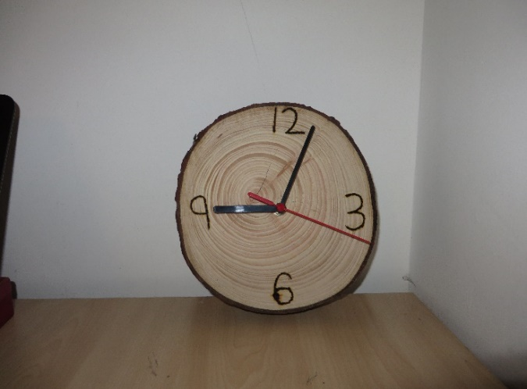  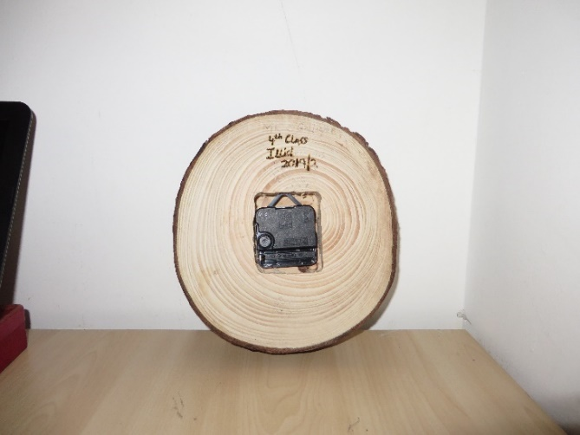
P.E | Rte Junior 10 @10  https://rtejr.rte.ie/10at10/  https://www.jumpstartjonny.co.uk/home  https://www.gonoodle.com/  The Stars/The Flying Friends/Core Balance/Wraps  Below is a list of suggested activities that you can try inside or outside. It is very important to try and be active at this difficult time. I would recommend 30mins of physical activity per day from any of resources mentioned.
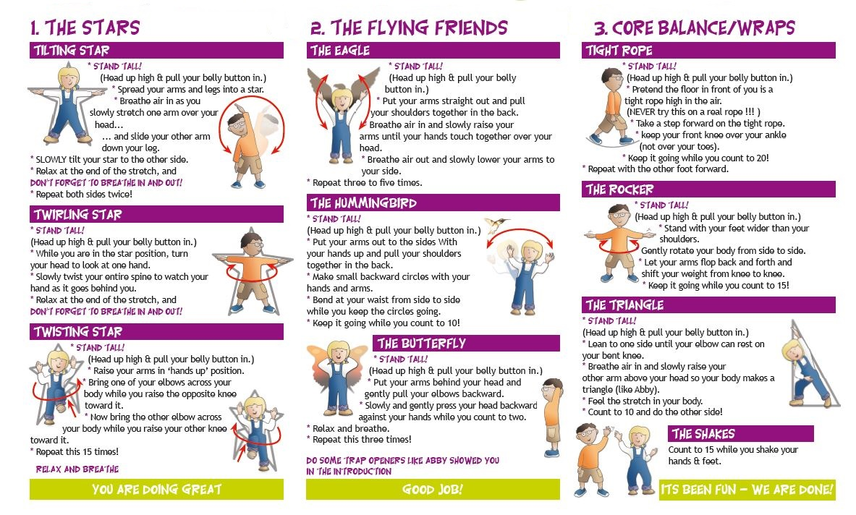

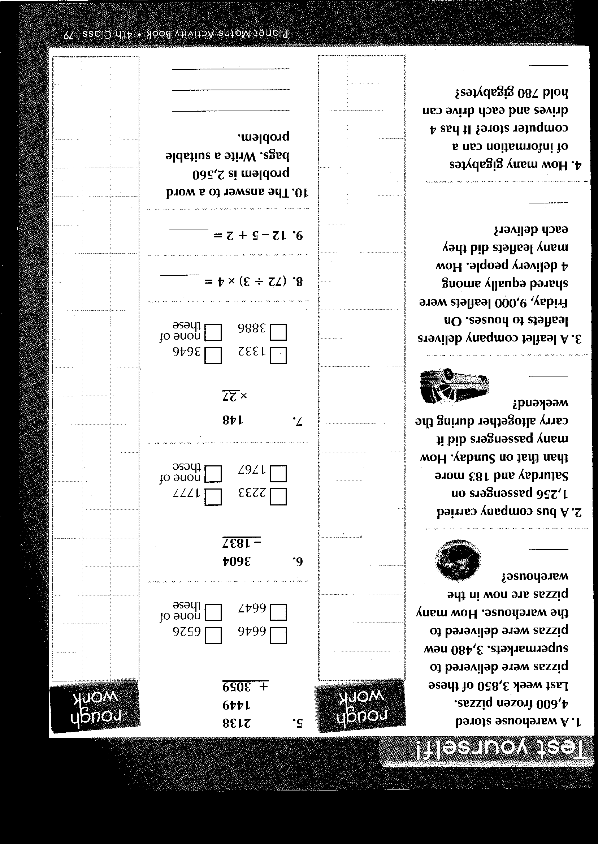
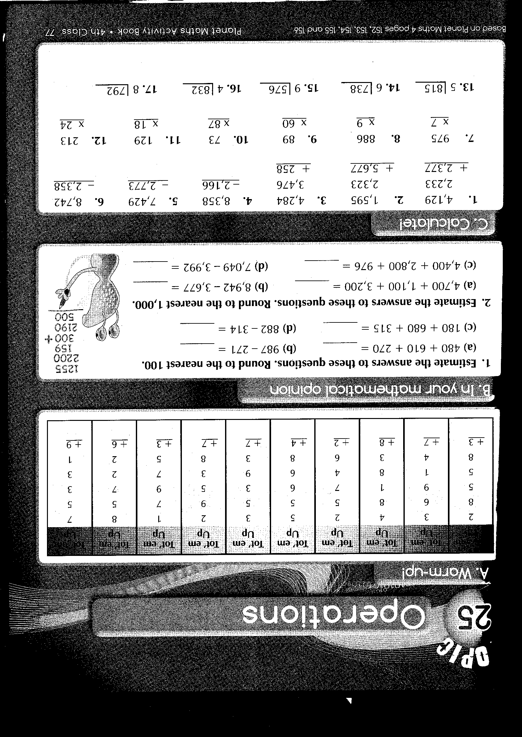
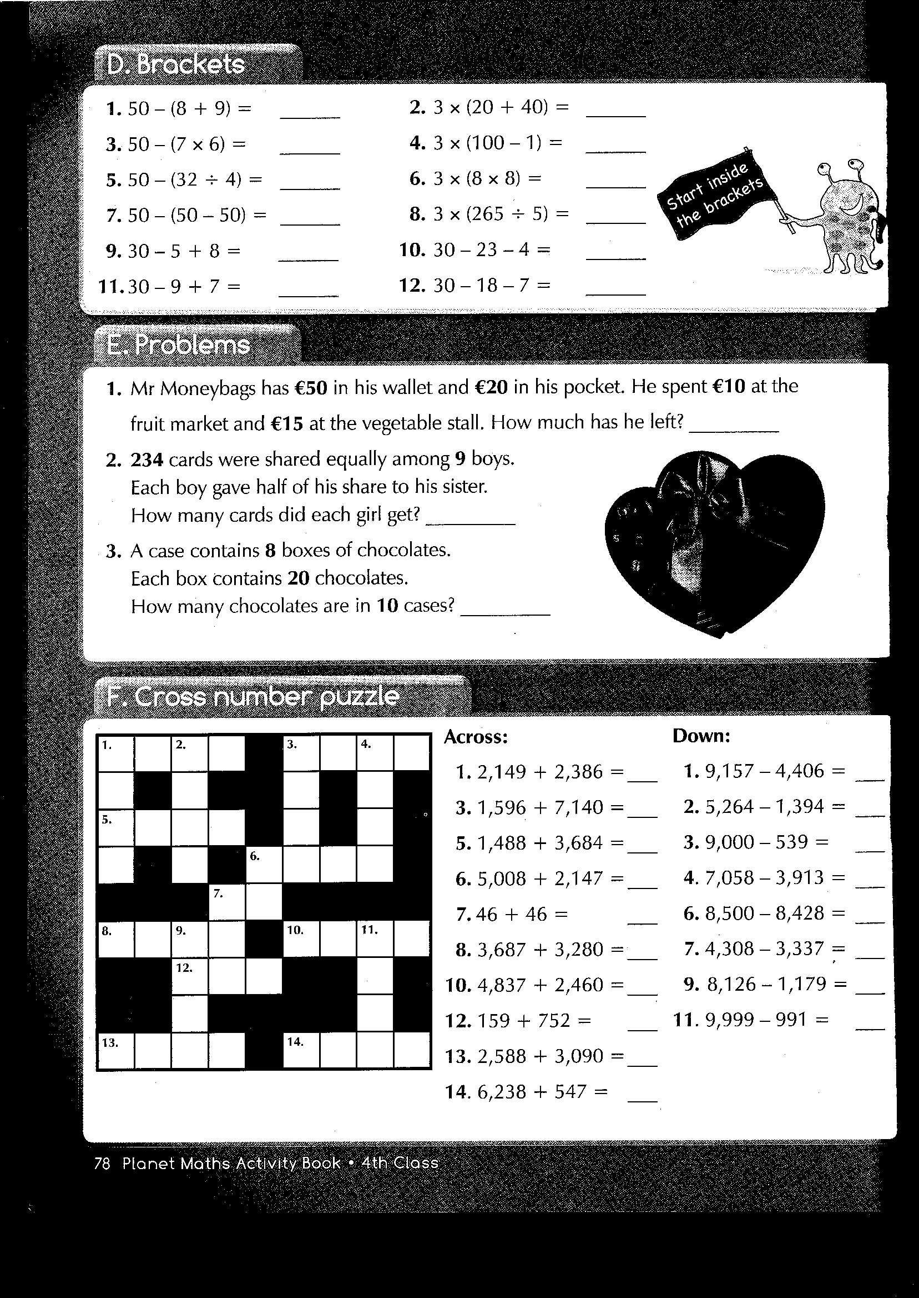
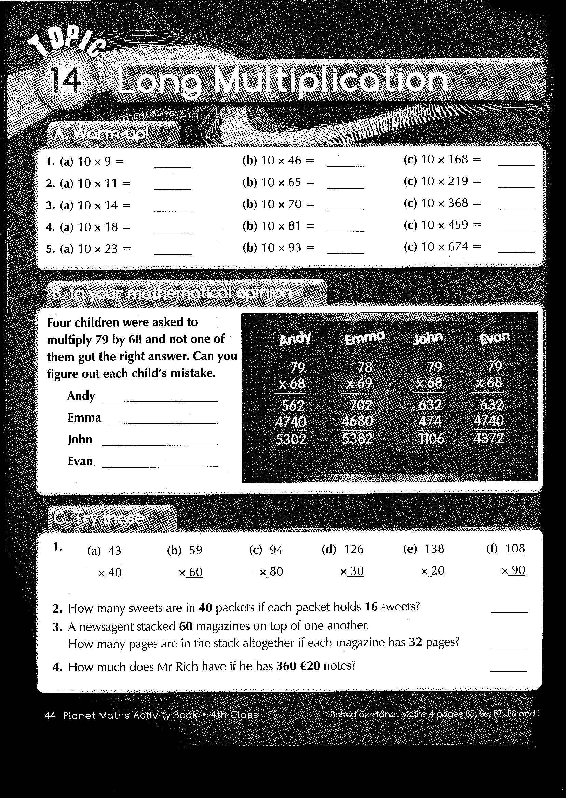
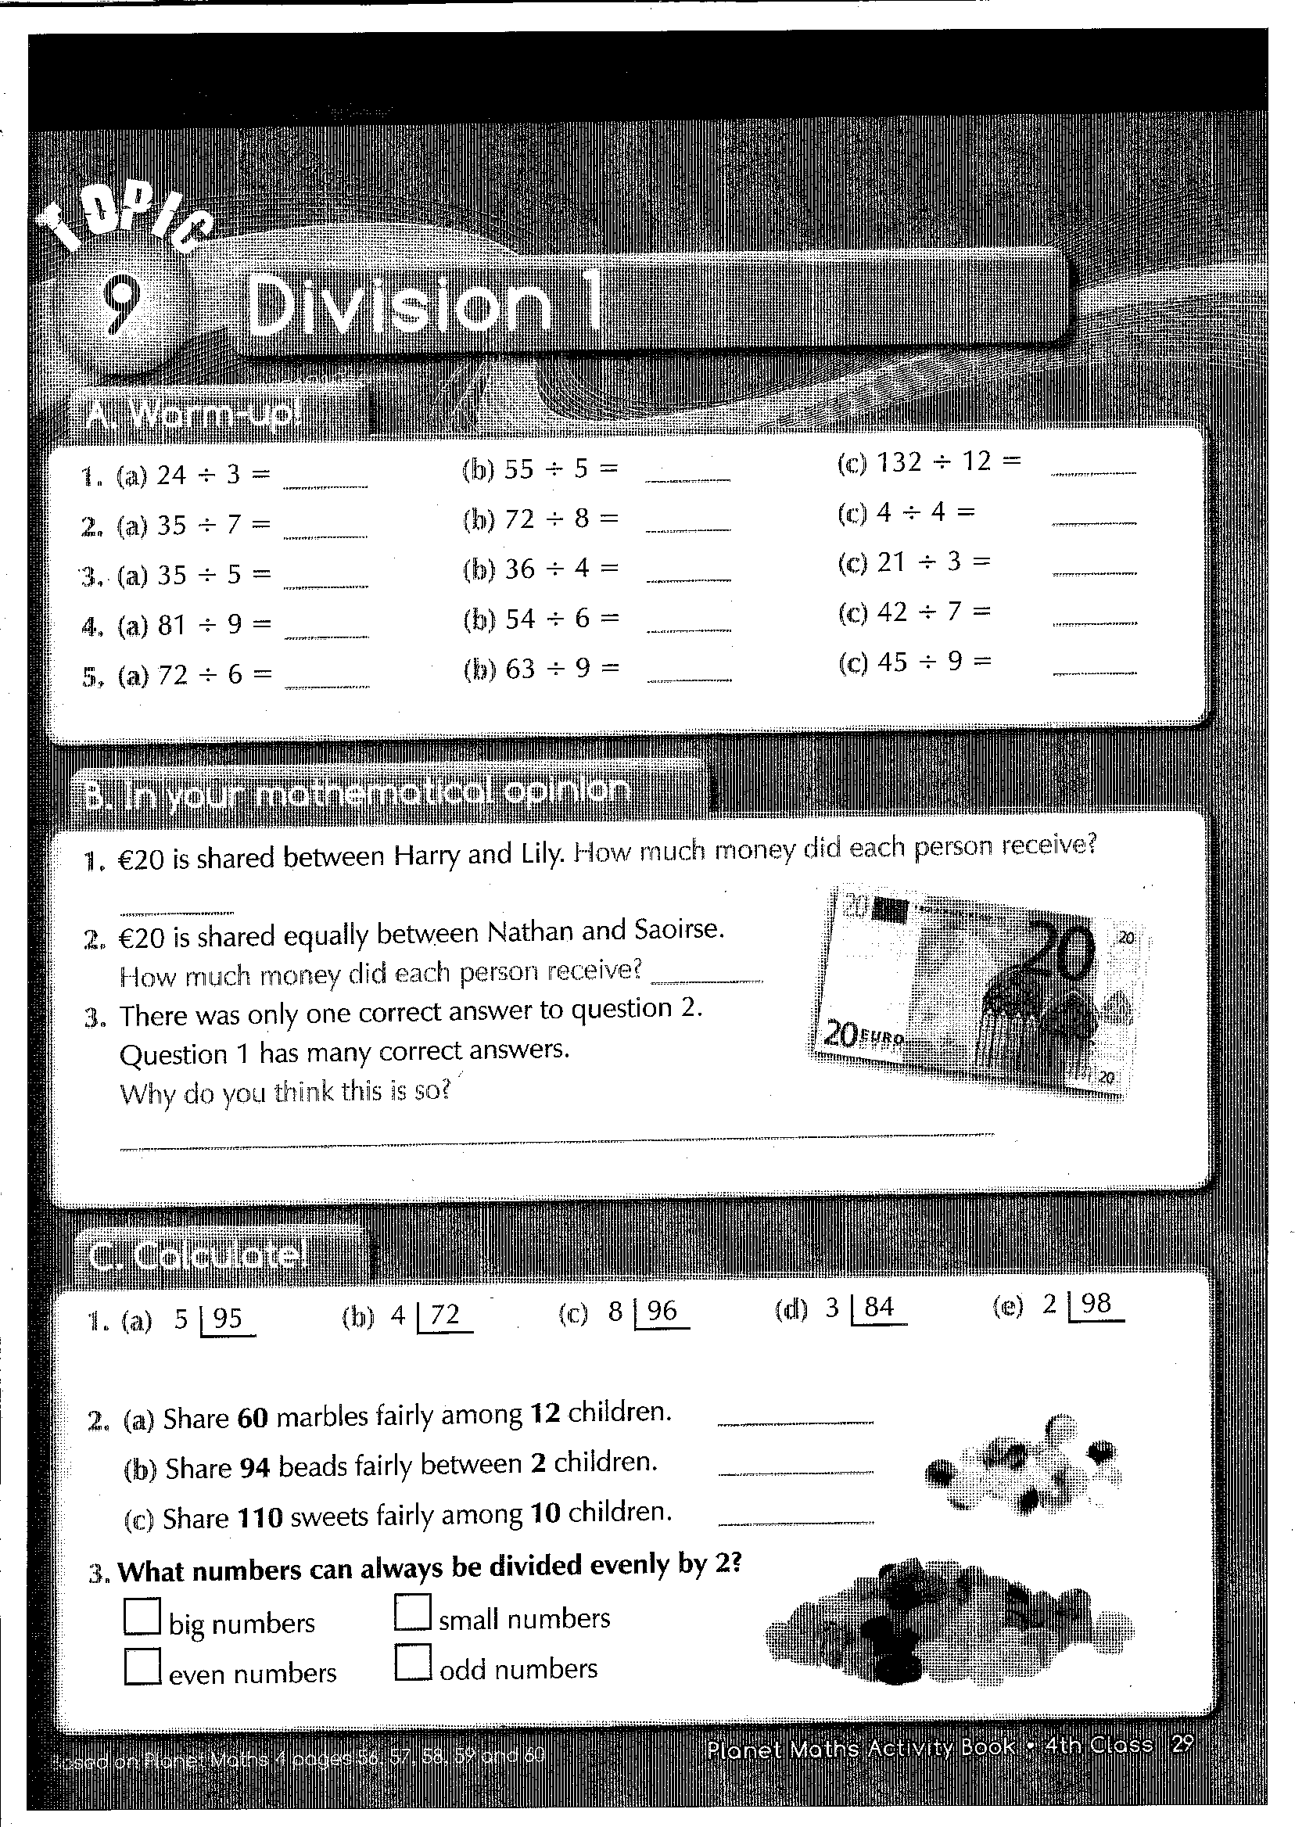
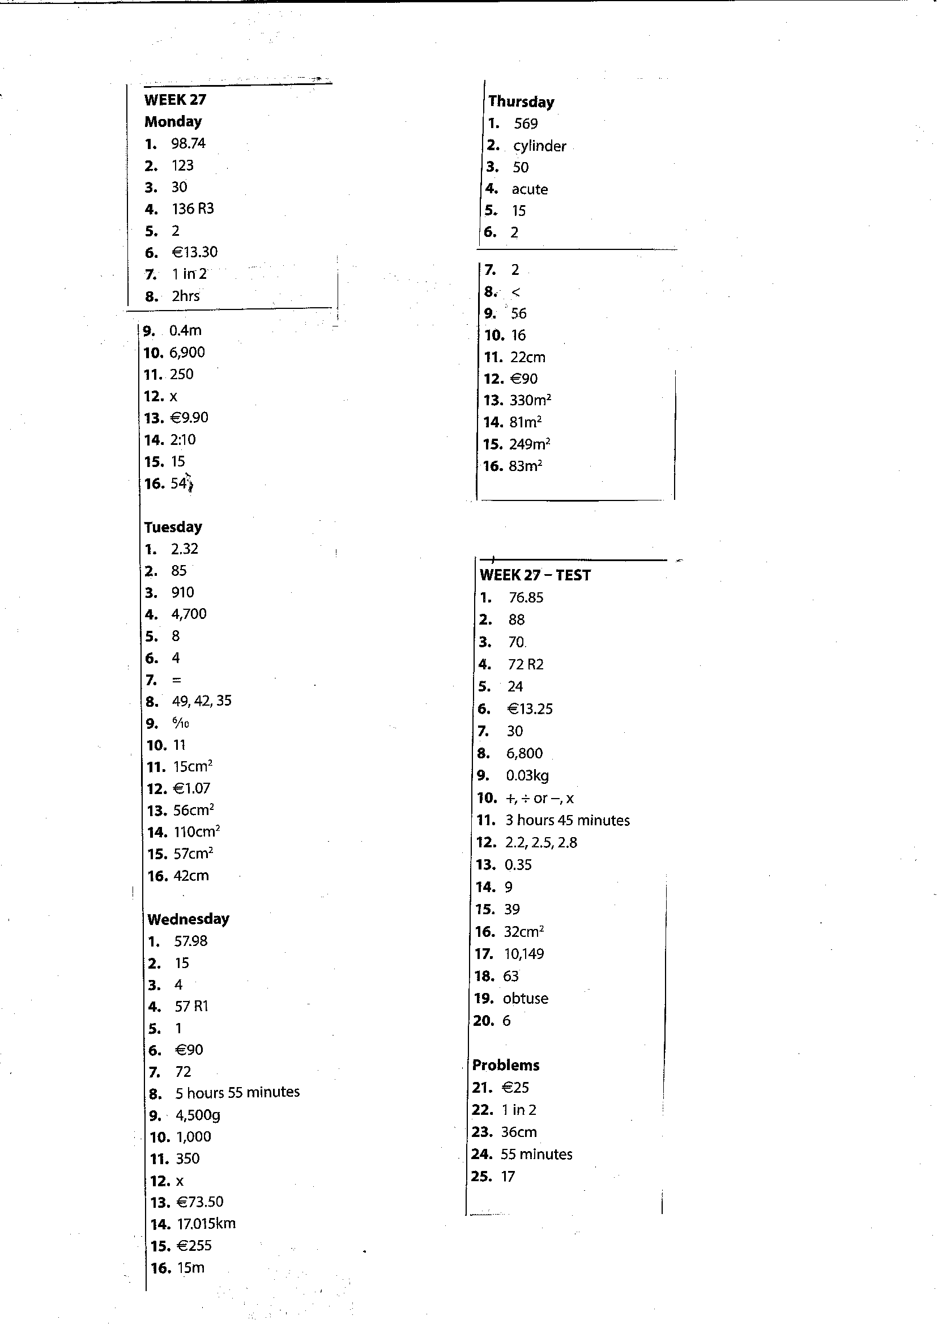

Master Your Maths Answers Week 27
